IBD I + II
&
Colonic Polyps And Carcinoma I + II

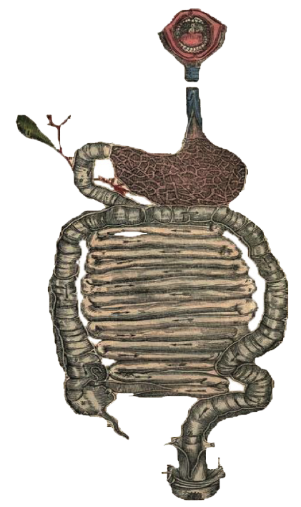
Objectives:
Upon the completion of IBD lecture the student will:
- Know the two forms of idiopathic inflammatory bowel disease (IBD).
- Describe the pathogenesis of IBD.
- Compare and contrast Crohn’s disease and ulcerative colitis with respect to:
- clinical features and extra intestinal manifestations
- pathology (gross and microscopic features) of IBD.
- Complications of IBD. (especially adenocarcinoma preceded by dysplasia)
Upon completion of Colon polyps and Carcinoma lecture the student will:
- Know common types of intestinal polyps.
- Differentiate between the neoplastic and non-neoplastic polyps.
- Know the clinical presentation of left and right sided colon cancer, and the environmental factors that increases its risk .
- Understand the pathogenesis of colon tumors of the small and large intestines.

• Black: Doctors’ slides. • Red: Important! • Light Green: Doctors’ notes • Grey: Extra. • Italic black: New terminology.
- Know The Two Forms Of Idiopathic Inflammatory Bowel Disease (IBD).

Inflammatory Bowel Disease

Inflammatory Bowel Diseases:
- Crohn's disease and ulcerative colitis.
- Although their causes are still not clear, the two diseases probably have an immunologic hypersensitivity basis.
You need to know 3 things about IBDs: 1. Chronic (remission and relapse) 2. Inflammatory 3. Unknown cause but it could be due to immune response to an antigen.

- Describe The Pathogenesis Of IBD.

Pathophysiology:
They are idiopathic disorders, but:
Mutation in NOD2 is thought to cause a mucosal immune response & inflammation. Which is why the treatment being mostly immunosuppression.

Clinical Manifestations of IBD:
The manifestations of IBD generally depend on the area of the intestinal tract involved.
Area | Clinical Manifestation
Colon | Bloody diarrhea & Tenesmus
Small Intestine | Abdominal pain, intestinal obstruction & steatorrhea.
Extra intestinal | Eye, Skin & joints(arthritis)

- Compare And Contrast Crohn’s Disease And Ulcerative Colitis

Crohn’s Disease: داء كرون
It’s a chronic inflammatory disorder that most commonly affects the ileum and colon but has the potential to involve any part of the alimentary tract from the mouth to the anus.

Clinical Features:
Age group: can affect any age but has a high incidence in young adults.
Extremely variable clinical features, but is divided into 2 phases.
Acute phase: Fever, diarrhea and right lower quadrant pain which may mimic acute appendicitis.
Chronic Phase: Remission and relapse of symptoms over a long period, thickening of the intestine may produce an ill-defined mass under radiology.
Acute phase: patient comes in to the ER with severe abdominal pain with no history, clinical examination shows the pain radiating to the lower right quadrant which is the exact same representation of appendicitis.
Chronic Phase: Usually less severe and when patient comes to the ER he tells you: “this happens to me every 1-2 months”

Sites of involvement in Crohn’s disease:
It can affect any part of the GI but most commonly affects the terminal ileum, 2nd most common is ileum (30%) as a whole & 3rd most common is the colon(20%). It’s also commonly (75%) associated with perianal lesions such as abscesses, fistulas and skin tags.

Gross Appearance:( The fat is normally attached to the Mesentery which attaches to one side of the intestine)
During inflammation the fat migrates and surrounds the intestine like a cylindrical coat.
Involvement is typically segmental (AKA: Skip lesion & discontinuous), with skip areas of normal intestine between areas of involved bowel.
Marked fibrosis causing luminal narrowing (More than ulcerative colitis) with intestinal obstruction. Where? In terminal ileum, treatment is resection.
Fissures (deep and narrow ulcers that look like stabs with a knife that penetrate deeply into the wall of the affected intestine) الألسر عميق ويوصل للمسلز فيحصل الإنفلميشن لكل القولون!
fistulas (communications with other viscera). E.g.: between the colon and small intestine or between the colon and the vagina)
Dr.Ahmed’s explanation of the ulceration.

Mucosa: typical cobblestone shaped ulcers grossly, caused by longitudinal serpiginous ulcers separated by irregular islands of edematous mucosa.
Fat: In involved Ileal segments, the mesenteric fat creeps from the mesentery to surround the bowel wall (creeping fat يزحف على الجوانب)

Microscopic Appearance:
- Distortion of mucosal crypts architecture. This indicates that the disease is chronic and it’s not characteristic (it also happens in ulcerative colitis). The tubules should be parallel to each other but because of chronic damage they become distorted. If it’s an active phase distortion we will notice intra-tubular neutrophil infiltration.

- Transmural inflammation. (Transmural the entire wall including mucosa, sub mucosa and serosa because of the deep ulceration.)
- Epithelioid granulomas.60% (Granuloma Crohn’s.)
Fissure-ulcers and fistulas can be seen microscopically.
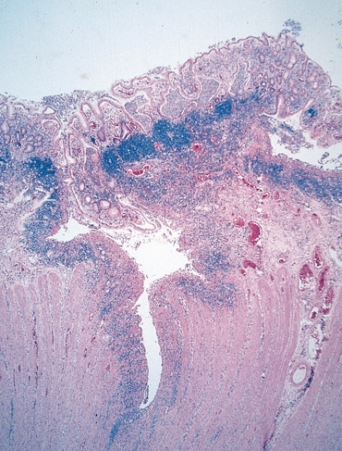
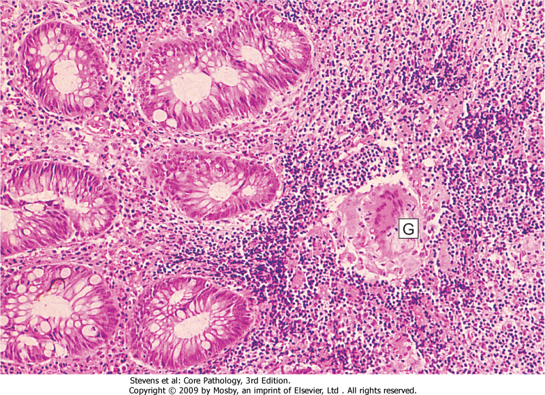
FISSURE
GRANULOMA

لو لقينا انفولفمنت لل colon and terminal ileumهذا يدل على مرض كرونز سواء فيه قرانيولوما او لا!
لأن الألسريتف كولَّلايتس ما يصيب إلا القولون hence the name “colitis” and rectum

Complications of crohn’s disease:
- Intestinal obstruction Due to fibrosis in terminal ileum by deep ulcer and inflammation
- Fistula formation:
- between the ileum and the colon result in malabsorption. (Because it takes a shortcut.)
- Enterovesical fistulas lead to urinary infections and passage of gas and feces with urine.
- Enterovaginal fistulas produce a fecal vaginal discharge.
- Extraintestinal manifestations (arthritis and uveitis) (Eye, Skin & joints)(u can remember it as sea).
- Slight increased risk of development of carcinoma of the colon (much less than in ulcerative colitis.)It means that ulcerative colitis has more risk of carcinoma

Ulcerative Colitis: التهاب القولون التقرُّحي
(colitis, which means it affects colon.)
is an inflammatory disease of uncertain cause. It has a chronic course characterized by remissions and relapses. 20- to 30-year age group but may occur at any age.

Etiology:
It’s Idiopathic. Thought to be an antibody that cross react with intestinal epithelial cells and certain serotypes of E.Coli which has been demonstrated in the serum of some patients with ulcerative colitis.

Clinical Features:
Has 2 phases:
Acute: and during relapse, fever, leukocytosis, lower abdominal pain, bloody diarrhea and mucus in the stool.
Chronic: Relapse and remission of acute phase symptoms.
The disease usually has a chronic course, with remissions and exacerbations. (gets worse with every episode.)
Sites of Involvement:
Ulcerative colitis is a disease of the rectum, and the colon.
Rectum is involved in almost all cases. The disease extends proximally from the rectum in a continuous manner without skip areas. (diffuse superficial involvement.)
The ileum is not involved as a rule.

Gross Appearance:
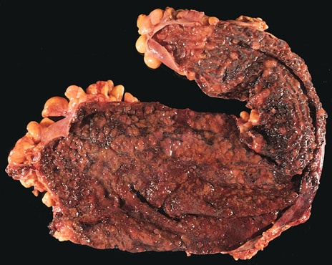
Involves mainly the mucosa (diffuse “AKA: Continues” hyperemia with numerous superficial ulcerations in the acute phase. The regenerated or nonulcerated mucosa may appear polypoid (inflammatory pseudo polyps) in contrast with the atrophic areas or ulcers.
diffuse hyperemia (redness) with numerous superficial ulcerations
NO skip lesion.

Microscopic Appearance:
The inflammation is usually restricted to the mucosa. (In crohn’s it was Trans mural)
In the active phase: neutrophils (Cryptitis, crypt abscess)
In the chronic phase: crypt atrophy and distortion
Active inflammation correlates well with the severity of symptoms.

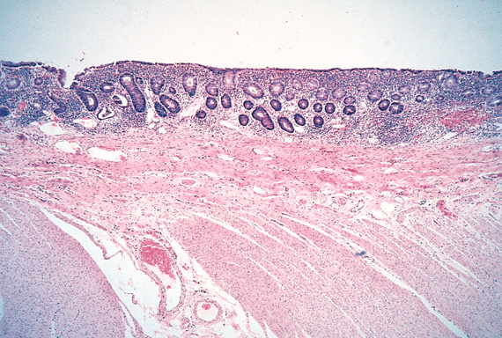
Inflammation

No inflammation

Complications:
Phase | Complication
Acute | - Severe bleeding (if the whole colon is involved.)  - Toxic megacolon (dilation of the colon, with functional obstruction يبطل يصير عندي كُنتراكشن
Chronic | - Increase risk of developing colon carcinoma.  - The presence of high-grade dysplasia in a mucosal biopsy imposes a high risk of cancer and is an indication for colectomy.
Extra intestinal Manifestations | - occur more commonly in ulcerative colitis than in Crohn's disease.  - Arthritis  - Uveitis  - skin lesions (pyoderma gangrenosum),  - sclerosing peri-cholangitis (fibrosis around bile ducts), leading to obstructive jaundice. (very specific for ulcerative colitis.)

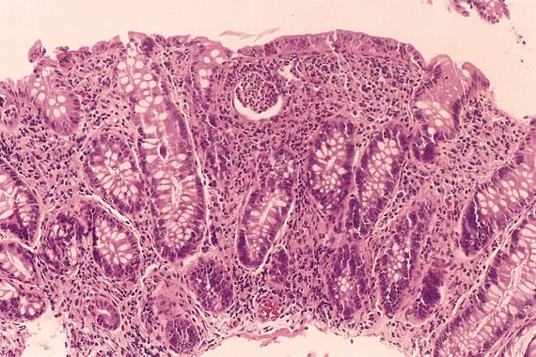
dysplasia
Colon polyps and carcinoma
- Know Common Types Of Intestinal Polyps

- Differentiate Between The Neoplastic And Non-Neoplastic Polyps.

1. Hyperplastic polyps hyperplasia of mucosal cells
- Asymptomatic
- More than 50% of hyperplastic polys located in rectosigmoid
- Saw tooth sufrace. key feature سطح مسنن
- Star shaped crypts. Normal crypts in transverse section in the shape of circles
Composed of well-deformed glands and crypts lined by differentiated goblet or absorptive cells. (Benign)
This picture shows hyperplasia glands, and you can see goblets & absorptive cells around gland. The crypts show star shape look.

2. Hamartomatous polyps
A hamartoma (from Greek hamartia, meaning “fault, defect,” and -oma, denoting a tumor or neoplasm) is a benign (noncancerous) it is a collection of smooth muscle+mucosa+lamina propria in colon as a polyp
- Juvenile polyps (retention polyps)
• Developmental malformations affecting the glands and lamina propria.
• Commonly occur in children under 5 years old in the rectum. (More than 90% of childhood colon polyps is Juvenile polyps)
• In adult called (retention polyp).

- Peutz-Jehgers syndrome
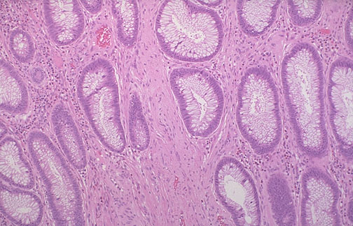
• Rare, autosomal dominant mucosal pigmentation
• hamartomatous polyps accompanied by mucosal and cutaneous
pigmentation around the lips, oral mucosa, face and genitalia.
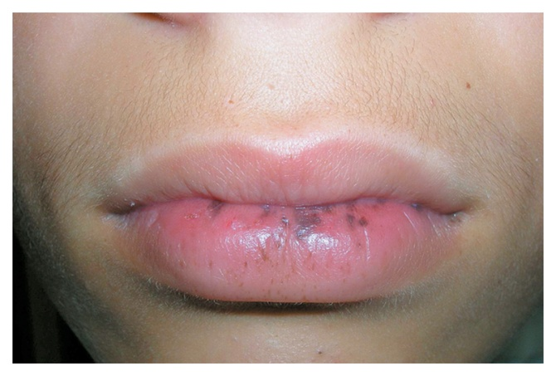
• Polyps tend to be large and pedunculated.
• Increased risk of developing carcinoma in other organs like: of the pancreas,
breast, lung, ovary and uterus. We do CT scan,MRI to exclude malignancy
EXTRA
The story behind the name of the syndrome.
In 1921, Peutz reported a Dutch family with gastrointestinal polyposis & distinctive pigmentation of the skin & mucous membranes & highlighted the inherited nature of the syndrome. In 1949, the combination of intestinal polyposis & pigmentation of the skin & mucous membranes (the same symptoms Peutz had reported) & established as a distinct entity in a publication by Jeghers et al. In 1954, Bruwer et al coined the eponym “Peutz–Jeghers syndrome” in the title of his article on this disorder.
The gab between Peutz & Jeghers diagnosis is 28 year, it’s too long to diagnose the syndrome maybe because it’s rare.

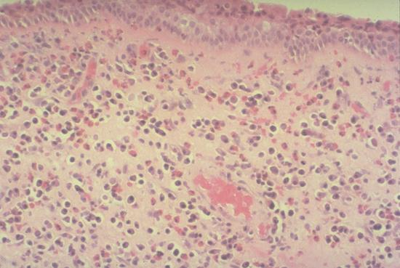
3. Inflammatory polyp
- Long standing IBD , especially in chronic ulcerative disease .and crohn’s disease
- Represent an exuberant reparative response to longstanding mucosal injury called pseudopolyps.
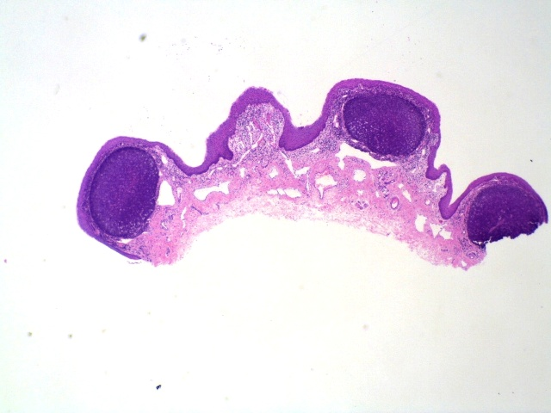
4. Lymphoid polyps -Not significant- Sometimes lymphoid tissues aggregate and are more reactive and raised than other tissues which is totally normal but some clinicians think it’s malignant and take a sample to test it.( It’s reactive changes causing raised mucosa which looks like polyps)

Neoplastic polyps "Adenoma /Adenomatous polyp"
We call it neoplastic polyp or adenoma because it contains dysplasia, and if untreated, can progress to invasive
Adenocarcinoma
- Occur mainly in large bowl.
- Sporadic and familial.
- Vary from small pedunculated to large sessile.
- Epithelium proliferation and dysplasia.
Tubulovillous adenoma | Villous adenoma** | Tubular adenoma*
- Villous architecture between 25-50%  - Intermediate in size, degree of dysplasia and malignant potential between tubular and villous adenoma. | - Villous architecture over 50%  - The least common, largest and most ominous of epithelial polyps.  - 75% located in rectosigmoid area.  - Age: 60-65 years.  - Present with rectal bleeding or anemia, large ones may secrete copious amounts of mucoid material rich in protein.  كل مازادت فيلاي بالبوليب تصير اكثر قابلية للتحول الى كانسر وهذي اكثر وحده فيها نسبه فيلاي  بالتالي اعراضها تشبه الكانسر: bleeding, which leads to anemia  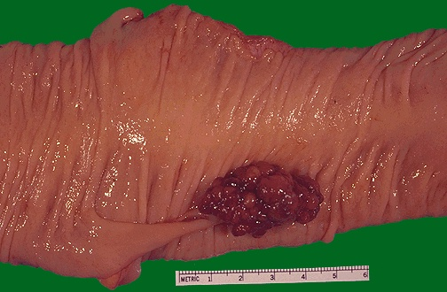 | - Less than 25% villous architecture  Formed mainly by tubules other than villi  - Represents 75% of all neoplastic polyps.  - 75% occur in distal colon  and rectum.  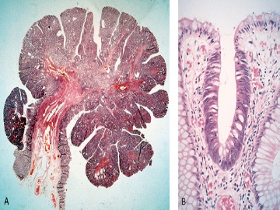
- Divided into 3 as the following:
Relationship of Neoplastic Polyps to Carcinoma
• Adenoma to carcinoma sequence is documented by several genetic alterations.
• The probability of carcinoma occurring in a neoplastic polyp is related to: المعايير اللي تحدد ان النيوبلاستيك بوليب يتحول لكارسينوما
1. The size of the polyp.
2. The relative proportion of its villous features.
3. The presence of significant cytologic atypia (dysplasia) in the neoplastic cells.
Dysplasia is of 2 kinds: high grade ((أكثر عرضة للتحول إلى كارسينوما and low grade (أقل عرضة)

Adenoma to carcinoma pathway:
Normal
- Understand The Pathogenesis Of Colon Tumors

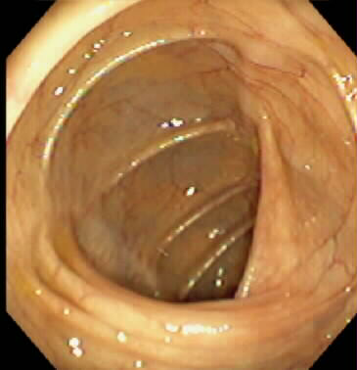
Adenoma
APC loss lead to
Hyper-proliferation > early adenoma
K-ras mutation lead to
Normal epithelium
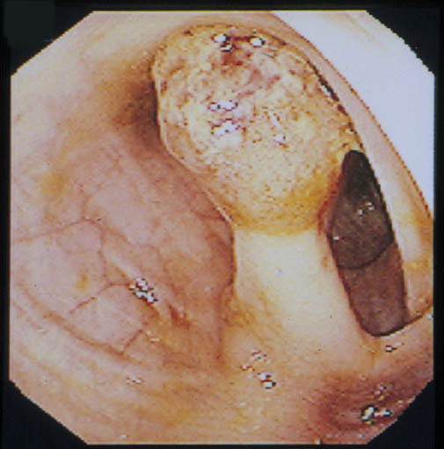
Cancer
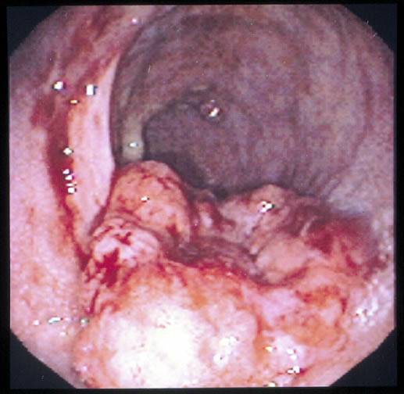
Chromosome 18 loss lead to
Intermediate Adenoma

Late Adenoma
P53 loss lead to

Those genes which are lost are tumor suppressor genes which means they suppress the appearance of tumors , so when they are lost we are prone to more tumors and can have one .
CANCER

Familial Polyposis Syndrome
Patients have genetic tendencies to develop neoplastic polyps.
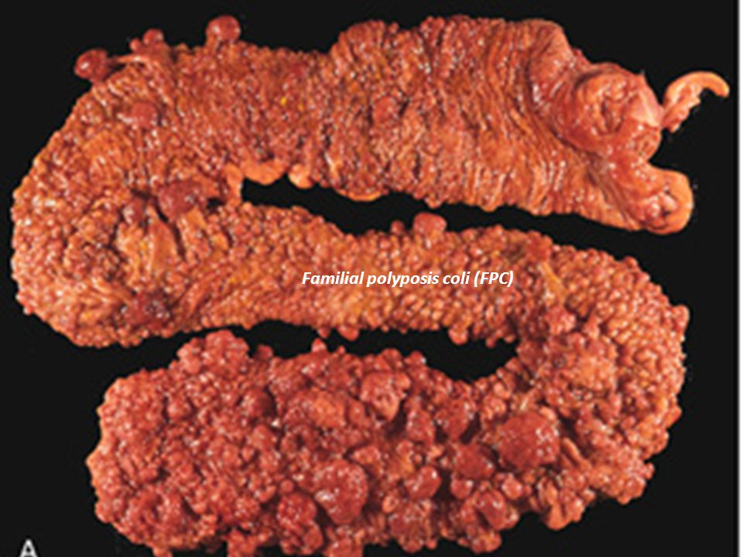
Familial polyposis coli (FPC)
- Genetic defect of Adenomatous polyposis coli (APC).
- APC gene located on the long arm of chromosome 5 (5q21).
- APC gene is a tumor suppressor gene.
- Innumerable neoplastic polyps in the colon (500 to 2500).
- Polyps are also found elsewhere in alimentary tract.
- The risk of colorectal cancer is 100% by midlife.30 yrs male has more than 100 adenoma treat it with colectomy
Gardener’s syndrome  - Polyposis coli,+multiple osteomas (Benin tumor of bone), epidermal cysts, and (fibromatosis) is a skin lesion with increase fibroblasts. | Turcot syndrome  - Polyposis coli,+glioma and fibromatosis  (CNS Tumors)

Malignant Tumors of Large Intestine
Adenocarcinoma:
- Adenocarcinoma of the colon is the most common malignancy of the GI tract.
- A major cause of morbidity and mortality worldwide.
- Constitutes 98% of all cancers in the large intestine.
Predisposing factors
- IBD, adenomas, polyposis syndrome.
- Diet appears to play an important role in the risk for colon cancer:

- Low fibre diet. - High fat content. fast food\genetic
- Alcohol. - Reduced intake of vit A, C & E

Carcinogenesis transformation of adenoma to carcinoma
Two pathogenetically distinct pathways for the development of colon cancer, both seem to result from accumulation of multiple mutations:

1- The APC/B-catenin pathway (85 %)
chromosomal instability that results in stepwise accumulation of mutations in a series of oncogenes and tumor suppressor genes..
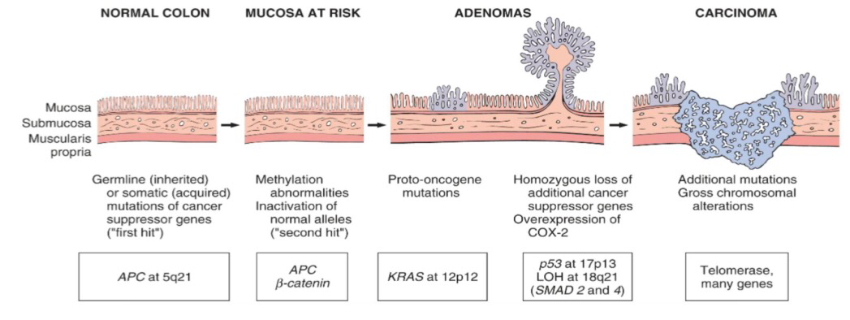
- Adenoma-carcinoma sequence

2- The DNA mismatch repair genes pathway:
• 10% to 15% of sporadic cases.
• There is accumulation of mutations (as in the APC/B-catenin schema).
• Five DNA mismatch repair genes (MSH2, MSH6,MLH1, PMS1, AND PMS2 that give rise to the hereditary non polyposis colon carcinoma (HNPCC).
Hereditary mutation of the APC gene is the cause of familial adenomatous polyposis (FAP), where affected individuals carry an almost 100% risk of developing colon cancer by age 40 years.

4 types of genes which lead to cancer:
- Tumor suppressor gene(APC).
- Oncogenes(KRAS).
- Apoptosis related(PCL2).
- DNA mismatch repair genes.

- Know The Clinical Presentation Of Left And Right Sided Colon Cancer, And The Environmental Factors That Increases Its Risk

Colorectal Carcinoma
Morphology and clinical are most important:
• 70% are in the rectum, rectosigmoid and sigmoid colon.
• Mucinous adenocarcinoma secret abundant mucin that may dissect through cleavage planes in the wall.
Left-sided carcinoma | Right-sided carcinoma
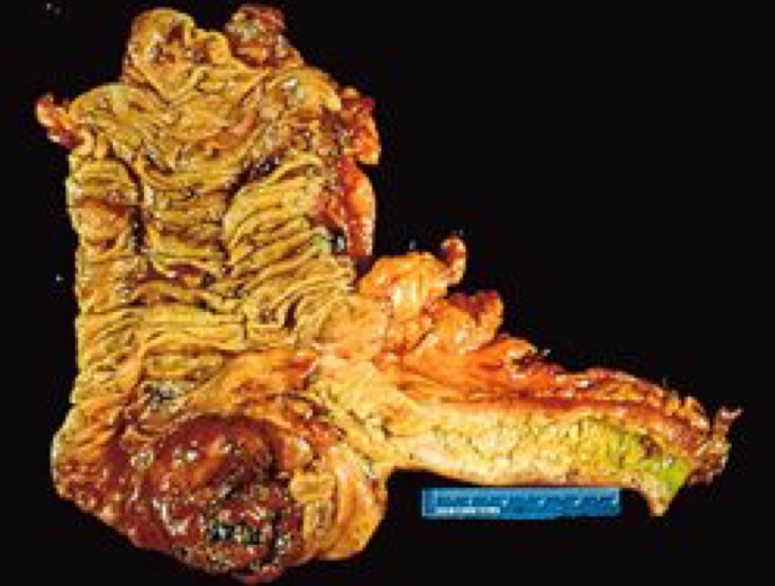 | 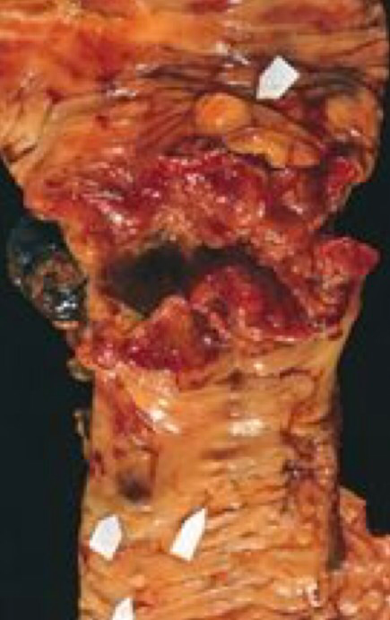
- Tend to be annular  - Encircling lesions  - Early symptoms of intestinal obstruction. Bleeding per rectum | - Tend to grow as polypoid, fungating masses.  - Obstruction is uncommon no abdominal pain and no acute bleeding but there is chronic bleeding leads to anemia we do stool analysis and find RBCs in stool or by endoscopy
Patient A: present with rectal bleeding + abdominal pain + intestinal obstruction. This indicates Left-sided colon cancer ( rectum and sigmoid).
Patient B: present with iron deficiency anemia due to chronic bleeding loose (non-frank bleeding). Because it affects cecum
إذا جاك واحد عمره 50\60 وعنده أنيميا لازم تحط ببالك right sided colon cancer

Signs and symptoms
• If located closer to the anus: change in bowel habit, feeling of incomplete defecation, PR(per rectal) bleeding.
• A tumor that is large enough to fill the entire lumen of the bowel may cause bowel obstruction.
- Right-sided lesions are more likely to bleed while left-sided tumors are usually detected later and could present with bowel obstruction.

Tumor markers
A tumor marker is a substance found in the blood , urine or body tissues that can be elevated in cancer, among other tissue types.
1-Carcinoembryonic antigen (CEA) in colectomy patient to check for recurrence not for diagnosis
&
2-Carbohydrate antigen (CA19-9) both of them are Useful to assess disease recurrence (late stage) NOT for diagnosing.
Elevated in:
CEA | CEA levels may also be raised in some non-neoplastic conditions like ulcerative colitis pancreatitis, cirrhosis COPD, Crohn's disease as well as in smokers.
CA199 | CA19-9 are raised in in patients with colon cancer and pancreatic cancer, esophageal cancer and hepatocellular carcinoma. Apart from cancer, elevated levels may also occur in pancreatitis, cirrhosis.

3-Tissue inhibitor of metalloproteinases 1 (TIMP1 ) = Early as well as late stage disease.

- Duke classification is used for staging

Malignant Small Intestine Neoplasm
In descending order of frequency :
- Carcinoid
- Adenocarcinoma
- Lymphoma
- Leiomyosarcoma

Carcinoid Tumors: neuroendocrine tumors of small intestine
- Neoplasms arising from endocrine cells found along the length of GIT mucosa.
- 60 to 80% appendix and terminal ileum: 10 to 20% rectum.
- Ultrastructral features: neurosecretory electron dense bodies in the cytoplasm.
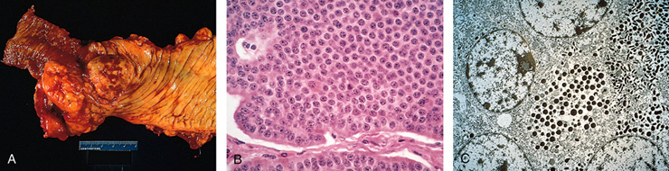

Clinical features:
- Asymptomatic
- May cause obstruction, intussusception or bleeding.
May elaborate hormones: Zollinger-Ellison (liberating gastrin), Cushing’s carcinoid (liberating serotonin), or other syndromes لأنها تطلع من الاندوكراين سلز فتزيد من افراز الهرمونات و على حسب أي هرمون تزيد يصير المرض .

Carcinoid Syndrome:
- 1% of carcinoid tumor & in 20% of those of widespread metastasis.
- Paroxymal flushing, episodes of asthma-like wheezing, right-sided heart failure, attacks of watery diarrhea, and abdominal pain.
- The principal chemical mediator is serotonin.
- The syndrome is classically associated with ileal carcinoids with hepatic metastases.skin,lung
- Affect hormones for example gastrin leading to zollinger-ellison syndrome
or cushing syndrome or carcinoid syndrome

Lymphoma –Not significant–
- Most often low-grade lymphomas arising in mucosal-associated lymphoid tissue (MALT) lymphoma or high-grade non-Hodgkin's lymphomas of B cell type.
- May occur in any part of the intestine.
- the ileocecal region is a favored site for Burkitt's lymphoma.

Summary
IBD
1-Inflammatory bowel disease is divided into: crohn's disease and ulcerative colitis both disease have immunologic hypersensitivity.
2-The manifestation of IBD depend on the area of the intestinal ( colon – small intestine – extraintestinal manifestation).
3-Crohn's disease is an inflammation that can affect any part of GIT, but the most common is the terminal ileum.
4- Crohn's disease commonly have perianal lesions (abscesses – fistulas – skin tags ).
5- The gross appearance of Crohn's disease : segmental (skip area)– fibrosis – fissures – fistulas- in the mucosa (cobblestone effect) – fat (creeping fat).
6-The microscopic features of Crohn's disease : Distortion of mucosal crypt architecture – transmural inflammation – epithelioid granulomas .
7- The complication of Crohn's disease : intestinal obstruction – fistula .
8- Ulcerative colitis it's start from the rectum going to the colon with continuous manner (without skip).
9- Grossly the UC there is superficial ulceration and under the microscopic there is inflammation restricted only in the mucosa and there is active phase (neutrophil's) and in the chronic phase ( crypt atrophy and distortion) and there is no epithelioid granulomas.
10-The complication of UC are toxic megacolon and sclerosing pericholangitis.
11- The dysplasia and carcinoma are common in UC more than CD.
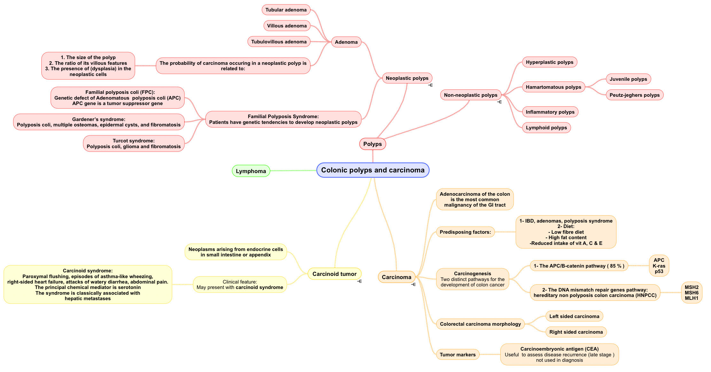
Colon polyps and carcinoma

Questions
1. Which of the following is true about inflammatory bowel diseases?
- Oncogenic, acute, and fatal.
- Acute, hypersensitivity based, and oncogenic.
- Idiopathic, chronic, and inflammatory.
- Idiopathic, inflammatory, and fatal.
Ans: C
- A 21-year-old lady presented to the hospital with fever, recurrent inclination to evacuate (Tenesmus), and blood in her diarrhea. Later she was diagnosed with crohn’s disease. Which of the following areas do you expect to be involved in her case?
- Colon.
- Small intestine.
- Stomach.
- Esophagus.
Ans: A
- A 26-year-old gentleman presented to the emergency with right iliac fossa pain with vomiting and fever. He noticed that he lost weight over the last 2 months. He was diagnosed with appendicitis and underwent appendectomy. Four weeks after he was discharged he had the same symptoms on top of a perianal abscess. Which of the following areas do you think is involved in his case?
- Colon.
- Small intestine.
- Appendix.
- Rectum.
Ans: B specifically the ileum
- In the previous case Which of the following is false about the gross appearance of the patients involved bowel?
- Segmental involvement.
- Only mucosal involvement.
- Cobblestone effect.
- Fissures.
Ans: B
- A 26-year-old man has had intermittent cramping abdominal pain and low-volume diarrhea for 3 weeks. A stool sample is positive for occult blood. The symptoms subside within 1 week. Six months later, the abdominal pain recurs with perianal pain. On physical examination, there is now a perirectal fistula. Colonoscopy shows many areas of mucosal edema and ulceration and some areas that appear normal. Microscopic examination of a biopsy specimen from an ulcerated area shows a patchy acute and
- chronic inflammatory infiltrate, crypt abscesses, and noncaseating granulomas. Which of the following best explains these findings?
- Crohn’s disease.
- Ulcerative colitis.
- Adenocarcinoma.
- Shigellosis.
Ans: A
- Which of the following is false?
- Ulcerative colitis is more likely to cause carcinoma than Crohn’s disease.
- Perianal lesions can be found in both crohn’s and ulcerative colitis.
- Crohn’s disease commonly involves the ileum.
- Ulcerative colitis is a disease of the rectum, and the colon.
Ans: B
- A 17-year-old presented to the hospital with fever, lower abdominal pain, and bloody diarrhea. Later the doctor asked for biopsy of the involved areas. Microscopic appearance showed numerous neutrophils, and cryptits. The histopathologist noticed that the inflammation only involved the mucosa. Based on this case which of the following is the starting site of inflammation?
- Appendix.
- Ileum.
- Colon.
- Rectum.
Ans: D
- Which of the following complications is not expected in the previous case?
- Sclerosing peri-cholangitis leading to obstructive jaundice.
- Arthritis.
- Toxic megacolon.
- Perianal fistulas.
Ans: D
- The most common malignancy of the GI tract :
- Adenocarcinoma.
- Carcinoid tumor.
- Gastrointestinal stromal tumor.
- Lymphoma
Ans: A
11. A young man has a defect in the APC gene, he is in risk to developed which type of GI malignancy?
- Adenocarcinoma.
- colorectal cancer
- Villous adenoma
- Carcinoid tumor
Ans: B
12. An old female with MRI shows rectosigmoid adenocarcinoma , she has a history of rectal bleeding for 15 years. What is the most likely predisposing lesion?
A. Untreated rectal hamartomatous polyp
B. Inflammatory polyps in response to chronic ulcerative colitis
C. Untreated polyp that was 90% formed of villi
D. peuts-jehgers syndrome
Ans:C
13. which one of the following has the highest risk to develop invasive carcinoma?
- dysplastic sigmoid adenoma with predominant tubular architectures
- polyp in colon with villi forming 15% of its structure
- rectal polyp with villi occupying 60% of its structure
- rectal polyp with underlying crypts changing to a star shape
Ans: c
14. An early symptom of left-sided carcinoma (Colorectal carcinoma)?
- Fibrosis B. Obstruction C. Bleeding D. Stricture.
Ans: B
15. which one of these chooses is a Predisposing factor for colon cancer?
- High fiber diet. B. Low fat content. C. Alcohol.
Ans: C
16. which one of these two tumor markers is useful to assess disease recurrence?
- CEA. B.TIMP1
Ans: A

الأعضاء
- صقر التميمي
- عبدالرحمن الراشد
- عبدالمجيد العمار
- محمد اليوسف
- ابتسام المطيري
- فاطمة الطاسان
- دعاء وليد
- نوف العمَّاري
- سمر القحطاني
- أمل القرني
- بشرى قوقندي

- ابتسام المطيري
- فاطمة الطاسان
- دعاء وليد
- سمر القحطاني
- بشرى قوقندي
- أمل القرني
- نوف العمَّاري

القادة
- مها الغامدي
- حنين السبكي
- عبدالله أبو عمارة

حسبي الله لا إله إلَّا هو عليه توكلت وهو رب العرش العظيم.

Editing File
Email: pathology436@gmail.com Twitter: @pathology436
References: Doctor’s slides + notes, Robbins basic pathology 10th edition.

Continual or recurrent inclination to evacuate the bowel. يعني تحس انك دايم تبغى تروح للحمام و انتم بكرامة. معناها الحرفي هو "زحير" قولها بعدين عند الناس عشان يحسبونك مثقف\ة
Wavy margin, متعرجة
giving the worrying impression that something bad is going to happen;
Is an inherited condition in which numerous adenomatous polyps form mainly in the epithelium of the large intestine, While these polyps start out benign, transformation to colon cancer occurs when they are left untreated.

