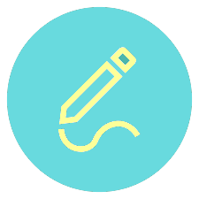
c
Objectives:

" أن اُجاهد في طلب العلم، أسخره لنفع الإنسان "
Please check the editing file before studying
Anterior Pituitary Disorders

      - To understand basic pathophysiology and feedback for anterior pituitary hormones
      - Know about clinical approach for common anterior pituitary gland disorders:
- Common clinical presentations.
- Main laboratory investigations.
- Radiological investigations
- Describe lines of management for each of these conditions.

Color index:

- Extra explanation
- Important
- Doctors notes
The table is very important
Most hormones from hypothalamus are releasing hormones. Most hormone from pituitary are stimulating hormones
What will happen if T4 was low?
TRH and TSH increase and stimulate gland to produce hormone.
it is inappropriate response when T4 low and TSH normal
 | Corticotroph | Gonadotroph | Thyrotroph | Lactotroph | Somatotroph
Hormone | POMC, ACTH | FSH, LH | TSH | Prolactin | GH
Stimulators | CRH, AVP, gp-130 cytokines | GnRH, Estrogen | TRH | Estrogen, TRH | GHRH, GHS
Inhibitors | Glucocorticoids | Sex steroids, inhibin | T3, T4, Dopamine, Somatostatin, GH | Dopamine | Somatostatin, IGF-1, Activins
Target Gland | Adrenals | Ovary, Testes | Thyroid | Breast and other tissues | Liver, bone and other tissues
Target hormone | cortisol | Testosterone, E2 | T4 |  | IGF-1
Trophic Effects | Steroid production | Sex Steroid, Follicular growth, Germ Cell maturation | T4 synthesis and secretion | Milk Production | IGF-1 production, Growth induction, Insulin antagonism
Pituitary Development:

Posterior pituitary gland cant produce any hormone just for storage
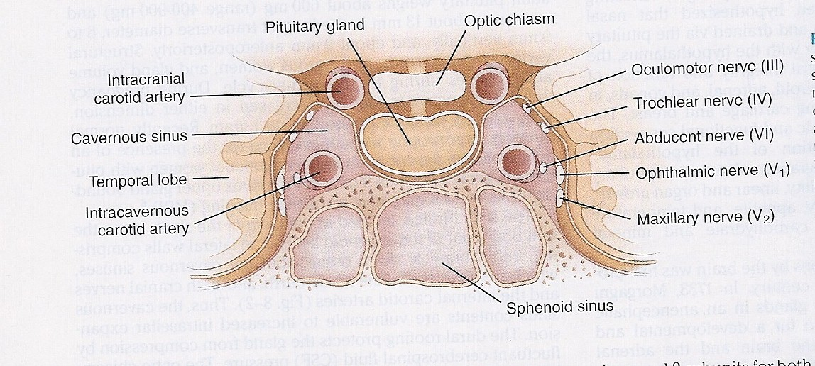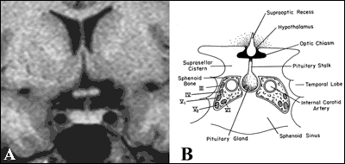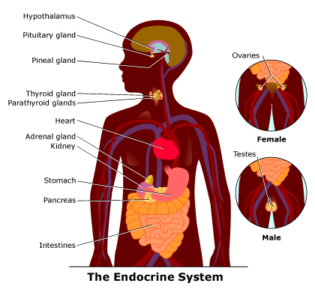
- Picture shows: Tumor extended upward. Moreover, the aﬀect optic chiasm that will aﬀect visual ﬁeld(bitemporal hemianopia)
- يسألون المريض اذا يقدر يشوف السيارات اللي جمبه وهو يسوق او المرايا الجانبيه ؟عادة يجاوب لا بكذا يعرفون انه مأثر على optic chiasm
- . If the mass extend down edit will cause CSF drain from the nose If it aﬀect temporal lobe it will cause seizure

othalamic Lesions:
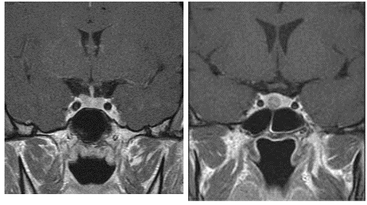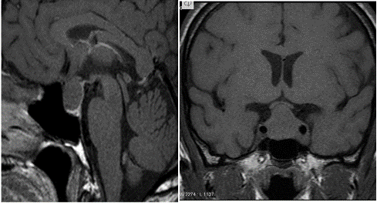

Disorders of Pituitary Function:

Evaluation of Pituitary mass:

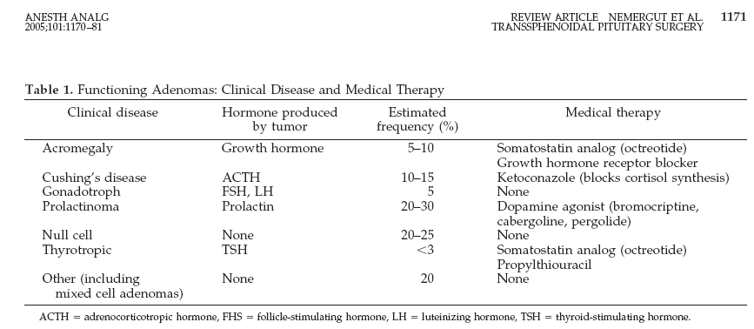
Non-Functional pituitary lesion:
(Nonfunctioning means hormone either normal or low)

Treatment:
Non-functional pituitary adenoma
C: Clinical | Asymptomtic , incidentaloma by imaging  Mass-effect ( mechanical pressure, hypopituitarism, visual ( bitemproal hemianopia)  Gonadal hypersecretion
B: Biochemical | GH,LH,FSH,TSH,ACTH: not high PRL : low ,high, normal
A: Anatomical | MRI
Treatment | Surgery if indicated Observation Adjunctive therapy:  - Radiation therapy  - Dopamine agonist  - Somatostatin analogue
Functional pituitary mass:
Prolactin is the only hormone has no direct
Releasing hormone comes from hypothalmus .
Prolactin
(REMEMBER: Not all hyperprolactinemia is due to a prolactinoma):

Low prolactin:
- No clinical significant if there is no mass invading the hypothalamus. N.B.: PRL is the only pituitary hormone that is inhibited by hypothalamus.

Causes of Hyperprolactinemia:
Hypothalamic Dopamine Deficiency | Defective Transport Mechanisms | Lactotroph Insensitivity to Dopamine | Stimulation of Lactotrophs
Diseases of the hypothalamus( including tumors, arterio-venous malformations, and inflammatory processes  Drugs (e.g. alpha-methyldopa and reserpine) | Section of the pituitary stalk  Pituitary or stalk tumors | Dopamine-receptor-blocking agents: phenothiazines (e.g. chlorpromazine), butyrophenones (haloperidol), and benzamides (metoclopramide, sulpiride, and domperidone) | Hypothyroidism- increased TRH production (acts as a PRF)  Estrogens: stimulate lactotrophs  Injury to the chest wall: abnormal stimulation of the reflex associated with the rise in prolactin that is seen normally in lactating women during suckling
when adenoma produce prolactin in high level, what will happen? In female, galactorrhea, infertility and amenorrhea (irregular cycle). in male, hypogonadism and gynecomastia, lebedo.

Clinical Features of Hyperprolactinemia/Prolactinoma:
45 years old with headache and amenorrhea prolactin is high. what is the treatment? Medical treatment (dopamine) in the same case, if the mass affects visual field we do not do surgery because the medical treatment causes the mass to shrink. Surgical treatment if there was no response to medical treatment for 1 year.

Normally prolactin increased during pregnancy, so the first thing should be done for lady with high prolactin level is pregnancy test.

Work up of Patient with Hyperprolactinemia:

Prolactinomas:

Growth hormone:
when the Mass cause
compression, the first
hormone will be released is
GH
what is the most important
hormone for life?
Cortisol.

Disease:
- Children: Short stature
- Adult: ??
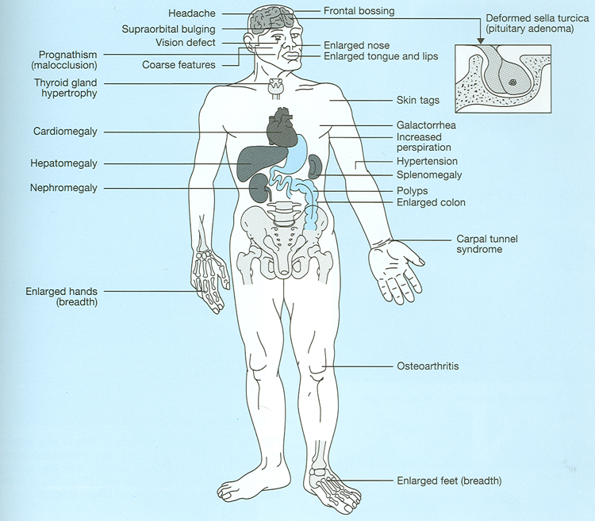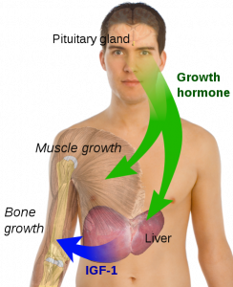
نعطي انسولين لشخص قصير
فبيصير عندنا بهذي الحالة GH وشاكين ان عنده نقص ب
والطبيعي ان hypoglycemia
نظرا لقلة السكر بالدم فلو ما افرز هذي دلالة على نقص هرمون النموGH
↑GH:
↑hand size,مايقدر يلبس gloves>called acral enlargement
↑feet size, يتغير مقاس الرجل >called acral enlargement
Knee pain
↑mandible size(jaw malocclusion), peace between teeth
Hypertrophy of frontal bones
↑risk of colon cancer
Headache
Seizures
hyperglycemia (DM in children)
↑cholesterol
↑visceral size
Cardiomegaly> heart failure >death

catecholamine, cortisol, GH and glucagon normally increase the glucose.
IGF1 is active form in muscle and skeleton.
↓GH:
Truncal obesity (in adult)>>because there is NO lipolysis

Acromegaly:
Clinical picture and presentation:

Medical treatment:
- Somatostatin analogue
- Surgical resection of the tumor

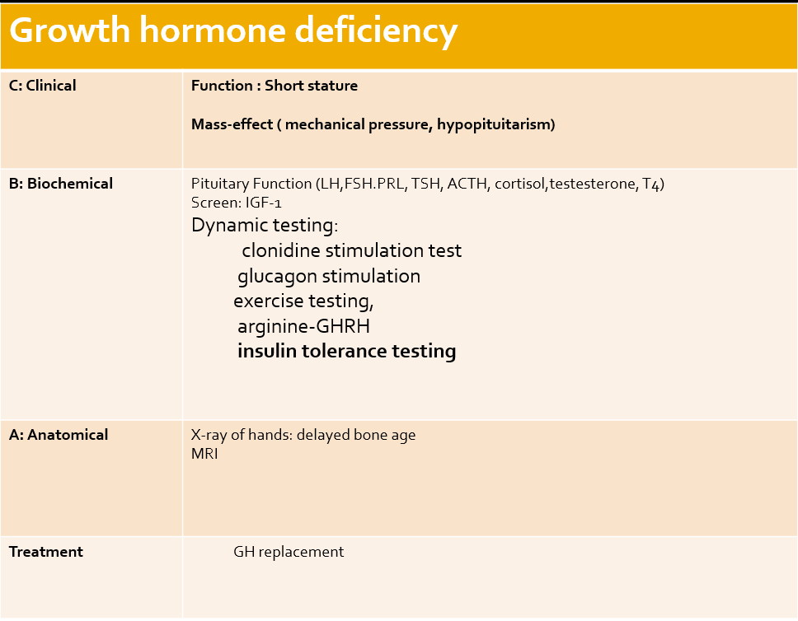
Important table
Very important table
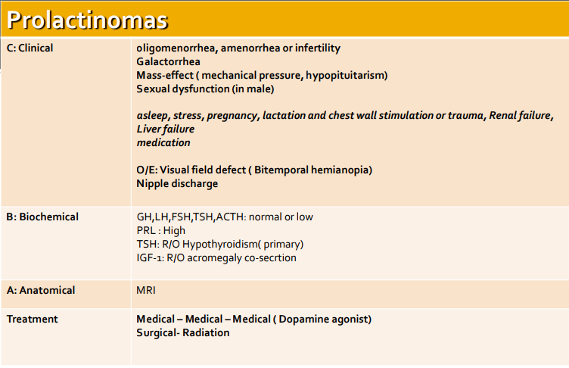

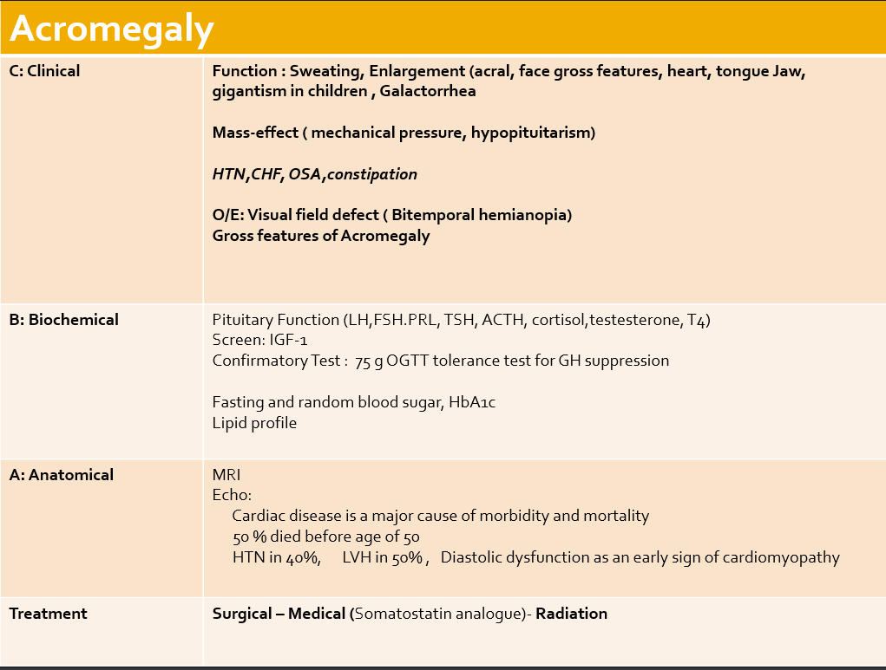
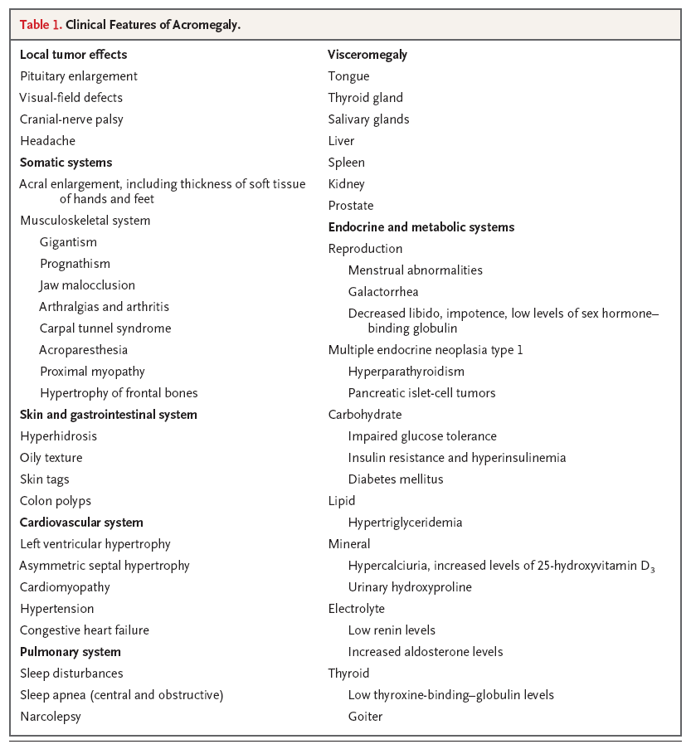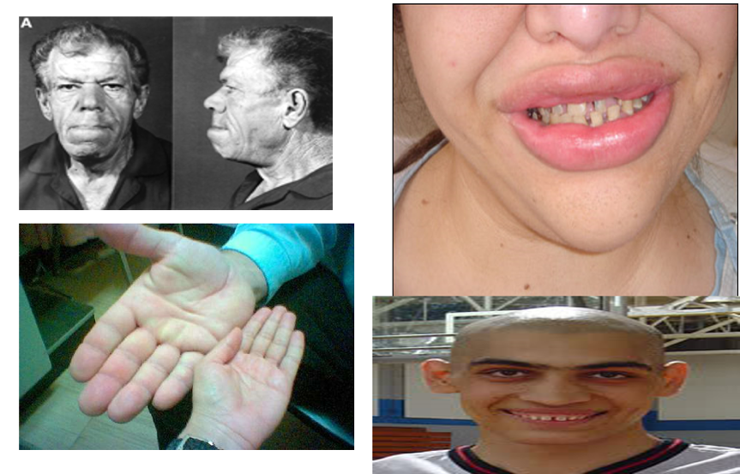

Diagnosis: first step>IGF-1
Why not diagnosed by GH test? BC IGF-1 value is constant during all the day not like GH which fluctuating during all the day
Growth hormone deficiency:
Treatment: GH replacement in children
In adult: عادة ما نعطيهم GH الا اذا كان عندهم truncal obesity or psychological problems
Hypoadrenalism
Other symptoms:
Moon like face ,Thin skin ,Fat pads (accumulation of fat in the dorsal neck),Truncal obesity,Red cheeks ,Thin arms and legs ,Hypertension ,Acne ,Hair over growth

Remember cortisol is the most
important hormone for life.
What is the difference between staria
in obesity and cushion syndrome.
the color. ACTH will stimulate the
melatonin and cause the color.
ACTH has the same origin of
melatonin.

Management of hypoadrenalism
- Cortisol replacement
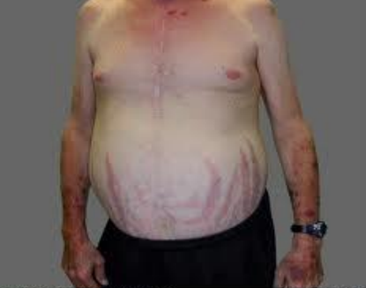
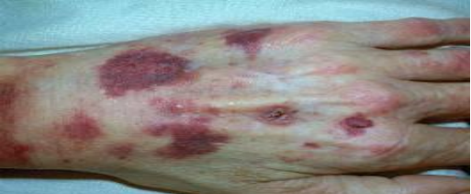
HPA-axis excessive cortisol:

excissive cortisol (cushings) stria purple wide >1 cm
excissive cortisol (cushings) ecchymosis
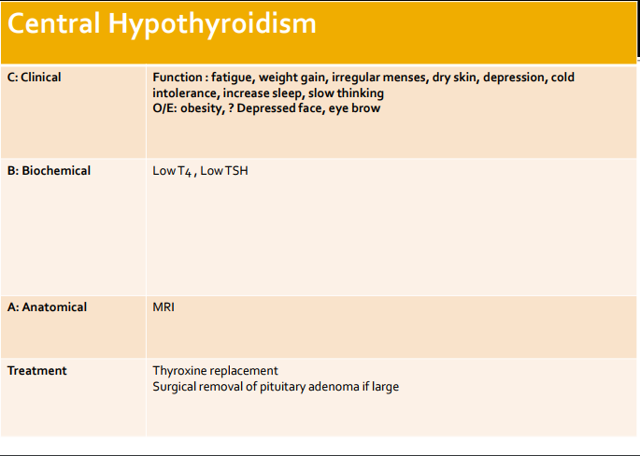
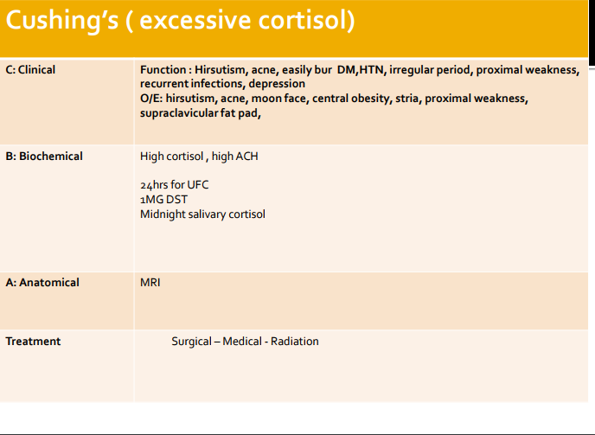

Central hypothyroidism

TSH producing adenoma

Gonadotroph adenoma vs. menopause and ovarian failure

Gonadotroph adenoma

- Surgical resection if large
- Radiation therapy

Assessment of pituitary function

Questions

Q1-a boy has a pituitary gland disorder, he is 16 years old and looks like he is 10 , what is the hormone that is effected:
A-TSH. B-GH. C-FSH. D-prolactin.
Q2-what is the most common functional pituitary adenomas:
A-prolactinoma. B-hypoadrenalism. C-Cushing. D-gonadotrophs adenoma.
Q3-a patient come to the ER with severe headache when taking the vital signs ha has a high blood pressure and the doctor noticed that the patient has a moon face with red cheeks, what is the most likely diagnosis:
A-high amount of cortisol. B-Cushing’s. C-A and B. D-none.
Q4- a patient come to the ER with severe headache when taking the vital signs ha has a high blood pressure and the doctor noticed that the patient has a moon face with red cheeks, which of the following will be seen in ECG:
A- low QRS voltage and inverted T wave.
B- - low QRS voltage and erect T wave.
Answers:
1-B
2-A
3-C
4-D
5-C
6-B

C-- high QRS voltage and erect T wave.
D- high QRS voltage and inverted T wave.
Q5-excess amount of GH will lead to:
A-dwarfism. B-diabetes. C-acromegaly. D-infertility in women.
Q6-How to manage a patient with hypoadrenalism:
A-insulin. B-cortisol replacement. C-dopamine agonist. D-non.

Videos

- Over view of pituitary gland tumor
- prolactinoma
- hyperprolactinemia
- hyperprolactinemia (2)
- Cushing
قـادة الـفريـق
جواهر الخيَّـال & ناصر أبو دجين

أعضاء الـفريـق

فارس النفيسة

Give us your feedback!

اللهم إني استودعتك ما حفظت وما فهمت، فردّه لي عند حاجتي إليه، إنك على كل شيءٍ قدير

@medicine436
Give us your feedback!
436.medicine@hotmail.com
Girls and boys slides
نجود العنزي
عروب الهذيل
أنوار العجمي
الاء العقيل
سما الحربي

