OBJECTIVES :
1/ Understanding the definition of osteoporosis
2/ Causes of osteoporosis
3/ Impact of osteoporosis
4/ Diagnosis of osteoporosis
5/ Treatment of osteoporosis

Editing file
Introduction to osteoporosis
Type of bones
the compact bone of Haversian systems  such as in the shaft of long bones | Cortical bone
The lattice – like network of bone found in the vertebrae and the ends of long bones | Trabecular bone
Major functions of bone :
we have a complete new skeleton every 9-10 year
Introduction

Disorders in which cortical bone is defective or scanty lead to fractures of long bones whereas disorders in which trabecular bone is defective or scanty lead to vertebral fractures and also may help in fractures of long bones because of the loss of reinforcement.
Bone is resorbed and formed continuously throughout life and these important processes are dependent upon three major types of bone cells

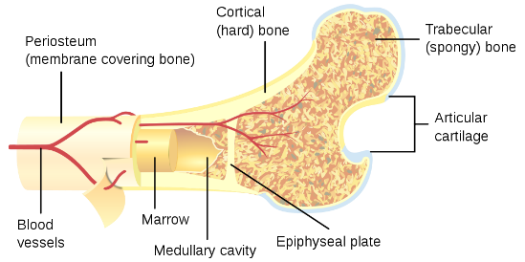

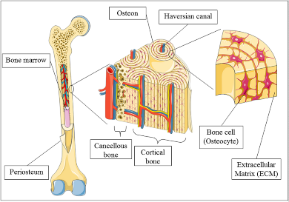
The difference pattern of bone loss affecting trabecular and cortical bone results in two different fracture syndromes
" bone consider as endocrine organ and bone marrow is a factory of bone cells "
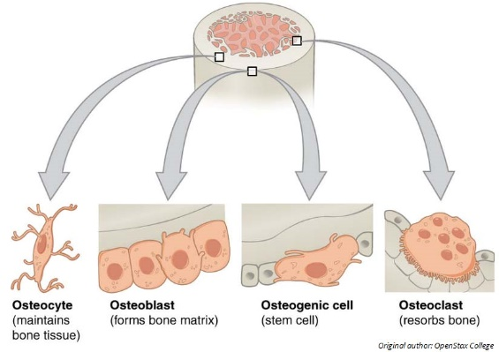
Bone cells :
OSTEOCLAST | OSTEOCYTE | OSTEOBLAST
The bone resorption cells | They are believed to act as a cellular syncytium that permits translocation of mineral in and out of regions of bone removed from surfaces. has branches called dendritic branches | The bone forming cells which are actively involved in the synthesis of the matrix component of bone (primarily collagen) and probably facilitate the movement of minerals ions between extracellular fluids and bone surfaces
" these cells is important in bone remolding "

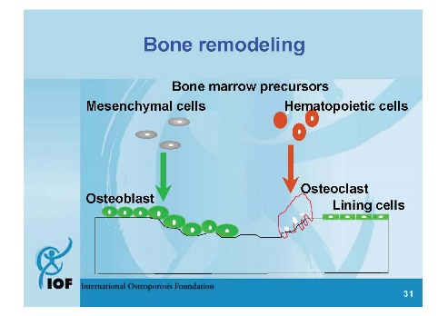

" bone consider as endocrine organ and bone marrow is a factory of bone cells "

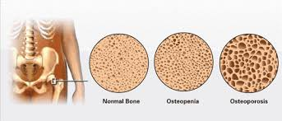
Mostly in elderly people
por تعني نخر
por تعني نخر
Definition :
1 in woman and 1 in 5 men over 50 will experience osteoporosis fracture

Osteoporosis " THE SILENT PAIN " "

Decrease in bone mass and strength associated with an increased tendency to fractures. ( less scientific straight forward definition)

Clinical features :

1/ It is usually an asymptomatic disease - patients are asymptomatic even with very low bone densities- until fractures occur. “no pain with osteoporosis”. Pain is associated rheumatoid arthritis .
2/ Subsequent vertebral fractures may contribute to chronic back pain.
3/ In well established osteoporosis dorsal Kyphosis and loss of height occurs.
4/ Hip fractures with its fatal complications also occur commonly as osteoporosis become more severe.
5/ Atraumatic or low impact fractures.

The first manifestation of reduced bone mass is usually a wrist fracture, or a vertebral crush fracture caused by a small amount of force which produces severe localized pain.

the early stage of osteoporosis fracture

Types of osteoporosis :
Common sites of fractures :
may come without any symptoms just kyphosis

Type I Osteoporosis (Post-Menopausal) :
Fractures of bones composed mainly of Trabecular bone.
Distal radius –+ colle's fracture vertebra ---+ wedge & crush fractures
Usually affects woman within 15 years of menopause.
No estrogen decrease density of bone
Type II Osteoporosis (Senile) :
Fractures of bones composed of both cortical & trabecular bone.
Hip --+ femur neck fracture
Usually affects individual over age of 70 years.

1/ SPINE
2/ FOREARAM
" radius "
3/ HIP
" Neck of femur "

even when she loses her menstruation after 30's or 40's she will have osteoporosis at this age

Pathogenesis of decrease in bone density
especially in the vertebrae
Bone profile, ALP and PTH are within normal in patients with osteoporosis due to sex hormones deficiency and aging.
X-rays of skeleton do not show a decrease in osseous density until at least 30% of bone mass has been lost.
وش الفائدة تعرف فجأة حسابك نقص 30% ، تبي تعرف اول ما يبدأ ينقص
X-ray of spine show prominent trabeculae and prominent end plates of the vertebral bodies
Cod fish appearance indicates protrusion of the disk into the body of the vertebrae secondary to mechanical failure.
X-ray of the upper part of the femur may also be helpful in assessing reduced bone mass and calculating the risk for hip fracture.
Laboratory & radiological finding :
Non-modifiable:
- Age (increasing)
- Low BMI (small, low weight;< 58 kg)
- Ethnicity: Caucasian > Asian/Latino > African American
- Family History of Fracture

Modifiable:

- Sex Hormones (low estrogen/testosterone)
- Low calcium and vitamin D
- Inactive lifestyle
- Excessive alcohol
- Cigarette smoking
- Rheumatoid arthritis
- Hyperparathyroidism (primary or secondary)
الجسم شغال بزيادة عشان كذا يزيد التدمير
- Hyperthyroidism
- GI conditions which impair adequate nutrition
- Steroids or Cushing’s
- Proton pump inhibitors
Risk factors :
It is appropriate to begin to look for risk factors that predispose a person to osteoporosis and develop a rational prevention program tailored to person’s risk before the menopause.
Women with thin light frame, history of low calcium intake, decreased physical activity, high alcohol or caffeine consumption, smoking, family history of osteoporosis, history of prior menstrual disturbances or history of drug like anti-epileptic’s or steroids are all high-risk groups and in the presence of one or more of such risk factors measurement of BMD provides further information to the risk of fractures.
They measure bone mass by the ability of the tissue to absorb the photons emitted from the radionuclide source or the X-ray tube.
Age related bone loss particularly trabecular bone in the spine begins in women before menopause.
1/DXA is the machine used .

2/SPA 3/DPA 4/CT

Assessment of bone mass available method :

Single-Photon absorptiometry
Dual-Photon absorptiometry
Computed Tomography
Dual-Energy X-ray Absorptiometry

Measure spine L1 – L4 and Hip ( neck of femur )
The picture above explains the T- score and the numbers reflect a standard deviation (SD).
-1 means there is a loss of about 10-12% of bone density. Therefore, individuals with -1 to 2.5 have osteopenia – they have lost from 10 – 25 % of their bone density.
In young individuals -Children- the Z score is used which is a comparison to age-matched norms- with an old individual. If ≤ 2 (below expected range for age)
Peak bone mass is between 20-30
cost US 17.9 billion a year and in UK: 1.7 billion + largely attributed to hip fractures . | Impact of Osteoporosis, cost and future projections
Strategy for management of osteoporosis :
ure :
1/ Hip fractures are bad (serious condition that can cause death).
2/ 20% patients with hip fracture die within the year
3/ 25-30% need placement in skilled nursing facility
4/ Cause serious disability and excess mortality
5/ Highest incidence in Scandinavian and N American countries.
6/ Women who have sustained fracture have a 10-20 % higher mortality than would be expected for their age.
7/ Above 50 years of age, female to male ratio is 2: 1.
8/ Mortality is higher in men, greater with co existent diseases
9/ 1-year mortality: 31 % in men and 17% in women
10/ Risk of death is greatest immediately post fracture
Hip fracture :
ure :

When to screen with DXA scan :
ure :

مثير للجدل

asses how much the bone absorb x-ray and reflected back

لين العظام
1/ Adequate nutrition, particularly calcium and vitamin D
2/ Calcium: 1000 – 1200 mg daily (diet plus supplementation)
3/ Vitamin D: goal level above 50-75 nmol/l
" Less than 20 nmol/l is Vit D deficiency "
4/ Weight bearing exercise
5/ Discourage smoking
6/ Reduction of risks for falling: consider OT evaluation for home hazards, minimize sedating medications.
7/ Hip protectors: can be useful if worn properly but often have low compliance

Prevention :
the most common metabolic bone disease are osteoporosis and osteomlasia
Osteomalacia
Definition :
Failure of organic matrix (osteoid) of bone to mineralize normally and the commonest cause is vitamin D deficiency .

Calcium and vitamin D

1/ At least 1000 mg /day for men ≤ 65 or younger
2/ 1500 mg /day for older men. Ca citrate vs. Ca carbonate.
Vitamin D : check 25 (OH) vit. D level. If very low, you need to “replete” the stores first.
Maintenance dose is 800 IU for men younger than 50 and 800-1000 IU for men older than 50 .
1000 IU or more for all patients with osteoporosis or reduced bone mass regardless of their age.

The doctor said " don't worry about the treatment so mush , because it will be covered in Pharmacology lecture "
BUT we added them in the next 2 pages any way , so be a Good MEDICAL STUDENT and read them .

activate osteoblast
Inactivate osteoclast
Monoclonal Ab to receptor activator RANKL
The Adolescent Group
(Peak bone mass attainment)
“Senile Osteoporosis is a pediatric disease”.
1/ A calcium intake of 1200 mg/day is recommended.
2/ Adequate sun exposure or vit D supplementation to ensure adequate level.
3/ A reasonable exercise program is recommended.
4/ Genetic influence on peak bone mass attainment.
Treatment :
Calcitonin: no longer used
Treatment options :
1/ Nonpharmacologic
2/ Modification of life style measures
3/ Exercise
4/ Prevention of falls
5/ Adequate calcium and vitamin D intake
6/ Stopping smoking ν More sun exposure
Management :
Adequate calcium intake: 1000-1500 mg/day
A reasonable exercise program with physical therapy instruction in para-spinous muscle group strengthening exercise.
Avoidance of osteopenia-producing conditions/medications/lifestyle:
Smoking & excessive alcohol intake, excessive caffeine/protein intake.
Cortisone, excessive thyroid hormone replacement (?), loop diuretics, prolonged heparin exposure.
Adequate supplementation with vitamin D
Consideration of Hormone replacement therapy
Other modalities of therapy : Bisphosphonates , SERMS , Anabolic Hormones e.g. PTH

Adequate calcium intake; 1000-1500 mg/day disease.
Adequate sun exposure or vit D supplementation
A reasonable exercise program is recommended, but not to the point of amenorrhea.
Avoidance of osteopenia-producing conditions/medications/lifestyle:
Smoking & excessive alcohol intake, excessive caffeine/protein intake.
Amenorrhea/oligomenorrhea.
Cortisone, excessive thyroid hormone replacement (?), loop diuretics, prolonged heparin exposure.

The elderly (>62) postmenopausal female with low bone mass but no compression fractures (Prevention of bone mass loss & restoration of bone mass previously lost)
The Premenopausal Female (Maintenance of bone mass) :

Adequate calcium intake; 1000-1500 mg/day disease.
A careful exercise program with physical therapy instruction in para-spinous muscle group strengthening exercises
Consideration of short-term back bracing (non-rigid brace)
Avoidance of osteopenia-producing conditions/medications/lifestyle:
Smoking & excessive alcohol intake, excessive caffeine/protein intake.
Cortisone, excessive thyroid hormone replacement (?), loop diuretics, prolonged heparin exposure.
Adequate supplementation with vitamin D
Consideration of Hormone replacement therapy
Other modalities of therapy
Bisphosphonates , SERMS , Anabolic Hormones e.g. PTH

The elderly (age>62) postmenopausal female with fragility fractures (Prevention of further fractures)

Consideration of Hormone replacement therapy (conjugated equine estrogen (CEE) or its equivalent, 0.625 mg daily or cycled, or transdermal estrogen by patch 0.05-0.1 mg/day daily or cycled).
If intact uterus, consideration of medroxyprogesterone 5-10 mg daily or cycled
Other modalities of therapy:
Bisphosphonates
SERMS (e.g., Evista)
Anabolic hormones e.g.PTH
The Immediately Postmenopausal Female (Prevention of bone mass loss) :

Bone mass measurement if possible to identify bone mass loss
Lowest possible dose of corticosteroids.
A program of reasonable calcium intake (1000-1500 mg), exercise, & avoidance of other osteopenia-producing situations is indicated.
Adequate supplementation with vitamin D
Other modalities of therapy
Estrogen (Females), Testosterone (males), Bisphosphonates, PTH

A program of reasonable calcium intake (1000-1500 mg daily), exercise, short term back bracing and avoidance of osteopenia-producing situation is indicated.
Consideration of testosterone therapy if total and free testosterone levels are low.
Prostate concerns
Cholesterol concerns
Other modalities of therapy
1. Bisphosphonates
2. Anabolic Hormones e.g. PTH

The male with low bone mass and/or fractures (Prevention of bone mass loss & restoration of bone mass previously lost; prevention of further fractures.)

The male or female with corticosteroid induced osteopenia
(Prevention of bone mass loss & restoration of bone mass previously lost)
General measures; decrease exercise if appropriate, regain body weight, adequate calcium intake (1000-1500 mg/day) and avoidance of other osteopenia-producing situations.
Regain menses
Other modalities of therapy
Estrogen replacement
Bisphosphonates

The amenorrheic female (Exercise induced amenorrhea, eating disorders, etc)
(Prevention of bone loss)

1. Screening
All women > 65 years
Men > 70
Women 50-64 with risk factors
Patients on steroids or anti-estrogen/anti-testosterone treatment

2. Prevention
with adequate calcium/vitamin D, weight bearing exercise should be advised for all.

3. DXA scan
is the primary screening tool

4. Aggressive therapy should be offered to patients with atraumatic/low-impact fractures and those with osteoporosis, osteopenia with multiple risk factors, patients on steroids, anti-estrogen, and anti-testosterone therapy with abnormal bone densities (T score <-1).

Summary

5- General clinical presentation of a patient with osteoporosis:
A Asymptomatic
B Osteodynia
C Ostealgia
D Osteoarthritis

4- All of the following are factors Associated with Decreased Bone density EXCEPT:
A Hemiplegia
B Chronic obstructive lung disease
C Anticonvulsants (Phenytoin, Phenobarbitone)
D Liver disease
Sun exposure

1/ C
2/ B
3/ A
4/ E
5/ A
6/ D

1- Which of these statements about osteoporosis is correct:
A Fractures in type 1 osteoporosis occur in cortical bones
B Fractures in type 2 osteoporosis occur in trabecular bones
C Type 1 osteoporosis usually affects women within 15 years of menopause
D Type 2 osteoporosis is also called post-menopausal osteoporosis

2- All of the following are risk factors for osteoporosis except:
A Low Calcium intake
B Obesity
C Alcohol
D Turner's syndrome pt. have low Estrogen levels

6- All of the following are common sites of fracture in osteoporosis EXCEPT:
A Spine
B Radius
C Hip
D Tibia

3- Which of the following is a non-modifiable risk factor for osteoporosis:
A Low BMI
B Oral steroids
C Proton pump inhibitors
D Thyrotoxicosis
Hyperparathyroidism

Questions

Nasser AbuDujain
Jawaher Alkhayyal

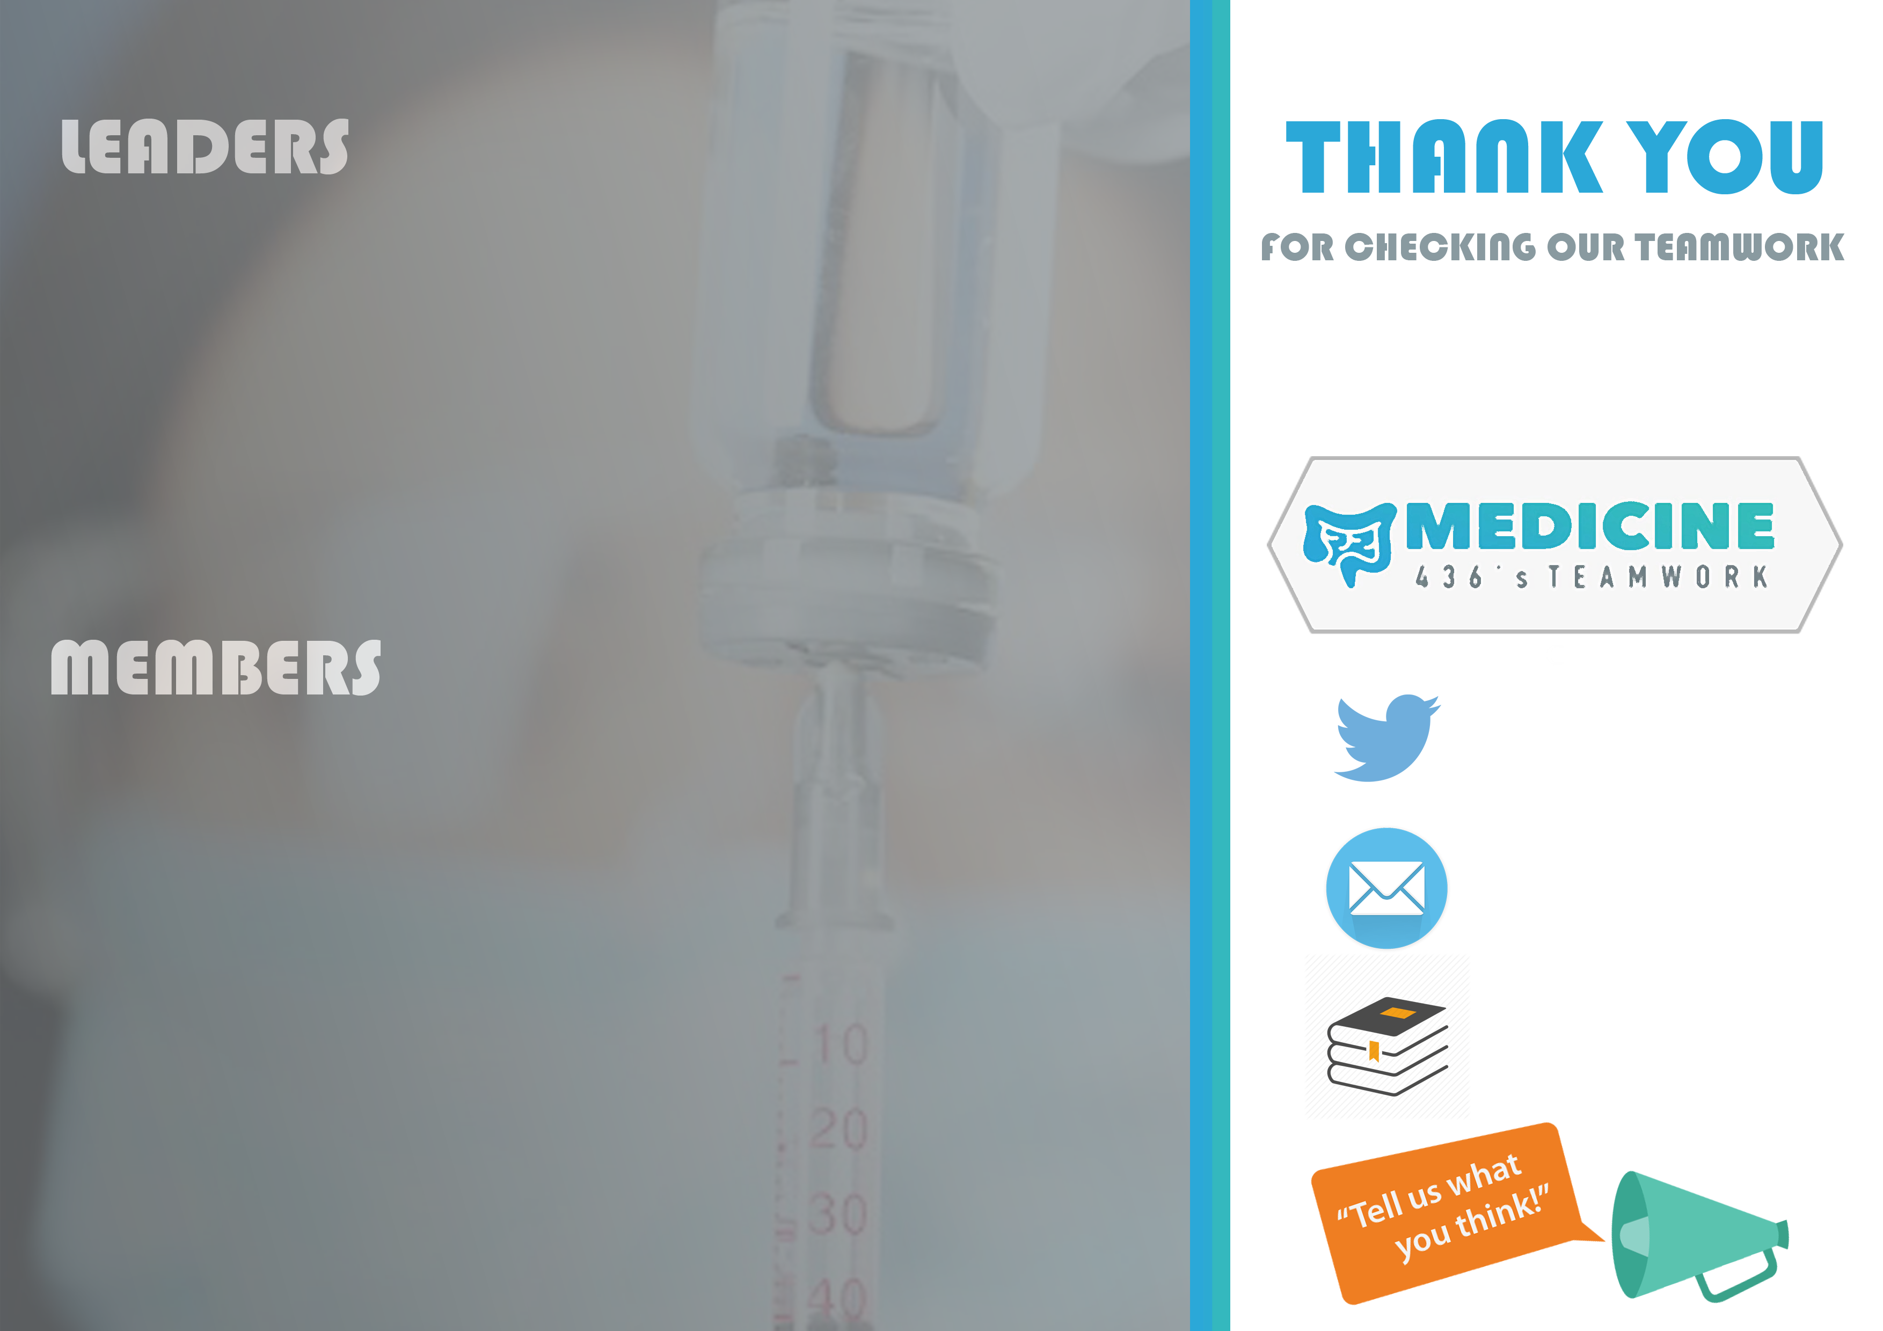

Reem Alshathri
Aroob Alhuthail
Anwar Alajmi
Zaina Alkaff
Ziad Hassan
Nawaf Alharbi
Faris bin Nafisah
Moayed Ahmed

Male & Female slides

436.medicine@Hotmail.com

@Medicine436

