

Epidemiology of Diabetes mellitus

**OBJECTIVES :**

**1. To list the types of Diabetes Mellitus.**

**2. To describe the prevalence of Diabetes Mellitus.**

**3. To recognize the importance of diagnostic criteria for estimating the prevalence of diabetes mellitus.**

**4. To discuss the risk factors and complications of type II diabetes mellitus.**

[Editing file](https://docs.google.com/presentation/d/115o2qE_lml6sXtf8FF3ksTmcfQ1iW-gmrwpE6MXw9TY/mobilepresent?slide=id.p)

|  |  |
| --- | --- |
| **Type 1**  (5-10%) | **sudden onset absolute deficiency in insulin. Usually affects younger age group (not always)** |
| **Type 2**  (90-95%)  **Most common** | **gradual onset of relative insulin insensitivity. Usually older age group (not always)** |

**Diabetes mellitus**

|  |  |  |
| --- | --- | --- |
| **Gestational diabetes** | **Secondary diabetes** | **Pre-diabetes** |
| **Gestational diabetes mellitus (GDM) is defined as any degree of glucose intolerance with onset or first recognition during pregnancy .** | **The diabetes is not the main illness, a secondary condition that results because of the main illness. If it is possible to treat the main illness successfully the diabetes may/will disappear e.g. cystic fibrosis, chronic pancreatitis, infections. (Also steroid drugs)** | **Impaired glucose tolerance - a person with pre-diabetes has a blood sugar level higher than normal, but not high enough for a diagnosis of diabetes; & is at higher risk for developing type 2 diabetes. May remain undiagnosed for years; risk of complications same as for T2DM** |

**هذي المرحلة اللي تهمنا اكثر في public health لأنهم اكثر ناس نقدر نطبق عليهم preventive measures**

**Main Types of diabetes :**

**Definition :**

**A metabolic disorder of multiple aetiology characterized by chronic hyperglycaemia with disturbances of carbohydrate, fat and protein metabolism resulting from defects in insulin secretion, insulin action or both.**

**Other types :**

**Diagnosis of diabetes:**

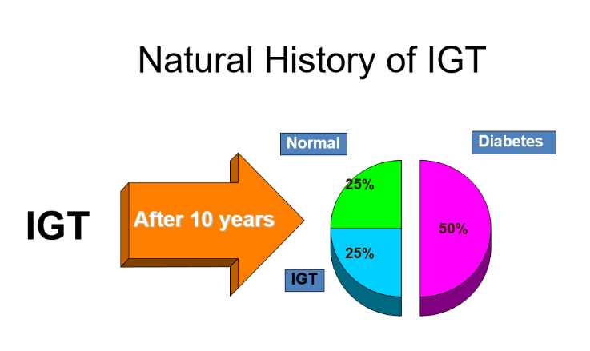****

*Important

**Biochemical tests**

**Thirst**

**Passing lots of urine**

**Malaise**

**Infections (thrush)**

**Weight loss**

**BUT – many years of pre-diabetes (type 2)**

**before these symptoms appear!**

**Random plasma glucose**

**Fasting plasma glucose**

**Oral glucose tolerance test – 2h glucose**

**Fasting Blood sugar ( FBS ) :**

**Non diabetic: FBS< 110 mg/dl (6.1m mol/dl)**

**Glucose Intolerance: FBS 110 -125 mg/dl (6.1-6.9 m mol/dl). (Increased risk of DM) .**

**Diabetic: FBS >126 mg/dl (>7 m mol/dl) OR Random BS >200 mg/dl (>11.1m mol/dl) .**

**Diagnosis based on :**

**Glucose Tolerance Test 2 hr post 75 gm glucose**

**If < 7.8 mmol/L = normal GTT**

**If ≥ 7.8 mmol/L and < 11.1 mmol/L = Impaired GTT**

**If ≥ 11.1 mmol/L = provisional diagnosis of Diabetes**

**Symptoms**

**Prevalence of 30% worldwide are Diabetic patient , but not all age , 30 years and above .**

**Why is diabetes so important ?**

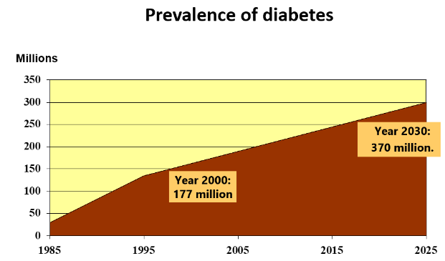

**Family history is a huge risk factor for having Diabetes Mellitus**

**Studies have shown that diabetes is a costly disease .**

**Type 2 diabetes accounted for between 3% and 6% of total healthcare expenditure in eight European countries .**

**Hospital in-patient costs are the largest single contributor to direct healthcare costs .**

**The burden to patients, careers, NHS**

**Complications :**

**Cardiovascular**

**Eyes**

**Renal - Hypertension, renal failure**

**Feet**

**Cost**

**Skin, infections, sexual, psycho-sexual, depression**

**Quality of life**

**Premature mortality**

**Urbanization and lifestyle changes -**

**- increased numbers of people being diagnosed with type 2 diabetes, and enhanced survival rates of those diagnosed will increase prevalence**

**Longevity**-

|  |  |
| --- | --- |
| **Epidemiology of Diabetes in USA:** | **Annual U.S. Diabetes Burden in 2050:** |
| **Diabetes affects 25.8 million people of all ages**  **8.3% of the U.S. population Diagnosed:**  **18.8 million**  **Undiagnosed:**  **7.0 million**  **Leading cause of kidney failure, nontraumatic lower-limb amputation, & new cases of blindness among adults**  **Major cause of heart disease and stroke**  **Seventh leading cause of death** | **By 2050, prevalence of total diabetes (diagnosed & undiagnosed) is projected to increase from 1 in 10 adults to between 1 in 5 and 1 in 3 adults**  **Largely attributed to three key factors :**  **1 Aging of the U.S. population**  **2 Increasing size of higher-risk minority populations**  **3 Declining mortality among those with diabetes** |

**Epidemiology of diabetes :**

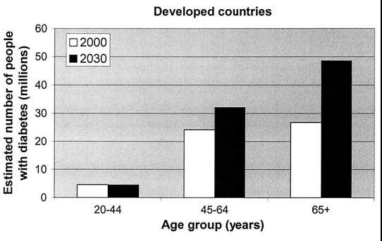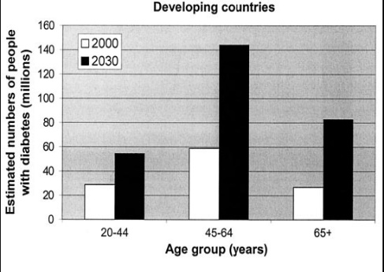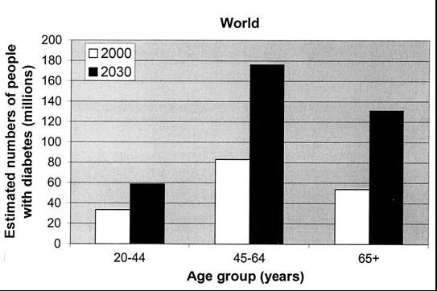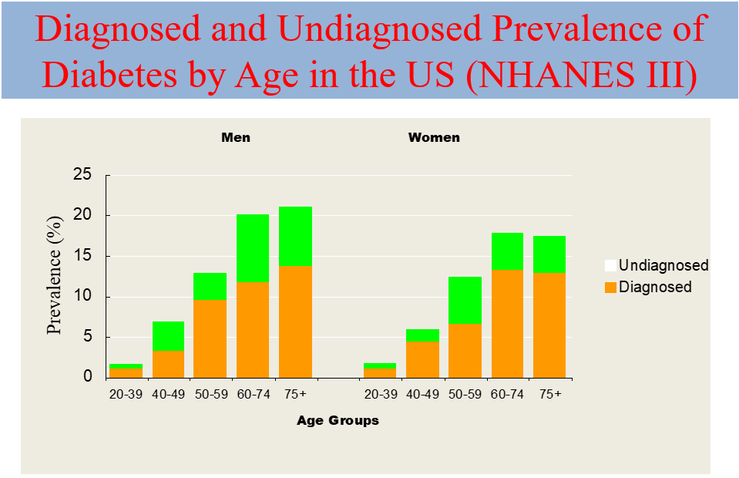

**\* (1) its age related , with increase age there will be increase perveance . +65 decrease because of deaths .**

**\* (2) in developed countries have lower incednce of diabetes mellitus , because they are catching up in developing new strategies in lowering it not like (3) the developing countries .**

*3

*2

*1

**2.8% in 2000**

**4.4% in 2030 worldwide**

**177 million in 2000; 370 million in 2030**

**Greatest rise in developing world-**

**- Prevalence estimates only include reported and diagnosed persons**

**- There is a large % that is undiagnosed as well as a large % at high risk of developing DM**

**Prevalence worldwide is increasing:**

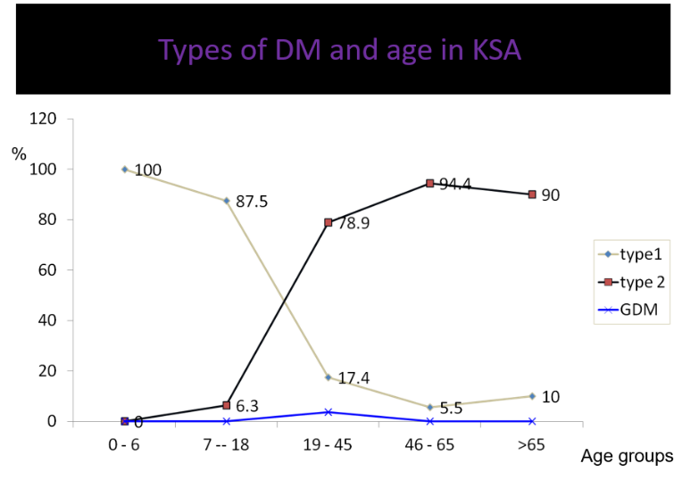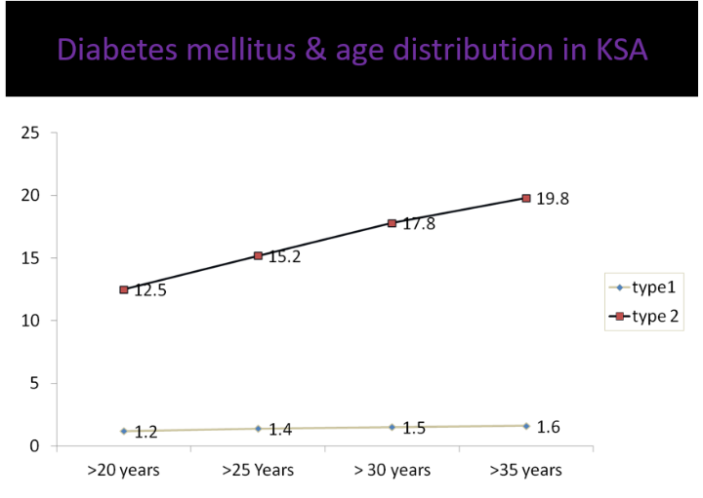

Important

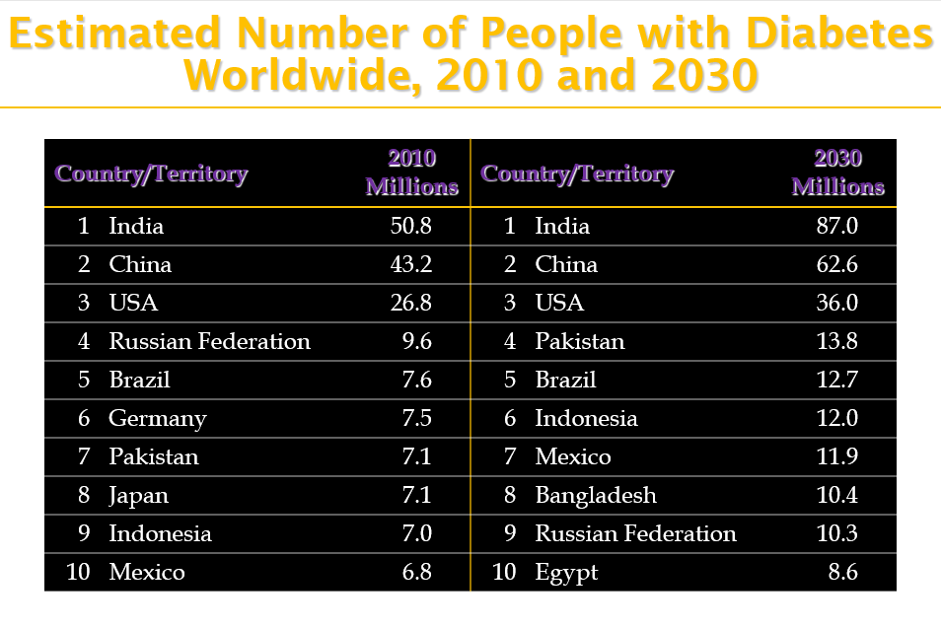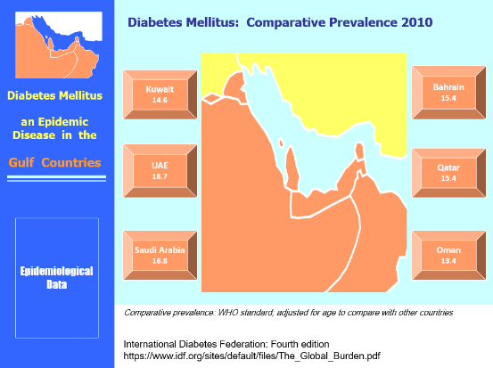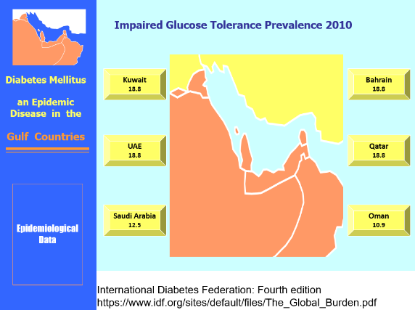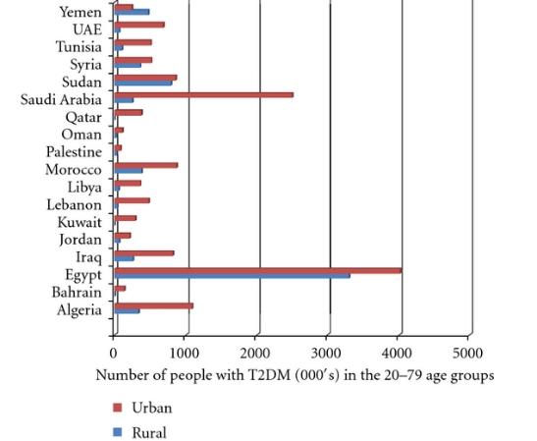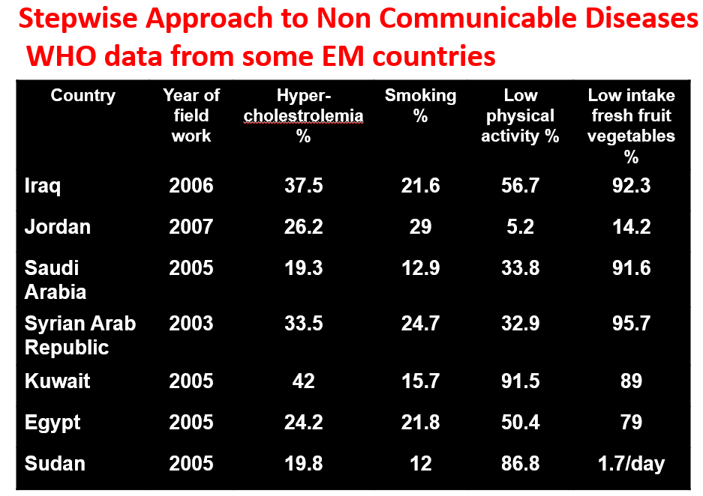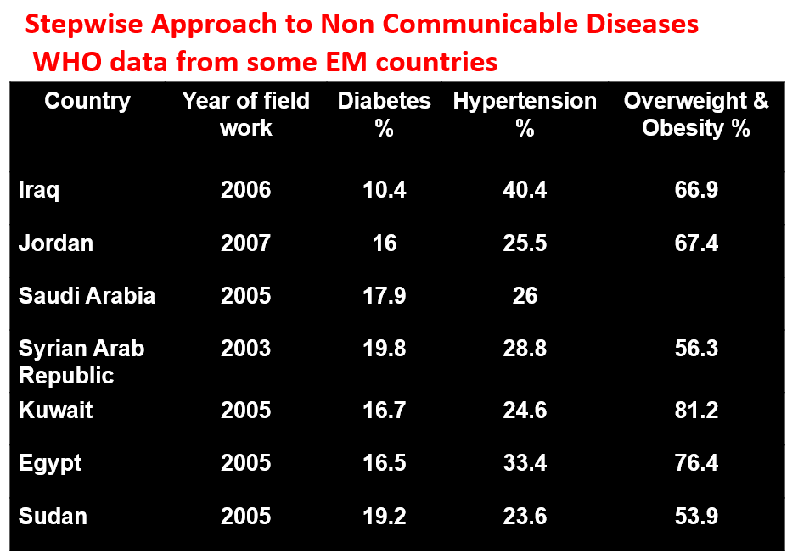

**This diagram shows KSA as the 2nd country in row .**

**But in fact KSA considered the 1st because this data depend on number , and Egypt have around 30 million in compare to KSA which have around 30 million .**

**- In KSA urban areas have higher prevalence of diabetes.**

**Type I 100% start at age 0-6 , and decrease )) (يعني كلما كبر قلت نسبه يجيه هذا النوع ) within age))**

**But Type II comes mostly after 20 up to 90 , not childhood**

**Type I is much lower compared to Type II , and they can survive in shallah up to 35 and more .**

**Neuropathy will increase with time in type 2 more than type 1 diabetes, why?**

**Because it is present in the patient before the diagnosis so, when the diagnosis done there will be high peak of complications.**

**Diabetic complications :**

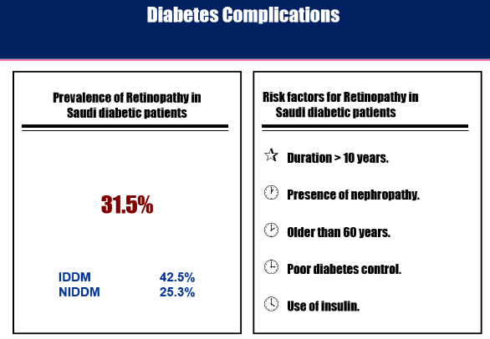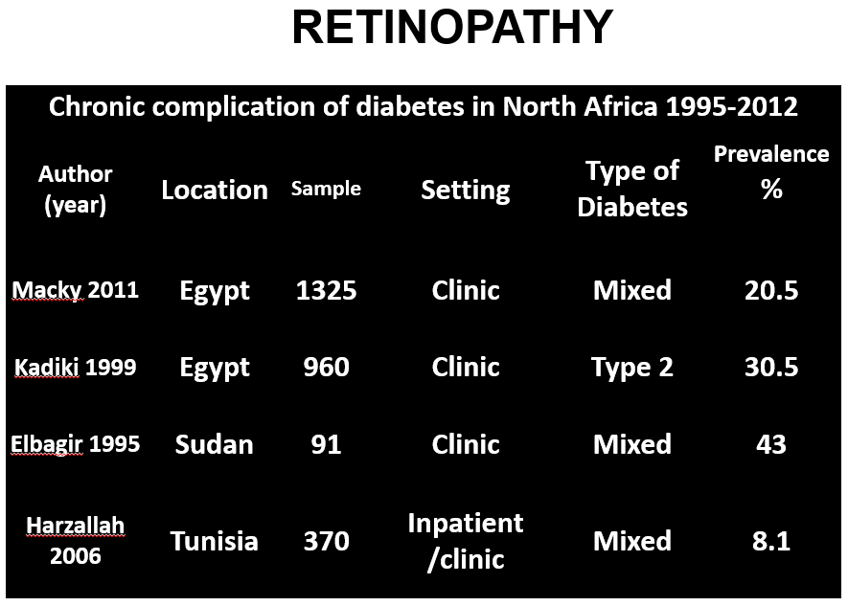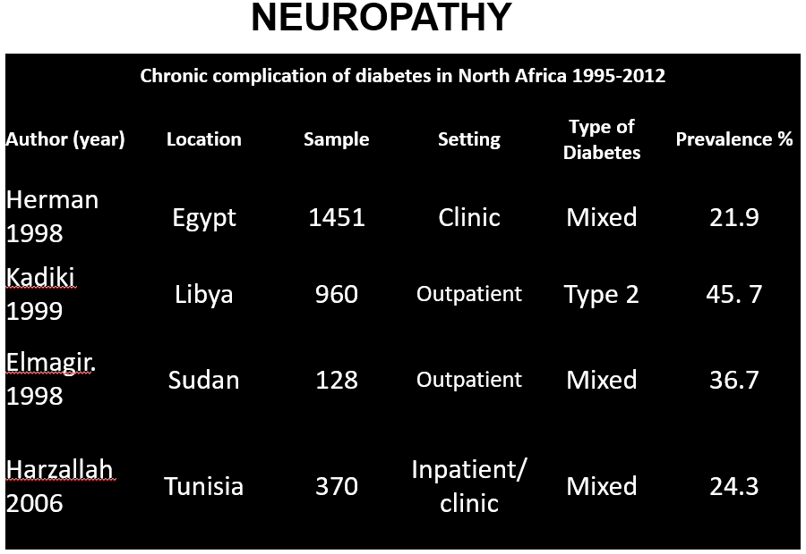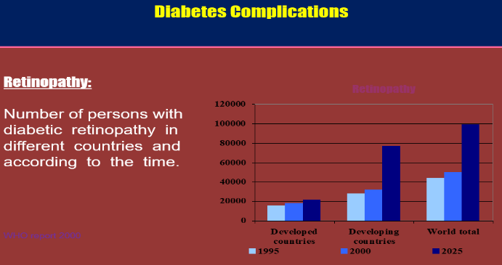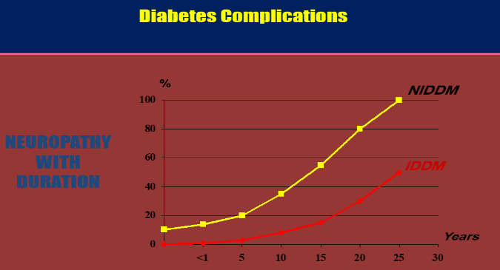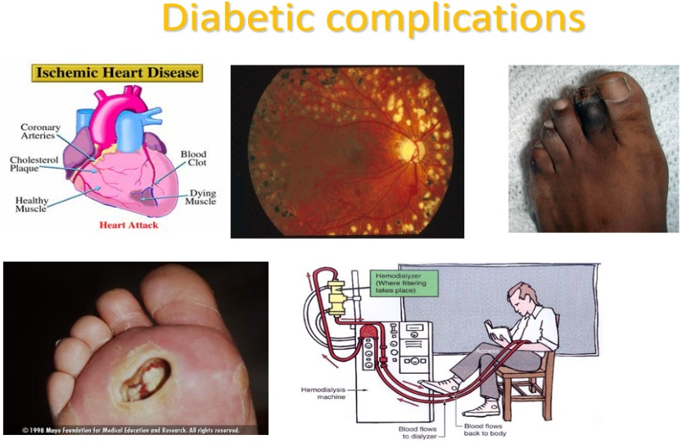

**Most Important complication**

**\* Diabetes accounts for more than 5% of the global deaths, which are mostly due to CVD.**

**\* Diabetes is responsible for over one third of end-stage renal disease requiring dialysis.**

**\* Amputations are at least 10 times more common in people with diabetes.**

**\* A leading cause of blindness & visual impairment. Diabetics are 20 times more likely to develop blindness than non-diabetics.**

**Risk Factors :**

**\* Risk factors for Type 2 DM are complex including obesity, genetic and life style factors (overfeeding and sedentary life). There is patho- physiological changes (weight gain insulin resistance and reduction of insulin secretion) may lead to glucose intolerance and diabetes.**

**\* Important factors are physical inactivity, dietary imbalance**

**\* Genetic factors may play a part in development of all types; autoimmune disease and viral infections may be risk factors in Type I DM.**

**\* Physiologic or emotional stress: causes prolonged elevation of stress hormone levels (cortisol, epinephrine, glucagon and growth hormone), which raises blood glucose levels, placing increased demands on the pancreas.**

|  |  |
| --- | --- |
| Predisposing factors | |
| • Pregnancy | **• Medications**  **(that are known to antagonize the effects of insulin )** |
| causes weight gain and increases levels of estrogen and placental hormones, which antagonize insulin | **thiazide diuretics, adrenal corticosteroids, oral contraceptives** |

**Obesity:**

**Contributes to the resistance to endogenous insulin.**

**RR risk of DM in females (ref. BMI < 22) not Important :**

**22-23 3.0**

**24-25 5.0**

**> 31 40**

**Diabetes and Obesity:**

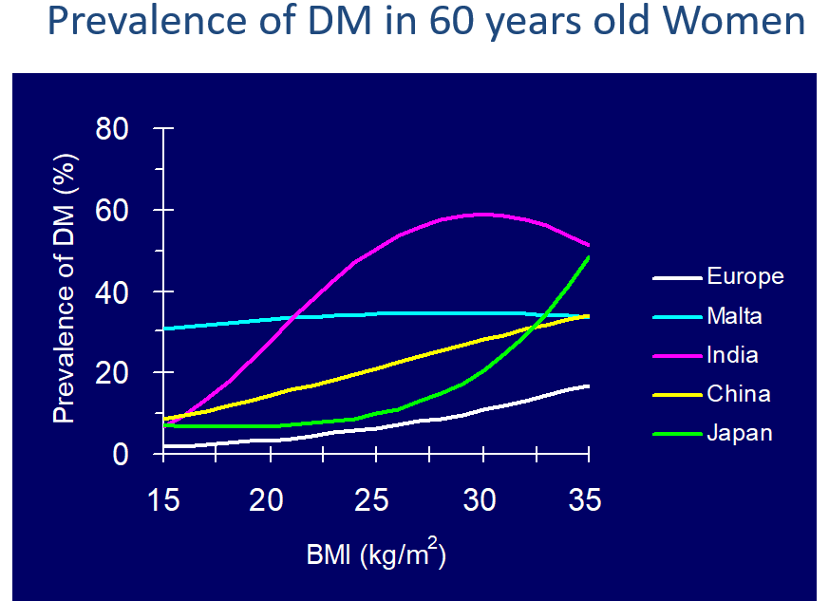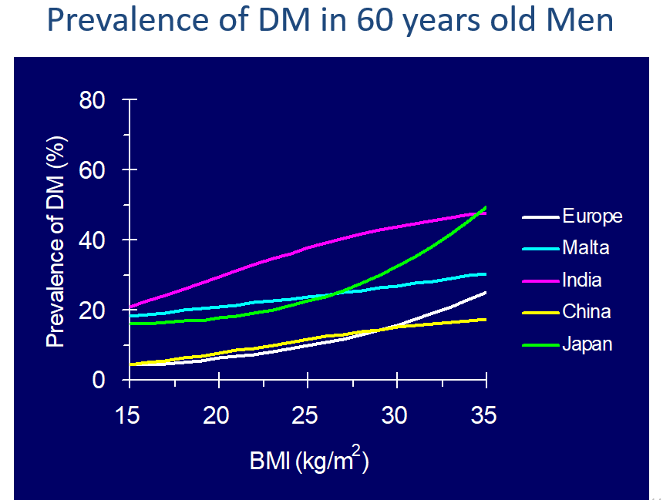

**Tackling environmental factors and lifestyle**

**Appropriate use of screening tools to control diabetes mellitus**

**Early interventions in high risk populations**

**Therapeutic and management choices and updated criteria for treatment**

**Rehabilitation services for complications**

**Future Directions:**

**\* Females of BMI >35 has 93 times the risk of developing diabetes compared to those with BMI<21**

**\* Increase in mean weight by one kg increase the risk of diabetes by 4.5% (recent data - 9%)**

**\* Ethnic populations, changed lifestyles, become more obese- diabetes**

**\* Not all obese have diabetes, but most of people with diabetes have excess weight**

**Summary**

**Risk factors:**

**Obesity**

**genetic factor**

**life style factor**

**Infections**

**Pregnancy and medications**

**Diabetes mellitus: A metabolic disorder of multiple etiology characterized by chronic hyperglycaemia with disturbances of carbohydrate, fat and protein metabolism resulting from defects in insulin secretion, insulin action or both**

**Symptoms:**

* **Thirst (polydipsia)**
* **Passing lots of urine (polyuria)**
* **Malaise**
* **Infections (thrush)**
* **Weight loss**

**Questions**

**1- What is the most common type of diabetes ?**

**a-type I**

**b-type II**

**c-Gestational**

**d-secondary diabetes**

**Answers:**

**1-A**

**2-B**

**3-D**

**4-D**

**5-C**

**6-B**

**2- witch of the following hormones is not an antagonist of insulin :**

**a-cortisol**

**b-ADH**

**c-growth hormone**

**d-glucagon**

**4- A fasting blood glucose test level of ……… indicates diabetes.**

**A-50 mg/dl to 69 mg/dl**

**B-70 mg/dl to 99 mg/dl**

**C-100 mg/dl to 125 mg/dl**

**D-126 mg/dl or higher**

**6- When a pregnant woman develops diabetes mellitus it is called _____.**

**A-diabetes insipidus**

**B-gestational diabetes**

**C-type 1 diabetes mellitus**

**D-type 2 diabetes mellitus**

**5- What is the most common type of Diabetes in subject under 18?**

**A-diabetes insipidus**

**B-gestational diabetes**

**C-type 1 diabetes mellitus**

**D-type 2 diabetes mellitus**

**3- the most serious complication of diabetes and eventually leading to death:**

**a-amputation and gangrene**

**B-Acute Renal Failure**

**C-Retinopathy and Blindness**

**D-Cardiovascular diseases.**



**Ebtisam almutairi**

**Sama alharbi**

**Faris bin nafisah**

**Abdulkarim alharbi**

**Zyad hassan**

**Moayed ahmed**

**Male & Female slides**

**436.medicine@Hotmail.com**

**@Medicine436**

**Nasser AbuDujain**

**Jawaher Alkhayyal**