

**King Saud University**

**College of Medicine**

**Department of Medical Education and the Department of Pathology**

MICROBIOLOGY

PRACTICAL CLASS

**YEAR TWO, GASTROINTESTINAL & HAEMATOLOGY BLOCK**

**STUDENT’S TASK-2018**

**Copyright Statement**

***This material is protected by copyright laws. For any other purposes other than teaching and research in the King Saud University, no part may be reproduced or copied in any form or by any means without prior permission of the King Saud University***

***© King Saud University, Kingdom of Saudi Arabia .***

**This practical class is designed and Prepared by:**

**Prof. Samy A. Azer (Medical Education)**

**Dr. Ali Somily (Microbiology)**

**Prof. Abdul Mageed Kambal(Microbiology)**

**Dr. Malak El-Hazmi (Microbiology)**

**Dr. Fawzia Al-Otaibi (Microbiology)**

**PART 1**

**objectives:**

1. **Understand the use of viral serological studies for the diagnosis of hepatitis A , B & C infections.**
2. **To know measures to prevent hepatitis A & B infections.**
3. **To know the viral serological tests used to screen blood donors.**
4. **Risk of transmission of HBV**



**King Saud University**

**College of Medicine**

**Department of Medical Education and the Department of Pathology**

**Case 1**

Mohammed Khan is a 20 year-old male who has recently arrived from India to work as a food handler in a restaurant in Riyadh. Three weeks after his arrival he was seen in A&E Dept. of KKUH because of repeated vomiting, abdominal pain and fever. On examination, his temperature was 38°C, his pulse rate 110/min and BP 120/80mmHg, he was jaundiced and had tenderness in the right upper quadrant of his abdomen.

**QUESTIONS**

1. **What are the possible causes for his presentation?**
2. Viral hepatitis
3. Acute Cholecystitis
4. Malaria
5. Leptospirosis
6. Typhoid
7. **What investigations would you like to order for him? Explain how these investigations would help you.**
8. CBC & ESR
9. Blood Film for Malaria
10. Liver function tests
11. Viral Hepatitis screening
12. Blood Culture

|  |  |
| --- | --- |
| **Test** | **How this investigation will help you?** |
| 1. CBC & ESR | Shows non-specific signs of infections or inflammation |
| 2. Blood Film for Malaria | To exclude malaria |
| 3. Liver function test | To asses liver function |
| 4. Viral Hepatitis screening | To exclude viral hepatitis |
| 5. Blood Culture | To exclude typhoid fever |

**Investigation**

|  |  |
| --- | --- |
| **CBC** | **LFTs** |
| Hb = 14.2 g/L  WBCs = 6100 mm3  Platelet= 271 g/L  ESR= 4 mm/h  Blood film for Malaria = -ve.  Blood culture is negative. | AST 1557 U/L  ALT 1879 IU/L  ALP 441 IU/L  Albn 42.3 g/L  Bilirubin 86 µmol/L |

1. **Based on these findings what is the most likely diagnosis?**

Viral Hepatitis

A

B

C

E

1. **What further investigations would you like to order?**

Hepatitis serology

1. **The serologic results were as follows:**

|  |  |  |
| --- | --- | --- |
| TEST |  | RESULT |
| Anti-HAV-IgM |  | Positive |
| HBsAg |  | Negative |
| Anti-HCV |  | Negative |
| Anti-HEV IgM |  | Negative |

1. **Based on the serologic results, what is the diagnosis?**

…………Hepatitis A …………………………………………………….

1. **Briefly outline the management of this patient.**

* Supportive
* Not working
* Contact tracing
* Follow up (Clinical and laboratory)

**Case 2**

Mohammed Abdullah is a 34 year old married Saudi male who has donated two units of blood at KKUH for a relative undergoing an operation. Two days later, the Blood Bank called him because of abnormal blood test results.

On arrival to the blood bank, the doctor informed him that his blood is not suitable for transfusion because of the presence of infection and advised him to see his physician

QUESTIONS

1. What type of infectious agents can be transmitted through blood transfusion?

(List 4 ).

* HBV
* HCV
* HIV
* HTLV

1. The next day Mohammed came to see his general practitioner with a letter from the Blood Bank. The letter revealed the result shown below.

what is your interpretation?

|  |  |  |
| --- | --- | --- |
|  | |  |
| Test |  | **Result** |
| HBsAg |  | Negative |
| Anti-HBc |  | Negative |
| Anti-HCV |  | Positive |
| HIV-Ag/Ab |  | Negative |
| Anti-HTLV |  | Negative |

2-What do you do next?

* Repeat tests and Serology
* LFTs

1. The results are available. See the table below.

How would you interpret these results?

|  |  |  |
| --- | --- | --- |
| **Normal Range** | **Patient Result** | **Lab. Test** |
| 20-65 IU | 49 | ALT |
| 10-31 IU | 29 | AST |
| 3-17 mol/L | 4 | Bilirubin |
| - | Negative | HIV-Ag/Ab |
| - | Positive | Anti-HCV |
| - | Negative | HBsAg |
| - | Negative | Anti-HBc |
| - | Negative | Anti-HBs |

1. How do you diagnose HCV infection?
   1. Screening for (Anti-HCV) by **ELISA**
   2. Confirmatory test by immunoblot assay

**What other laboratory test needed?**

The General practitioner arrange for him to see hepatologist who examine him and review his results. He further added PCR with genotype for Hepatitis C. What is the significance of these tests and how they can help in the management:

|  |  |  |
| --- | --- | --- |
| **How it can help?** | **Significance** | **Test** |
| 1. Confirm the Dx 2. Monitor response to Rx | 1-Qualitative: - or + (HCV-RNA)  2-Quantitative: viral load | 1. PCR |
| Guide the choice antiviral & duration of therapy | Identify the genotype of HCV | 2. Genotype |

**Case 3**

A 15-weeks pregnant Saudi woman was seen for the first time at the antenatal clinic at KKUH. As part of the antenatal screening, the doctor arranged for blood screening for viral serology.

The results were as follows:

|  |  |
| --- | --- |
| Test | Result |
| HBsAg | positive |
| HBeAg | negative |
| Anti-HBe | positive |
| Anti-HBc IgM | negative |
| Total Anti-HBc | positive |
| HIV Ag/Ab | negative |
| Anti-HCV | negative |

1. How would you interpret these results?

She has a hepatitis B with low infectivity.

She is not infected by HCV or HIV

1. On the lights of these Laboratory results how would you manage the newborn?

Post-exposure prophylaxis:

1. Hepatitis B immune globulin (HBIG) within 12 hours of birth.
2. First dose of HBV vaccine.
3. Is there a risk of transmission of HBV to the newborn?

10-20% of women seropositive for HBsAg transmit the virus to their neonates in the absence of immunoprophylaxis. In women who are seropositive for both HBsAg and HBeAg vertical transmission is approximately 90%. In patients with acute hepatitis B vertical transmission occurs in up to 10% of neonates when infection occurs in the first trimester and in 80 -90% of neonates when acute infection occurs in the third trimester

1. What further management would you offer to the mother?

**Pregnant Hepatitis B carriers should be advised to**  
 Not donate blood, body organs, other tissue.

Not share any personal items that may have blood on them (e.g., toothbrushes ).

Obtain vaccination against hepatitis viruses A as indicated.  
 Be seen at least annually by their regular medical doctor.  
 Discuss the risk for transmission with their partner and need for testing

Today the mother is admitted in labour and you were among the staff involved in the delivery. During a repair of the episiotomy , you accidentally prick your finger with a needle stained by the patient blood?

1. **What should you do?**
   1. report occupational exposures immediately
   2. The hepatitis B vaccination status and the vaccine-response status

(if known) should be reviewed

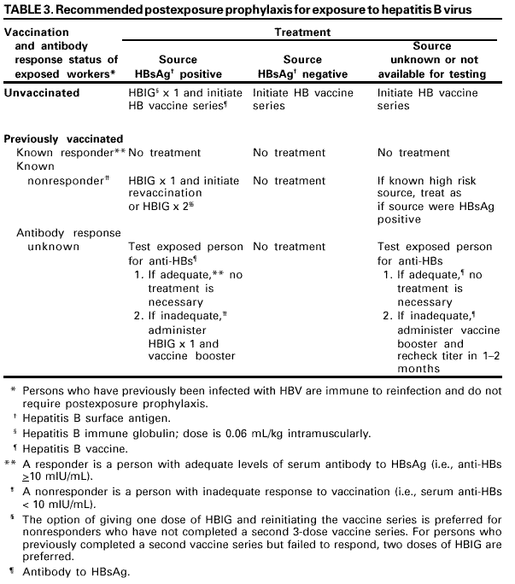

1. **What is the risk of infection to you?**

the risk of developing clinical hepatitis if the blood was both hepatitis B surface antigen (HBsAg) and HBeAg-positive was 22%--31%; the risk of developing serologic evidence of HBV infection was 37%--62%. By comparison, the risk of developing clinical hepatitis from a needle contaminated with HBsAg-positive, HBeAg-negative blood was 1%--6%, and the risk of developing serologic evidence of HBV infection, 23%--37% .

**Interpretation of the Hepatitis B Panel Tests Results Interpretation**

|  |  |  |
| --- | --- | --- |
| Tests | Results | Interpretation |
| HBsAg anti-HBc anti-HBs | negative negative negative | susceptible |
| HBsAg anti-HBc anti-HBs | negative positive positive | immune due to natural infection |
| HBsAg anti-HBc anti-HBs | negative negative positive | immune due to hepatitis B vaccination |
| HBsAg anti-HBc IgM anti-HBc anti-HBs | positive positive positive negative | acutely infected |
| HBsAg anti-HBc IgM anti-HBc anti-HBs | positive positive negative negative | chronically infected |
| HBsAg anti-HBc anti-HBs | negative positive negative | four interpretations possible * |

|  |
| --- |
| *  1. May be recovering from acute HBV infection.     2. May be distantly immune and test not sensitive enough to to detect very          low level of anti-HBs in serum.     3. May be susceptible with a false positive anti-HBc.     4. May be undetectable level of HBsAg present in the serum and the           person is actually a carrier. |