

**King Saud University**

**College of Medicine**

**Department of Medical Education and the Department of Pathology**

**Integrated Biochemistry & Pathology Practical Class**

Year Two, GASTROINTESTINAL & HAEMATOLOGY Block

Student’s Tasks

**2017**

**Copyright Statement**

*This material is protected by copyright laws. For any other purposes other than teaching and research in the King Saud University, no part may be reproduced or copied in any form or by any means without prior permission of the King Saud University.*

*© King Saud University, Kingdom of Saudi Arabia (2017).*

**This Practical Class is Designed and Prepared By:**

Professor Samy A. Azer (Medical Education)

Dr Rana Hassanato (Biochemistry)

Dr Reem Sallam (Biochemistry)

Dr. Muhammed Azhar Chishti (Biochemistry)

Dr. Abdullah Basabein (Pathology)



**King Saud University**

**College of Medicine**

**Integrated Practical Class- Year 2**

**Gastrointestinal & Haematology Block**

**(Department of Medical Education, Biochemistry and Pathology)**

**Design of the Practical Class:**

Students will be divided into two equal groups (Groups 1 and 2). Group 1students will start in the Pathology Laboratory at Level 1 and work on case scenarios for one hour. The case scenarios will provide students to integrate knowledge from Biochemistry and Pathology related to malabsorption. Group 2 will start in the Multipurpose Laboratory at level 2 and have interactive discussion related to α-amylase followed by hands-on training for measuring serum amylase for one hour. Then students will switch to the other Lab to complete the second task for another one hour.

**Objectives of the Practical Class**

1. Understand the uses of serum amylase in the assessment of patients with acute pancreatitis.
2. Hands-on training on measurement of serum amylase by using a biochemical kit and spectrophotometer.
3. Discuss and work on cases covering concepts related to the practical class and application of knowledge learnt.

**PART 1**

**Venue: Pathology Laboratory, Level 1**

**(Group 1 will start by undertaking this part for 60 minutes)**



**King Saud University**

**College of Medicine**

**Department of Medical Education and the Department of Pathology**

**Case 1**

A 65-year-old retired school teacher is referred to King Khalid Hospital by his general practitioner because of repeated abdominal pain and evidence of gallstones shown by ultrasound. On arrival to the hospital, he has upper abdominal pain, vomited once, and tenderness in the epigastrium. His vital signs are shown in the table below:

|  |  |  |
| --- | --- | --- |
| Vital signs | Patient’s results | Normal Range |
| Blood pressure | 120/80 mmHg | 100/60-135/80 mmHg |
| Pulse rate | 95/min regular | 60-100/min |
| Respiratory rate | 18/min | 12-16/min |
| Temperature | 37.4 °C | 36.6-37.2 °C |

The emergency registrar arranges for some blood tests. Results are shown in the table below

|  |  |  |
| --- | --- | --- |
| Blood test | Patient’s results | Normal Range |
| Haemoglobin | 135 | 115-160 g/L |
| White blood cells | 12.5 x 109 | 4.0-11.0 x 109/L |
| Platelet count | 330 x 109 | 150-400 x 109/L |
| Serum amylase | 1100 | 25-125 U/L |
| Serum lipase | 430 | 10-150 U/L |
|  | | |

**Liver function Tests** (including serum bilirubin, Aspartate aminotransferase (AST), Alanine aminotransferase (ALT), Alkaline phosphatase (ALP), serum albumin, and prothrombin time): all within normal range.

**Question 1:**

Which body organ do you think is the source of his pain?

………………………………………………………………………………………………………………………………………………………………………………………………………………………………………………………………………………………………………………………………………………………………………………………………………………………………………………………………………………………………………

**Question 2:**

Interpret the clinical presentation and the laboratory test results.

…………………………………………………………………………………………………………………………………………………………………………………………………………………………………………………………………………………………………………………………………………………………………………………………………………………………………………………………………………………………………………………………………………………………………………………………………………………………………………………………………………

**Question 3**

What is your possible diagnosis? Justify your views.

…………………………………………………………………………………………………………………………………………………………………………………………………………………………………………………………………………………………………………………………………………………………………………………………………………………………………………………………………………………………………………………………………………………………………………………………………………………………………………………………………………

**Question 4**

1. Which **one/or more** of the following images represents the pathological changes you would expect?
2. Describe the pathological changes in the image you have selected.
3. Justify your views for selecting this particular image.

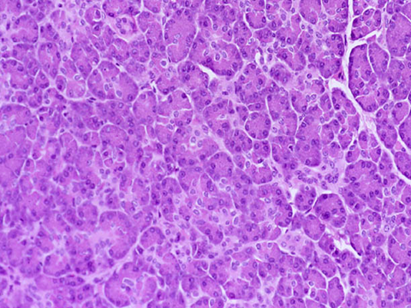

Image A

Image B 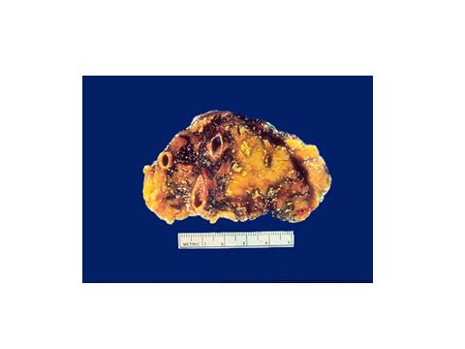

Image C 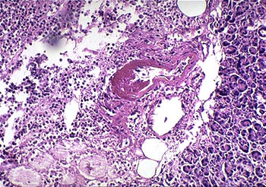

The image(s) I select is (are) (select one/or more): A, B or C …………………………………………………………………………………………………………………………………………………………………

Description of the pathological changes:

………………………………………………………………………………………………………………………………………………………………………………………………………………………………………………………………………………………………………………………………………………………………………………………………………………………………………………………………………………………………………

Justification for your selection:

…………………………………………………………………………………………………………………………………………………………………………………………………………………………………………………………………………………………………………………………………………………………………………………………………………………………………………………………………………………………………………………………………………………………………………………………………………………………………………………………………………

**Case 2:**

James Michael is a 55-year-old engineer who works with a Saudi construction in Riyadh. He travels a lot from the UK to Riyadh to supervise the developments of the joint projects, and at times spent 30-40 days abroad. During his last visit to Riyadh, he has upper abdominal pain and was admitted to King Khalid Hospital. He gives a history of recurrent upper abdominal pain for over 2 years. The pain this time is felt also into his back. He has loose bowel motions for some time and he gives a history of loss of 3 kg in body weight. He has no family history of diabetes or hypertension.

On examination, his vital signs are within normal range. His Body Mass Index is 25 Kg/m2. The doctor arranges for some investigations and the results are shown in the table below:

**Stool tests:**

|  |  |  |
| --- | --- | --- |
| Test | Patient’s results | Normal Range |
| Faecal fat (collected over 72 hours) | 25 g/24 hours | ≤ 7 g/24 hours |
| Stool analysis | No Red blood cells, no pus cells, no mucous, no ova, no parasites. | Nil |

**Biochemistry tests:**

|  |  |  |
| --- | --- | --- |
| Blood test | Patient’s results | Normal Range |
| Serum amylase | 125 | 25-125 U/L |
| Fasting blood glucose | 6.8 | 3.9-5.5 mmol/L |

**Liver function Tests** (including serum bilirubin, AST, ALT, Alkaline phosphatase, serum albumin, and prothrombin time): all within normal range.

**Complete blood count:** Normal

**Question 1:**

Which body organ do you think is the source of his pain?

………………………………………………………………………………………………………………………………………………………………………………………………………………………………………………………………………………………………………………………………………………………………………………………………………………………………………………………………………………………………………

**Question 2:**

Interpret the clinical presentation and the laboratory test results. What is the significance of high faecal fats together with a raised blood glucose level?

…………………………………………………………………………………………………………………………………………………………………………………………………………………………………………………………………………………………………………………………………………………………………………………………………………………………………………………………………………………………………………………………………………………………………………………………………………………………………………………………………………

**Question 3**

What is your possible diagnosis? Justify your views.

…………………………………………………………………………………………………………………………………………………………………………………………………………………………………………………………………………………………………………………………………………………………………………………………………………………………………………………………………………………………………………………………………………………………………………………………………………………………………………………………………………

**Question 4**

1. Which **one/or more** of the following images represents the pathological changes you would expect?
2. Describe the pathological changes in the image you have selected.
3. Justify your views for selecting this particular image.

Image A



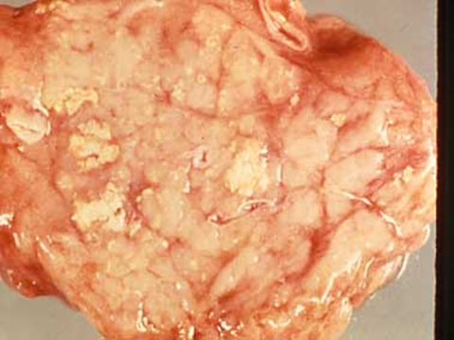

Image B

Image C 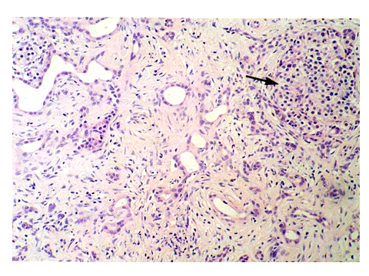

The image(s) I select is (are) (select one/or more): A, B or C …………………………………………………………………………………………………………………………………………………………………

Description of the pathological changes:

………………………………………………………………………………………………………………………………………………………………………………………………………………………………………………………………………………………………………………………………………………………………………………………………………………………………………………………………………………………………………

Justification for your selection:

…………………………………………………………………………………………………………………………………………………………………………………………………………………………………………………………………………………………………………………………………………………………………………………………………………………………………………………………………………………………………………………………………………………………………………………………………………………………………………………………………………

**PART 2**

**Venue: Multipurpose Laboratory,**

**Medical Biochemistry Unit,**

**Level 2**

**(Group 2 will start by undertaking this part for 60 minutes)**

1. **What is amylase, and what are its sources in the human body?**
2. **What is the physiological action of amylase?**
3. **Would you expect a high level of amylase in blood under normal conditions?**
4. **What are the uses of amylase measurement in clinical practice?**
5. **Changes in serum amylase activity during course of an injury (time course)**
6. **What are the possible factors responsible for these changes in the curve?**
7. **With knowledge about amylase activity overtime, what is the clinical application?**

|  |
| --- |
| Calculation & Interpretation  **Δ A = A2 – A1**  **3**  **Serum Amylase (U/L) = 5544 × Δ A**  **Results:………………………………. U/L**  **Normal reference values for the used kit: Serum**: up to 52 U/L (at room temp.: 25◦C) |