King Saud University
College of Medicine
Department of Medical Education and Department of Pathology

Integrated Practical Class

Year Two, Neuropsychiatry Block

Student’s TASKS

This integrated Practical Class is designed by:

- Professor Samy A. Azer (Department of Medical Education)
- Dr Rana Hasanato (Clinical Biochemistry Unit)
- Dr. Ali Somily (Microbiology Unit)

Copyright Statement

This material is protected by copyright laws. For any other purposes other than teaching and research in the King Saud University, no part may be reproduced or copied in any form or by any means without prior permission of the King Saud University.

© King Saud University, Kingdom of Saudi Arabia

KING SAUD UNIVERSITY
College of Medicine
Department of Medical Education and the Department of Pathology
(Biochemistry & Microbiology Units)

Central Nervous System Block

Integrated Practical Class
(Biochemistry & Microbiology)

Objectives:

By the end of this practical session, students will be able to:

- Identify the functions of CSF.
- Recognize the normal and abnormal constituents of CSF.
- Understand the role of CSF in diagnosis of different diseases of CNS.
- Interpret the microbiological and biochemical investigation results of CSF.
- Hands-on the procedure for estimation of total protein in CSF.

Organization of the Practical Class:

This practical class is for 2 hours.
- Students are divided into two main groups as per information provided earlier (Group (I) and Group (II)).
- The practical class has two main sessions ;( Microbiology and Clinical Biochemistry), each session is about 60 minutes long.

Session I: (Microbiology)

Group (I) will start by completing Session I of the practical class.
- The venue for this component is the Microbiology lab.
- This session comprises three cases to be discussed in small groups.
- The time allocated for each case is 15 minutes followed by a tutor discussion and model answers for 5 minutes.
- At the end of this session, the tutor will guide you to do component two of the practical class in the multipurpose lab in the Second floor.

Session II: (Clinical Biochemistry)

Group (II) will start by completing Session II of the practical class.
- The venue for this session is in the Biochemistry Lab .
- This session will be 1 hour (a presentation followed by hands-on training practical component).
- Overview of the CSF specimen handling and the physical and chemical investigations done with CSF.
- Procedure for estimation of proteins in CSF.
- Students will be divided into 3 small subgroups and they will estimate protein using manual method and calculate the results.
- Students in each sub-group should submit CSF examination report at the end of this session.
- At the end of this session, the tutor will guide you to do session I of the practical class in the Pathology lab, in the first floor, college building.

The attendance of the practical will be taken at the end of the second component of the practical.

Group ( I )

VENUE
Microbiology Lab

(I Hour)

Case 1 (20 minutes)

A 15-year-old healthy male visited emergency room presenting with fever, headache, vomiting and drowsiness. Physical examination showed decreased level of consciousness, neck stiffness, skin rash and high temperature (38ºC). Cerebrospinal fluid (CSF) examination revealed opening pressure of 210 cmH₂O. Microscopy of the cerebrospinal fluid showed gram –ve cocci. The patient showed complete recovery after administration of ceftriaxone for 10 days.

The doctor in the emergency department takes a detailed history and conducts a clinical examination. Because of clinical findings, he decides to do a lumber puncture. The results of the lumber puncture are shown below:

CSF | Patient’s results | Normal range
Appearance | Turbid | Clear
WBCs and differential | 8.320 per mm³  Mainly polymorphonuclear leucocytes (84%) | Few (<5 cells/mm³)
Protein | 5.0 | 01-0.4 g/L
Glucose | 1.3 | 3.0-4.5 mmol/L
Chloride | 110 | 115-130 mmol/L
Microscopy | Gram-ve cocci | -

Question 1:
What is your most likely clinical diagnosis?

Question 2:
What is the most likely aetiology? (select only one)
Mycobacterium Avium
Fungal
Parasitic
Viral
Bacterial
Treponema pallidum (Neurosyphilis)
Mycobacterium tuberculosis

Question 3:
Justify your answer to question two?
Question 4:
What further investigation would you like to do at this stage?

Question 5:
Mention two of the recommended antibiotics that can be used as empiric treatment in such a case?

Case 2 (20 minutes)

A 10-year-old boy is brought to the emergency department (A & E) at King Khalid Hospital accompanied by his mother. He has fever, headache, and vomiting for the last 2 days. Clinical examination confirmed that he has meningeal irritation. The doctor decides to do a lumber puncture.
The results of the lumber puncture are shown below:

CSF | Patient’s results | Normal range
Appearance | Clear | Clear
WBCs and differential | 100 per mm³  Mainly lymphocytes (80%) | Few (<5 cells/mm³)
Protein | 0.5 | 01-0.4 g/L
Glucose | 3.7 | 3.0-4.5 mmol/L
Chloride | 115 | 115-130 mmol/L

Question 1:
What is your most likely diagnosis?

Question 2:
What is the most likely infection responsible? (select only one)
Mycobacterium Avium
Fungal infection
Parastic infection
Viral infection
Bacterial infection
Trepanoma pallidum (Neurosyphilis)
Mycobacterium tuberculosis

Question 3:
What is your justification for your answer to question two?
Question 4:
What further investigation would you like to do at this stage?

Case 3 (20 minutes)

A 65-year-old is referred from a general practitioner because of headache, fever, excessive sweating at night, and weight loss over the last 4-5 months. He has also lost his appetite for food. On examination, there is neck rigidity. Laboratory tests including blood count, serum electrolytes, blood urea, creatinine, and blood culture are all normal. The doctor decides to do a lumber puncture.

The results of the lumber puncture are shown below:

CSF | Patient’s results | Normal range
Appearance | Turbid | Clear
WBCs and differential | 300 per mm³  Mainly lymphocytes | Few (<5 cells/mm³)
Protein | 0.8 | 01-0.4 g/L
Glucose | 2.0 | 3.0-4.5 mmol/L
Chloride | 110 | 115-130 mmol/L

Question 1:
What is your most likely diagnosis?

Question 2:
What is the most likely infection responsible? (select only one)
Fungal infection
Parastic infection
Viral infection
Bacterial infection
Trepanoma pallidum (Neurosyphilis)
Mycobacterium tuberculosis

Question 3:
What is your justification for your answer to question two?

Question 4:
What further investigation would you like to do at this stage? (State 3)

Group (II)

VENUE
Biochemistry Lab
(I Hour)

-Pre-lab presentation (15 minutes).

-Hands-on estimation of protein in CSF (45 minutes).

Cerebrospinal fluid Analysis

Indications for CSF analysis:

- CNS infection.
- Demyelinating diseases.
- CNS Malignancy.
- Hemorrhage in CNS..

The following examinations are performed for C.S.F samples:
- Physical examination.
- Chemical examination.
- Microscopic examination
- Microbiological tests.

Physical examination:

1- Volume:
Normal CSF volume: 100 - 150 ml.

2- Turbidity:
- Normal CSF is clear.
- Cloudy or turbid CSF may indicate the presence of white, or red blood cells, micro-organisms, or an increase in protein level.
3- Color:
- Normal CSF is colorless, and free from blood and clots.
- Changes in color may point to additional substances in the fluid.
- Yellow, orange to brown or red colors may indicate blood or hemoglobin pigments.
4- Viscosity:
- Normal CSF should have the same consistency as water.
- Thicker CSF may be seen in patients with certain types of cancers or meningitis.

Chemical examination:

- Routinely performed biochemical tests in CSF are:
  - Glucose
  - Total Protein (Total- Specific e.g albumin and immunoglobulin)
  - Lactate
  - Lactate dehydrogenase
  - Glutamine and acid-base parameters
Remember!!

- Before any analysis, the fluid should be centrifuged to avoid contamination by cellular elements.
- CSF is the most precious biological material. Often, only small volumes of CSF are available for analysis due to difficulty in collection; hence handle this with care.
- The specimen may not be pre-tested for micro-organisms, so strict safety precautions should be followed.

Estimation of Total Protein in CSF

Principle of the method:

- Protein present in the CSF is detected by a series of enzymatic reactions that ultimately form a colored product.
- The intensity of color is proportional to the amount of protein in CSF
- Color intensity is determined by measuring the absorbance by the colored solution at a wavelength of 546nm
- Absorbance is measured by an instrument, spectrophotometer

Procedure:

 | Test | Standard | Blank
Reagent | 2 ml | 2 ml | 2 ml
CSF sample | 40 μl | - | -
Standard | - | 40 μl | -
Dist. H₂O | - | - | 40 μl

- Mix and incubate for 15 minutes at room temperature.

- Measure absorbance at 546 nm

Calculation:

Total Protein conc. ( g / L) =

Abs of sample (Test)
Abs of standard
X
Conc of standard (60 g/L)

CSF Examination Report

Group number: ………………………………………

Students’ names and numbers:

………………………………………………………………… ………………………………

………………………………………………………………… ………………………………

………………………………………………………………… ………………………………

………………………………………………………………… ………………………………

I. Physical properties:

- Color : …………………………………………….……………………………………………
- Appearance : …………………………………………….……………………………………………
- Viscosity : …………………………………………….…………………………………………….

II. Chemical Examination:
- CSF protein concentration (mg/dl) = …………………………

Reference value: 15-45 mg/dL (0.15 -0.45 g/L)

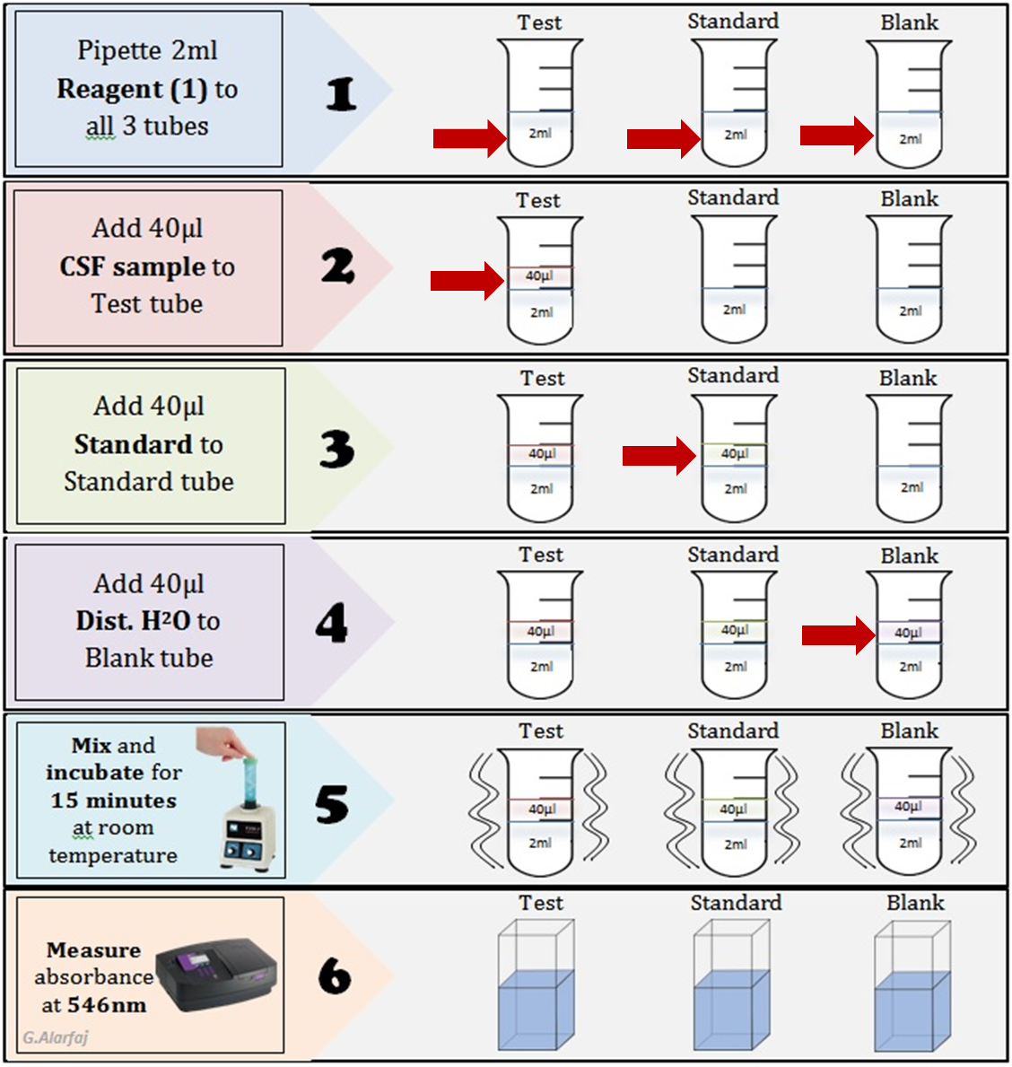
Calculation:
Abs of sample (test)
Total Protein conc. (g/L) = × conc. of standard (60g/L)
Abs of standard

