

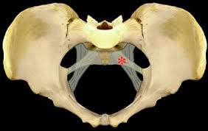 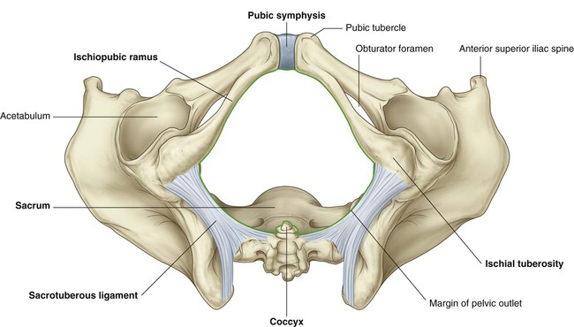

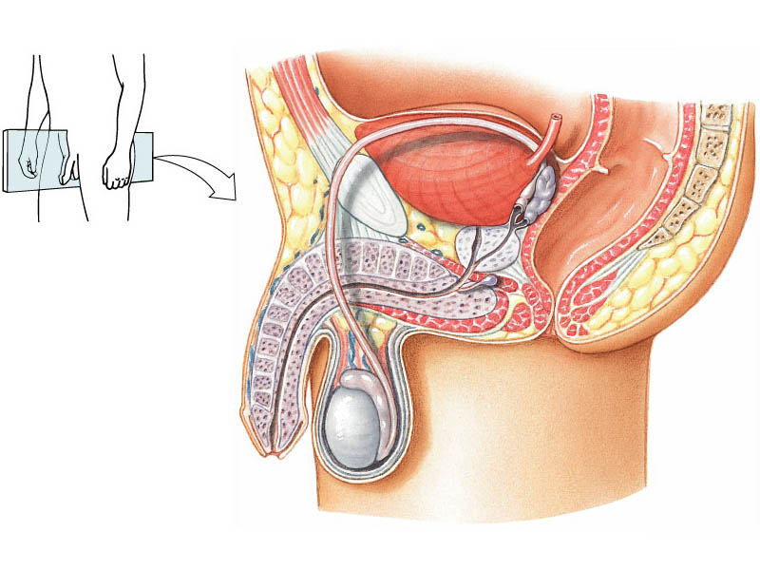

**C**

**B**

**A**

Venous drainage of structure (B) is

* Internal Iliac Vein
* Right Renal Vein
* Inferior Vena Cava

Marked area (C) is which prostatic lobe

* Median lobe
* Anterior lobe
* Posterior lobe
* Lateral lobe

Lateral relation of structure (C) is

* Piriformis muscle
* Levator ani muscle
* Psoas major muscle

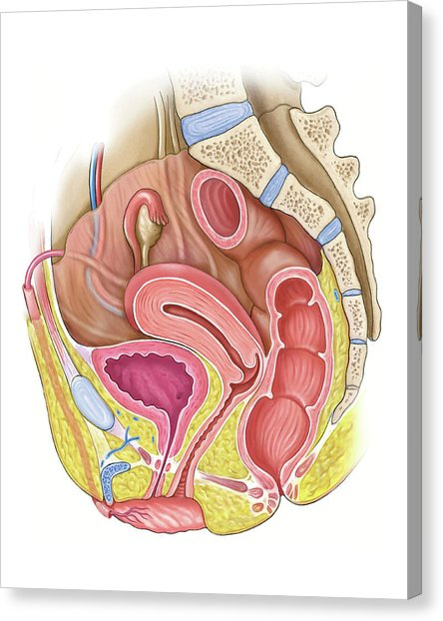

**A**

**C**

b. Mesovarium.

c. Ligament of ovary.

d. Round ligament.c

In the female reproductive system, structure [C] is named:

a. Fundus of uterus.

b. Mesovarium.

c. Ligament of ovary.

d. Round ligament.

Lateral relation of structure (A) is

1. Ureters
2. Urinary bladder
3. Rectum

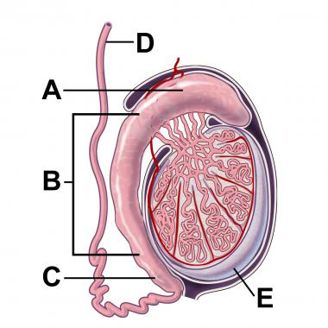

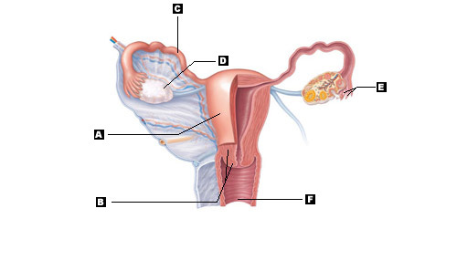

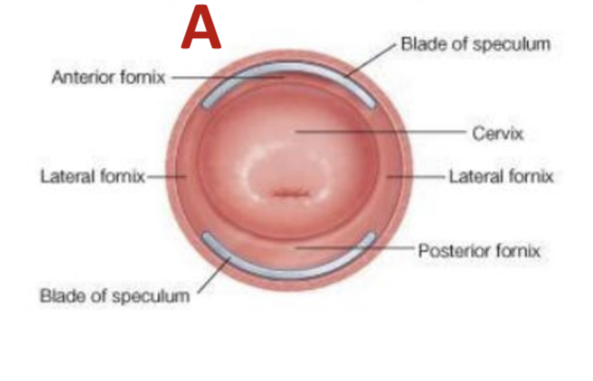

External os

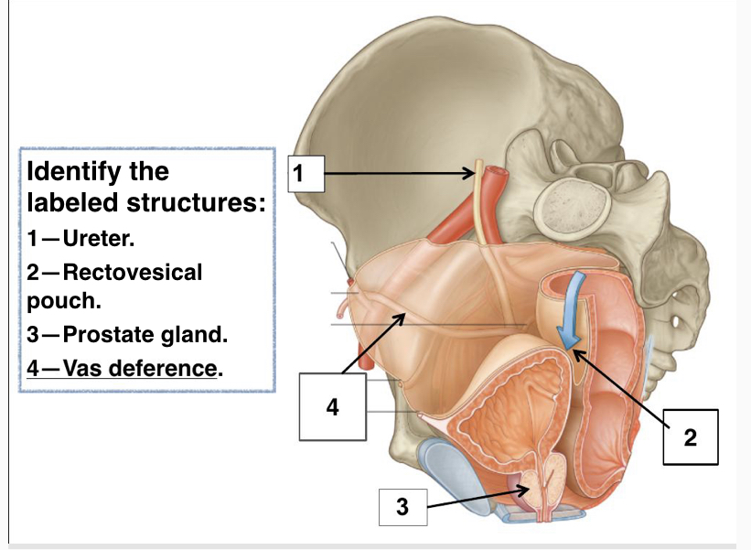

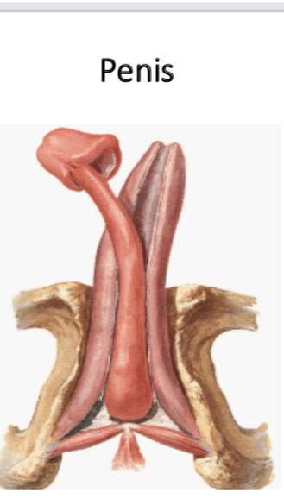

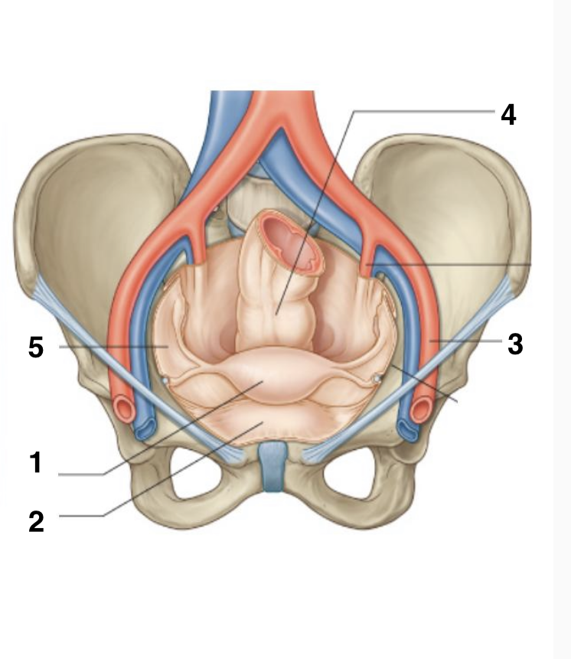

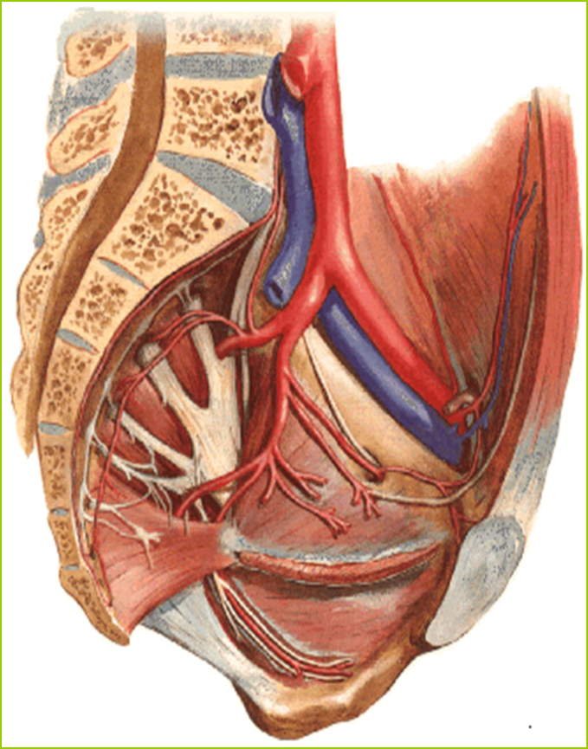

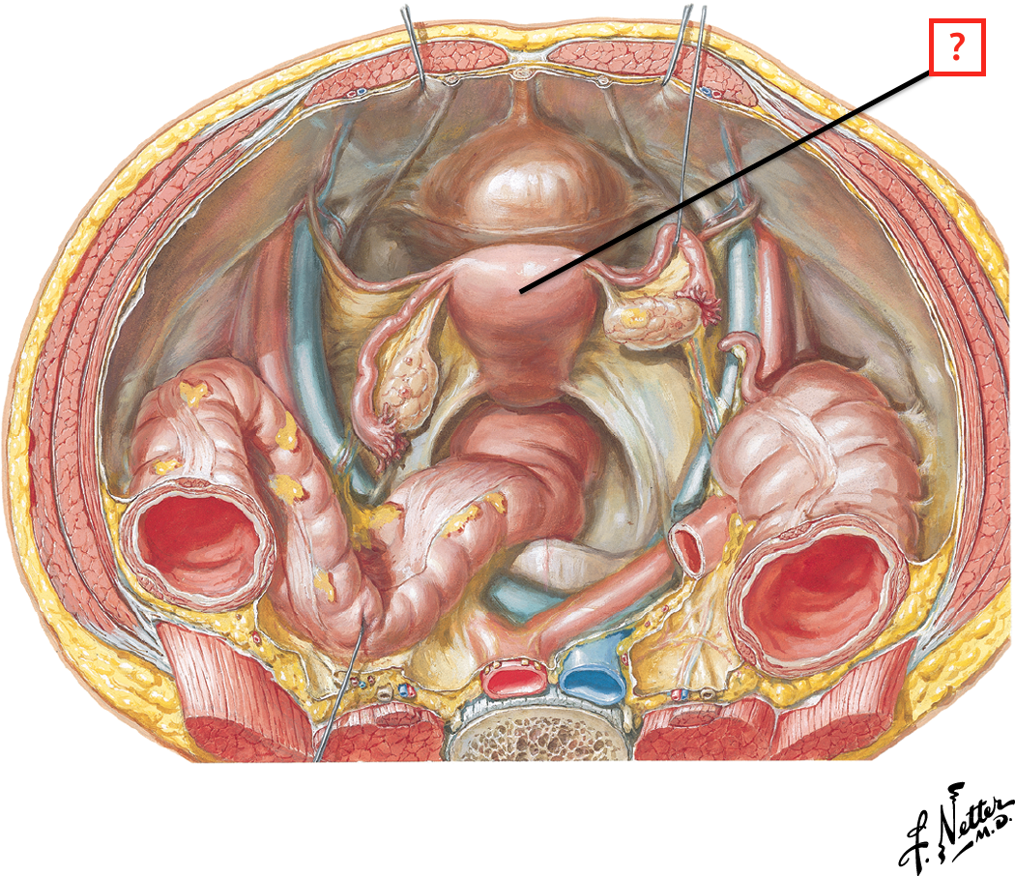In the female reproductive system, the blood supply to organ [A] is a branch from:

**A**

A. External iliac artery.

B. Internal iliac artery.

C. Internal pudendal artery.

D. Common iliac artery

Posterior relation of structure (A) is

1. Sigmoid colon
2. Uterine artery
3. Urinary bladder
4. Fallopian tubes

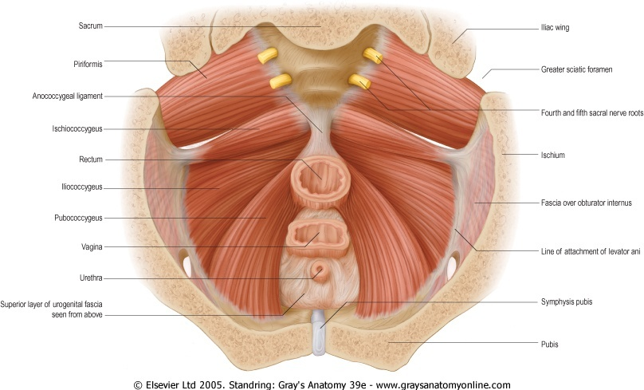

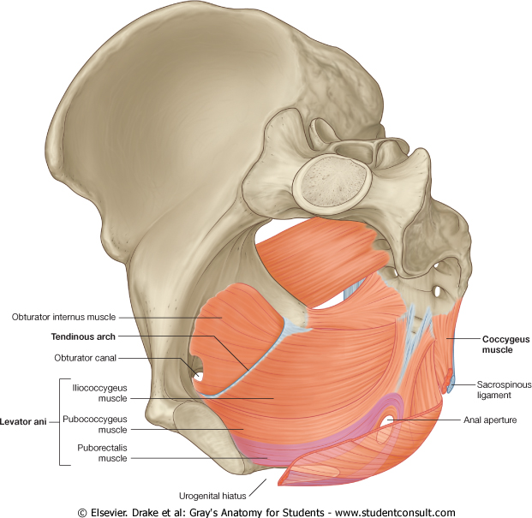

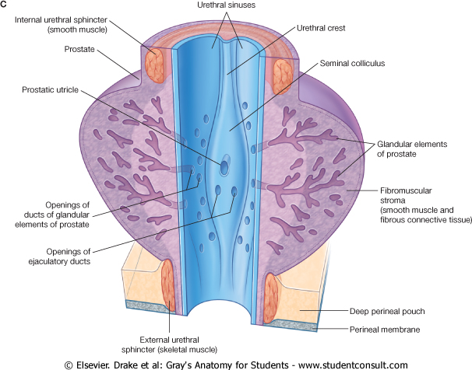

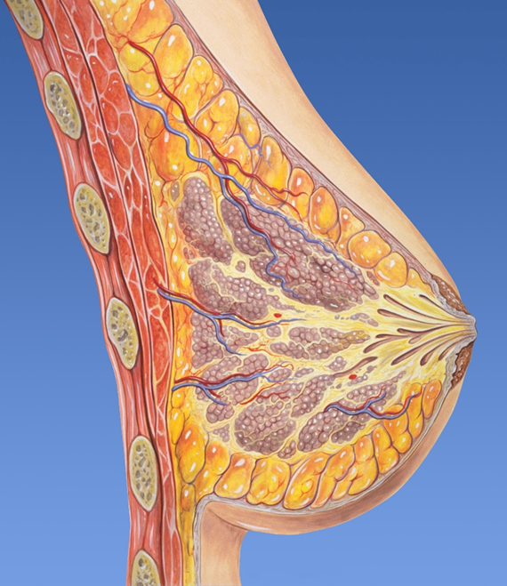

**A**

The nipple of the female breast lies opposite to which intercostal space?

a- Fourth intercostal space.

b- Second to sixth intercostal space.

c- Second intercostal space.

d- Fifth intercostal space.

Marked area (A) is

1. Pectoralis minor muscle
2. Serratus anterior muscle
3. Pectoralis major muscle
4. Subclavius muscle

