Infectious Disease Epidemiology
Chain of infection
Learning objectives:
By the end of this lecture student will be able to::
- Describe the infectious disease process (Chain of infection)
- List the types of reservoir of infectious diseases of man
- Define a carrier and list its types.
- Define zoonoses and list examples.
- Identify the different modes of transmission of the organisms from the reservoir to the susceptible host.

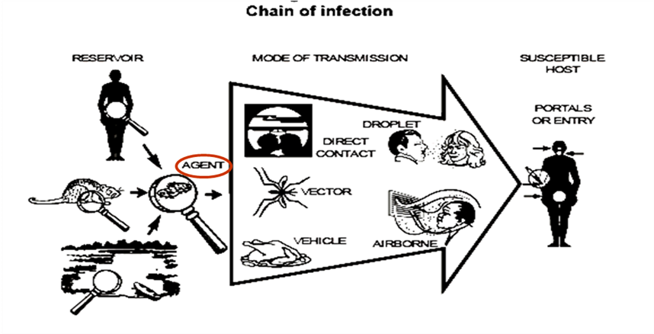
Chain of infection
A process that begins when an agent leaves its reservoir or host through a portal of exit, and is conveyed by some mode of transmission, then enters through an appropriate portal of entry to infect a susceptible host.

Cycle of infection
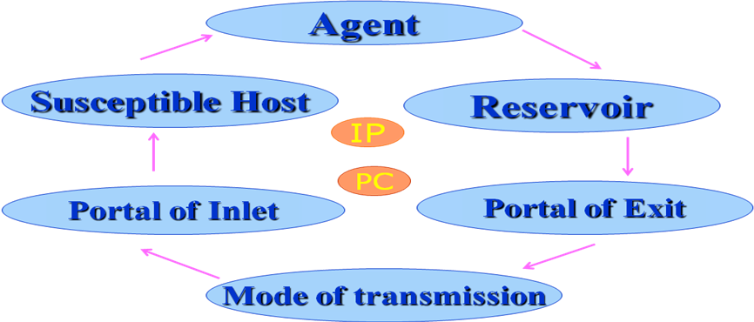
*IP = incubation period.
*PC = period of communicability

The requisites (essentials) for the perpetuation of communicable diseases:
The elements of the cycle of infection:
- Presence of microbiological agent.
- Presence of reservoir.
- Portal of exit.
- Mode of transmission.
- Portal of entry (inlet).
- Presence of susceptible host.

1. Agent:
- Microorganisms are responsible for disease production (viruses, bacteria, protozoa, parasites, fungi,..
- Agent factors that affect disease transmission: Infectivity, Pathogenicity, Virulence, Antigenicity,…
- Mechanisms of disease production (pathogenesis):
- Invasiveness: (Pneumococcosis, measles).
- Toxicity: (Tetanus, Botulism).
- Hypersensitivity: (Tuberculosis).
- Others: (Immune suppression; AIDS).
- Infectivity:
- The ability of an agent to invade and multiply (produce infection) in a susceptible host.
- How to measure (Infectivity); ease & spread of infection?
- Secondary Attack Rate : The proportion of exposed susceptible persons who become infected.
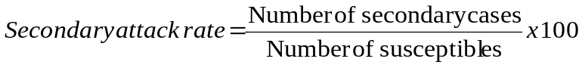
- Examples:
- High infectivity: Measles, Chickenpox
- Low infectivity: Leprosy
- Pathogenicity
- Is the ability of the organisms to produce specific clinical reaction after infection
- It refers to the proportion of infected persons who develop clinical disease.
- Examples:
- High pathogenicity: Measles, Chickenpox (Class B)
- Low pathogenicity: Polio, Tuberculosis, Hepatitis A, Meningitis, AIDS (Class A)
- It can be measured by:
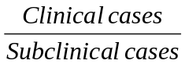
Ratio of clinical to sub-clinical case =

*ratio of clinical to subclinical ratio in polio= 5/95 >> very low.
- Virulence
- It refers the ability of organisms to produce severe pathological reaction.
- It is the proportion of persons with clinical disease who become severely ill or die.
- Examples:Rabies, Hemorrhagic fevers caused by Ebola and Murberg viruses.(Class C)
- It can be measured by: Case fatality rate
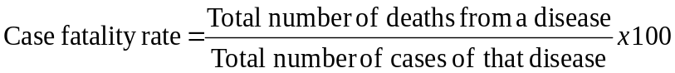

*avian flu (H5N1)= high fatality rate
*H1N1= low fatality rate
- Antigenicity (Immunogenicity)
- The ability of the organism to produce specific immunity (antibodies or antitoxin).
- It can be measured by: Second attack frequency
- Second attacks are rare in measles, mumps and chickenpox.
- Re-infection occurs as in case of common cold, syphilis and gonorrhea.

2. Reservoir of infection
- The reservoir of an agent is the habitat in which an infectious agent normally lives, grows, and multiplies.
- Types of reservoirs: Humans, animals, and the environment.
- Human reservoirs
Two types of human reservoir exist:
- Case: A person with symptomatic illness
- Carrier: A person or animal without apparent disease who harbors a specific infectious agent and is capable of transmitting the agent to others.

Pathogen Reservoirs

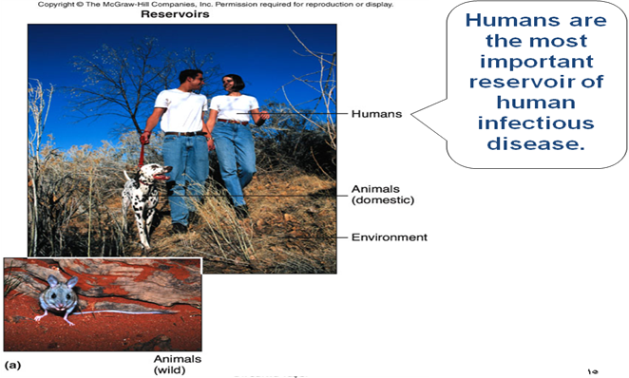

- Carriers are dangerous because:
- They do not show any clinical manifestation so they carry normal life.
- The carrier and his contacts are not aware of their condition so, they take no precautions.
- It is difficult to discover them.
- It is not always possible to deal with them.
- Chronic carriers can remain infectious for a long time leading to repeated introduction of the disease to contacts.
- Types of Carriers:
- Asymptomatic (In-apparent) carrier:
The carrier state that may occur in an individual with an infection that is in-apparent throughout its course
- Examples: Polio virus, meningococcus, hepatitis A virus
- Incubatory, Convalescent, Post-Convalescent carriers:
The carrier state may occur during the incubation period, convalescence, and post convalescence of an individual with a clinically recognizable disease.
- Examples of Incubatory carrier: Measles, chickenpox
- Examples Convalescent carriers: : Diphtheria, hepatitis B viruses and Salmonella species
- According to duration of carriage:
The carrier state may be (transient carrier or chronic carrier).
Chronic carriers:
They continue to harbour an agent for an extended time (months or years) following the initial infection.
- Examples: Hepatitis B virus and Salmonella typhi

- Animal reservoirs
- Zoonoses: Infectious diseases that are transmissible under normal conditions from vertebrate animals to humans. (with humans as incidental hosts)
- Zoonotic diseases include:
- brucellosis (cows and pigs),
- anthrax (sheep),
- plague (rodents),

Zoonoses
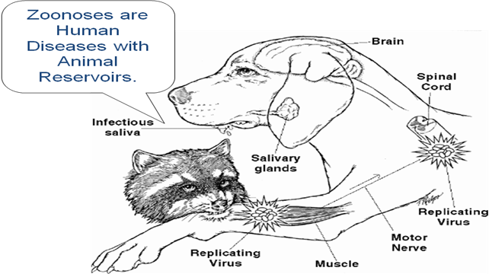

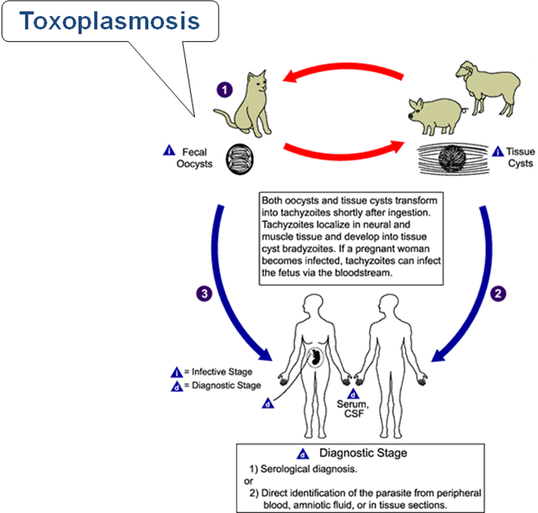

- Environmental reservoirs:
- Soil, and water
- Soil: Agents live and multiply in the soil.
- Examples:
- Tetanus spores and
- Fungal agents; (those causing histoplasmosis)
- Pools of water are the primary reservoir of Legionnaires’ bacillus.

3. Portal of exit
- Portal of exit is the path by which an agent leaves the source host.
- Examples:
  - Respiratory tract
  - GIT
  - Skin and mucous membrane
Portals of Entry
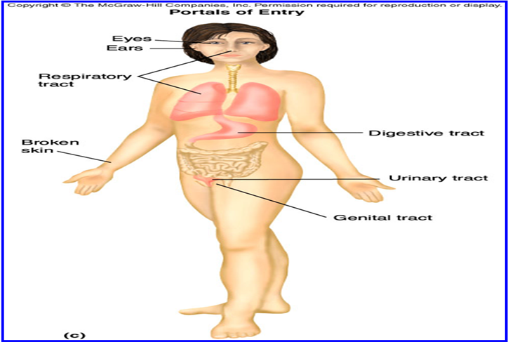

4. Modes of transmission
- Direct transmission
      - Direct contact
      - Droplet spread
- Indirect transmission
      - Airborne
      - Vehicle borne
      - Vector borne:
          - Mechanical
        - Biologic
Pathogen Transmission
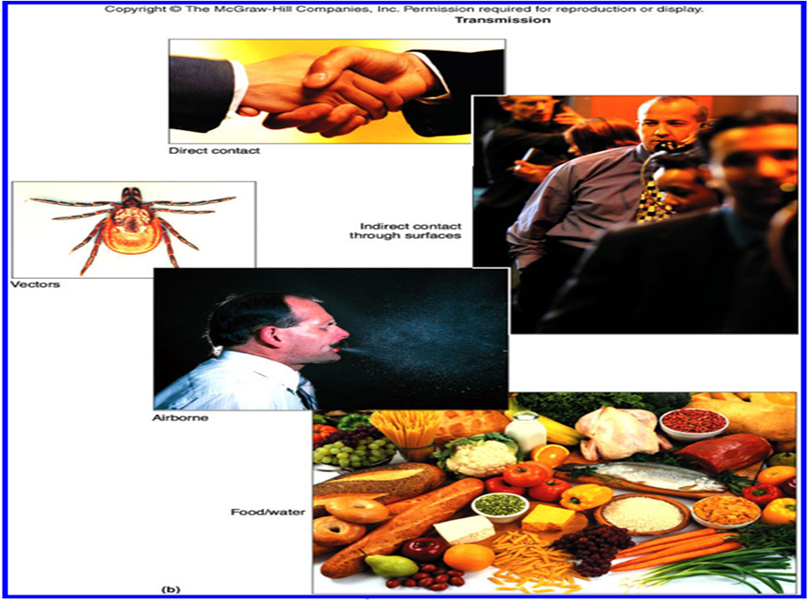
- Direct transmission
There is essentially immediate transfer of the agent from a reservoir to a susceptible host by direct contact or droplet spread.
- Direct contact occurs through:
- Skin-to-skin contact, kissing, and sexual intercourse.
- Direct contact refers also to contact with soil or vegetation harbouring infectious organisms.
Contact Transmission
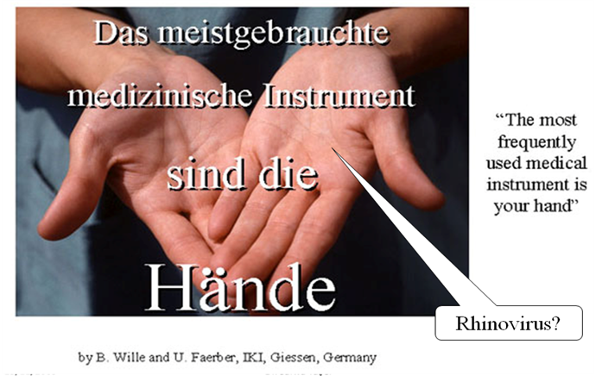

Direct-Contact Transmission
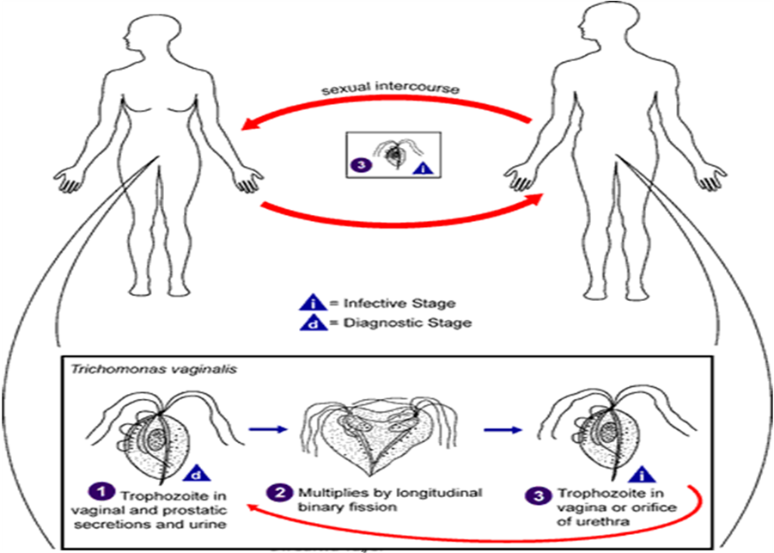

- Droplet spread
  - Transmission by direct spray of relatively large, short-range aerosols over a few feet, before the droplets fall to the ground.
  - These aerosols may be produced by sneezing, coughing, or even talking.

Droplet Transmission
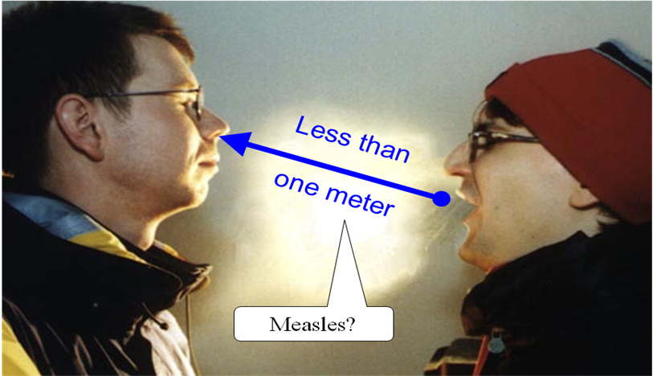
- Indirect transmission:
An agent is carried from a reservoir to a susceptible host by:
- Vehicle borne: inanimate vehicle
- Vector borne: animate vector
- Airborne transmission: suspended air particles
- Vehicle borne:
- An infectious agent is carried from a reservoir to a susceptible host by an inanimate intermediary.
- Vehicles include:
- Contaminated food and water, typhoid, paratyphoid, food poisoning, dysentery and cholera.
- Biologic products (blood), viral hepatitis, AIDS, syphilis and malaria.
- Fomites (inanimate objects such as: door knobs, toys, handkerchiefs, bedding, or surgical instruments).
Foodborne Transmission
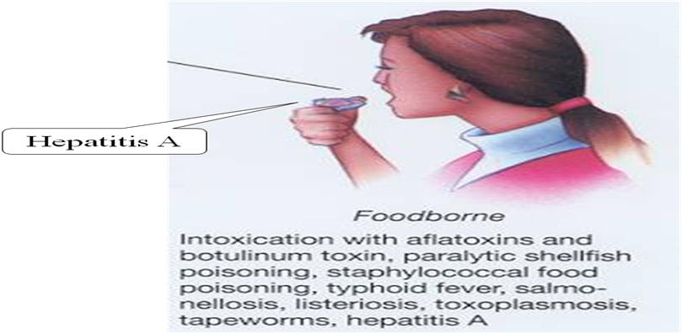

Waterborne Transmission
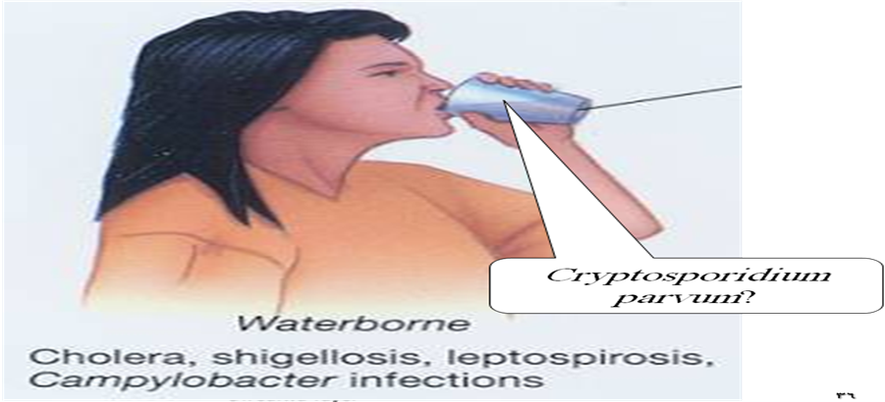

Common-Source Outbreak

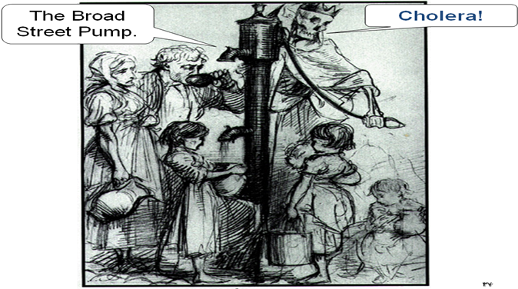

Indirect-Contact Transmission

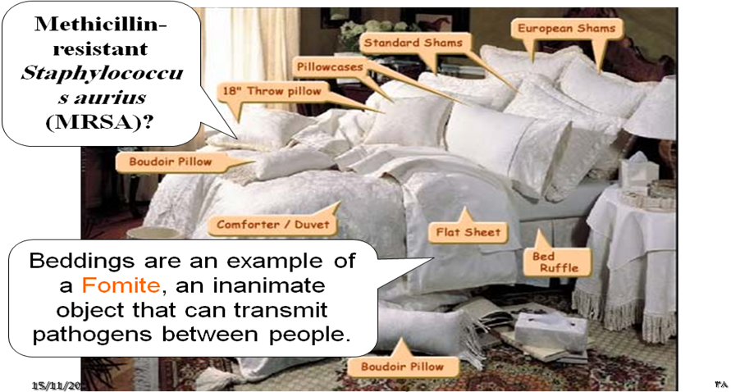
___________________________________________________________________________________________________

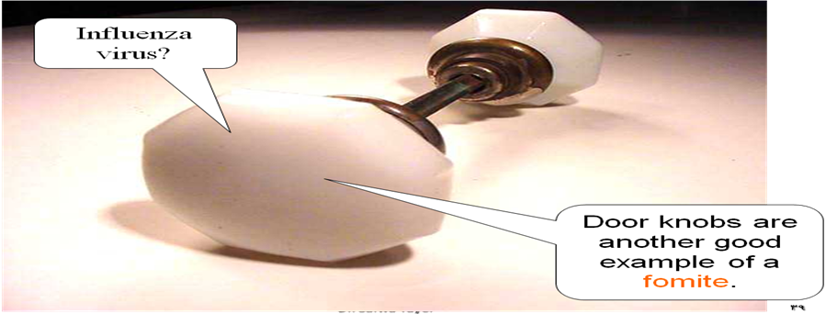
- Mechanical transmission:
- the agent does not multiply or undergo physiologic changes in the vector.
- For example, flies carry Shigella on appendages.
- Biologic transmission:
- When the agent undergoes changes and/or multiplication within the vector before it is transmitted.
- (Extrinsic incubation period). Example: Malaria, Filariasis .

Modes of Transmission
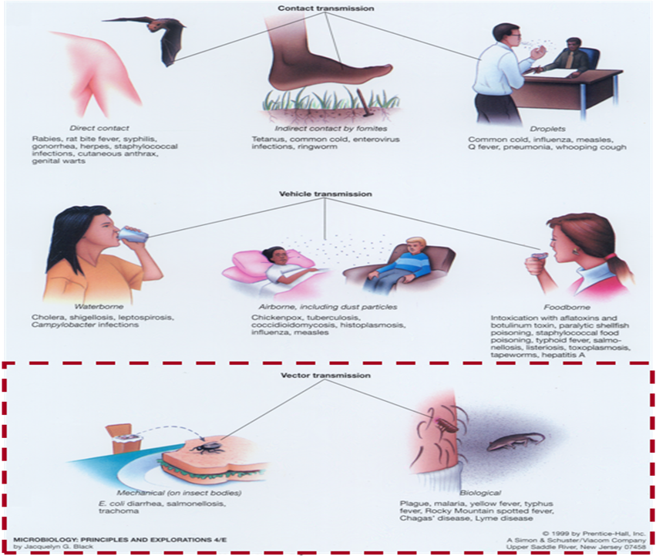

- Airborne transmission occurs by particles that are suspended in air.
There are two types of these particles:
- dust and
- droplet nuclei.
- Dust particles:
- result from re-suspension of particles that have settled on floor or bedding,
- infectious particles blown from the soil by the wind. Example: Fungal spores.

Airborne Transmission
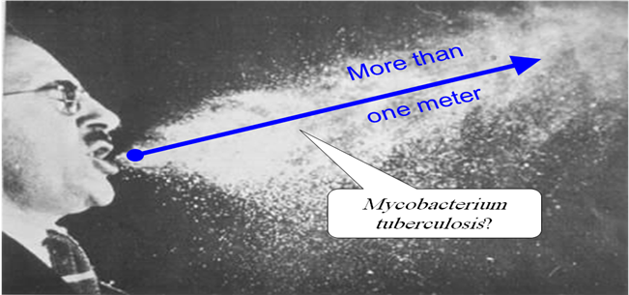
- Droplet nuclei
- They represent the dried residue of droplets that have been coughed or sneezed into the air.
- They are very tiny particles less than 5 µ (microns) in size and may remain suspended in the air for long periods.
- Examples:
- Tuberculosis is transmitted more often indirectly, through droplet nuclei, than directly, through direct droplet spread.
- Legionnaires’ disease and histoplasmosis also spread through airborne transmission.

Modes of Transmission
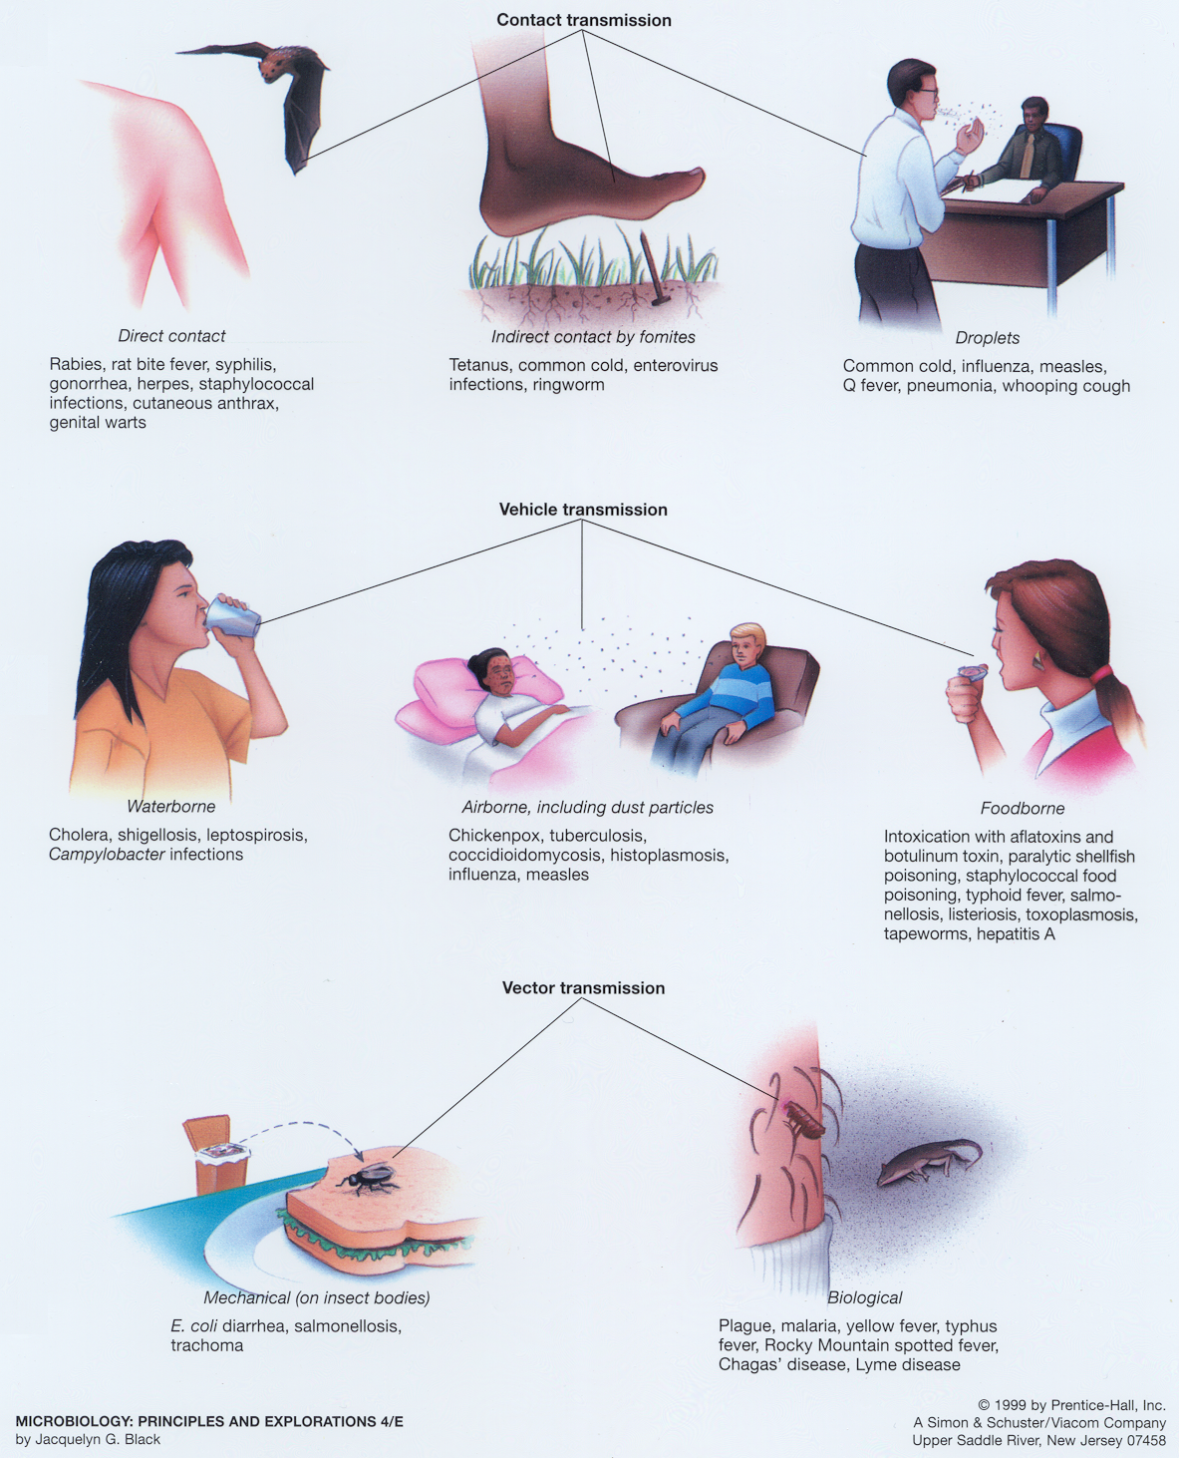
5.Portal of entry
- An agent enters a susceptible host through a portal of entry.
- The portal of entry must provide access to tissues in which the agent can multiply or a toxin can act.
- Often, organisms use the same portal to enter a new host that they use to exit the source host.
Portals of Entry
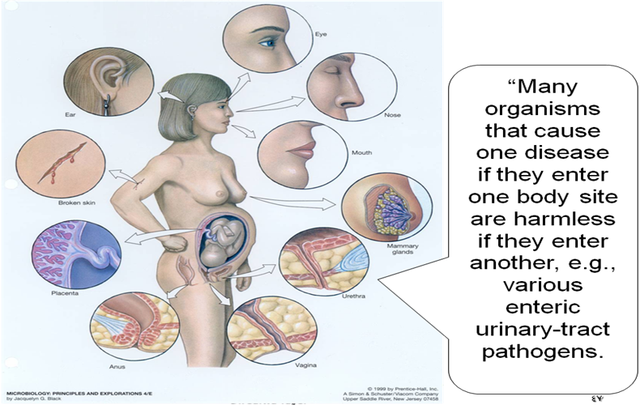

- Host:
- A susceptible host is the final link in the chain of infection.
- The host is a person or other living organism that can be infected by an infectious agent under normal conditions.
Susceptibility of a host depends on:
- Genetic factors
- General factors
- Specific acquired immunity
General factors which defend against infection:
- the skin,
- mucous membranes,
- gastric acidity,
- cilia in the respiratory tract,
- the cough reflex, and
- nonspecific immune response.

General factors that may increase susceptibility are:
- malnutrition,
- alcoholism, and
- disease or therapy which impairs the immune response (Cortisone, cytotoxic drugs, ...

- Specific acquired immunity:
- It refers to protective antibodies that are directed against a specific agent (depends on antibodies production).
- two types:
- Active immunity: Resistance developed in response to stimulus by an antigen either;
- Naturally by infecting agent (Post-Infection) or
- Artificially by vaccine (Post-Vaccination) and usually characterized by the presence of antibody produced by the host.
- Passive immunity: Immunity conferred by an antibody produced in another host and may be acquired;
- Naturally by an infant from its mother(Trance-placental) or
- Artificially by administration of an antibody containing preparation (antiserum or immune globulin) (Immune-sera).

- Herd immunity
- It is the state of immunity of a group or a community.
- Also it is; “The resistance of a group to invasion and spread of an infectious agent, based on the immunity of a high proportion of individual members of the group”.
Factors Affecting Herd Immunity:
- The extent of coverage of the immunization program.
- The degree of resistance to infection afforded by the vaccine.
- Duration and degree of infectivity of the organism.
- Past experience with different infections.
- Overcrowding and environmental sanitation.
(people who live in very sanitized conditions and have not been exposed to subclinical infections are more susceptible than those who live in poorly sanitized conditions )
Cycle of infection
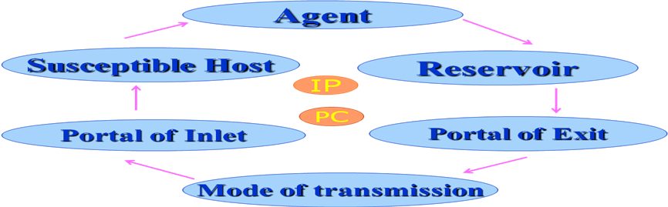

Period of Communicability
- The time during which an infectious agent my be transmitted directly or indirectly from an infected person to a susceptible person or animal.
- Its length varies from one disease to another.

Incubation period (IP)
- The period from exposure to infection to the onset of symptoms or signs of infectious disease.
- The length of incubation period depends on:
- The portal of entry.
- The rate of growth of the organism in the host.
- The dosage of the infectious agent. (high dosage ➔ short IP)
- The host resistance.

Extrinsic incubation period:
- This is the period taken by the infectious agent outside the human body until it becomes infective again to a new individual.
- e.g. Rickettsia takes five days in the intestinal villi of louse.

