* Morbidity Rates
* Learning objectives:

*At the end of this lecture you (will) be able to:*

* List the main measures of morbidity
* Define and calculate Morbidity Rates
* Recognize the relation between incidence and prevalence rates

**The epidemiological approach:**

Studying health-related events involves answering five questions:

* What?
* Who?
* Where?
* When?
* Why?
* **Measures of morbidity**
* Morbidity rates are used as indicators of health
* In epidemiology, the main measures of disease frequency are:
* Incidence Rate
* Attack Rate
* Prevalence Rate
* **Incidence rate:**

Incidence measures the number of new cases of a disease (or other health-related phenomenon) that occur during a specified period of time in a population at risk.



* **The numerator should reflect new cases of a disease which occurred during the specified period.**
* **The numerator should not include cases which occurred earlier.**
* **The numerator has to come from the population at risk for developing disease (it is a part of the denominator)**
* **Incidence Rate = X/(X+Y)**
* The denominator should include persons at risk to develop the disease that is being described during the time period covered.
* The denominator does not include persons with the disease.
* The denominator may change over time as people develop disease

**What is the incidence rate from**

**October 1, 1990 to Sep 30, 1991?**

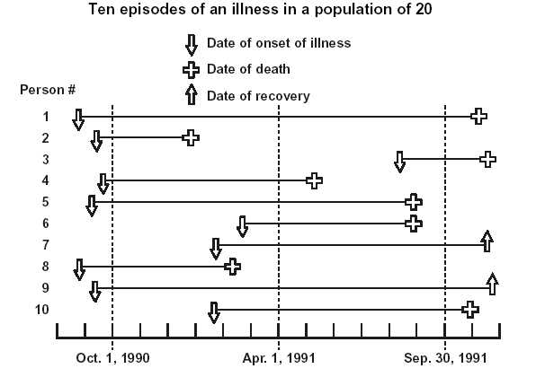

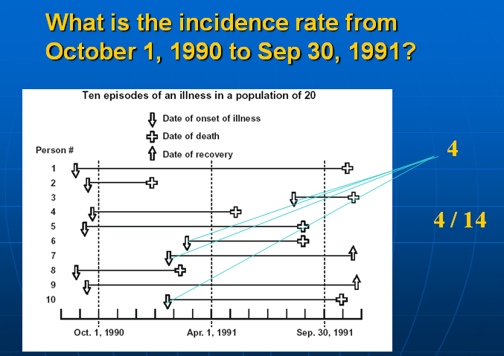

* Factors affecting incidence rate
* New risk factor
* oral contraceptives and increase in thromboembolism;
* food additives and cancer
* New virus (HIV and AIDS)
* Changing habits
* increased smoking and lung cancer
* fluoridated water and decrease in dental caries
* Factors affecting incidence rate
* Changing virulence of causative organisms
* drug-resistant bacteria (TB)
* Influenza virus mutation Increase influenza (H1N1)
* drug resistance to malaria prophylaxis and increase in malaria
* Changing of intervention programmes
* vaccination against measles measles
* Polio eradication campaigns polio
* Chemoprophylaxis meningitis, Rheumatic diseases
* Selective migration of susceptible persons to an endemic area incidence
* Population pattern
* Aging Degenerative diseases
* *Reporting*
* Increase reporting incidence
* *Screening*
* Early detection of cases incidence
* *New diagnostic tools*
* New diagnostic tools detection of cases
* Attack Rate

An attack rate is a variant of an incidence rate, applied to a narrowly defined population observed for a limited time, such as during an epidemic.

The attack rate is usually expressed as % percent.



***Example***

**Of 76 persons who attended a picnic, 46 subsequently developed gastroenteritis.**

**Calculate the attack rate of gastroenteritis,**

**Attendees = 76**

**ILL = 46**

**Attack rate = (46 ÷ 76) X 100**

**= 61%**

* Prevalence Rate

Prevalence measures the number of cases (new and old) of the disease (or other health-related phenomenon) at a point or period in time.





* The numerator for prevalence includes:
* all persons ill from a specified cause during a specified time interval (or at a specified point in time)
* regardless of when the illness began.
* The denominator includes
* total population in the same place during a specified time interval (or at a specified point in time)

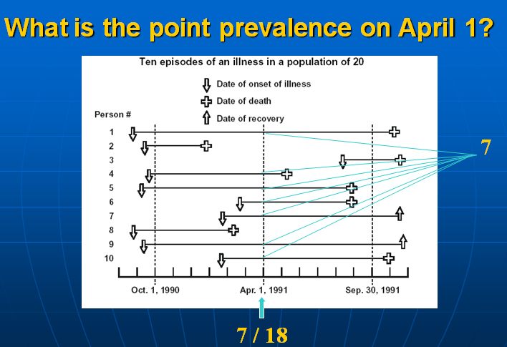

**Relationship between incidence and prevalence:**

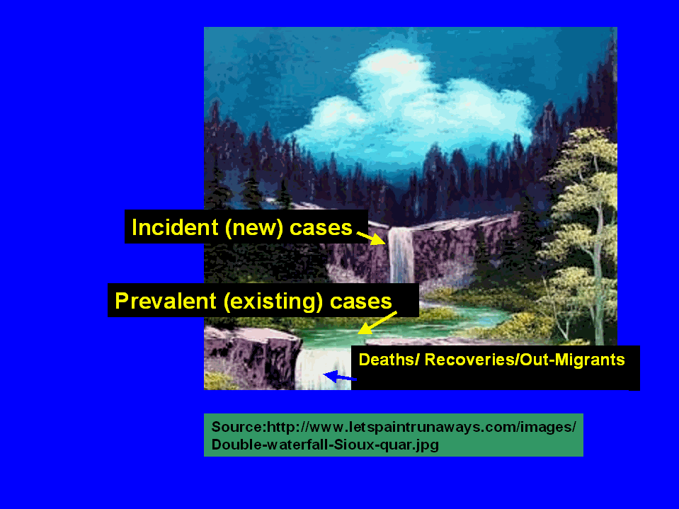

* Incidence and prevalence
* A waterfall metaphor can be helpful in illustrating the concepts of incidence and prevalence.
* Commencing at the top of the falls, we see the new cases flowing into the prevalence pool below.
* The water flowing out of this pool reflects the individuals who die, recover, or migrate out of that population for which the prevalence is measured.
* Several factors may affect prevalence rate
* Incidence
* Duration of disease
* Selective Migration
* Disease treatments & outcome
* Factors affecting Prevalence:
* Changes in incidence

Prevalence rate= Incidence rate x average duration of disease.

High incidence produce high prevalence

* Changes in disease duration and chronicity
* Longer duration of disease, higher prevalence
* Chronic diseases are accumulating so increase the prevalence
* Acute diseases of a high recovery rate or high case fatality rate decrease prevalence
* Intervention programs
* Better treatment with high cure rate decrease prevalence
* If treatment only increase survival without cure, increase prevalence.
* Selective attrition
* selective migration of cases, or susceptible or immune persons.
* *Changing classifications*:
* the data coding according to various disease categories often changes, and variations in prevalence may be reported due to misclassification).

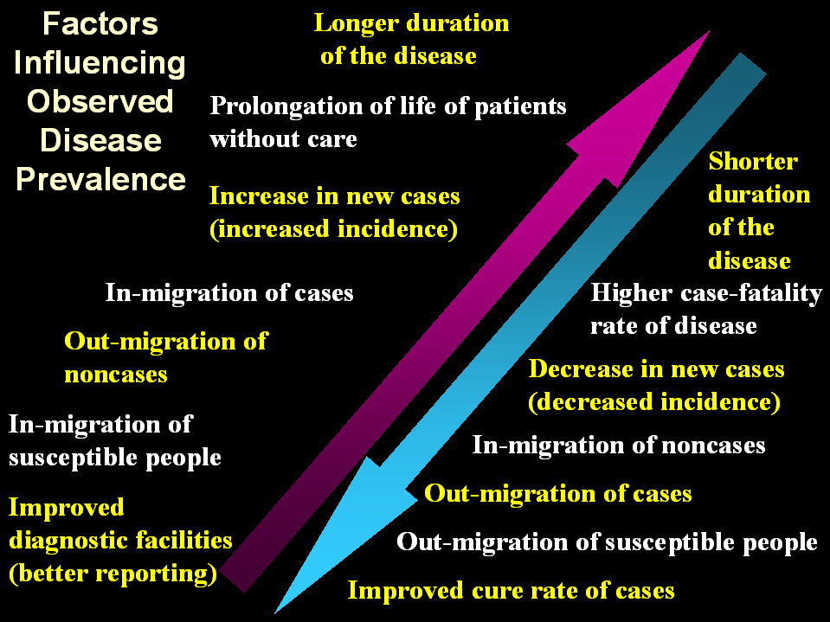

This diagram shows factors that alternatively can increase or decrease the magnitude of the observed prevalence of a disease.



1. Rapid recovery from disease for example,
   * a new drug has been discovered.

2. The disease is becoming more fatal for example,

* + an increase in disease virulence,
  + increasing failure of treatment, or
  + decreasing application of effective treatment.

3. Selective out migration of cases (perhaps seeking treatment elsewhere).



1. **Slow Recovery**

**(the disease is becoming more chronic) due to**

* + **less effective drugs or**
  + **Poor compliance (drugs are less frequently used), or**
  + **resistance to the drugs is increasing.**

1. **The disease is becoming less fatal due to,** 
   * **Use of a newly discovered, potent drug or**
   * **the organism is becoming less virulent.**
   * **Early detection of diseases**
2. **There is selective immigration of cases to the area.**



1. **The disease is becoming significantly shorter in duration**
2. **Better treatment with high cure rate**
3. **New agent more frequently, more acute.**
4. **The disease is becoming more fatal.**

**Notes from Bright <3**

Measuring morbidity

***I-Incidence rate:***

New cases during a given time period

**-------------------------------------------------**

Population @ risk during the same period

NB.

**Population@risk** =

Total population **–** cases which occurred or diagnosed earlier or dead

n= any number (1, 2……)

بإمكانك الضرب في العشرة ومضاعفاتها ، المهم أن يكون ناتج القسمة صحيح دون النظر لموضع الفاصلة

بمعنى: **لن** يوجد في الخيارات مثلا:

-11.2

-112.0

-1.12

-.112

لكن في حال كانت **n معطاة** مثلا = 2 فلابد من التحقق من موضع الفاصلة

***II-Attack rate :***

New cases among the population during the period

---------------------------------------------------------------

Population @risk @ the begging of the period

It's observed for a limited time, such as during an epidemic

***III-2nd attack rate :***

يقيس عدد الحالات الجديدة من المرض والتي كانت على اتصال بالحالات القديمة

Number of cases among contacts of primary cases during the period

---------------------------------------------------------------------------------

Total number of contact

***1V-Prevalence:***

All new & pre- exiting cases during a given time period

--------------------------------------------------------------------

Population during the same time period

NB.

Here population = total population regardless when illness began

**إذا مع incidence نستخدم Population @ risk**

**ومع prevalence نستخدم Total population**

***V-Point prevalence:***

All new & pre- exiting cases during a given point of time

---------------------------------------------------------------------

Population during the same point of time

***Relation ship b/w incidence & prevalence:***

|  |  |
| --- | --- |
| **Factors ↑ observed disease prevalence** | **Factors ↓ observed disease prevalence** |
| 1-longer duration of the diseases  2- prolongation of life pts w/o care  3- increase of new cases (increase incidence )  4- in migration of cases  5- out migration of non cases  6- in migration of susceptible people  7- improved diagnostic facilities(better reporting ) | 1-shorter duration of the disease  2-higher case fatality  3- decreases in new cases (decrease incidence )  4- in- migration of no cases  5- out-migration of cases '  6- out migration of susceptible people  7- improved cure rate of cases |

***Factors affecting incidence & prevalence:***

|  |  |
| --- | --- |
| ***Factors affecting prevalence*** | ***Factors affecting incidence*** |
| 1-changing incidence  2- changing in disease duration & chronicity  3- intervention programmed  4- selective attrition  5- changing classifications | 1-new risk factor  2-changing habits  3-chaning virulence of causative organisms  4-changing of intervention programmes  5-selcective migration  6-population pattern  7-reporting  8-screening  9-new diagnostic tools |

***Divergence b/w incidence & prevalence :***

|  |  |
| --- | --- |
| ***Interpretation*** | ***Case*** |
| 1- rapid recovery from disease  2- disease become more fatal  3-selective out migration | 1**- stable incidence & decrease prevalence** |
| 1- slow recovery  2-disease becoming less fatal  3- selective immigration | **2- stable incidence & increasing prevalence** |
| 1-disease becoming shorter in duration  2- new agent, more frequent exposure ,more acute  3-diseses becoming more fatal | **3-over time increasing incidence & decreasing prevalence** |