AntiCancer Drugs

- Cancer is characterized by uncontrolled growth of abnormal cells.
Cancer cells do not respond to the normal processes that regulate cell growth, proliferation, and survival, they can't carry out the physiologic functions of their normal mature cells.
  - Prevalence:
    - In USA 1 in 2 American men.
    - 1 in 3 American women.
  - Etiology & pathogenesis:
Cancer arises from the transformation of a single normal cell, by damage or mutation to the DNA.
  - Risk factors:
Lifestyle, environmental, occupational factors, medical therapies, genetic factors and smoking.
  - Damage to cellular DNA can result in mutation &cancer development
  - As normal cells:
The cell cycle contains 4 phases (S, M, G1, G2) each responsible for a different task necessary for cell division.
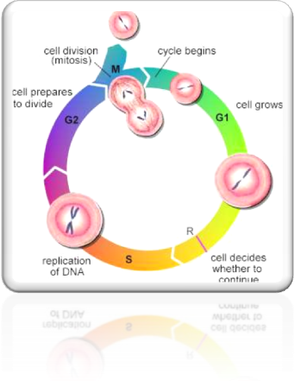
    - During the first activity phase, the M phase, the cell
undergoes mitosis (cell division).
    - Then, the cell enters the first gap or resting phase G₁.
During this the cell makes the enzymes necessary for
DNA synthesis.
    - The synthesis of DNA occurs during the next activity
phase called S phase.
    - After that, the cell enters a second gap phase, resting G₂.
RNA & other proteins are synthesized during this phase to
prepare for cell division during the M phase.

After that:
    - Continue to proceed through the cell cycle to divide again.
    - Mature into specialized cells & eventually die.
    - A third resting phase G_{o}, proliferation of some normal cells under fine control to balance the loss of mature functional cells with the production of new cells.
Classification of anti cancer agents

1-alkylating agents:
- Cyclophosphamide
- Nitrosoureas eg.lomustine & carmustine
- Cisplatin
Mechanism of action of the alkylating agents:
- Alkylation of one or both strands of DNA molecule through cross linking inhibiting the replication & facilitating DNA strand breakage.
- Another mechanism with nitrisourea involves inhibition of RNA & protein synthesis.
- They affect cycling or resting cells (cell cycle non specific=)
- All are mutagenic & carcinogenic can lead to secondary malignancy (acute leukemia) [this is unfortionately a common side effect]
Drug resistance of the alkylating agents:
- Increased capability to repair DNA lesions.
- Decreased permeability of the cell to alkylating drugs.
- Increased production of glutathione. [glutathione inactivate alkylating drugs]
Toxicity of the alkylating agents::
[Almost all anti cancer agents have this triad of common side effects but may differ in severity ]
- Bone marrow depression
- GI upset anorexia, nausea, vomiting.
- Alopecia.
Cyclophosphamide:
- Is most widely used alkylating agents.
- It must be activated to cytotoxic form by CytP450 system [in the liver].
- The intermediate hydroxylated form break down to form 2 active forms:
Phosphoramide and acrolein.
Pharmacokinatics of Cyclophosphamide:
- Cyclophosphamide given mainly orally.
- Excreted via feces & urine.
Adverse effects of Cyclophosphamide:
- The common triad (N.V.D,BM depression,Alopecia)
- Hemorrhagic cystitis. [Leads to bladder fibrosis bec of acroleine so, hydrate the pt(give him saline) or give the pt mesna (a drug acts as anti-oxidant) as prophylactic IV infusion or prolamine.]
- Amnorrhea, testicular atrophy, sterility.
Nitrosoureas:
- No cross resistance with other alkylating agent.
- It is highly lipid soluble.
- Cross BBB.(useful in brain tumor)
- Eg. Carmestine & lomustine
Carmestine | lomustine
IV | Orally
No active metabolite | Active metabolite
Both readily penetrate into CNS
Undergoes extensive metabolism.
Urinary excretion is main route.

Cisplatin: [nephrotoxic]
- Kills cells in all stages of the cell cycle (not specific cell cycle)
- Inhibits DNA synthesis & function.
- Aggressive hydration with IV saline infusion significantly reduce the incidence of nephrotoxicity (b/c it wash the kidney)
- Effective against : [Broad anticancer effect]
- solid tumors includes (lung, esophagus, gastric)
- Genitourinary cancer as testicular,ovarian & bladder.
- Generally, the alkylating agents are used to treat hematological & solid tumors.

2-anti metabolite: (S phase, cell cycle specific)
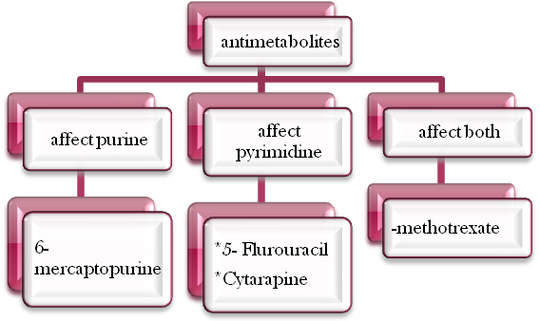
Mechanism of action:
Inhibits purine or pyramidine synthesis. [synthesis of nucleic acid, DNA or RNA]

2- Methotrexate:
inhibits folate synthesis through inhibition of dihydrofolate reductase step in the formation of purine & nucleiac acids DNA or RNA. [Inhibits purine & pyramidine , as trimethoprim
Resistance of methotrexate:
- Decreased drug transport into the cell. [cell wall permeability]
- Decreased reductase enzyme.
Route of administration of methotrexate:
- IV, intrathecal, oral. (intrathecal route used for brain tumor)
- Does not penetrate BBB
- Excreted mainly through kidney & less extent in feces.
Adverse effects of methotrexate:
- Common triad (VND, BM depression, alopecia)
- Renal damage
- Hepatic fibrosis or cirrhosis.
- Neurologic (mainly with intrathecal route) [e.g headache, peripheral neuropathy,changes in mental concentration, seizures]
- Pulmonary(cough, dysnea,cyanosis)
- Headache, fever, seizures.
- Contraindicated in pregnancy. [All the cytotoxic drugs. Not prove to be safe.]
- The hematological toxic effect of methotrexate can be reversed by leucovorin. [only hematological effect, does not prevent pulmonary or neurologic side effects ]

2- Purine Antagonist:
6-Mercaptopurine (6MP)
Metabolized by hypoxathine guanine phosphoribosyl transferase to monophosphate 6-thioinosinic acid [active form] which inhibites purine synthesis.
Therapeutic uses of 6MP:
In the treatment of childhood acute lymphoblastic leukemia.
Pharmacokinatics of 6MP:
- Given orally.
- Widely distributed except CNS
- Metabolized by liver, excreted by kidney.
Toxicity of 6MP:
- The common triad
- Nephrotoxicity
- Acute gout (hyperuricemia) b/c of uric acid metabolism defect so give the pt alopurinol as prophylactic, or to reduce the symptoms].
- GI upset.
3-Pyramidine Antagonist:
5-Fluorouracil
It is pro-drug →converted to deoxyuridine monophosphate [active form], inhibits thymidylate synthase enzyme → inhibition of thymidylic acid, one of the essential precursors for DNA synthesis.
Pharmacokinatics of 5-Flurouracil:
- Not given orally as 80-85% of the dose is catabolized by dihydropyrimidne dehydrogenase in gut mucosa.
- So, Given IV
- In cancer skin applied topically.
- Penetrate well into all tissues including CNS.
- Metabolized in liver& excreted in urine & lung.
Clinical uses of 5-Flurouracil::
Widely used to treat colorectal, breast, gastric, pancreatic carcinoma. [GI mainly)
Toxicity of 5-Flurouracil::
- Common triad But bone marrow depression is severe
- Severe ulceration of oral & GIT mucosa [ painful]
- neurotoxicity& Myleosupression [severe BM depression]

Cytrarabine:
- pyraramidine antagonist.
- Is converted to arabinoside triphosphate which acts as pyramidine antagonist.
- It is incorporated into nuclear DNA & retard chain elongation.
- Also, inhibits DNA polymerase α &β resulting in blockade of DNA synthesis & repair.

Pharmacokinatics of Cytrarabine:
- Given IV route (inactivated orally by cytidine deaminase in intestinal mucosa)
- Poorly penetrate CNS, given intrathecaly in meningeal tumor.
- Metabolized to inactive metabolite & excreted in urine.
Uses of Cytrarabine:
Treatment of hematologic cancer & non Hodgkin leukemia.
Adverse effects of Cytrarabine:
- The common triad, with Severe BM depression.
- Stomatits.
- Cerebral ataxia. [An example of nurotoxicity, others:seizures, nuropathy.]
N.B some drugs cannot penetrate BBB in good concentration→ cannot treat brain tumor,But this does not mean it will Not cause neurotoxicity because some concentration can pass ]
3- Plant alkaloids.
1-vinca alkaloids:
A)Vinblastin & Vincristine:
Mechanism of action:
Inhibition of tubulin polymeraization →mitotic arrest leading to cell death. [Stop at metaphase→lysis&death
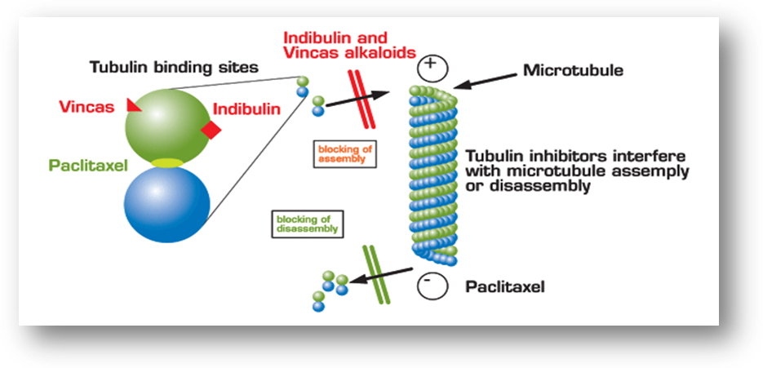

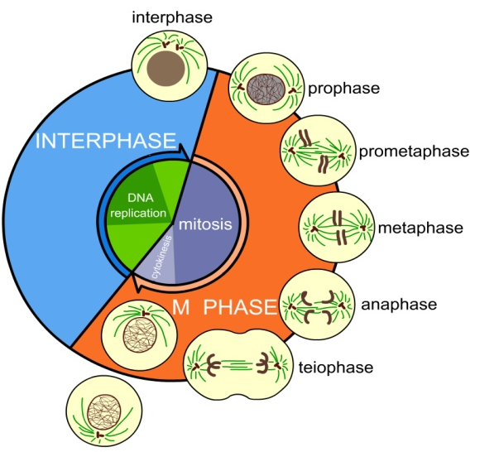
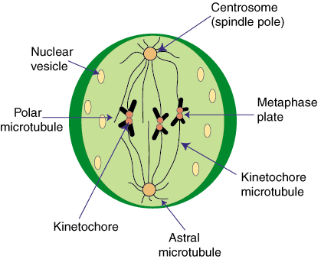
Pharmacokinatics of Vinblastin & Vincristine:
- IV concentrated & metabolized in liver by CytP450.
- Excreted in bile / feces.
Toxicity :
- Phlebitis or cellualitis. (Wrong in technique)
- Vinblastin more potent as myleosupressant.
- Vincristine neurotoxicity (mainly peripheral neuropathy……….., constipation.
Clinical uses of Vinblastin & Vincristine:
- Several pediatric tumors.
- Hematological malignancies such as Hodgkin & non Hodgkin lymphoma & multiple myeloma.
2-etoposide: (VP-16)
Semisynthetic derivative of plant alkaloids.
Mechanism of action of VP-16:
- Block cell division in the late S-G2 phase of cell cycle.
- Inhibits topoisomerase 2 causing DNA damage
Pharmacokinatics of VP-16:
- Given IVI, 90-95% bound to plasma protein.
Uses of VP-16:
- In combination with bleomycin & cisplastin for testicular carcinoma.
- Small cell & non small lung cancer.
- Hodgkin &NHL
- gastric cancer
- Breast cancer
3-taxane family:
Eg. Paclitaxal alkaloid ester
Mechanism of action of Paclitaxal:
- Mitotic spindle poison.
- Bind to microtubules stabilizing them in polymerized state causing inhibition of mitosis & cell division.
- It resembles the plant alkaloids BUT it differs in that it allows polymeraization then stabilizes it.]
Uses of Paclitaxal:
- Advanced ovarian & metastatic breast cancer
- Non small cell &small cell lung cancer.
Pharmacokinatics of Paclitaxal:
- Given IV
- metabolized by hepatic CytP450
- Excreted in feces.
Adverse effects of Paclitaxal:
- The common triad
- BM depression ( neutropenia)
- Hypersensitivity reactions, 5% of patients characteristic]
- Neurotoxicity
- Edema in the legs
4-anti tumor anti biotics
1-anthracycline eg. Doxorubicin
Has a broad spectrum of clinical activity against hematological as well as solid tumor. [breast, lung, esophagus]
Mechanism of action of Doxorubicin:
- inhibition of topoisomerase 2
- high affinity binding to DNA causing blockade of the synthesis of DNA
- generation of free radicals (causing cardiotoxicity)
- Binding to celluar membrane to alter permeability & ion transport.

Pharmacokinatics of Doxorubicin:
- Given IVI (inactivated by GIT)
- Metabolized in liver giving an active & inactive metabolite.
- Do not penetrate BBB or testis.
- Up to 50% is eliminated in the feces via biliary excretion.
- Causes red color to the urine. [As rifampicin]
Adverse effects of Doxorubicin:
- Dose related cardiac damage leading to arrhythmias & heart failure.
- Skin pigmentation
2- dactinomycin:
- Inhibits DNA dependent RNA polymerase.
- Mainly used to treat
  - Pediatric tumors eg. Willm’s tumor, soft tissue sarcoma & Ewing’s sarcoma.
3-bleomyicn:
Liberates oxygen free radicals resulting in breaking of DNA strands & chromosomal aberrations.
Pharmacokinatics of bleomyicn:
- SC, IM,IV
- Most of the drug is excreted unchanged in urine.
Uses of bleomyicn:
- Hodgkin & NHL.
- Testicular tumors
- Carcinoma
Toxicity of bleomyicn:
- The common triad.
- Pulmonary toxicity (pnumonaitis,cough,dysnea,fibrosis) [we use Mensa]
- Skin toxicity (hypertrophic skin changes& hyper pigmentation of the hands)

5-HORMONAL AGENTS:
Steroid hormones & their antagonist
- Hormone sensitive tumor
May be
1- hormone responsive
2-hormone dependent [eg.breast ca depend on estrogen for growth, so
we prevent the hormone]
3-both in which treatment is only palliative [surgical جزئية من العلاج و الباقي]
1-prednisone:
- Potent, synthetic, anti inflammatory corticosteroid.
- Given orally
- Activated in liver by 11-β hydroxysteroid dehydrogenase to prednisolone.
- Excretion is through urine
Mechanism of action:
Steroid hormones form an intracellular steroid receptor complex that binds directly to chromatin, activating the transcription of specific genes causing production of specific proteins that effect the cellular growth & proliferation of tumor cells.
Therapeutic uses:
Lymphoma & other hematological tumors.
Adverse effects:
- Infections
- Ulcers [PU-GIT???]
- Pancreatitis
- Hyperglycemia
- Osteoporosis
- Change in mood [plus cataract]

- Estrogen stimulates the growth of breast & endometrial cancer.
- In prostate cancer, androgen stimulates growth but estrogen suppress.

Estrogen & androgen inhibitors
Tamoxifen: anti-estrogen
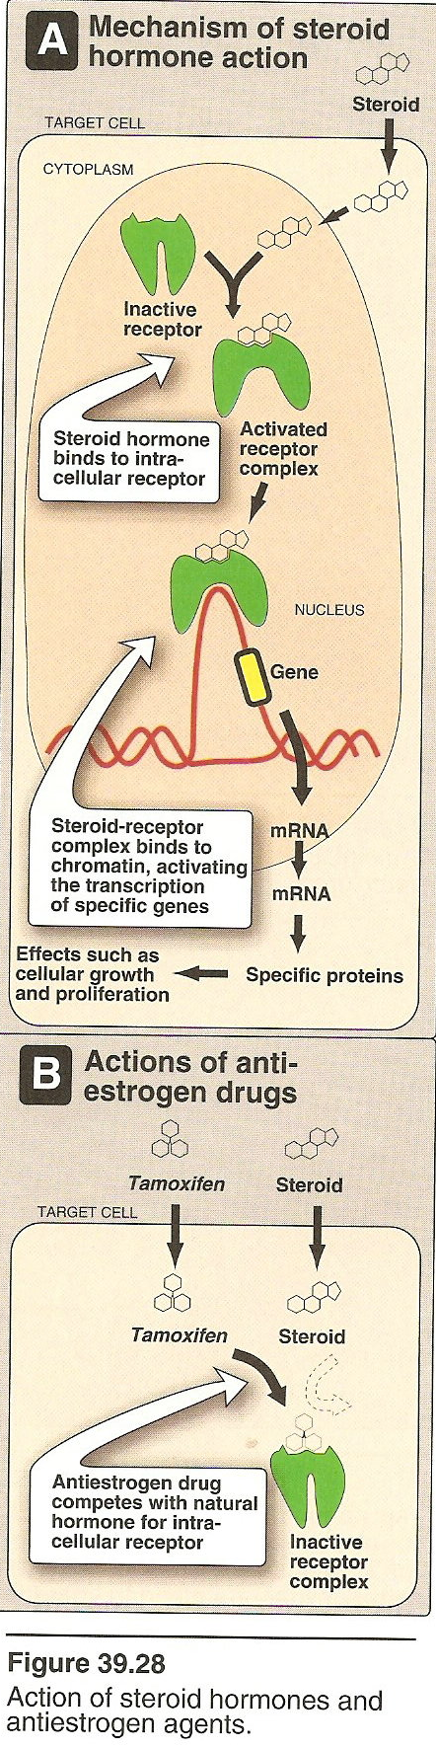
- Used for the treatment of both early stage & metastatic breast cancer.
- Also, as chemopreventive agent in women at high risk for breast cancer.
- Binds to estrogen receptors of estrogen sensitive tumors. [Occupy the receptor, no place for the hormone to bind]

- Given orally
- Half live is long 7-14 days
- Metabolized in liver giving active metabolite
- Well tolerated
- Excreted through bile
Side effects:
- Menopausal symptoms
- Fluid retention, edema.
- Increase incidence of endometrial hyperplasia &cancer. Follow up is Very important
Flutamide:( anti-androgens)
- Binds to androgen receptor that inhibits androgen effects.
- In combination with radiation for treatment of early stage prostate cancer& metastatic prostate cancer.
- Given orally.
- Given IM once every 3 months → transient release of FSH, LH, followed by inhibition of the release of testosterone.
Leuprolide:
- Is indicated in treatment of an advanced prostate cancer usually in combination with flutamide.
Side effects of anti androgens:
- Hot flushes, impotence, gynecomastia, GI upset.
- Flutamide can cause liver failure.**

6-miscellanous anti cancer:
Asparaginase:
- An enzyme isolated from various bacteria.
Mechanism of action:
- Hydrolyzes L-aspargine to aspartic acid & ammonia.
- Effective inhibitor of protein synthesis.
- Tumor cells lack aspargine synthetase, so they require an exogenous source of L-aspargine.
- In contrast, normal cells can synthesize L-aspargine, so they are less susceptible to cytotoxic action of asparaginase.
Therapeutic uses:
Childhood acute lymphocytic leukemia.
Side effects:
- Hypersensitivity reactions.
- Alternation in clotting factor [increase or decrease]→risk for bleeding or clotting.
- Pancreatitis.
- Neurologic toxicity.
- Coma(ammonia)
Treatment regimen:
- Combination drug chemotherapy is more successful than single drug treatment in most types of cancers.
- [We use single drug in certain types & in early stages]

Advantages of drug combination:
1- Providing maximal cell killing within the range of tolerated toxicity.
2-are effective against broader range of cell lines of tumor population.
3-may delay or prevent development of resistant cell lines.
Problems associated with chemotherapy:
- Resistance or multi-drug resistance.
- Toxicity. [BM depression, alopecia, GI upset]
- treatment induced tumor [tamoxifen, cyclophosohamide]
Treatment protocols:
  - POMP is
Pednisone, oncovin (vincristine), methotrexate, purinethol (mercaptopurine) for acute lymphocytic leukemia.

