Antiprotozoal drugs
Treatment of Malaria
بسم الله الرحمن الرحيم January 7, 2009
This is the 11th lec, it will be very helpful for u all Enshallah
Good luck, & be sure that the full mark is waiting for u☺
DONE BY:
PHARMA-426-TEAM
عروبة المفلح
إيمان حجر
منيرة المهيدب
دانة البسام
الهنوف القباني
Dr.Je'We'Ls
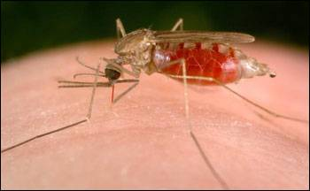

infective female Anopheles mosquito

Species of plasmodium that cause human malaria:
1- Plasmodium falciparum (Severe, 80% of infections; 90% of deaths)
2- P vivax
3- P malariae
4- P ovale. (in Africa)

Chronic malaria:
is seen in P. vivax & ovale, but not in P. falciparum. Here, the disease can relapse months or years after exposure, due to the presence of latent parasites in the liver.
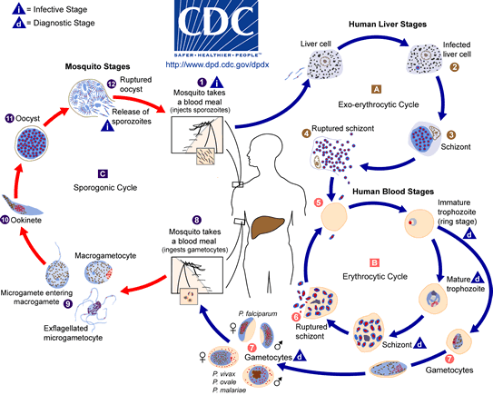
Clinical Features of malaria:
- 10 -15 d after mosquito bite:
- Vomiting , headache, shortness of breath, tachychardia ,
- Also, general symptoms: fever, shivering, arthralgia, Nausea, flu-like illness, anemia ,hemolysis, Hguria(heamoglobinuria), retinal damage, & convulsions.

Complications of malaria:
- Splenomegaly, severe headache, cerebral ischemia, Pulmonary Embolism, hepatomegaly, hypoglycemia, & Renal Failure.
In severe cases: coma & death.

Drugs classification:
- Tissue schizonticides:
Drugs that eliminate developing& dormant liver forms (exo-erythrocytic cycle)
- Primaquine
- Blood schizonticides:
act on erythrocytic parasites, terminate clinical attack
  - Chloroquine.
  - Quinine.
  - Mefloquine.
  - Proguanil & pyrimethamine.
  - Artemisinins.
- Gametocides:
kill sexual stages in blood & prevent transmission to mosquitoes
  - Primaquine in→ P.Falciparum,
  - Chloroquine in→ P.vivax, malarae, ovale
- Hypnozotocides:
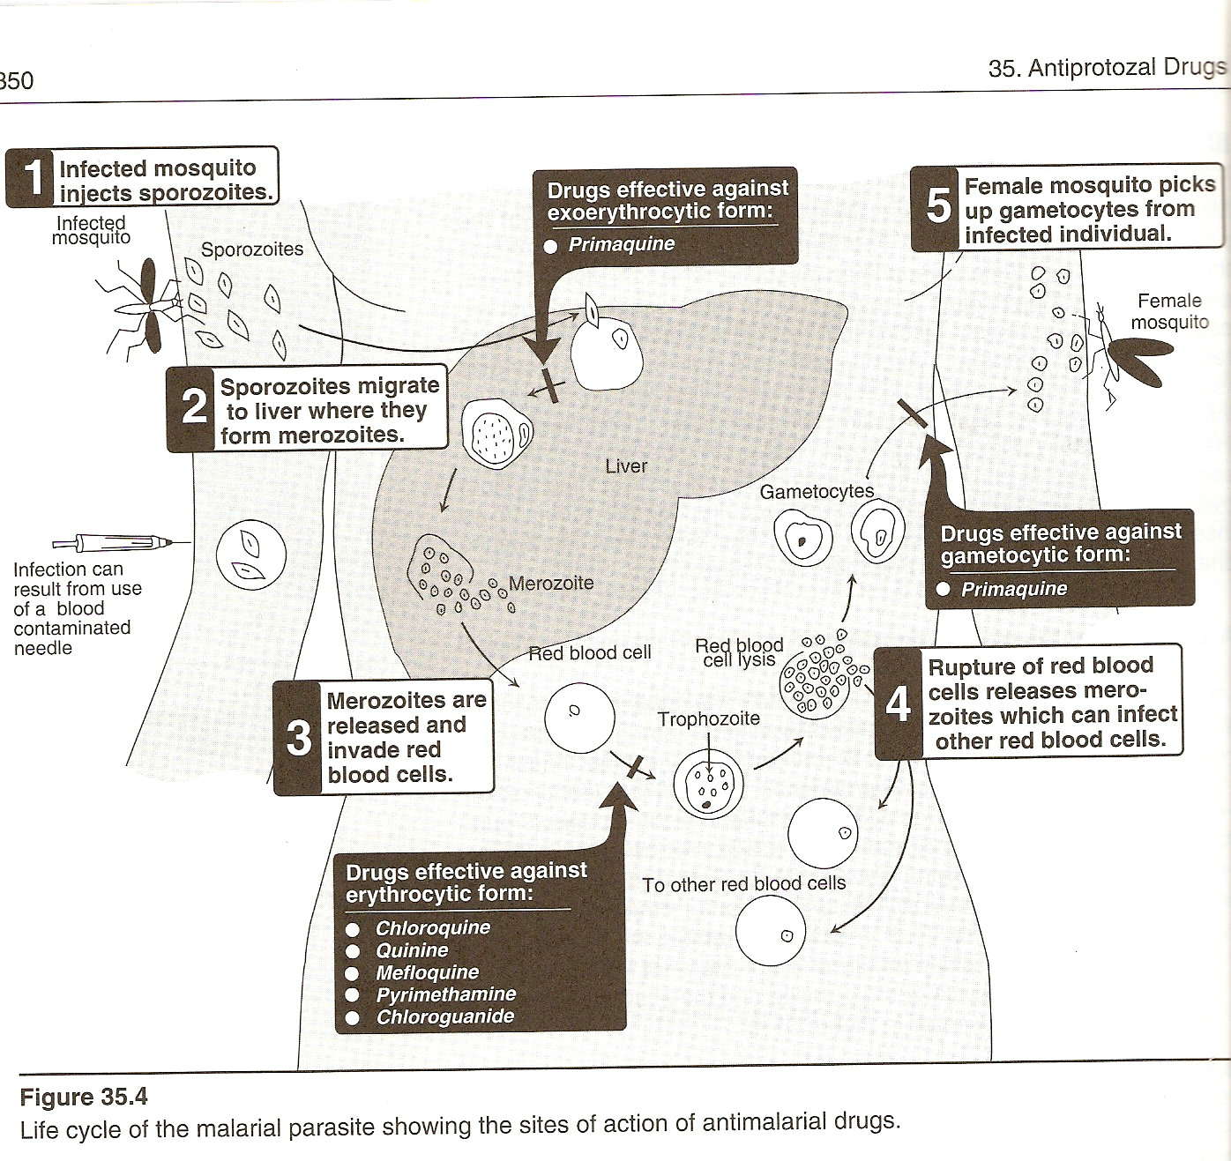
kill the dormant hypnozites of P. vivax & ovale (anti-relapse).

Chloroquine

Pharmacokinetics:
- Synthetic 4-aminoquinoline
- 2 forms:
  - Chloroquine phosphate (oral),
  - Chloroquine hydrochloride (parentral)
- Rapid & complete absorption from GIT
- Reaches maximum plasma concentration in 3 hr
- Excreted in urine
- Initial T_{1/2}: 3-5 d
- Released slowly from tissues, 55% protein bound;
- Terminal t_{1/2}: 1-2 months.
- Penetrate CNS & placenta.
Clinical uses:
- The drug of choice in the Treatment & prophylaxis of non-falciparum (P.vivax, ovale, malarae) & sensitive falciparum malaria.
- Potent blood schizonticide
- Rapidly terminates fever (in 24-48 hr).
- Safe & low cost
- Does Not eliminates dormant liver forms of P vivax & ovale.
- Effective against gametocytes of P vivax, ovale, & malariae but Not P falcparum.
  - Not active against liver stage parasites.
- For amebic liver abscesses
- Safe in pregnancy & young children.
Mechanism Of Action:
- Choroquine enter red blood cells & act by inhibiting polymerization of Hb breakdown products (heme) into hemozoine, thus build up of the heme that damage membrane & lead to lysis of both parasite & RBCs.
- Binding to heme & alkalinization of acidic food vacuole.
Resistance:
- Its usefulness now is reduced due to rapid resistance to P falciparum. Due to multiple mutations in P.fal.CRT, a transporter protein in the parasite's digestive vacuole membrane.

Side Effect:
- Pruritus is common
- Neusea, Vomiting, abdominal pain, headache, Anorexia, malaise, blurring vision r uncommon. (take it after meal to avoid these)
- Long term: ototoxic, retinopathy, & peripheral neuropathy.
- Large, rapid, IM/IV doses: severe hypotension, arrhythmia & respiratory + cardiac arrest. (To avoid these Slowly infused).
ContraIndication & precautions:
- In patient with psoriasis or porphyria (precipitate acute attacks)
- Not to be used in Retinal, visual abnormalities or myopathy
- In caution in patient with Hx of kidney or liver Disease or neurologic or hematologic disorders (as G6PD deficiency).
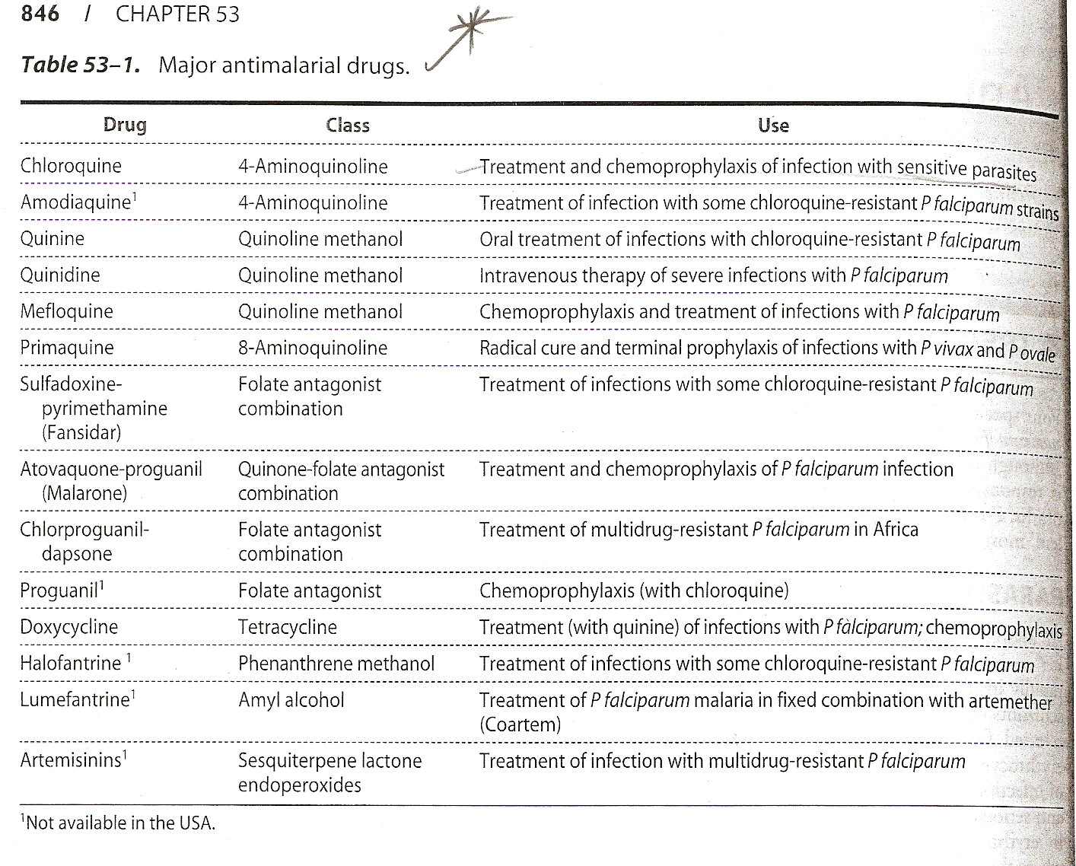
- Antidiarrheal agents (e.g Kaolin) & antacids interfere with its absorption.

Amodiaquine

- Share Mechanism Of Action & resistance with chloroquine
- Low cost, limited toxic
- Against chloroquine-resistance strains of P fal.
Side Effect & toxic:
Granulocytosis, aplastic anemia & hepatotox. (The only antimalira drug cause haematotoxicity)
Quinine & quinidine

1st line therapy for falciparum malaria, especially in severe Disease.

Chemistry & PK:
- Alkaloides, derived from the bark of the cinchona tree
- Quinidine: d-isomer of quinine
- Quinine:
    - rapid oral absorbtion (sulphate) or parenteral (hydrochloride)
    - reaches peak plasma levels in 1-3 hr.
    - Quinine T_{1/2} increase from 11 (healthy) to 18 hr in malaria patient
- Quinidine:
    - Less protein bound
    - has shorter t_{1/2} than quinine
    - Given parenterally only.
- Metabolism in liver & excreted in urine.

Antimalarial action & resis:
- Rapidly acting
- Inhibit parasite’s heme polymerase; allowing accumulation of its cytotoxic substrate, heme.
- Blood schizonticide against the 4 species
- Gametocidal against P vivax & ovale but NOT falciparum.
- Due to resistance, the drug should be used with pyrimethamine & sulfonamide.
- Antiarryhthmic agent.

Clinical uses:
A- Parenteral Treatment of severe falciparum malaria
- Quinine / quinidine is the Treatment of choice for severe fal malaria. (except if there is no resistance to chloroquine)
- Slowly IV/ dilute solution, & IM.
- Monitor heart activity (cardiotoxicity).

B- orall Treatment of fal malaria
- Quinine sulfate: in uncomplicated fal malaria.
- Used with doxycycline or in children with clindamycin to shorten duration (3 d) & limit toxicity.
- Due to toxicity, not used in chemoprophylaxis.
SideEffect:
- Bitter taste→ poor compliance
- Cinchonism: Tinnitus, headache, Neusea, dizziness, flushing, & visual disturbances.
- Prolonged use: marked visual & auditory abnormalities, Vomiting, Diarrhea, & abdominal pain.
- Hypersensitivity reactions
- Hemolysis in G6PD deficiency, leukopenia, agranulocytosis, & thrombocytopenia.
- Hypoglycemia
- IV: ECG changes & thrombophlebitis
- Rapid IV: severe hypotension
- Oxytocic (mild) & fetotoxic. (although Quinine has proved to be safe when used in normal therapeutic doses, and since the risks of malaria are great, there is no debate about using a less effective therapy.)
- Rare & severe: blackwater fever: massive intravascular hemolytic anemia, Renal Failure, dark urine & Hguria.

Resistance:
Increased expression of P-glycopt which pumps the drug out of the parasite.

ContraIndication & cautions:
- Discontinue if: cinchonism, hemolysis, or hypersensitivity.
- Patients with G6PD deficiency, visual or auditory problems.
- Cardiac abnormalities.
- Not given with mefloquine (ECG abnormalities & cardiac arrest).
- Reduce the dose in renal Disease.

Drug Interaction:
- Has curare- like action & potentiate neuromuscular blocking agents
- Absorption is blocked by antacids
- Raise plasma level of warfarin & digoxin
Mefloquine
For many chloroquine-resistance strain of P fal & other species.

Chemistry & Pharmacokinetics:
- Mefloquine HCl: synthetic 4-quinoline methanol, chemically related to quinine.
- Only orally (severe parenteral local irritation)
- Well absorbed, plasma conc. peaks in 18 hr.
- High protein bound, metabolized in liver
- Slow elimination in feces (20 d); single dose.
- Weekly dose for prophylaxis.
Clinical Uses:
- Antimalarial action: Strong blood schizonticidal activity against P fal & vivax
- Not against hepatic stages or gametocytes.
- Prophylaxis 4 all species

Mechanism Of Action:
- Inhibit heme polymerase
- Resistance has occurred in Southeast Asia.
- Not for severe cases; Quinine & quinidine are more rapidly active & have less resistance.

Side Effects:
- GIT, dizziness, sleep & behavioral disturbances, & rash.
- Seizure & psychosis
- Leukocytosis, thrombocytopenia, & increase AminoTransferase.
- Alter cardiac conduction & arrhythmias.

ContraIndication & caution:
- Epilepsy, psychiatric disorder, arrhythmias & sensitivity.
- Not co administered with quinine, quinidine or halofantrine.

Primaquine

- Primaquine phosphate: synthetic 8-aminoquinoline.
- Absorbed orally, reaches peak plasma conc. in 1-2 hr.
- NOT parenteral: hypotension.
- T_{1/2}: 3-8 hr.
- Rapidly metabolized to active metabolites & excreted in urine.

Clinical uses:
- Antimalarial:
    - Against hepatic stages of all malarial parasites.
    - Against the dormant hypnozoite of P vivax & ovale (the drug of choice).
- Gametocidal against the 4 species, preventing transmission of the Disease.
- Radical cure of acute Vivax & Ovale malaria
- Chloroquine is given to eradicate erythrocytic forms then primaquine (30 mg daily, for 14 d) to eradicate liver hypnozoites & prevent subsequent relapse.
- With Clindamycin in pneumocystic pneumonia
- rare resistant

Side Efeect:
- Nausea, epigastric pain, abdominal cramps, & headache (especially in High dose or empty stomach).
- Hemolysis, metHgemia (with cyanosis), esp. in G6PD deficiency. (metabolites have greater hemolysis activity)
- Rare\ serious: leukopenia, agranulocytosis, leukocytosis, & cardiac arrhythmias.
ContraIndication & caution:
- Avoided in patients with granulocytopenia/ metHgemia, or those receiving myelosuppressive drugs (quindine) / disorders of myelosuppression.
- In patients with G6PD deficiency.
- Discontinue if hemolysis or anemia.
- Not used in pregnancy (fetus hemolysis).

Atovaqone: Hydroxynaphthoquinone.

- Decrease parasite’s electron transport by mimicking the natural substance ubiquinone.
- Only orally.
- Heavily protein bound, t_{1/2}: 2-3 d.
- Synergistic, (Malarone: atovaqone + proguanil) is effective in Treatment & chemoprophylaxis of falciparum malaria.

Advantage over mefloquine & doxycycline:
- It requires shorter periods of Treatment at risk of malaria transmission but it is more expensive.
- Atovaquone is an alternative therapy for P jiroveci pneumonia. but its efficacy is lower than trimethoprim-sulfamethoxazole.

Side Effect:
- Fever, rash, Nausea, Vomitting, diarrhea, insomnia & headache.
  - Malorone SideEffect (with High dose): abdominal pain, Nausea, Vomitting, diarrhea, headache & rash.
- Reversible elevation of liver enzymes
- Plasma conc. of atovaquone is decreased by 50% if administered with tetracycline or rifampin.

Antifolates

Used in combination, Treatment & prevention of malaria.
Chemistry & PharmacoKinetics:
- Pyrimethamine, 2,4 di-amino-pyrimidine.
- Proguanil, biguanide derivative. Prodrug (cyclo-guanil), excreted in urine.
- Both slowly\ adequately absorbtion from GIT.
- Pyrimethamine bound to plasma protein & has elimination t_{1/2}: 3.5 d (once a wk for prophylaxis).
- Proguanil has elimination t_{1/2}: 16 hr (daily for prophylaxis).

Antimalarial action & resistance:
- Sulfonamide & sulfone are active against the erythrocytic forms of P fal.
- Pyrimethamine: blood schizonticide
- Proguanil is active against hepatic forms.
- Effective in combination with other agents.

Mechanism Of Action:
- Selectively inhibit plasmodial dihydrofolate reductase.
- Resistant P fal. Due to mutation of dihydrofolate reductase.

Clinical uses:
A- Chemoprophylaxis:
- Chloroquine + proguanil: alternative to mefloquine.
- Lower efficacy but less toxic.

B- Treatment of chloroquine-resis. fal malaria:
- Fansidar (sulfadoxine + pyrimthamine), used for Treatment of uncomplicated fal malaria (low resis & tox), single oral dose + low cost.
- Chlorproguanil + dapsone in resistant to fansidar.
- Also Melaprim: pyrimthamine + dapsone Adjunct to quinine therapy (shorten the course & less toxic).

C- Presumptive Treatment of falciparum malaria:
- Fansidar is also used as presumptive therapy for travelers who develop fever in malaria endemic regions.

Side Effect:
GIT, skin rash & itching
- Proguanil: mouth ulcers & alopecia.
- Fansidar: severe cutaneous skin reactions.
- Melaprim: hemolytic anemia & agranulocytosis
- High dose of pyrimethamine: megaloblastic anemia.
Folate antagonists should be used in caution in renal/ hepatic dysfunction.

Antibiotics

- Tetracycline & doxycycline: active against erythrocytic schizonts.
- Doxycycline: for Treatment of fal malaria + quinidine/ quinine.
- Doxycycline is a standard chemoprophylactic drug in areas with High rates of resistance to other antimalarials, including mefloquine.
- Clindamycin is slowly active against erythrocytic schizont + quinine in children & pregnant women.

Artemisinin

- Derived from the herb quinghaosu (Artemisia)
- Artemisinin is insoluble, used orally.
- Metabolized in liver to active metabolite(dihydro-artemisinin).
- T_{1/2}: 1-3 hr
- NOT prophylaxis
- Rapidly acting blood schizonticides against all malarial parasites.

Mechanism of Action:
- Production of FR, damage parasite membrane.
- Used in the Treatment of multidrug-resis P fal malaria.
- Effective in Treat acute attack, including chloroquine- resis & cerebral malaria.

Derivatives of Artemisinin:
- Arte-sunate: water soluble (oral, IV, IM, rectal)
- Arte-mether: lipid soluble (tablet & IM).
- Have higher activity & better tolerated.
Side Effect:
- GIT
- Transient hrt block
- Decrease neutrophil count
- Neurotoxic & teratogenic in animals.

Resistance:
- The increased malarial morbidity & mortality is mainly due to increase resis of P falciparum to chloroquine, sulfodoxin-pyrimethamin & amodiaquine.
- Artemisinin produces a very rapid therapeutic response, against multidrug resis P fal, well tolerated, decrease gametocyte carriage, No resis is detected.
- Artemisinin cure fal malaria in 7 days, if combined with another drug in 3 d.

Halofantrine
- Blood schizonticide
- Against chloroquine-resis strains of P fal
- Its orally absorbtion increased with food.
- T_{1/2}= 4 d.
- Cross resistant with mefloquine.
Side Effect:
- Abdominal pain, headache, elevate liver enzymes, cough, pruritus, & prolong QT & PR intervals.
- ContraIndicated in pregnancy, with mefloquine, & patient with cardiac conduction defect.

WHO recommends the following therapeutic options:
For uncomplicated malaria in regions with resistant to older drugs.
1- Artemther + lumefantrine
2- Artesunate + amodiaquine
3- Artesunate + mefloquine
4- Artesunate + sulfadoxine + pyrimethamine.

Gooooood Luck to All☺☺☺☺

