- Viruses are obligate intracellular parasites so symptoms take time to appear.
Introduction

- Consist of a core genome in a protein shell and some are surrounded by a lipoprotein
- lack a cell wall and cell membrane
- do not carry out metabolic processes
- Replication depends on the host cell machinery

Steps for Viral Replication (the targets of Antiviral drugs) :

1) adsorption and penetration into cell

2) uncoating of viral nucleic acid

3) synthesis of regulatory proteins (e.g: nucleic acid polymerases)

4) synthesis of RNA or DNA

5) synthesis of structural proteins

6) assembly of viral particles

7) release from host cell

* The most antiviral agents interfere with nucleic acid synthesis (80%) or late synthesis of viral proteins

Best Classification Based on Type of Viral Infections :

1- Agents to Treat Herpes Simplex virus (HSV) and Varicella Zoster Virus (VZV) infections

2- Agents To Treat Cytomegalovirus infection (CMV)

3- Drugs Used for Rx of AIDS (Antiretroviral Agents)

4- Antihepatitis Agents

5- Antiviral Used for Respiratory Tract Infections

Anti Herpes & varicella zoster Drugs

1- Acyclovir (prototype)

2- Valcyclovir

3- Famiciclovi

4- Trifluridine (Topical)

Mechanism of action

These agents are guanosine analogs without sugar moiety which needs Three phosphorylation Steps for their activation (one of the steps depends on viral thymidine kinase, forming triphosphate form "irreversible complex" ). This, will incorporate into viral DNA-causing premature DNA-chain termination.

Simply competing with dGTP for viral DNA polymerase then inhibit viral replication (not human )

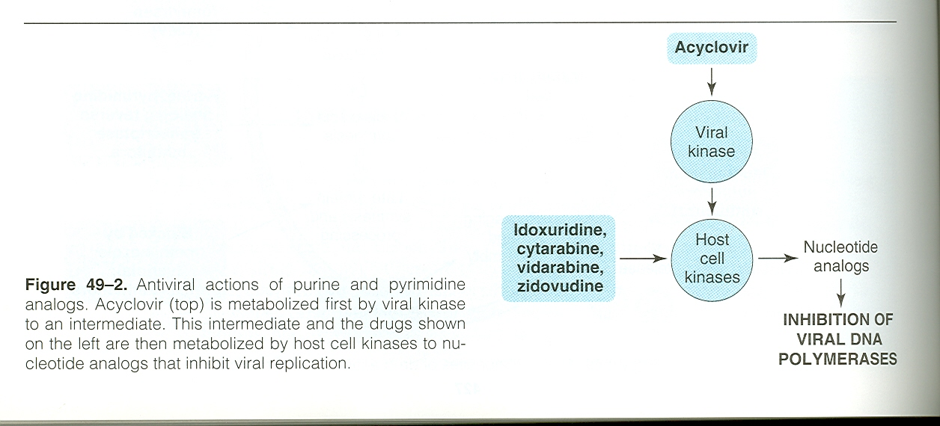

Mechanism of Resistance of Acyclovir

By Alteration or deficient in viral thymidine kinase OR,

By Alteration or deficient in viral DNA polymerase

There is Cross-resistance with valacyclovir, famciclovir, and ganciclovir but not cidofovir so we used cidovir if there is resistance to acyclovir in herpes infections

Anti Herpes & varicella zoster Drugs

Pharmacokinetics of Acyclovir

Acyclovir is available as oral (15-20% absorption ), topical and i.v.

Intravenous form used in herpes encephalitis and in severe infections

Short T1l2 (thus given 4 times daily) and eliminated mainly by kidiney (t1l2 prolonged in renal impairment).

Distribute in ALL parts of the body, including CNS

It has an antimetabolite activity

Valacyclovir (prodrug ) is an ester of acyclovir with more oral absorption five times (50%) and longer duration.

Clinical Uses of acyclovir
- HSV infections (type 1 and 2 )
- HZV infections
- Not used in CMV infections because this virus lacks Thymidine kinase
- Not used topically ( Trifluridine and vidarabine are preferred in herpetic keratitis )

Side Effects of Acyclovir

1 . Transient Renal dysfunction at high dose or at i.v treatment causing (Crystalline nephropathy)

2. GIT disturbances

Ganciclovir:
Anti CMV Drugs

, there is cross resistance between them because they both act in DNA polymerase. Analog of acyclovir

Mechanism of action

Similar to Acylovir but first stem phosphorylation by another viral specific protein kinase in the CMV-infected cells act in DNA polymerase.

Pharmacokinetics of Ganciclovir

Similar to Acyclovir

Valgancivlovir is prodrug which converts to ganciclovir by hepatic and intestinal esterases so has higher bioavailability than Ganciclovir

Clinical uses of Ganciclovir

i.v:

- to delay the progression of CMV retinitis in patients with AIDS

- for CMV colitis, esophagitis and pneumonitis.

Oral:

- prevention of end organ CMV disease in AIDS patients.

- as maintenance therapy for CMV retinitis.

Intraocularly:

- CMV retinitis.

Adverse effects of Ganciclovir

Myelosuppression with iv (neutropenia 20-30%) and increases if given with other immunosuppressants .

Nausea, diarrhea, fever, rash, insomnia and peripheral neuropathy

Vitreous hemorrhage and retinal detachment with intraocular implant

carcinogenic and teratogenic in animals only .

Cidofovir
Anti viral Drugs

Analog of cytosine

Differs from acyclovir , Its active metabolite prolong its t_{1/2} 26 hr.

Mechanism of Action

: phosohorylation does not depend on viral enzyme, & works as inhibitor & alternative substrate for viral DNA polymerase.

Clinical uses

vs CMV; HSV; VZV for CMV retinitis (IV), colitis, esophagitis & adenoVi infections. + & for Acyclovir-resistance.

Pharmacokinetics

eliminated mainly in kidney. Has poor CNS penetration different from acyclovir

IV cidofovir must be given with probenecid, to prolonged its action, block active tubular secretion and decrease nephrotoxicity

Adverse effects
- dose-dependent nephrotoxicity (prehydration)
- Avoid Nephrotoxicity drugs.
- Uveitis, neutropenia, & metab acidosis.
- GIT intolerance, fever & rash (probencid).

- AIDS are caused by HIV, and zidovudine was the first drug used (1987).
Anti AIDS Drugs

- Drug combination HAART ( highly active antiretroviral therapy ) as well as adherence to the regimen both are very essential.
- Combination of drug is important to decrease resistance ,i.e. HIV has a high rate of mutation .
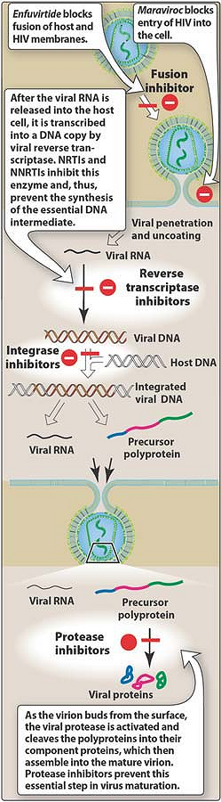figure show Drugs used to prevent HIV from replicating

Advantages of HAART:
- reduce Virus replication .
- decrease the resistance.

Classification of Anti AIDS (Based on life cycle):
1) Nucleotide Reverse Transcriptase Inhibitors (NRTIS) .
2) Non Nucleotide Reverse Transcriptase Inhibitors (NNRTIS) .
3) Protease Inhibitors .
4) Viral Fusion Inhibitor .

Objectives of HIV Treatment :
- Suppression of Virus replication (decrease viral load).
- Restoration of immunocompetency to host.
- Decrease opportunistic infections.
- prolonged survival.

- Nucleotide Reverse Transcriptase Inhibitors (NRTIS)
Anti AIDS Drugs

Chemistry:
~ These are analogs of native ribosides (nucleotide with side chain containing ribose) but lack the 3’-hydroxy group.
MOA:
~Similar to most antiviral drugs, require triphosphorylation but mainly by cellular (i.e. human) enzyme. ~The triphosphorylated analog incorporate into viral DNA by virus RT, preventing DNA chain elongation. ~They are competitive inhibitors .
~NRTIS can be classified into group A (Zidovudine and Stavudine) and B ( Didanosin; Zalcitabine; Limovidin and abacavir) .

Group A

Group B

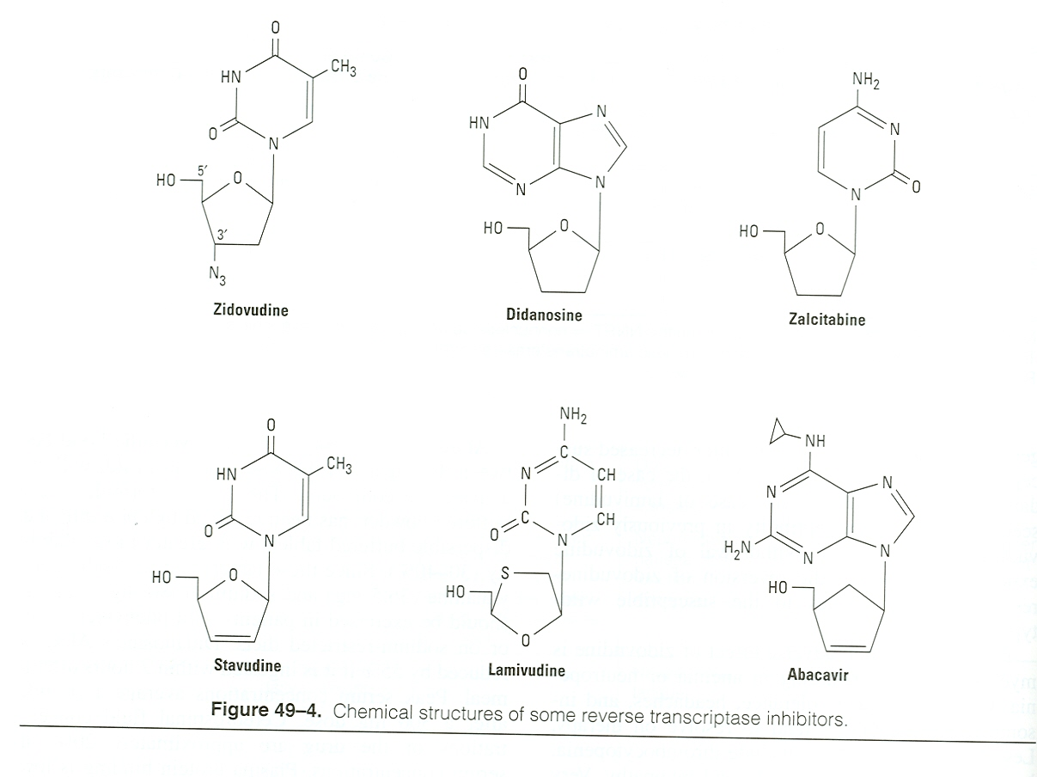

Anti AIDS Drugs

Zidovudine ( 3-azido-3-deoxythymidine; AZT)
A Pyrimidine Analog ( Thymidine ) .

MOA:
- Requires mammalian thymidine kinase for triphophorylation, AZT triphosphate selectively inhibit viral reverse transcriptase (RNA dependent DNA polymerase). Thus blocking the formation of new double stranded viral DNA.
- Resistance usually develop Due to high rate of mutation at several code.
Pheytion is liver enzyme-inducer but it compete with the same site for AZT metabolism therefore, it is ↑ T_{1/2} of AZT
PK:
- Excellent oral absorption but has short T_{1/2} .
- Penetrate well to CNS .
- Metabolized by liver to glucuronated AZT.
- Its T_{1/2} is affected ( increased ) by drugs that metabolized by glucoronidation. E.g. pheytion, valproic acid and fluconazide, lamivudine.
- It is eliminated by renal excretion. Therefore its toxicity may increase in liver and renal impairment .

Adverse effects:
- Pronounced bone marrow suppression as severe anemia & leucopenia , especially if it's given with ganciclovir
- Cardiomyopathy .
- Headache & seizure.
- Should not be combined with stavudine because Cross-resistance and antagonism may occur between them ( their action depends on the same enzyme i.e. mammalian thymidine kinase ) .
Uses :
- It is the most important drug in HAART . ( for 4 weeks )
- For reduce the vertical transmission from mother to neonate ( drug of choice in this situation )

Stavudine

- Like Zidovudine, it is thymidine analog, thus should not be combined with it.
- Is taken Orally , Excellent absorption & secreted unchanged into the urine .
- Stavudine has higher incidence of peripheral neuropathy (incease if given with Didanosine or zalcitabine). But, unlike AZT has no leucopenia.
- May cause Pancreatitis, arthralgia, and incerease serum aminotrasferase.
- Has higher incidence of Lactic acidosis lipoatrophy, hyperlipidemia, and mitochondrial toxicities than other NRTIs.
- Why Stavudine should not be given with Didanosine? Because of its similar adverse effect profile .

Didanosine (dideoxyinosine ; ddl )
Anti AIDS Drugs

- adenosine analog .
- Differ from Zidovudine:
- Lacks two hydroxyl groups, used for AZT resistance.
- Lower bioavailability (35 vs 55) with active metabolite 20-40 hr.
- Its elimination is dependent on kidney.
- It is chelating agent (interaction with tetracyclins and fluroquinoline) and their absorption significantly decreased (( administer 2 hours before or 2 hours after ddl )) .

- Adverse affects include :
- Pancreatitis (check serum amylase) , peripheral neuropathy (Dose related), Hyperuricemia , and
hepatitis, but no leucopenia.

Lamivudine:
- -This cytosine analog is the most interesting anti viral drug, because it can be used for HIV and HBV infections but it is 10-20 times more effective in HBV infections therefore we use less doses .

Advantages:

- Synergism when given with AZT (Combivir 300 mg AZT + 150 Lam) or Stavudine. but it should not be used with other cytosine analogs due to antagonism.
- No significant side effects because it does not affect mitochondrial DNA synthesis or bone marrow precursor cells .
- it has high oral bioavailability.

Disadvantages:
- has high rate of mutation if given alone ; should not used alone .

Emtricitabine:
- This is fluoro-derivative of Lamuvidine, can replaced the former in HBV and HIV patients.
- high oral bioavailability .
- may cause hyperpigmentation on the palms of the hand soles of the feet .

Zalcitabine (dideoxycytidine; ddc)
Anti AIDS Drugs

- It is cytosine analog like lamivudine , has High oralbioavailability 80%
- This drug used as replacement for Lamivudine in HIV, but differ in the following:
1) it is chelating agent ; Oral bioavailability is dependent on food (plasma levels ↓ when it is administered with food and antiacid ).
2) Similar to didanosine, , it produces dose dependent neuropathy due to inhibition of mammalian mitochondrial DNA polymerases ,and it also cause Pancreatitis but less than didanosine.
- it should not be combined with didanosine; overlapping toxicity .

Abacavir
- guanosine analog, well absorbed orally & unaffected by food. T_{1/2}: 12-26 hr.
side effect :
- Skin rash & hypersensitivity reaction (fatal) → make it unused these days .
- Fever, malaise, Nausea , vomiting , dizziness & anorexia .
- Respiratory : dyspnea, pharyngitis & cough.

- Non Nucleotide Reverse Transcriptase Inhibitors (NNRTIS)
Anti AIDS Drugs

MOA:
- Bind selectively and non-competitive way to HIV reverse transcriptase at a side adjacent to that of NRTIs, and from their names they are neither nucleotide triphosphate nor require phosphorylation to be active.

Resistance:
- Rapid resistance can be developed but it is not cross resistance to NRTIs or protease inhibitor.

Main features:
- These drugs are lipophilic in nature with high degree of protein binding so they have long T_{1/2} . Also, some of them either inhibit or enhance the liver metabolic enzymes. Hypersensitivity is common as serious rashes & Steves-Johnson syndrome. All depend on liver for metabolism .

Efavirenz
- Commonly used orally : long t_{1/2} ( 40-55 hours ) , High albumin binding .
- empty stomach or fat meals increase bioavailability & toxic .
- commonly used In ( HARRT ) because of its long half life and it doesn't cause steiven Johnson syndrome .
- efavirenz is Both liver enzyme inducer and inhibitor thus inducing its own metabolism & decrease metabolism of other drug ( e.g. indinavir, lopinavir, & saquinavir ) .

side effect : Occur ONLY in ! beginning
- CNS: dizziness, insomnia, confusion, agitation, delusions, depression, nightmares, & euphoria
- Skin rash
- Elevated liver enzsyme & cholesterol.
- it is teratogenic lead to Congenital anomalies , should be avoided in pregnant women .

Nevirapine
PK:
- Lipophilic drug with high oral bioavailability.
- Metabolized by liver , it is liver enzyme inducer, may ↓ the t1/2 of some drugs including anti AIDS.

Uses:
- In AIDS, it is only used together with other antiretrovirals.
- Single dose (200 mg) is effective in the prevention of transmission of HIV from mother to newborn.

Disadvantages:
- Life threatening skin rashes including Stevens-Johnson Syndrome , toxic necrolysis (Start with low dose).
- Fulminant hepatitis, Toxic epidermal necrolysis (Start with low dose).

Drug interaction :
Anti AIDS Drugs

- Liver Enzyme inducers (e.g. tipranavir, rifampin, rifabutin) decrease nevirapine level.
- Liver enzyme inhibitors (e.g. fluconazole, ketoconazole, & clarithromycin) increase its level.

Delaviridine:
- taken orally , high oral bioavailability .
- It is unlike nevirapine, it inhibits CYP3A ( liver enzyme inhibitor ).
- may cause rash but not to the degree of Stavens-Johnson Syndrome .
- doesn't produce Fulminant hepatitis .

- HIV Protease Inhibitors ( ended with the suffix –navir )
What is aspartyl protease?
The viral enzyme responsible for cleavage of the viral polyprotein into a number of essential enzymes (reverse transcriptase, protease, and integrase) and several structural proteins.
MOA:
- Reversible inhibitors of the HIV aspartyl protease

- The protease inhibitors exhibit at least a 1000 -fold greater affinity
for HIV enzymes than they have for comparable human proteases .

PK:
- In contrast to NNRTIs, most protease inhibitors have poor oral bioavailability , affected by meal.
- All are metabolized in the liver, and some of them like Ritonavir is CYP3A4 inhibitor.

Ritonavir
- It differ from other drugs in this class , since it has a High oral bioavailability (60-70%) and not affected by food (but it has bad taste).
- Inhibit CYP3A4, therefore, it is used as pharmacokinetic enhancer in subtheraputic doses .

Saquinavir

- Available as hard gel capsule or soft. However, this drug has very short t1/2 and low bioavailability (12%); therefore, it is combined with ritonavir .
- Doesn’t affect liver enzymes ( not inhibitor or inducer ).
- Side Effects: Headache and nausea.

Lopinavir/Ritonavir ( kaletra™)
Anti AIDS Drugs

- Here, Ritonavir is used to suppress CYP3A4 .

Advantages
- potent antiretroviral activity .
- co-formulated as Kaletra(R) .
- once daily dosing is an option for treatment-naive patients .
- no food restriction with oral tablet formulation .

Disadvantages
- GI intolerance (once daily associated with a higher incidence compared with twice daily) .
- hyperlipidemia .
- possibly lower drug exposure in pregnant women .

Indinavir

- Well absorbed orally with low protein binding and high penetration to the CNS.
- An Enzyme inhibitor.

Side Effects:
- Indirect hyperbilirubinemia and nephrolithiasis due to crystallization of the drug.

Atazanavir
- Orally , acidic medium for absorption, Penetrate CSF
- Ritonavir can increase its t_{1/2}.
- Avoid atazanavir in severe hepatic insufficiency.

Side effect :
- Nausea , Vomiting , Dizziness , abdominal pain, peripheral neuropathy, & skin rash.
- Hyperbilirubinemia & jaundice
- ECG changes: increase PR & QT intervals.
- Unlike other PIs, it doesn’t cause dyslipidemias, fat distribution, or metabolic syndrome
- Indinavir increase its toxic.

- 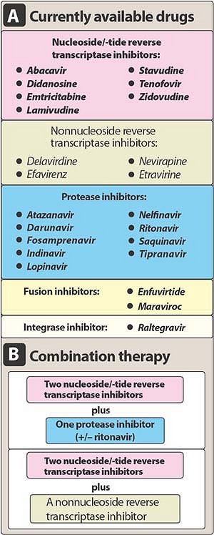Viral Fusion Inhibitor:
Anti AIDS Drugs

Enfuvirtide

MOA: Block entry into the cell.
Use: Reserved for resistance HIV-1 patients.

Regimens for treatment of AIDS patients :
HAART = ( 2 NRTIs + 1 NNRTI or 1 PI)
To decrease mutation to HIV medications?
1) Drugs combination
2) Adherence to medication.

First : NNRTIs-based Regimens (1 NNRTIs + 2 NRTIs)

- Preferred:
Efavirenz + (lamivudine or emtricitabine) + (AZT or tenofovir ) .

- Alternative:
Efavirenz + (lamivudine or emtricitabine) +
(abacavir or ddI or stavudine) (except in 1st trimester of pregnancy
or women with high pregnancy potential) .
Second : PI-based Regimens (1 PI + 2 NRTIs)

- Preferred:
Indinavir/ritonavir (Kaletra) + (lamivudine or emtricitabine) + (AZT or stavudine or abacavir or tenofovir or ddI) .

- Alternative:
Lopinavir/ritonavir + (lamivudine or emtricitabine) + (stavudine or abacavir or tenofovir or ddI) .

Drug | Zidovudine (AZT)
Mechanism of action | ~ selectively inhibit viral reverse transcriptase , A Pyrimidine Analog ( Thymidine ) .
pharmacokinetic | ~ Orally & Excellent absorption but has short T_{1/2} .  ~ Penetrate well to CNS .  ~ Metabolized by liver , eliminated by kidney (( toxicity may ↑ with liver or renal impairment ))
Clinical uses | ~ most important drug in HAART .  ~ drug of choice For reduce the vertical transmission from mother to neonate .
Side effects | ~ bone marrow suppression ( anemia and leucopenia ) .  ~ cardiomyopathy.
Drug | Stavudine ( d4T )
Mechanism of action | ~ selectively inhibit viral reverse transcriptase , A Thymidine Analog .
pharmacokinetic | ~ Orally & Excellent absorption .  ~ secreted unchanged into the urine .
Clinical uses | ~used as part of highly activeantiretroviral therapy (HAART) for the treatment of HIV .
Side effects | ~ peripheral neuropathy .  ~ Pancreatitis, arthralgia, and ↑ serum aminotrasferase.  ~ Lactic acidosis ,lipoatrophy and hyperlipidemia .
Anti AIDS Drugs

Atazanavir | Indinavir | Lopinavir/Ritonavir  ( kaletra™) | Saquinavir | Ritonavir | Drug
~ They are Reversible inhibitors of the HIV aspartyl protease (prevent the cleavage of the viral polyprotein ) .  ~ All are metabolized in the liver . |  |  |  |  | MOA
~ Orally , once-daily .  ~ can cross BBB . | ~ Well absorbed orally with low protein binding .  ~can cross BBB .  ~ An liver Enzyme inhibitor. | ~ One tablet daily ,not affect by food . | ~ Available as hard gel capsule or soft.  ~has very short  t1/2 .  ~ low bioavailability (12%); therefore, it is combined with ritonavir . | ~ High oral bioavailability (60-70%) , and not affected by food.  ~ Inhibit CYP3A4  (enhancer ). | PK
~ it is used only in combination with other HIV medications. |  |  |  |  | Clinical uses
~ Nausea , Vomiting , Dizziness , abdominal pain, peripheral neuropathy, & skin rash.  ~ Hyperbilirubinemia & jaundice .  ~ In ECG it increase PR & QT intervals . | ~Indirect hyperbilirubinemia and nephrolithiasis due to crystallization of the drug .  ~ Unlike other PIs, it doesn’t cause dyslipidemias . | ~ GI symptoms.  ~ Hyperlipidemia.  ~ possibly lower drug exposure in pregnant women. | ~ Headache and nausea. | ~ Taste abonormality .  ~ dyslipidemias . | Side effects

Drug | Efavirenz
Mechanism of action | ~ selectively and non-competitive inhibit viral reverse transcriptase .
pharmacokinetic | ~ Commonly used orally : long t_{1/2} ( 40-55 hours ) , High albumin binding
Clinical uses | ~ used as part of HAART for the treatment of HIV .
Side effects | ~ CNS: dizziness, insomnia, confusion, agitation, delusions, depression,  nightmares, & euphoria .  ~ Skin rash .  ~ Elevated liver enzsyme & cholesterol .  ~ it is teratogenic .

Drug | Efavirenz
Mechanism of action | ~ selectively and non-competitive inhibit viral reverse transcriptase .
pharmacokinetic | ~ Commonly used orally : long t_{1/2} ( 40-55 hours ) , High albumin binding
Clinical uses | ~ used as part of HAART for the treatment of HIV .
Side effects | ~ CNS: dizziness, insomnia, confusion, agitation, delusions, depression,  nightmares, & euphoria .  ~ Skin rash .  ~ Elevated liver enzsyme & cholesterol .  ~ it is teratogenic .
Drug | Lamivudine (3TC )
Mechanism of action | ~ selectively inhibit viral reverse transcriptase , A Cytosine Analog .
pharmacokinetic | ~ orally, with a bio-availability of over 80%.  ~ can cross the blood-brain barrier .
Clinical uses | ~ used for HIV and HBV ( 10-20 times more effective in HBV ).
Side effects | ~

Like in AIDS, they are suppressive rather than curative. Among many hepatitis viruses, HBV and HCV are the most common cause of chronic hepatitis, cirrhosis, and hepatocelluar carcinoma ( HCC ) .
Anti-hepatitis Drugs

Lamivudine
- This antiretroviral drug, shows prolonged intracellular t_{1/2} in HBV cell lines (17-19 Hr), than in HIV-infected cell line.

MOA:
- after diphosphorylation it competitively inhibits HBV DNA polymerase leading to chain termination .

Effectiveness:
- Achieves universal HBV DNA suppression, with ↓ in viral replication, and ↓ progression to liver fibrosis.
- Response is more rapid than interferon but the recurrence is high if the drug is discontinued .
- Always given with interferon.
- It has no significant adverse effect .
- Resisitance can occur after 8-9 months of therapy in 20 % of cases , manifested by seropostive test .

Aldefovir
- This nucleotide (NRTIs) analog is used in case of lamivudine (HBV) resistance at lower doses as compared to AIDs , to limit side effects.

Side effects:
- Eliminated by glomerular filtration .and tubular secretion, thus it is nephrotoxic.
- Lactic acidosis and hepatomegaly with steotosis may occur.

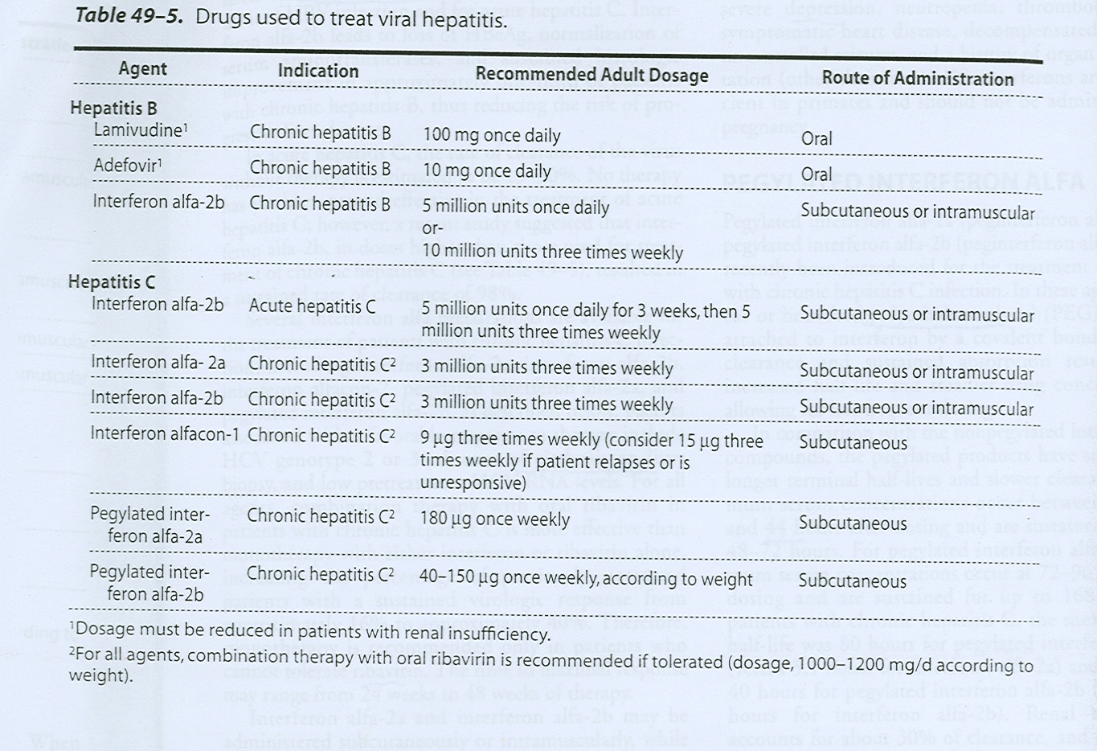

Interferon Alfa
Anti-hepatitis Drugs
- Endogenous glycoprotein produced in human leukocytes commercially available as :
- Interferon alfα-2b: Licensed for treatment of HBV and acute hepatitis C (higher doses than HBV).
- Interferon alfα-2a: can be used for HCV (Either alone or better with oral Ribaverin (quanosine analog).

Mechanism of Action:
- INFs exert antiviral , immunomodulatory, & antiproliferative activities.
- It bind to specific cell membrane receptors & induction of intracellular signals & host cell enzyme , inhibit of Virus RNA translation, & thus degradation of Virus mRNA & tRNA.

PK of interferons:
- Both types could be administered either S.C or I.M. with short t_{1/2} (4-7 hrs).
- Filtered unchanged in the glomeruli with protolytic degradation in the tubule.

differences between interferon and pegylated interferon Alfa:
1) Strucure:
Pegylated Interferon alfa-2a and 2b represent the corresponding interferons with branched polyethylene moiety is attached by covalent bind.

2)half life :
Pegelated has longer t_{1/2} as compared to normal interferon (80 Hours) and increase in renal impairement.

3) Efficacy ( the capacity to produce an effect ) :
is superior to non-pegelated interferon.

- Pegylated interfron are used mainly on HCV.

Other Uses of Interferon:
- Cancers such as hairy-cell leukemia and Kaposi sarcoma.
- Multiple Sclerosis
- genital warts.
- prevent dissemination of HZV in cancer patients .

Side Effects of interferons:
- Since they are endogenous types of proteins, they may produce Flu-like symptoms within 6 hr in more than 30%, with Nausea ,vomiting , anorexia , fatigue,rash and alopecia.
- Thrombocytopenia , granulocytopenia and elevation in aminotransferase level.
- Induction of autoantibodies.
- Neurotoxicity

Contraindications:
Anti-hepatitis Drugs
~ Psychosis
~ neutropenia and thrombocytopenia.
~ dermatomyositis because patients already have high interferons
~ organ transplanted patients.

Ribavirin
- Guanosine analog requires phosporylation
- inhibits the replication of wide range of DNA and RNA viruses, including HCV; HIV; influenza A & B and respiratory syncytial virus (RSV).

Uses:
- Orally: together with interferons for HCV.
- Inhaled: For (RSV).
- Intravenously : for serous and complicated respiratory infections (e.g. measles pnemonitis ).

Side effect:
- Teratogenic .
- Myelosuppression with hemolytic anemia .

Drug | Ribavirin
Mechanism of action | ~ Guanosine analogue , requires phosphorylation.  ~ Inhibits the replication .
pharmacokinetic | ~ Bioavailability ( 64 % ) , with high-fat meals .. with co-administration of antacids .  ~ Elimination is primarily through the urine.
Clinical uses | ~ Orally: together with interferons for HCV .  ~ Inhaled: For (RSV).  ~ Intravenously : for serious and complicated respiratory infections (e.g. measles pneumonitis ).
Side effects | ~ Teratogenic.  ~ Dose-dependent hemolytic anemia with myelosuppression .
Drug | Interferons
Mechanism of action | ~ Antiviral , immunomodulatory and antiproliferative activities .  ~ Bind to special cell membrane receptor and induction of intracellular signals & host cell enzymes ;; inhibition of viral RNA translation, & thus degradation of viral mRNA & tRNA.
pharmacokinetic | ~ Both ( α2b and α2a ) either SC or IM , with short T_{1/2} (increased in renal impairment ).  ~ Filtered unchanged in the glomeruli with protolytic degradation in the tubule.
Clinical uses | ~ α2a : HCV ( Either alone or better with oral Ribavirin) , α2b : of HBV and acute hepatitis C (higher doses than HBV).  ~ Other uses : Cancers ( hairy-cell leukemia , Kaposi sarcoma) , Multiple Sclerosis , genital warts , prevent dissemination of HZV in cancer pts.
Side effects | ~ Thrombocytopenia , granulocytopenia and elevation in aminotransferase level.  ~ Neurotoxicity , Induction of autoantibodies and flu-like symptoms (30 % ) .

Drug | Adefovir
Mechanism of action | ~ NRTI analogue .
pharmacokinetic | ~ Oral bioavailability (59 % ) , unaffected by meals .  ~ T_{1/2} : 7.5 hours . Eliminated by glomerular filtration .and tubular secretion .
Clinical uses | ~ In case of lamivudine (HBV) resistance at lower doses as compared to AIDs , to limit side effects .
Side effects | ~ Nephrotoxicity .  ~ Lactic acidosis and hepatomegaly with steatosis may occur.

Drug | Lamivudine (3TC )
Mechanism of action | ~ selectively inhibit viral reverse transcriptase , A Cytosine Analog .
pharmacokinetic | ~ orally, with a bio-availability of over 80%.  ~ Prolonged intracellular T_{1/2} in HBV cell lines (17-19 Hr), than in HIV-infected cell line.  ~ can cross the blood-brain barrier .
Clinical uses | ~ used for HIV and HBV ( 10-20 times more effective in HBV ).
Side effects | ~ No significant side effects

Amantadine and Rimantadine
Drugs used for RTIs
MOA:
- Inhibit uncoating of viral RNA of influenza via blocking the viral membrane matrix M2 protein. The latter acts as an ion channel.

PK:
- Amantadine eliminated unchanged in kidney, while rimantadine is metabolized in the liver. Both drugs can pass BBB and available in Tablet forms.

Uses:
- For prophylactic and treatment of Influenza A , not effective against Influenza B because it has different protein in the membrane.
* Note: Amantadine is also used for management of Parkinson disease ( ↑ dopamine release ).

Side Effects:
- CNS: Nervousness, difficulty in concentration, lightheadedness .
- GIT symptoms .

Neuraminidase Inhibitors ( zanamivir and oseltamivir ):
- What is neuraminidase?
Viruses that cause influenza like orthomyxovirus contain the neuraminidase; which can be selectively inhibited by Zanamavir and Oseltamivir.

~ effective against both influenza A and B viruses .
~ zanamivir is available as an inhaled form ( nasal ) and oseltamivir is taken orally .
~ zanamivir is contraindicated for asthmatic patient because it is cause bronchospasm and irritation .
MOA:
- Via inhibition of neuraminidase these drugs inhibit the release of new virions.

side effects :
- nausea , vomiting , diarrhea , bronchitis , abdominal pain , headache and dizziness .

Ribaverin: (discussed before)

Palivizumab
Drugs used for RTIs
~ Humanized monoclonal antibodies directed against an epitope in the A antigenic site of the F protein of the Respiratory Syncytial Virus .
~ Given monthly (15 mg/kg) to prevent RSV infection.
Outcome:
~ Significantly decrease hospitalization to 50% and decrease need for supplement oxygen.
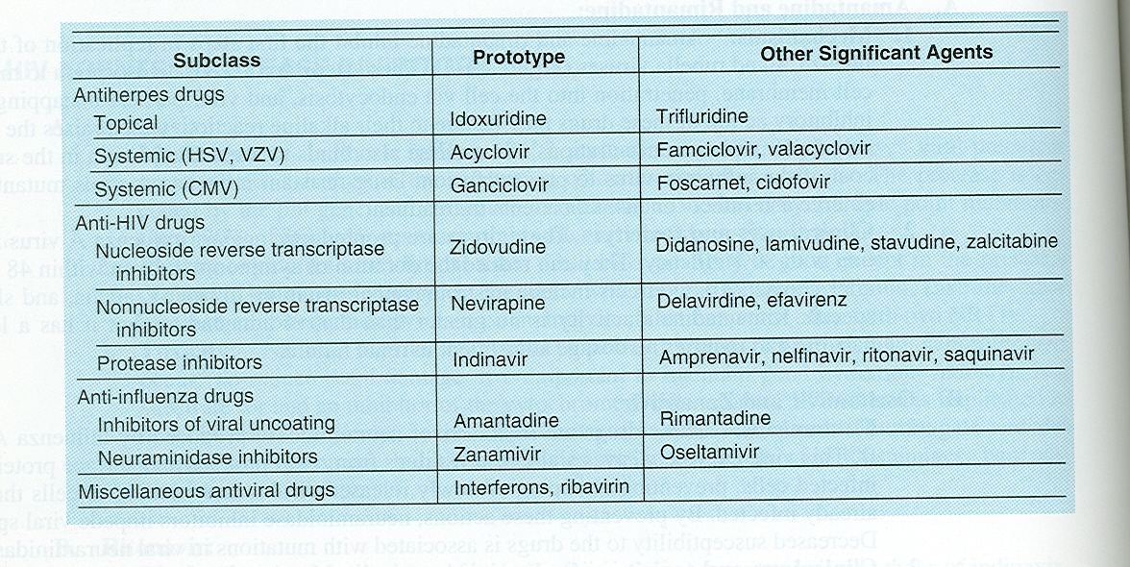

Drug | Amantadine and Rimantadine
Mechanism of action | ~ Inhibit uncoating of viral RNA of influenza via blocking the viral membrane matrix M2 protein.
pharmacokinetic | ~ Amantadine eliminated unchanged in kidney, while rimantadine is metabolized in the liver. Both drugs can pass BBB and available in Tablet forms.
Clinical uses | ~ For prophylactic and treatment of Influenza A
Side effects | ~ CNS: Nervousness, difficulty in concentration, lightheadedness .  ~ GIT symptoms .
Drug | zanamivir and oseltamivir
Mechanism of action | ~ Neuraminidase Inhibitors
pharmacokinetic | ~ Zanamivir: available as an inhaled form ( nasal ) .  ~ Oseltamivir: taken orally .
Clinical uses | ~ For influenza A & B
Side effects | ~ nausea , vomiting , diarrhea , bronchitis , abdominal pain , headache and dizziness .  ~ zanamivir cause bronchospasm & irritation ,therefore it is contraindicated in asthma .

Drug | Palivizumab
Mechanism of action | ~ Humanized monoclonal antibodies directed against an epitope in the A antigenic site of the F protein of the Respiratory Syncytial Virus .
pharmacokinetic | ~ Intramuscular, Given monthly (15 mg/kg)
Clinical uses | ~ to prevent RSV infection.

1 .Which one of the following antiviral drugs is most likely to produce pancreatitis?
MCQs
a) Lamovudine.
b) Didanosine.
c) Zidovudine.
d) Ritonavir.
2 .Which one of the following antiviral drugs is used in cytomegalovirus retinitis?
a) Idoxuridine.
b) Acyclovir.
c) Ganciclovir.
d) Rimantadine.

3 .Severe respiratory syncytial viral pneumonia is treated by:
a) amantadine.
b) ribavarin.
c) acyclovir.
d) foscarnet.

4.Used in the prophylaxis and treatment of infection due to influenza viruses, this drug facilitates
clumping of mature virions and inhibits their release :
a) Amantadine
b) Efavirenz
c) Oseltamivir
d) Rimantadine

5.Which of the following drugs is most likely to cause additive anemia and neutropenia if
administered to an AIDS patient taking zidovudine :
a) Acyclovir
b) Amantadine
c) Ganciclovir
d) Pentamidine

6. which drugs bind to a viral envelope protein preventing the conformational changes required for the fusion of viral and cellular membranes ?
- Abacavir
- Adenavir
- Enfuvirtide
- Oseltamivir ( tamiful )

7.Over 90% of this drug is excreted in the urine in intact form. Because its urinary patients should be well hydrated to prevent nephrotoxicity.
a) Acyclovir
b) Amantadine
c) Indinavir
d) Zanamivir
1 | 2 | 3 | 4 | 5 | 6 | 7
B | C | B | C | C | C | A

MCQs

8.Which one of the following statements about stavudine is accurate
a) Bone marrow suppression is dose
b) It causes marked neurotoxicity
c) It inhibits HIV protease
d) It is a non-nucleoside reverse transcriptase inhibitor
e) Resistance occurs via mutations in the gene that codes for thymidine kinase

9.An HIV-positive woman is diagnosed with CMV retinitis. She has been on a HAART regimen
containing zidovudine. Which of the following anti-CMV drugs is likely to cause additive
myelosuppression with zidovudine ?
a) Acyclovir
b) Ganciclovir
c) Amantadine
d) Foscarnet

10.A 25-year-old man is diagnosed with HIV, and therapy is initiated. After the first week of
therapy, the patient complains of headaches, irritability, and nightmares. Which one of the
following antiretroviral drugs is most likely to be causing these symptoms ?
a) Efavirenz
b) Indinavir
c) Lamivudine
d) Nevirapine

11.Regarding interferon alpha. which one of the following statements is LEAST accurate ?
a) At the start of treatment, most patients experience flu-like symptoms
b) Indications include treatment of genital warts
c) It is used in the management of hepatitis C
d) Lamivudine interferes with its activity against hepatitis B

12.In an accidental needle-stick, an unknown quantity of blood from an AIDS patient is injected into a nurse. The most recent laboratory report on the AIDS patient shows a CD4 count of 20/µL and a viral RNA load of greater than 107copies/mL. The most appropriate course of action
regarding treatment of the nurse is to :
a) Monitor the nurse's blood to see if HIV transmission has occurred
b) Treat him with full doses of zidovudine for 2 weeks
c) Treat him with full doses of zidovudine for 4 weeks
d) Administer zidovudine with lamivudine for 4 weeks
8 | 9 | 10 | 11 | 12
B | B | A | D | D

1 .Regarding the pharmacokinetics of antiviral drugs:
T/F
a) Ribavarin is given by aerosol to achieve high concentrations in the respiratory tract.
- Acyclovir does not cross the blood–brain barrier.
- Rimantadine is mainly excreted in urine as unchanged drug.
- Indinavir has poor oral bioavailability.

2.According to Grisofulvin:
  - Used topically
  - It has wide spectrum
  - It is very effective on athletic foot
  - CYTP 450 inducer
  - Absorption increase with fatty meal

3.According to interferons alfa2:
a) May cause nephrotoxicity
b) May cause bone marrow depression
c) with ribavirin can treat HBV

4. drugs used in Rx. of HBV infection :
a) alpha interferon
b) amantidine
c) didanosine
d) lamivudine

5. Ribavirin :
a) inhibit viral mRNA
b) effective as monotherapy for Rx. of HCV infec
c) lead to hemolysis
d) one of the side effects is that it’s teratogenic

1 | 2 | 3 | 4 | 5
A B C D  T F F T | A B C D E  F F T T T | A B C  F T F | A B C D  T F F T | A B C D  T F T T

