Radiology 426 Cat2 Exam

أولا: الله يوفق 425 على الأسئلة اللي كتبوها لنا ثانيا : ادعوا لنا ثالثا : جمعوا أسئلتكم عشان يدعون لكم 428☺
- Which of the following imaging technique is safe for a pregnant?
- Bone scan
- ERCP
- CT scan
- X-ray
- MRCP
MRCP is the true answer because it is MRI, bone scan is not safe, also ERCP is safe????
- According to the following figure
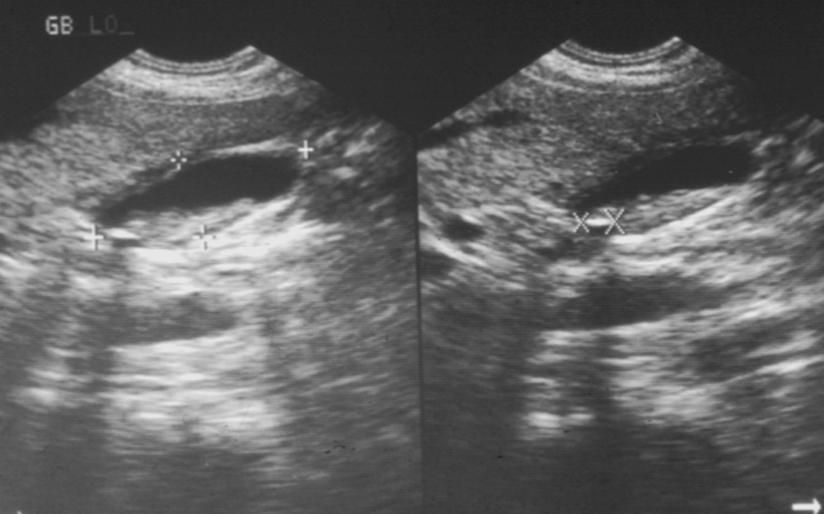
- This is a kidney image
- The ecogenic things r stones
- In ultrasound we can't differentiate between air and stone …. (I am not sure if this is wrong)
- Both pictures are transverse section وكان مكتوب على كل واحدة وش نوعها )

جابوا صور لثايرويد قلاند و قالوا وش فيه هل هو؟
- Left cold nodule
- Right hot nodule
- Hypothyroidism
- Diffuse goiter
فاعرفوا كل واحد كيف يصير شكل الثايرويد فيه؟؟
هذا شرح لهذا الموضوع للي ما فهمه...
- Localization and size. Uptake of isotope in a normal gland and in a patient whose left lobe was surgically removed . Arrow indicates uptake of iodine in the salivary glands.
- Overall function. More rapid and increased uptake of the isotope in primary hyperthyroidism compared with normal thyroid activity and slower, reduced uptake in hypothyroidism .
- Regional function. ‘Hot’ nodule in upper left lobe of the thyroid gland (arrow) showing increased isotope uptake and suppression of uptake in surrounding tissue . ‘Cold’ nodule in lower left lobe (arrow) showing reduced isotope uptake .
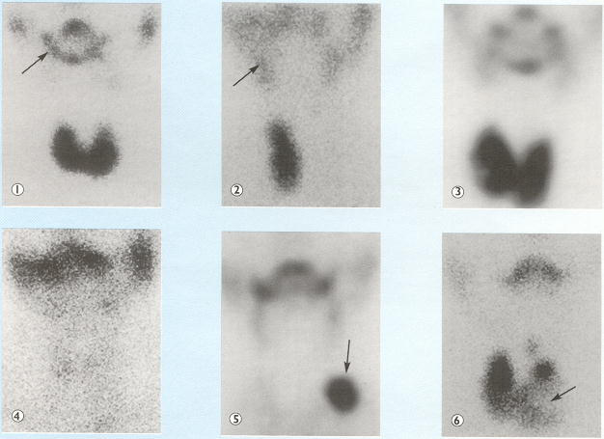
هذي تشبه الصورة اللي جتنا في الاختبار
☺☺☺☺☺☺☺☺
- Mickel's diverticulum is best imaged by:
- Tc & Pertechnetate
- Tc & sulfar colloid
- Tc & DTPA

- Half life of Technitium 99m is:
- 10 hr
- 6 hr
- 4 hr
- 3 seconds

جابوا لنا صورة هيكل عظمي بالبون سكان و السؤال كان على ما أذكر
Full body bone scan is required for
- Normal ……
- Recurrent infection
- Osteomylitis
- Recurrent bone metastasis
- Achalasia is:
  - Eosophagial web → try to know what is this
  - Degenerative disease in the esophagus
  - Failure of distal sphincter to relax leads to proximal dilatation
  - Infection in the stomach
- Pneumoperitoneum:
  - Best diagnosed by MRI
  - Best diagnosed by CT scan
  - crescentic area of lucency under Rt diaphragm in PA chest x-ray
- 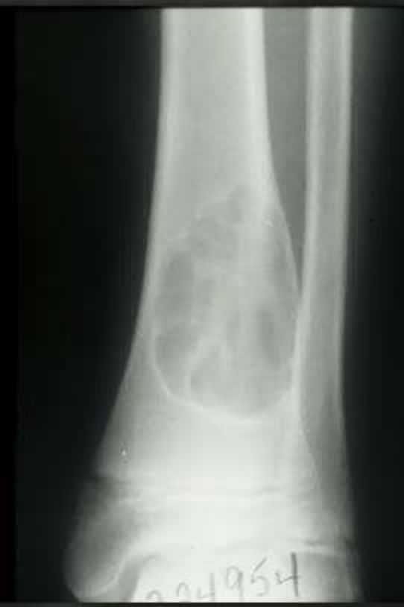
  - This lesion is likely benign (non aggressive lesion)
  - The borders are ill defined
  - There is perosteal reaction
  - This a sclerotic lesion of the tibia
  - The lesion is in the epiphysis
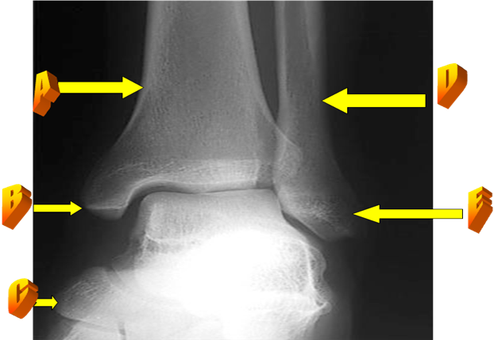
- In figure (7) all true except:
A) A refers to tibia.
B) G refers to talus.
C) C refers to fibula.
D) E refers to lateral malleolus.
E) B refers to medial malleolus.

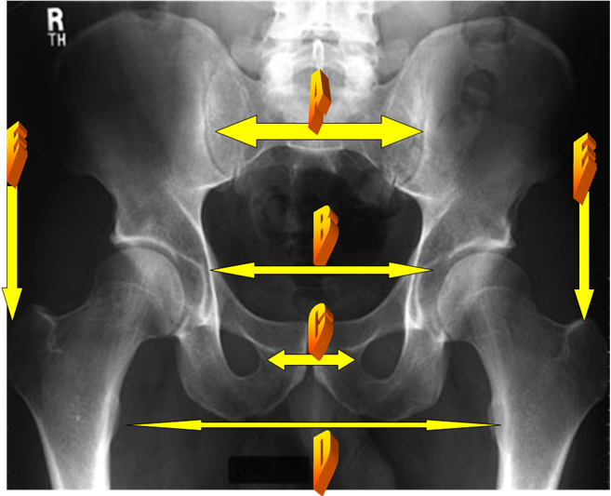
In the above figure all are true except :
A) A refers to sacroiliac joints.
B) B refers to symphysis pubis.
C) G refers to obturater foramen.
D) D refers to lesser trochanter.
E) E refers to greater trochanter.

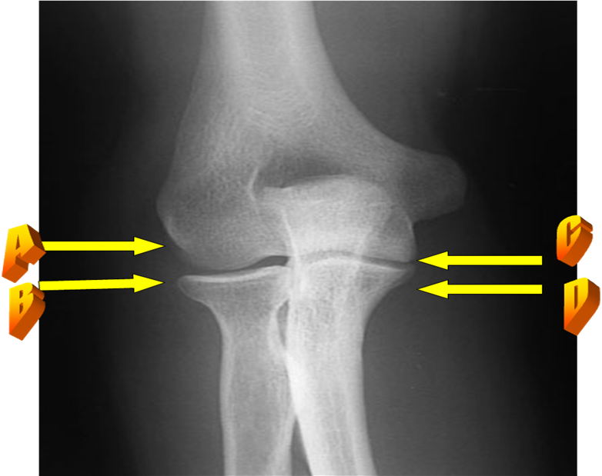
In the above figure all are true except:
A) A refers to trochlea.
B) B refers to radial head.
C) G refers to trochlea.
D) D refers to coronoid process.
E) This is AP view of the elbow.

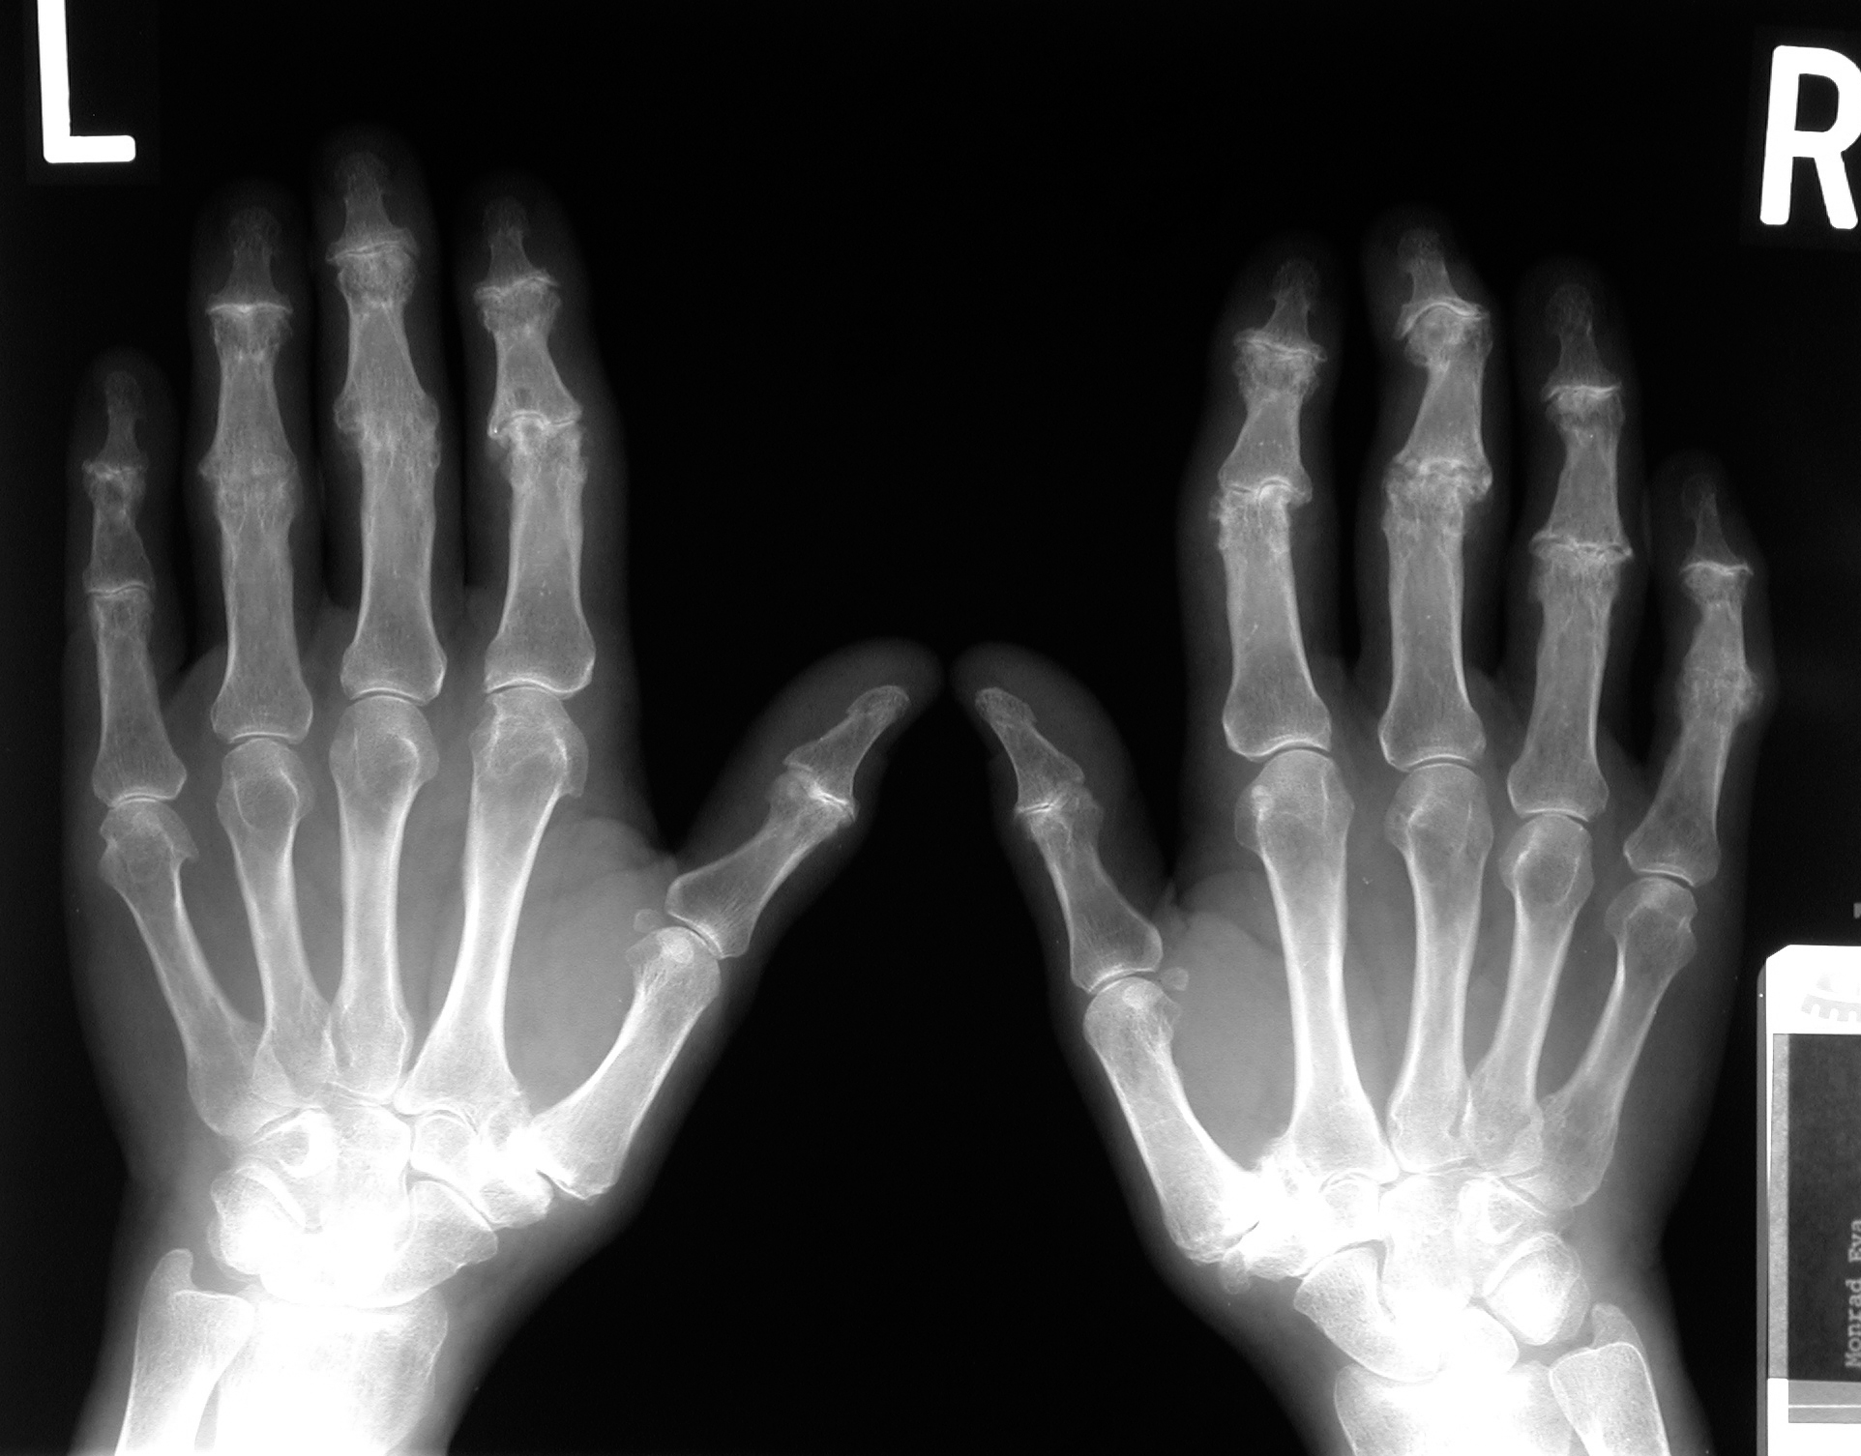
In the above figure all are true except:
A) This is AP view of the hand.
B) No bony erosions
C) The finding are nearly symmetrical
D) There is collapse of the carpal bones
E) The diagnosis is likely rheumatoid arthritis.

- Osteoarthrosis (it is osteoarthritis) , all are true except :
A) Hip and knee are commonly affected.
B) Positive rheumatoid factor.
C) Can be secondary to congenital hip dislocation.
D) Marginal osteophyte formation of the affected joint.
E) Hand involvement is a recognized feature.

- Torus fracture :
A) Is seen in young adult age.
B) Indicating cortical buckling.
C) Disruption of cortex from one side only .
D) Include skull in particular.
E) Occur at physeal plate.

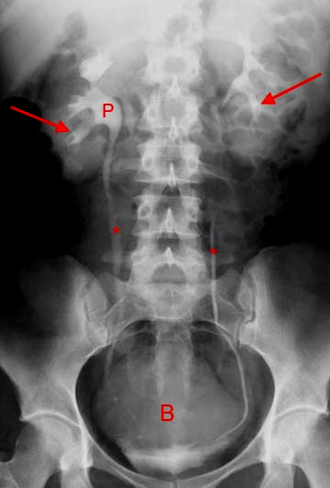
In the above figure all true except:
A) This is an IVU study.
B) (P) Is the renal pelvis.
C) The double arrow pointed to the left ureter.
D) The single arrow pointed to renal vein.
E) This exam is contraindicated in allergic patients.

- All are true except, renal imaging :
A) Renal vein is the most anterior structure of the renal hilum.
B) Renal pelvis the most posterior structure of the renal hilum.
C) Each kidney can have more than one artery up to 30 % of cases.
D) Renal pelvis is clearly identified and dilated on normal CT study.
E) Both adrenal gland are of the important anatomical relation of the kidneys.
- Which is true, imaging of urinary tract:
A) MRI is the most important ionizing radiation exam.
B) Renal papilla is the apex of pyramidal shaped medulla bulging in to renal pelvis.
C) The right kidney is normally slightly lower than the left one.
D) Both kidneys are normally extending from the level of L2 to L5 vertebra.
E) The left renal vein is shorter than the right one on CT exam
- A b
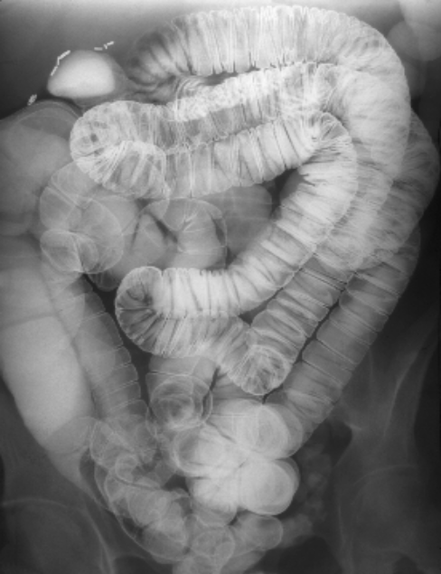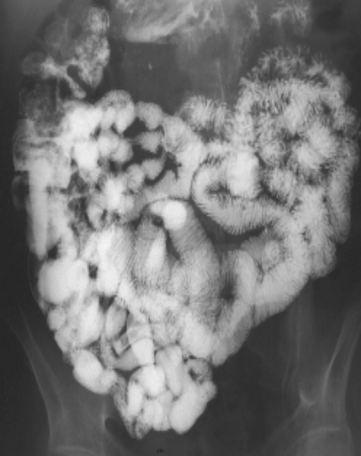
which is true according to A & B pictures
  - A is a picture of barium meal follow throw
  - B is a picture of small bowel enema
  - Small bowel enema is easier
  - Both can demonstrate inflammatory bowel diseases

Goooood luck to all,,
Ur leader☺

