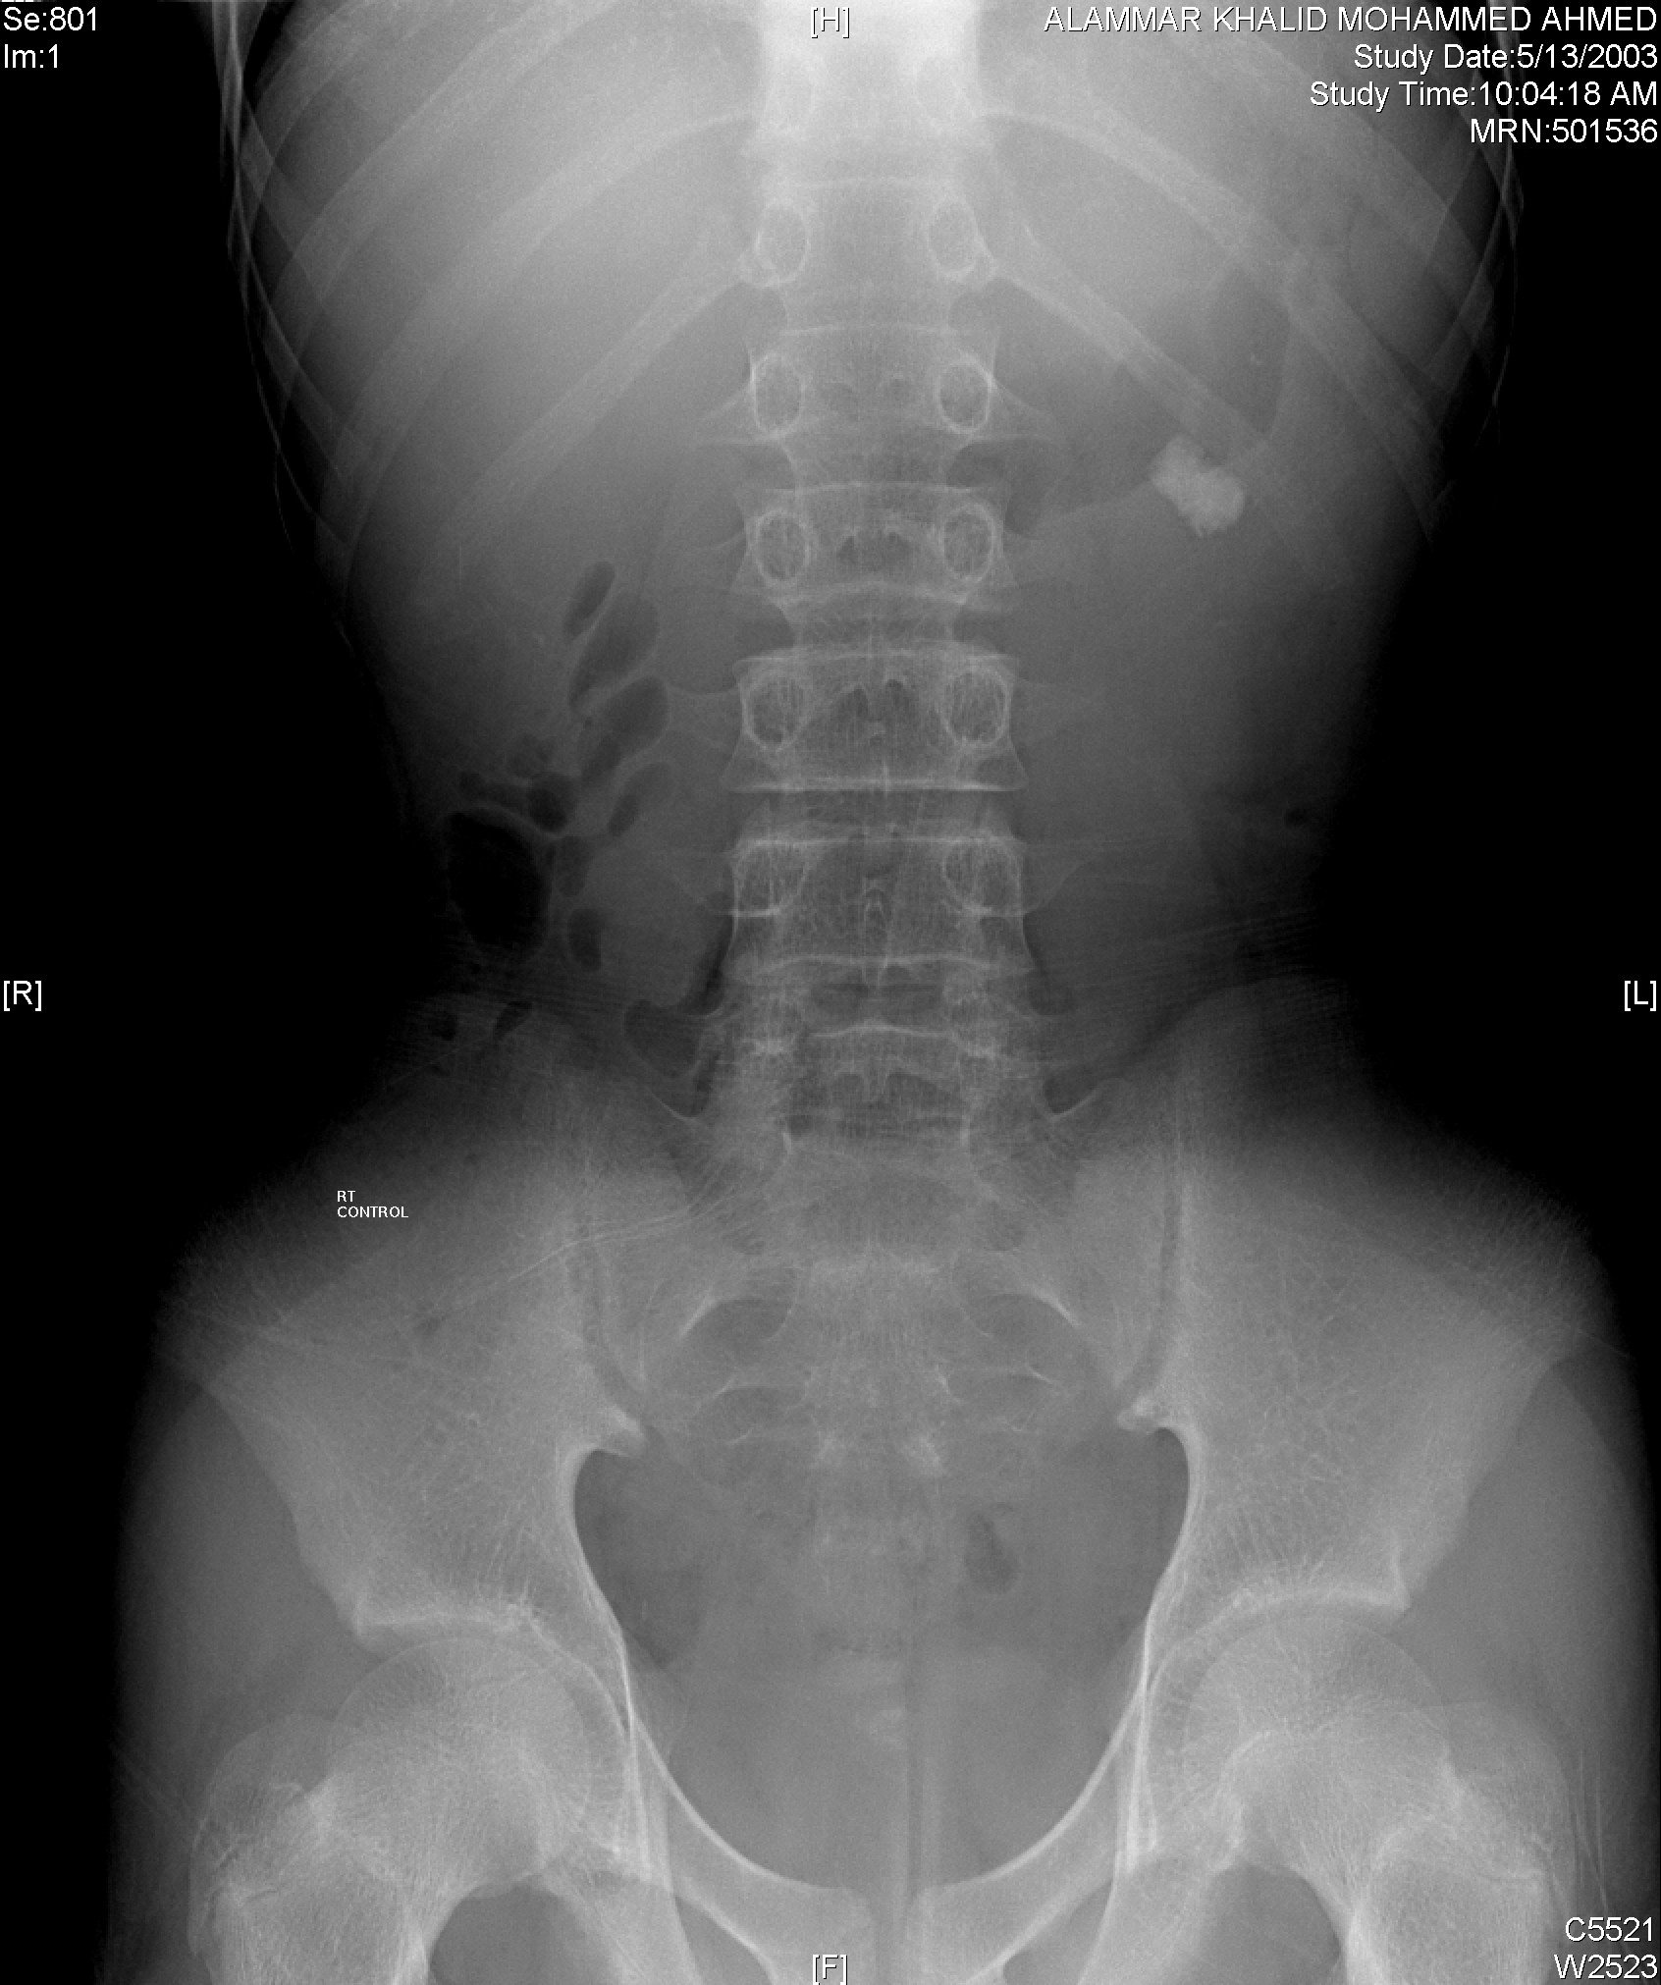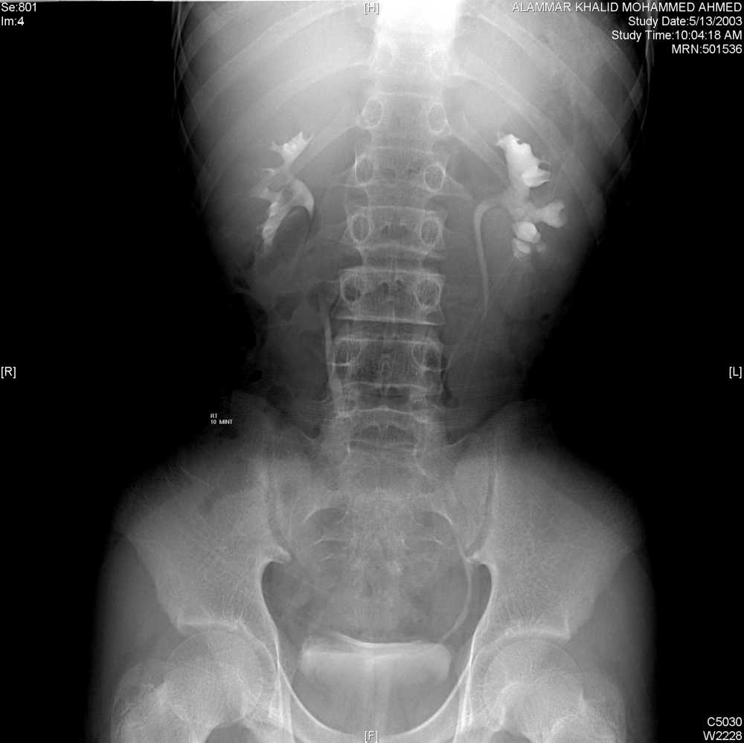

This 30 year old male presented with left flank pain

Look at the film and answer the following questions

List 2 findings in the films above

1-
2-

Mention one other imaging modality that can be used in this patent

1-

List 2 treatment options for the patient in the previous images

1-
2-

Answers

List 2 findings in the films above (one mark each)

1-Left renal stone (Left radio-opaque shadow)

2- Left hydronephrosis (dilatation of the Left calyces)

Mention another imaging modality that can be (one mark)
used in this patent

1- CT scan (renal ultra sound)

List 2 treatment options for the patient (one mark each)
in the previous images

1- Shock wave lithotripsy (SWL, ESWL)
2- Percutaneous nephrolithotripsy (PCNL, PNL)
3- Ureteroscpoy
4- Open surgery

