Vaccination in KSA
Immunization is a method used to stimulate the body immune system to recognize and overcome a specific organism by using vaccines.
Immunization proven its importance throughout time in controlling many diseases such as smallpox and different types of vaccine preventable diseases. About 2-3 million deaths per year estimated to be prevented by vaccination (WHO)
Types of acquired immunty
1-Naturally acquired immunity occurs through not deliberated contact with a disease causing agent.
2- Artificially acquired immunity occurs only through deliberate actions such as vaccination.
Both naturally and acquired immunity can be further subdivided in to :
- Passive immunity is acquired by transfer of antibodies or activated T-cells from an immune host .
(usually lasting only a few months.)
- Active immunity is induced in the host itself by antigen and
(lasts much longer, sometimes lifelong.)
The diagram below summarizes these divisions:

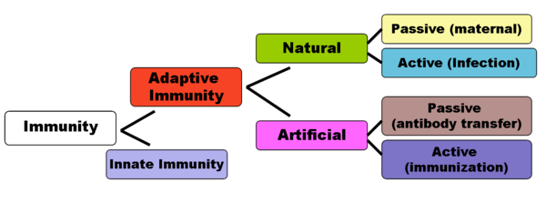
Herd immunity (community immunity)
Type of immunity that occurs when the vaccination of a big portion of a population (or herd) provides protection for individuals who have not developed immunity.
Types of Vaccines
Live, Attenuated Vaccines
Live, attenuated vaccines contain a version of the living microbe that has been weakened in the lab so it can’t cause the disease.
Examples of this type of vaccines are Vaccines against measles, mumps, and chickenpox.
Inactivated Vaccines
Inactivated vaccines produced by killing the disease-causing microbe with chemicals, heat, or radiation. This type of vaccines are more safer than live vaccines as the dead microbes can’t mutate back to their disease-causing state .
Subunit Vaccines
Instead of the entire microbe, subunit vaccines include only the antigens that best stimulate the immune system response.
An example of the recombinant subunit vaccine is hepatitis B virusvaccine .
Toxoid Vaccines
Used with the bacteria that secrete toxins and when the bacterial toxin is the main cause of illness. Vaccines against diphtheria and tetanus are examples of toxoid vaccines.
Conjugate Vaccines
Polysaccharide coatings disguise a bacterium’s antigens so that the immature immune systems of infants and younger children can’t respond to them. The vaccine that protects against Haemophilusinfluenzae type B (Hib) is a conjugate vaccine.
Routes of administration of vaccines:
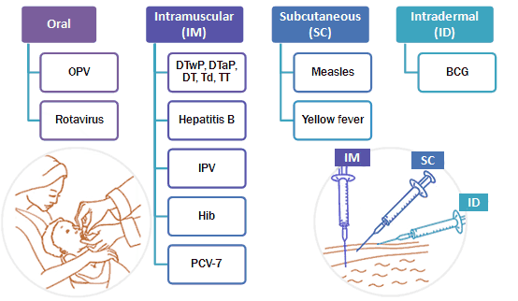

Childhood Immunization Schedule in KSA - 2013
Age | Vaccines:
At birth | BCG / Hepatitis B
2 Months | IPV /DTaP / Hepatitis B/ Hib/Pneumococcal Conjugate (PCV)/Rota
4 Months | IPV /DTaP / Hepatitis B/ Hib/Pneumococcal Conjugate (PCV)/Rota
6 Months | OPV/IPV /DTaP/ Hepatitis B/ Hib/Pneumococcal Conjugate (PCV)
9 Months | Measles / Meningococcal Conjugate quadrivalent (MCV4)
12 Months | OPV/ MMR/ Pneumococcal Conjugate (PCV)/Meningococcal Conjugate quadrivalent (MCV4)
18 Months | OPV/DTaP/Hib/ MMR/ Varicella/ Hepatitis A
24 Months | Hepatitis A
First class Primary School age | OPV/ DTaP(Td) / MMR/Varicella

