COMM 311

Obesity

Definition: As a biomedical entity, obesity is defined as the excess amount of body fat accumulated to the extent that it may impair health. Overweight and obesity are both labels for ranges of weight that are greater than what is generally considered healthy for a given height.

Measures: Body mass index (BMI) is a simple index of weight-for-height that is commonly used to classify overweight and obesity in adults. Body mass index is an indirect measure of body fat content as it correlates positively with amount of fat in general. The terms also identify ranges of weight that have been shown to increase the likelihood of certain diseases and other health problems. BMI is reliable indicator of body fatness for most people (Because BMI does not distinguish between body fat and muscle mass, as in many athletes who have huge BMIs because of muscle mass, but in many cases are not fat).
Anthropometric measures for skin fold thickness, waist circumference, provide a cheap and quick method to screen populations at risk of cardiovascular, and cerebrovascular diseases and risk factors. Body fat is accurately measured by Dual energy X-ray absorptiometry ( DEXA) scans, under-water weighing, and bio impedance.
A BMI kg/m² is obtained simply by dividing the weight (Kilograms) by the highlight (Meters) squared. An adult BMI kg/m² between 25 and 29.9 is considered overweight and a BMI kg/m² of 30 and over is considered obese.

Table 1: Classification (BMI=weight (kg) / [ height (m)² ])
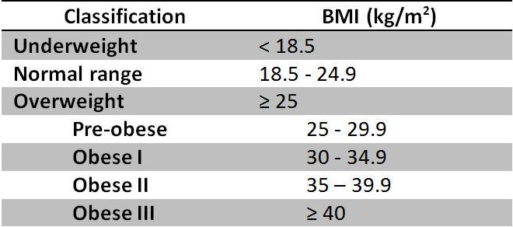

Skin fold thickness: measurement of subcutaneous fat located directly beneath the skin by grasping a fold of skin and subcutaneous fat and measuring it using calipers. Results rely on formulas that convert these numbersinto an estimate of a person's fatness and the percentage of body fataccording to a person's age and gender. For children and teens, BMI is age- and sex-specific and is often referred to as BMI-for-age. After BMI is calculated for children and teens, the BMI number is plotted on the CDC BMI-for-age growth charts (for either girls or boys) to obtain a percentile ranking.
Percentiles are the most commonly used indicator to assess the size and growth patterns of individual children. The percentile indicates the relative position of the child's BMI number among children of the same sex and age.
Table 2: Percentiles cutoff for children Figure 1: Types of obesity
Weight Status Category | Percentile Range
Underweight | Less than the 5th percentile
Healthy weight | 5th percentile to less than the 85th percentile
Overweight | 85th to less than the 95th percentile
Obese | Equal to or greater than the 95th percentile

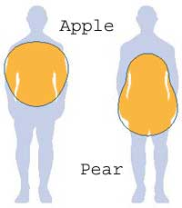

Types of obesity
The fat distribution in the body is identified among the two types of obesity; android (apple obese) in which person stores fat around his or her abdominal region; gynoid (pear obese), in which excess fat are being deposited somewhere at the hip and thigh areas. Android obese individuals are more prone to obesity-related diseases compared to the gynoid obese.

Prevalence
Obesity around the world has doubled since 1980; it has reached epidemic proportions globally, with at least 2.8 million people dying each year as a result of being overweight or obese. Once associated with high-income countries, obesity is now also increasing in low- and middle-income countries, particularly in urban settings. Overall, more than 10% of the world’s adult population was obese in 2008. In 2011, more than 40 million children under the age of five were overweight; more than 30 million overweight children are living in developing countries and 10 million in developed countries. The MONICA Project, sponsored by the World Health Organization, discovered that 30% of the population in the Arab World is overweight or obese, including adolescents and adults. In 2005, the Coronary Artery Disease in Saudi Study (CADISS), estimated an overall obesity prevalence of 35.5% in the Kingdom: in other words one in every three people in the country is obese. In 2007, prevalence of obesity in KSA based on the National Nutrition Survey was 23.6% in women and 14% in men. The prevalence of overweight in the community was determined to be 30.7% for men as compared to 28.4% for the women.

Table 3: Interpreting increased risk of diabetes mellitus, cardiovascular & cerebro-vascular diseases related to BMI and waist circumference in men and women.
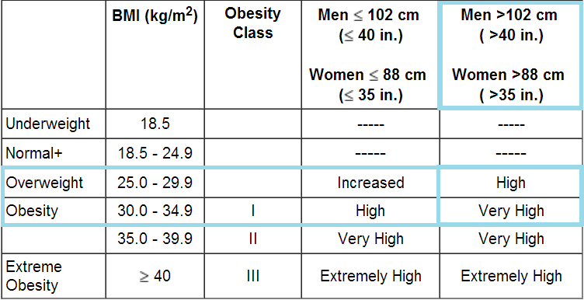

Risk factors for development of obesity include individual level factors related to lifestyle; eating habits, number of calories consumed, and expenditure of calories in the form of physical activity. Genetic risk factors have been postulated among which thrifty gene hypothesis attempts to explain today’s obesity epidemic. It proposes that the unpredictable availability of food supplies and potential famine faced by our ancestors, led to the multiplication of “energy thrifty genes” needed to survive those harsh conditions. Of course, the need for these genes nowadays has been abolished by our abundant food supply, and these genes have now been transformed into risk factors. Another important mechanism underlies mutations in leptin gene. Leptin is an adipokine that is synthesized, secreted and expressed in adipose tissue in proportion to its mass. When leptin is released, it binds to hypothalamic receptors. This leads to suppression of appetite and decrease in energy expenditure. Studies have shown that a mutation in the leptin gene located on chromosome 7 is associated with early onset morbid obesity.

Increased mortality and morbidity is reported to be related to obesity and overweight. Mainly by hypertension, heart diseases, stroke, sleep apneoa, dyslipedemia, diabetes mellitus, infertility, gall bladder diseases, osteoarthritis, liver diseases and cancers.

Prevention: Primary prevention includes breast feeding, awareness and practices related to good nutrition and physical activity. Secondary prevention includes management of obesity and overweight by low calories diet, physical activity, and major changes in lifestyle. Behaviour therapy is the main component. Tertiary prevention includes pharmacotherapy, and surgical interventions. In general individual, societal, and industrial level interventions will support reduction in morbidity and mortality associated with obesity and overweight. WHO recommends preventive measures at three levels; governmental, population and community.

