INTRODUCTION
Introduction

Definition :
Diabetes mellitus is a metabolic disorder characterized by hyperglycemia (high blood sugar) and other signs, as distinct from a single disease or condition. The World Health Organization recognizes three main forms of diabetes: type 1, type 2, and gestational diabetes (occurring during pregnancy),(1) which have similar signs, symptoms, and consequences, but different causes and population distributions. Type 1 is usually due to autoimmune destruction ………

Major Types of Diabetes

1-Type 1 diabetes
Type 1 diabetes mellitus—formerly known as insulin-dependent diabetes (IDDM), childhood diabetes or also known as juvenile diabetes, is characterized by loss of the insulin-producing beta cells …………….
4-Pre-diabetes
Pre-diabetes is a condition …………………….

The Genetics of Diabetes
Both type 1 and type 2 diabetes are at least partly inherited. Type 1 diabetes appears to be triggered by some (mainly viral) infections). …………………

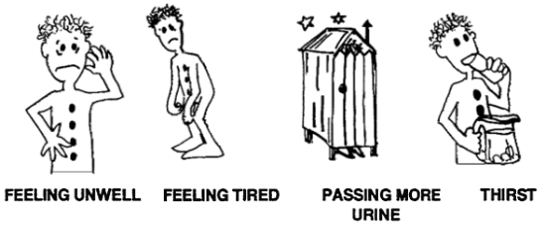
Clinical picture of diabetes:

INVESTIGATION
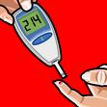
1-Blood glucose test: Traditional Home Blood Glucose Monitoring. The traditional method of testing your blood glucose involves pricking your finger ……………….
2- Fasting plasma glucose test: measures your blood glucose after you have gone at least 8 hours without eating.
People with diabetes should have this test every three months to determine whether their blood sugars have reached the target level of control. (9)

Treatment & Management of Diabetes :
The main goal of diabetes treatment is to keep blood sugar levels within a normal range most of the time. . Treatment advice is individualized according to the needs of the person.(10)
. Treatment may include: …………………………………….

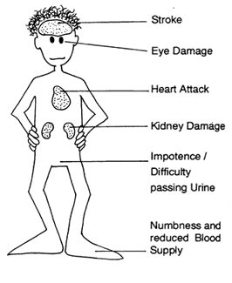
Complications :

Cardiovascular complications:
Heart attack, stroke, and others related to poor circulation. Cardiovascular disease is the most common complication of type 2 diabetes. In fact, people with diabetes have a risk of cardiovascular disease that is two to five times that of people without the condition.(16)
Cardiovascular complications Among people with diabetes the men and women (especially those with type 2 diabetes) have an equal chance of suffering heart attacks; they have a much higher cardiovascular death rate than their nondiabetic people.(16)
Compared with men without diabetes, men with diabetes have about two times the average risk of developing cardiovascular disease; women with diabetes have

