Compulsory vaccination in KSA handout
Introduction:
- The Immune system: The immune system is a network of cells, tissues, and organs that work together to defend the body against attacks by “foreign” invaders.
- A vaccine is a product that produces immunity from a disease and can be administered through needle injections, by mouth, or by aerosol.
- A vaccination is the injection of a killed or weakened organism that produces immunity in the body against that organism.
- An immunization is the process by which a person or animal becomes protected from a disease. Vaccines cause immunization, and there are also some diseases that cause immunization after an individual recovers from the disease
Types of vaccines:
- Live, attenuated vaccines contain a version of the living microbe that has been weakened in the lab so it can’t cause disease. They elicit strong cellular and antibody responses and often confer lifelong immunity with only one or two doses
- Inactivated vaccines Scientists produce inactivated vaccines by killing the disease-causing microbe with chemicals, heat, or radiation. Such vaccines are more stable and safer than live vaccines: The dead microbes can’t mutate back to their disease-causing state
- Subunit vaccines Instead of the entire microbe, subunit vaccines include only the antigens that best stimulate the immune system. In some cases, these vaccines use epitopes—the very specific parts of the antigen that antibodies or T cells recognize and bind to.
- Toxoid vaccines For bacteria that secrete toxins, or harmful chemicals, a toxoid vaccine might be the answer. These vaccines are used when a bacterial toxin is the main cause of illness. Scientists have found that they can inactivate toxins by treating them with formalin, a solution of formaldehyde and sterilized water
- Conjugate vaccines If a bacterium possesses an outer coating of sugar molecules called polysaccharides, as many harmful bacteria do, researchers may try making a conjugate vaccine for it. Polysaccharide coatings disguise a bacterium’s antigens so that the immature immune systems of infants and younger children can’t recognize or respond to them. Conjugate vaccines, a special type of subunit vaccine, get around this problem
- DNA vaccines Once the genes from a microbe have been analyzed, scientists could attempt to create a DNA vaccine against it.
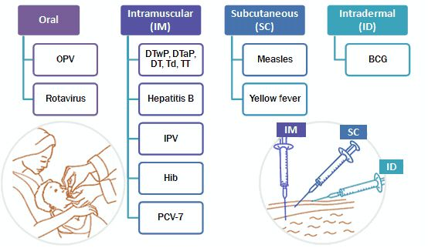
Administration of vaccines:
- Intramuscular (IM) injection
Administers the vaccine into the muscle mass. Vaccines containing adjuvants should be injected IM to reduce adverse local effects.
- Subcutaneous (SC) injection administers the vaccine into the subcutaneous layer above the muscle and below the skin.
- Intradermal (ID) injection administers the vaccine in the topmost layer of the skin
- Oral administration of vaccine

Compulsory vaccinations in Saudi Arabia:

* basic vaccinations schedule ..
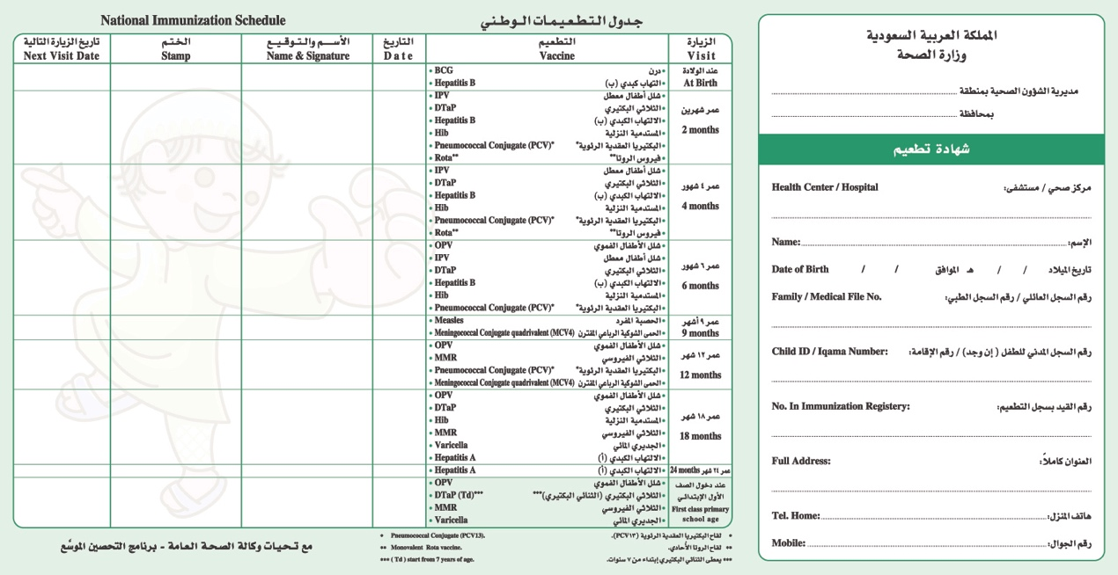
The main vaccinations identified in the Vaccination Certificate, from birth to entering the first primary grade, aims to protect children in the Kingdom and all community groups from diseases targeted by immunization, keep the Kingdom free of polio, as well as getting rid of measles, rubella, mumps, in addition to reducing the infection with any of these diseases targeted by immunization.

Age | Vaccines:
At birth | BCG / Hepatitis B
2 Months | IPV /DTaP / Hepatitis B/ Hib/Pneumococcal Conjugate (PCV)/Rota
4 Months | IPV /DTaP / Hepatitis B/ Hib/Pneumococcal Conjugate (PCV)/Rota
6 Months | OPV/IPV /DTaP/ Hepatitis B/ Hib/Pneumococcal Conjugate (PCV)
9 Months | Measles / Meningococcal Conjugate quadrivalent (MCV4)
12 Months | OPV/ MMR/ Pneumococcal Conjugate (PCV)/Meningococcal Conjugate quadrivalent (MCV4)
18 Months | OPV/DTaP/Hib/ MMR/ Varicella/ Hepatitis A
24 Months | Hepatitis A
First class Primary School age | OPV/ DTaP(Td) / MMR/Varicella

Hajj vaccination:

- Yellow fever
- Meningococcal meningitis
- Poliomyelitis
- Seasonal influenza
- Zika virus disease and Dengue

Guide to Contraindications and Precautions to Commonly Used Vaccines
Generally:
- Anaphylaxis or a severe hypersensitivity reaction is an absolute contraindication to subsequent doses of a vaccine. Persons with a known allergy to a vaccine component should not be vaccinated.
Vaccine | Contraindications | Precautions
Hepatitis B | - Severe allergic reaction | - Infant weighing less than 2000 grams
Rotavirus | - Severe allergic reaction  - Severe combined immunodeficiency (SCID)  - History of intussusception | - Altered immunocompetence other than SCID  - Chronic gastrointestinal disease  - Spina bifida or bladder exstrophy
Haemophilus influenzae type b (Hib) | - Severe allergic reaction  - Age younger than 6 weeks
- Inactivated poliovirus vaccine  - Human papillomavirus | - Severe allergic reaction | - Pregnancy
- Pneumococcal  - Hepatitis A  - Meningococcal | - Severe allergic reaction
Measles, mumps, rubella | - Severe allergic reaction  - Known severe immunodeficiency  - Pregnancy | - Recent receipt of antibody-containing blood product  - History of thrombocytopenia or thrombocytopenic purpura
Varicella | - Severe allergic reaction  - Known severe immunodeficiency =  - Pregnancy | - Recent receipt of antibody-containing blood product  - Receipt of specific antivirals (i.e., acyclovir, famciclovir, or valacyclovir)
Zoster (HZV) | - Severe allergic reaction  - Known severe immunodeficiency  - Pregnancy | - Receipt of specific antivirals (i.e., acyclovir, famciclovir, or valacyclovir)
- Persons with moderate or severe acute illness with or without fever should be vaccinated with precaution

http://www.vaccines.gov
http://www.vaccines.gov
http://vaccine-safety-training.org
http://www.moh.gov.sa/en/HealthAwareness/EducationalContent/HealthTips/Pages/Tips-005.aspx
http://www.moh.gov.sa/en/Hajj/Pages/HealthRegulations.aspx
http://www.who.int/immunization/policy/contraindications.pdf
http://www.cdc.gov/vaccines/hcp/admin/contraindications-vacc.html

