Course 311 - Outbreak Investigations

Practical session

**Food-Borne Outbreak**

**Scenario 1:** An outbreak (epidemic) of gastroenteritis occurred in a suburban town, on the evening of April 28. A total of 89 people went to the emergency departments of the three local hospitals during that evening. No more cases were reported afterward. These patients complained of headache, fever, nausea, vomiting and diarrhea. The disease was severe enough in 19 patients to require hospitalization for rehydration. Gastroenteritis outbreaks like this are usually caused by the consumption of a contaminated or poisoned meal. Meal contamination can often be caused by pathogenic viruses or bacteria. However, acute outbreaks are more often produced by toxins from bacteria such as *Staphylococcius* spp., *Clostridium perfringens, Salmonella* spp*.* And *Vibrio cholerae*. Food poisoning can also be caused by chemicals or heavy metals, such as copper,cadmium or zinc, or by shellfish toxins.

**Calculate, interpret and answer the following exercises based on the given scenarios**

Question1:

1. What is the type of outbreak that is projected in the above curve?

Answer :Point source epidemic.

1. What is the duration of the illness?

Answer: The acute onset of illness occurred in five hour period.

Question 2

1. Calculate the attack rates and relative risk for each food item? (fill in the table above)



1. What are the reasons of the outbreak?

Answer : Tossed salad and fruit cocktail.

**Scenario 2 Measles Outbreak**

There was an outbreak of measles epidemic after the winter season in a small coastal hamlet southern Australia in 1970. Cases were subsequently being reported for a certain period after which the epidemic declined slowly until no more new cases were recorded. The epidemic had spread and reached the higher proportions within two months. The epidemic curve below explains the situation from the date of onset until last case.

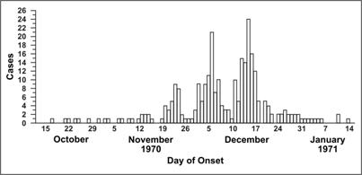

1. What is the type of outbreak that is projected in the above curve?

Answer : Propagated epidemic

1. What is the duration of the illness?

Answer : Duration of illness is over a 3 month period from mid October 1970 to mid January 1971.

Question on current affairs

There is currently an epidemic outbreak on the outskirts of Riyadh, Saudi Arabia first noticed in mid November 2016. Name the epidemic.

Answer: Avian Flu Influenza