CASE-1: CHEST PAIN
Case-1 Chest Pain: Student Handout
Mr. Ali, a 55 - year old teacher, presented to the hospital complaining of recurrent attacks of pain in the left side of the chest over the last few months. At that time, the patient described the pain as tight, centrally located and always coming after climbing stairs rapidly. Over the last one month, the pain pattern has been changed.
The pain comes on walking and relieves by rest or some sublingual drugs and other medication prescribed by his family doctor. The patient smokes about 30 cigarettes/day for at least 25 years. He usually eats fast food. His father died of stroke few years ago.
Examination revealed:
BMI: 31
Blood Pressure: 150/100 mmHg.
Pulse rate: 85/minute with regular rhythm.

Investigations:
ECG was performed outside which is shown below:

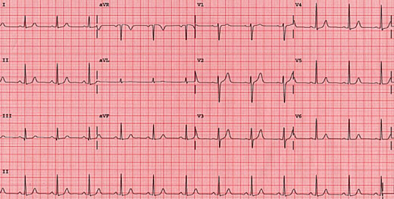

Further workup included requesting CBC which came out to be following:

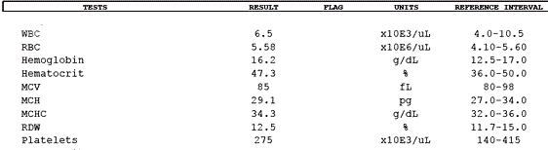

Exercise ECG revealed ST segment depression at the time when pain was experienced.

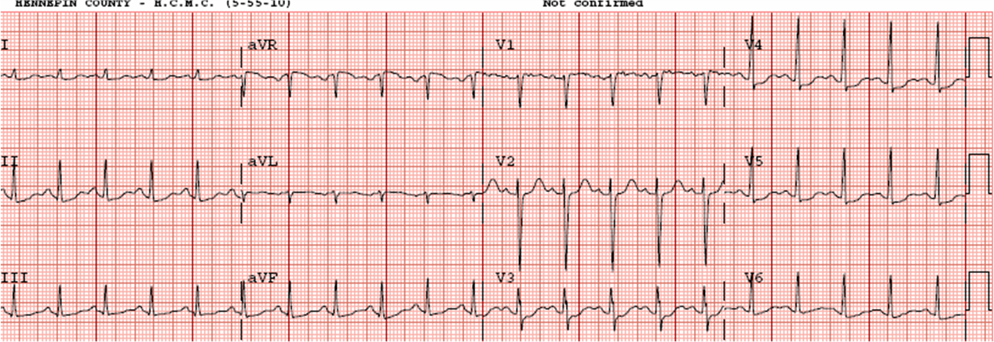

Learning Objectives:
At the end of the session, the student should be able to:
- Enlist the differential diagnosis of the chest pain experienced by the patient.
- Identify the causes of chest pain under most likely & less likely categories.
- Identify the important questions he need to ask the patient while taking the history.
- Identify the most likely diagnosis of this patient.
- Explain the abnormal findings in the history and clinical examination.
- Determine any required further investigations.
- Assess future cardiovascular risk for this patient.
- Describe the management of this patient during and after the attack (i.e. prophylactic and long term treatment)
- Describe the some medications used in such condition, modes of action and side effects.
- Describe the non-drug advices the treating physician has to give to the patient

INSTRUCTION TO STUDENTS:
Please, read the case carefully, individually or in the group, before you are coming to the "Case Based Learning" (CBL) session. Look at the objectives and try to fulfill these objectives. Prepare for the case by refer to some suggested reading list. Prepare the case well, the tutor in CBL session will ask you to go through the case, and answer to his some stimulating and specific questions related to the case to ensure that you have fulfill these objectives.
Suggested Reading:

- Clinical Medicine: Parveen Kumar. 6th edition. Pages 798- 806

- Clinical methods by McLeod

- Lawrence M Tierney & Mark C Henderson, The Patient History, Evidence-Based Approach, LANGE

Important Information to students:

- The students are expected to read the case and related question carefully, try to answer them before they come case-based learning session.
- Every student must bring the following book to the session:
  - Lawrence M Tierney & Mark C Henderson, The Patient History, Evidence-Based Approach, LANGE

