CASE-3: COUGH
Case-3 Cough: Student Handout
A 69-year-old widower smoked 20 cigarettes a day for over 40 years but then gave up 9 months ago when his first grandchild was born. He has had a cough with daily sputum production for the last 20 years and has become short of breath over the last 3 years. He coughs up a little white or yellow sputum every morning. He has put on weight recently and now weighs 100 kg. His ankles have become swollen recently and his exercise tolerance has decreased. He can no longer carry his shopping back from the supermarket 180 m (200 yards) away. He worked as a warehouseman until he was 65 and has become frustrated by his inability to do what he used to do. He is not able to look after his grandchild because he feels too short of breath.
There is no other relevant medical or family history. He lives alone and has a cat and a budgerigar (a kind of parrot) at home.
His general practitioner (GP) gave him a salbutamol metered-dose inhaler which produced no improvement in his symptoms.

Examination revealed:
He is overweight. He appears to be centrally and peripherally cyanosed and has some pitting edema of his ankles. His jugular venous pressure (JVP) is raised 3 cm. He has poor chest expansion. There are some early inspiratory crackles at the lung bases.

Investigation
Respiratory function test results are shown:
Actual Predicted
FEV1 (L) 0.55 2.8–3.6
FVC (L) 1.35 3.8–4.6
FER (FEV1/FVC) (%) 41 72–80
PEF (L/min) 90 310–440

FEV1: forced expiratory volume in 1 sec; FVC: forced vital capacity; FER: forced expiratory ratio; PEF: peak expiratory flow.

His chest X-ray is shown below:

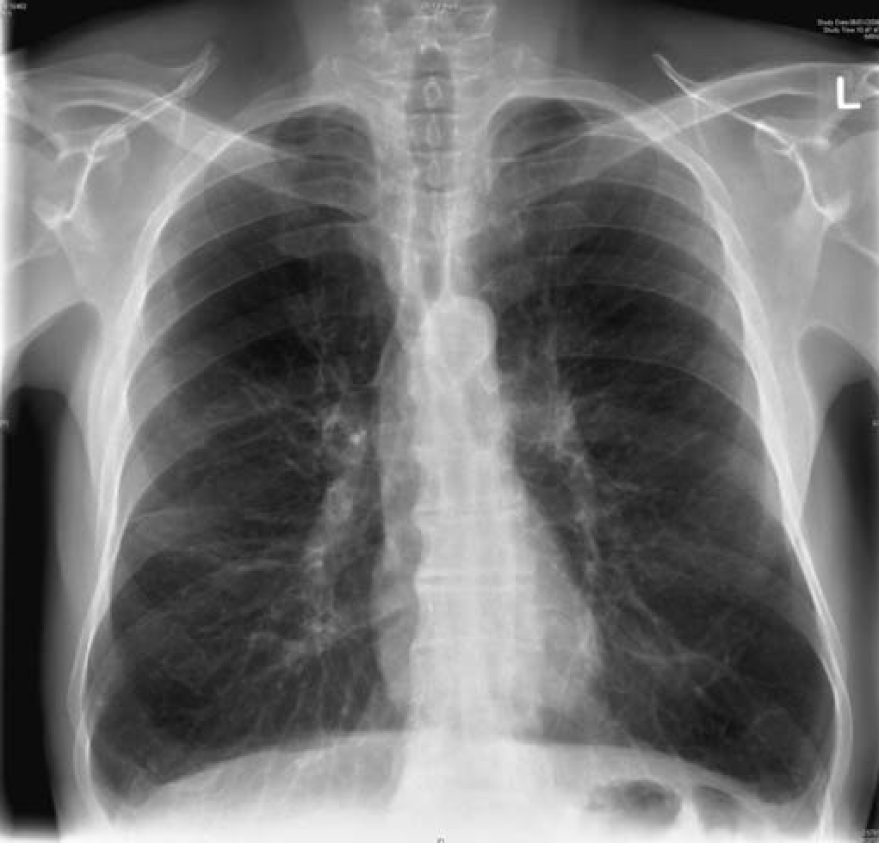

Learning Objectives:
At the end of the session, the student should be able to:
- Determine the basis on which the cough is classified as acute and chronic and under what category this patient’s cough will fall.
- Quote the conditions that can manifest as acute and chronic cough.
- Identify the alarm symptoms associated with cough that will alert a physician for a serious underlying pathology.
- Identify the important questions a physician won’t miss out to ask from the patient while taking the history.
- Describe the diagnostic approach while evaluating a patient with chief complaint of cough.
- Enlist the differential diagnosis of the cough experienced by the patient.
- Establish the most likely diagnosis of this patient.
- Explain the abnormal findings in the history and clinical examination of this patient.
- Identify the presence of a complication in this patient and discuss briefly other complications of chronic cough.
- Device a management plan for his condition and its complication.
- Discuss the some medications used in such condition, modes of action and side effects.
- Describe the importance of the non-drug advices to this patient.

INSTRUCTION TO STUDENTS:
Please, read the case carefully, individually or in the group, before you are coming to the "Case Based Learning" (CBL) session. Look at the objectives and try to fulfill these objectives. Prepare for the case by refer to some suggested reading list. Prepare the case well, the tutor in CBL session will ask you to go through the case, and answer to his some stimulating and specific questions related to the case to ensure that you have fulfill these objectives.
Suggested Reading:

- Clinical Medicine: Parveen Kumar. 6th edition.

- Clinical methods by McLeod

Important Information to students:
- The students are expected to read the case and related question carefully, try to answer them before they come case-based learning session.
- Every student must bring the following book to the session:
Lawrence M Tierney & Mark C Henderson, The Patient History, Evidence-Based Approach, LANGE

