Case-6 : Difficulty in swallowing: Student Handout
Part 1
Omar a 44 year old businessman from Riyadh comes to Dr. Khalid Al Matham with the complaints of difficulty in swallowing. Omar explains that the problem started 2 years back and troubles him occasionally. At times he feels that his food is stuck in the food pipe and takes times to get into the stomach. His complaint is for both solid foods and liquids. Often he feels that his meal comes up into the food pipe especially at night when he lies down. Omar has been ignoring his condition for quite a while but now he has decided to seek medical help. There is no pain associated with swallowing; neither does he have bad breath, nausea, vomiting, fever, chest pain, and bleeding or weight loss.
Past medical history
No history of angina, past surgery or any hospital admissions.
Allergy and Medication
Nil
Family history
His parents are alive and healthy. His two elder sisters are healthy and have no similar complaints
Alcohol and smoking
No history of smoking or alcohol drinking.
Social history
Omar is married for the last 10 years and he has a two girls aged 7 and 5 years

Part 2
He is 170 cm tall and his body weight is 80 Kg.
His vitals are as follows:
Pulse: 77 beats /min
Blood pressure: 120/80
Respiratory rate: 16 breaths /min
Temperature: 37.2 °C
Chest, Heart and Abdominal Examination: Normal
Part 3
Omar’s physical examination was normal. However to aid in the diagnosis of his complaint of difficulty in swallowing the following investigations were done.
Barium Swallow:
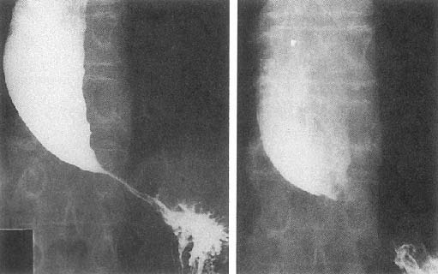
Adapted from: http://www.patient.co.uk/doctor/Achalasia.htm
Report: The distal oesophagus has a narrow segment and the image resembles a bird's beak.
Esophageal manometry:
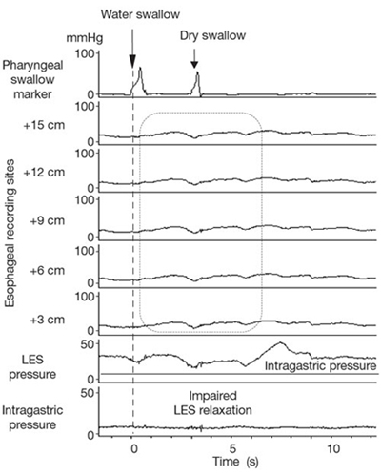
Adapted from: http://www.nature.com/gimo/contents/pt1/fig_tab/gimo22_F2.html#figure-title
Report: The tracing illustrates the findings in classic achalasia with esophageal body aperistalsis with low-amplitude simultaneous esophageal body contractions and failed relaxation of the lower esophageal sphincter.
CT Scan:
No evidence of distal esophageal cancer.
Learning objectives of the case
By the end of the session the student should be able to
- Describe the different clinical presentations associated with swallowing (such as: odynophagia, heart burn/ substernal discomfort, regurgitation and globus).
- Discuss the different characteristics of dysphagia (that is oropharyngeal and esophageal)
- Formulate the differential diagnosis of dysphagia
- Explain the abnormal findings in the history and investigations.
- Enlist the investigations required.
- Devise the management plan for a patient with achalasia.
- Discuss the role of medications including the mechanism of action and side effects of the drugs used.
- Describe the procedure of dilation of the lower esophageal sphincter
- Discuss the risk factor of developing a cancer associated with achalasia.

Instruction to the students:
Please read the case carefully, individually or in the group before you come to the “Case based learning” session. Look at the objectives and try to fulfill them. Prepare for the case well by referring to some suggested reading list. The tutor in CBL session will ask you to go through the case and answer some of his stimulating questions to ensure that you have achieved the objectives

Suggested Reading:

- Clinical Medicine: Kumar P and Clark M. Clinical Medicine. 7th ed. Edinburgh: WB Saunders, 2009..

- Clinical examination: Nicholas J. Talley and Simon O'Connor. Clinical examination: A Systematic Guide to Physical Diagnosis. 6th Revised edition, 2009

Important Information to students:

- The students are expected to read the case and related question carefully, before they come case-based discussion session.
- Every student must bring the following book to the session:
Clinical methods by McLeod

