
King Saud University
College of Medicine
Department of Medical Education
Riyadh, KSA

Cardiovascular Examination
OBJECTIVE: To conduct a complete Cardiovascular Examination.
MATERIALS: Well illuminated examination room, examination table, stethoscope and ophthalmoscope.

D: Appropriately done PD: Partially done ND: Not done/Incorrectly done
 | STEP/TASK | D | PD | ND
 | Preparation
 | Introduce yourself to the patient.
 | Confirm patient’s ID.
 | Explain the procedure and reassure the patient.
 | Get patient’s consent.
 | Wash hands.
 | Prepare the necessary materials.
 | Show the patient each object and allow him/her to touch them to reduce any fear of being hurt during the examination.
 | Position the patient in a 45 degree sitting position and uncover his/her upper body.
 | Examination
 | General inspection
 | Observe the patient's general appearance (age, state of health, nutritional status and any other obvious signs e.g. jaundice, cyanosis, dyspnoea).
 | Hands and pulse
Pick up the patient’s hand; inspect and examine (Temperature, Color, Nail clubbing,
Nail splinter haemorrhages, Nail signs of iron deficiency).
 | Take the patient’s radial pulse (Determine the Rate, Rhythm and the Character of the pulse).
 | Blood pressure
 | Take his/her blood pressure (Lying and standing or sitting-postural hypotension).
 | Face
 | Inspect the patient’s face (sclerae, pupils, malar rush, mouth, palate, dentition).
 | Neck
Assess the jugular venous pressure and the jugular venous pulse form:
• Ask the patient to turn his head slightly to one side.
• Look at the internal jugular vein medial to the clavicular head of sternocleidomastoid.
• Assuming that the patient is at 45 degrees, the vertical height of the jugular distension from the sternal angle should be no greater than 4 cm.
 | Locate the carotid pulse and assess its character.
 | Precordium
 | Inspect the patient’s chest (scars, deformity, apex beat, abnormal pulsation, pacemaker).
 | Palpate (apex beat, thrills, abnormal impulses).
 | ➔ Continues on the next page
 | Cardiovascular Examination
 | STEP/TASK | D | PD | ND
 | Examination
 | Auscultation of the heart
Place your stethoscope’s diaphragm on auscultation areas and listen for:
Heart sounds, additional sounds, murmurs, and pericardial rub.
General auscultation areas:
• Aortic area - right second intercostal space near the sternum.
• Pulmonary area - left second intercostal space near the sternum.
• Tricuspid area - left third, fourth, and fifth intercostal spaces near the sternum.
• Mitral area - left fifth intercostal space, in the mid-clavicular line.
Ask the patient to turn onto his left side and to hold his breath in expiration.
Using the stethoscope's bell, listen in the mitral area for the middiastolic murmur of mitral stenosis.
Ask the patient to bend forward and to hold his breath in expiration.
Using the stethoscope’s diaphragm, listen at the left sternal edge in the fourth intercostal space for the mid-diastolic murmur of aortic regurgitation.
 | Listen over the carotid arteries for any bruits.
 | Back (patient is in sitting forward position)
 | Inspect the patient’s back (scars, deformity).
 | Percuss his/her back (pleural effusion).
 | Auscultate for inspiratory crackles (left ventricular failure).
 | Abdomen (patient is laying down)
 | Inspect the patient’s abdomen (scars, deformity).
 | Palpate his/her abdomen for hepatomegaly (right ventricular failure), pulsatile liver (tricuspid regurgitation), splenomegaly (endocarditis) and aortic aneurysm.
 | Ballot the kidneys and listen for any renal artery bruits.
 | Legs (patient is laying down)
Examine all peripheral pulses bilateraly.
• Femoral pulses. • Popliteal pulses. • Posterior tibial pulses.• Dorsalis pedis pulses
 | Look for peripheral vascular disease, peripheral oedema and clubbing of the toes.
 | Cover the patient up.
 | Eyes
 | Examine the retina with an ophthalmoscope.
 | After the examination
 | Indicate that you would test the urine.
 | Ensure that the patient is comfortable.
 | Make explanations to the patient, answer his/her questions and discuss management plan.
 | If appropriate, order diagnostic investigations (e.g. ECG, CXR, echocardiogram).
 | Dispose of sharps and waste material according to infection control standards.
 | Wash hands.
 | Document the procedure.

Auscultation areas of the heart *
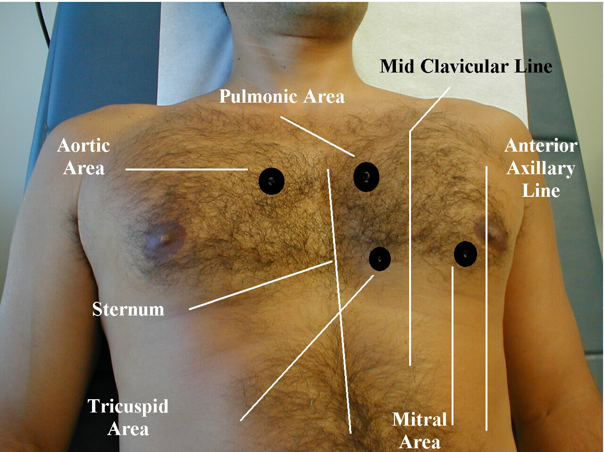
* Photograph by Charlie Goldberg, M.D., University of California San Diego School of Medicine and VA Medical Center, San Diego, California, USA. (Available at: http://meded.ucsd.edu/clinicalmed/heart.htm).

