
King Saud University
College of Medicine
Department of Medical Education
Riyadh, KSA

Intramuscular (IM) Injection
OBJECTIVE: To administer an intramuscular (IM) drug to dorsogluteal region.
MATERIALS: IM drug, syringe, clean gloves, alcohol swab, sterile gauze/cotton, adhesive tape.

D: Appropriately done PD: Partially done ND: Not done/Incorrectly done
 | STEP/TASK | D | PD | ND
 | Preparation
 | Introduce yourself to the patient.
 | Confirm patient’s ID.
 | Explain the procedure and reassure the patient.
 | Get patient’s consent.
 | Wash hands.
Prepare the necessary materials.
(Medication should be drawn up into the syringe beforehand and expiration dates checked.)
 | Check the doctor’s order with the drug to be administrated to ensure correct drug and dosage
 | Put on a pair of clean gloves.
Position the patient in a prone position and expose the gluteal (buttock) region
(maintain the patient’s privacy and dignity).
 | The procedure
 | Identify the injection site*.
 | Clean the site with an alcohol swab using an expanding circular motion or a single wiping from distal to proximal. Do this 3 times with separate swabs. Let it air dry.
 | Take the syringe and open its cap.
 | Hold the syringe (from its barrel) like a pencil or dart with your dominant hand and place a sterile cotton wool between 4th and 5th finger.
 | With your non-dominant hand, taut the gluteal muscle at the site of injection.
 | Insert the needle at a 90 degree angle to the patient’s skin in a quick, firm motion.
 | With your non-dominant hand, pull on the syringe's plunger to ensure that you have not entered a blood vessel. (If you aspirate blood, withdraw the needle and repeat the procedure at another site with a new needle.)
 | Inject the drug very slowly.
 | With your non-dominant hand, take the cotton wool and quickly remove the needle while applying pressure with the cotton wool, maintain gentle pressure for a minute.
 | Observe your patient at least 15 min. for any possible adverse effects of the injected drug.
 | After the procedure
 | Dispose of sharps and waste material according to infection control standards.
 | Ensure that the patient is comfortable.
 | Remove the gloves and wash hands.
 | Document the procedure.

Identifying injection sites*
Drug injection sites vary with the administration route. The instructions below describe proper identification of injection sites for I.M. drugs.
You can administer an I.M. injection into the muscles shown below. In these illustrations, specific injection sites are shaded.

Deltoid site  - Locate the lower edge of the acromial process.  - Insert the needle 1" to 2" below the acromial process at a 90-degree angle.  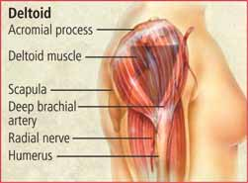 | Vastus lateralis and rectus femoris sites  - Find the lateral quadriceps muscle for the vastus lateralis, or the anterior thigh for the rectus femoris.  Insert the needle at a 90-degree angle into the middle third of the muscle, parallel to the skin surface.  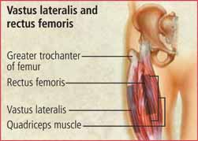
Dorsogluteal site  - Draw an imaginary line from the posterior superior iliac spine to the greater trochanter.  - Insert the needle at a 90-degree angle above and outside the drawn line.  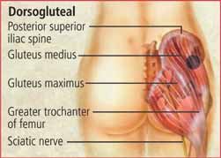  You can administer a Z-track injection through this site. After drawing up the drug, change the needle, displace the skin lateral to the injection site, withdraw the needle, and then release the skin. | Ventrogluteal site  - With the palm of your hand, locate the greater trochanter of the femur.  - Spread your index and middle fingers posteriorly from the anterior superior iliac spine to the furthest area possible. This is the correct injection site.  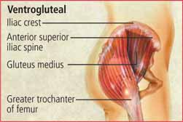  Remove your fingers and insert the needle at a 90-degree angle.
* http://books.mcgraw-hill.com/medical/NursesDrugHandbook/safe_drug_admin/identifying_injection_sites/IdentifyingInjectionSites.php

