**Elbow Examination**

1. Wash your hands and introduce yourself to the patient. Clarify the patient’s identity and explain what you would like to examine, gain their consent. Ensure the elbows are appropriately exposed, in this case the patient will probably be wearing a t-shirt.
2. INSPECTION - Begin with observation of the joint.
3. Inspect the front to check the carrying angle
4. Inspect from the side to check for a fixed flexion deformity
5. Inspect from behind and on the inside to check for scars, swellings, rashes,rheumatoid nodules and psoriatic plaques.
6. PALPATE
7. Feel the elbow, assessing the joint temperature relative to the rest of the arm.
8. Palpate the olecranon process as well as the lateral and medial epicondyles for tenderness.
9. The movements at the elbow joint are all fairly easy to describe and assess. These are:
10. Flexion
11. Extension
12. Pronation
13. Supination.

Once these have been assessed actively they should be checked passively feeling for crepitus.

1. Finally you should check for [tennis elbow](http://en.wikipedia.org/wiki/Tennis_elbow) and [golfer’s elbow](http://en.wikipedia.org/wiki/Golfer%27s_elbow).

**Tennis elbow** localises pain over the LATERAL epicondyle, particularly on active EXTENSION OF THE WRIST with the elbow bent.

**Golfer’s elbow** pain localises over the MEDIAL EPICONDYLE and is made worse by flexing the wrist.

**Hand & Wrist Examination**

Common acute problems include fractures, tendonitis and [trigger finger](http://en.wikipedia.org/wiki/Trigger_finger).

Common chronic problems include [carpal tunnel syndrome](http://en.wikipedia.org/wiki/Carpal_tunnel_syndrome), ganglions and arthritis.

There are three main conditions commonly examined on in this station:

1. Osteoarthritis
2. Rheumatoid arthritis and
3. Psoriatic arthritis this is due to the availability of patients with these conditions

… as well as the changes specific to each e.g [swan neck deformity](http://en.wikipedia.org/wiki/Swan_neck_deformity), [Bouchard’s nodes](http://en.wikipedia.org/wiki/Bouchard%27s_nodes) and [Heberden’s nodes](http://en.wikipedia.org/wiki/Heberden%27s_node).  You should therefore be familiar with the changes that each of these conditions can cause.

The examination of all joints follows the general pattern of **“look, feel, move”** as well as an assessment of function and occasionally special tests.

Subject steps

1. Wash your hands and introduce yourself to the patient. Clarify the patient’s identity.Explain what you would like to examine and gain their consent.  Ensure the hands and wrists are appropriately exposed, in this case the patient will probably be wearing a t-shirt as you will also need to inspect the elbows
2. Firstly place the patient’s hands on a pillow in between you and them, ensuring the patient is comfortable.
3. INSPECTION - Inspect the patient’s hands.
   * 1. In particular LOOK for swellings, deformities, muscle wasting, scars – particularly carpal tunnel release scars, skin changes, rashes, nail pitting, [onycholysis](http://en.wikipedia.org/wiki/Onycholysis" \t "_blank" \o "Onycholysis), nailfold vasculitis, [palmar erythema](http://en.wikipedia.org/wiki/Palmar_erythema" \t "_blank" \o "Palmar erythema). If there are joint swellings note which joints are involved and whether the changes are symmetrical or not. Remember to check both sides of the hands
     2. Now examine the hands. This should look as smooth as possible so try and develop your own technique. A good suggestion is to start proximally and work towards the fingers.
     3. Assess the temperature over the joint areas and compare these with the temperature of the forearm.
4. PALPATE
   * 1. Take the RADIAL PULSE and PALPATE THE WRIST JOINTS with your thumbs on the extensor surface and your index fingers on the flexor surface, work your way distally to the carpal bones.

[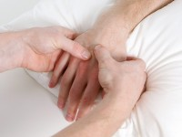](http://www.osceskills.com/resources/Carpals-inspection.jpg)

* + 1. FEEL the muscle bulk in the thenar and hypothenar eminences.  In the palms, feel for any tendon thickening and assess the sensation over the relevant areas supplied by the radial, ulnar and median nerves.
  + [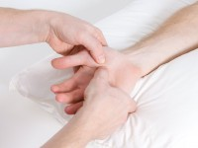](http://www.osceskills.com/resources/Feel-the-muscle-bulk-in-the-thenar.jpg)Feel the muscle bulk in the thenar eminence

1. Now squeeze over the row of metacarpophalangeal joints whilst watching the patient’s face for any discomfort. You should then move onto any MCP joints which are noticeably swollen. Palpate these,  gently, bimanually with your thumbs on the dorsum and index fingers on the palm.  Move  
   onto the interphalangeal joints and again palpate any which are swollen. This palpation is done with one of the thumbs on the top and the other on one of the sides. The index fingers go on the vacant sides of the joint.

[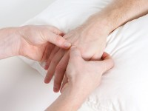](http://www.osceskills.com/resources/Metacarpophalangeal-joint-inspection.jpg)Metacarpophalangeal joint palpation

[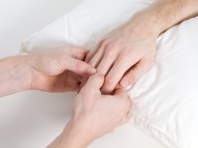](http://www.osceskills.com/resources/Interphalangeal-joint-inspection.jpg)Interphalangeal joint palpation

1. At this point the extensor surface of the elbows should be checked for any psoriatic plaques and rheumatoid nodules. Psoriatic plaques could suggest the presence of [psoriatic arthritis](http://en.wikipedia.org/wiki/Psoriatic_arthritis).

[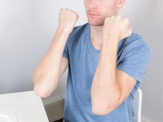](http://www.osceskills.com/resources/Check-the-underside-of-the-elbows-should-be-checked.jpg)Inspect the elbows

1. ASSESS THE MOVEMENTS OF THE WRIST:
   1. wrist flexion [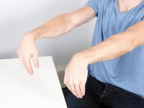](http://www.osceskills.com/resources/Wrist-flexion.jpg)
   2. wrist extension [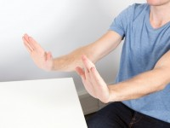](http://www.osceskills.com/resources/Wrist-extension.jpg)
   3. finger extension [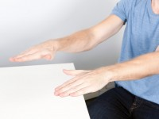](http://www.osceskills.com/resources/Finger-extension.jpg)
   4. finger flexion [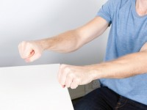](http://www.osceskills.com/resources/Finger-flexion.jpg)
   5. finger abduction [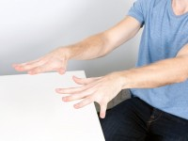](http://www.osceskills.com/resources/Finger-abduction.jpg)
   6. thumb abduction [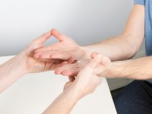](http://www.osceskills.com/resources/Thumb-abduction.jpg)
   7. thumb opposition [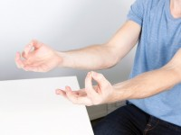](http://www.osceskills.com/resources/Thumb-opposition.jpg)
2. One special test which you may like to employ is [Phalen’s maneuver](http://en.wikipedia.org/wiki/Phalen_maneuver" \t "_blank" \o "Phalen maneuver) which is a diagnostic test for [carpal tunnel syndrome](http://en.wikipedia.org/wiki/Carpal_tunnel_syndrome).

FORCED FLEXION of the wrist, either against the other hand or by the examiner for 60 seconds will recreate the symptoms of carpal tunnel syndrome.

[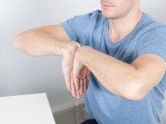](http://www.osceskills.com/resources/Phalens-maneuver.jpg) Phalens maneuver

[Froment’s sign](http://en.wikipedia.org/wiki/Froment%27s_sign) is a test which may also be performed to check Ulnar nerve function. This is performed by asking the patient to hold a piece of paper between their thumb and index finger; this will check the function of the [adductor pollicis](http://en.wikipedia.org/wiki/Adductor_pollicis_muscle). In a patient with Ulnar nerve palsy the interphalangeal joint of the thumb will flex to compensate.

1. Finally a functional assessment of the patient should be carried out. This involves firstly forming a POWER GRIP around your middle and index fingers; then a PINCER GRIP against your index finger; and lastly asking your patient to PICK-UP a small object such as a coin.

[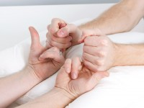](http://www.osceskills.com/resources/Power-grip-around-middle-and-index-fingers.jpg)Power grip around middle and index fingers

[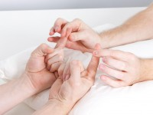](http://www.osceskills.com/resources/Pincer-grip-against-index-finger.jpg)Pincer grip against index finger

[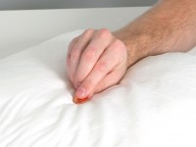](http://www.osceskills.com/resources/Pick-up-a-small-object.jpg)Pick up a small object

1. On completion, thank the patient for their time and wash your hands. Report your findings to the examiner.

**KNEE JOINT EXAMINATION**

Common conditions that cause these symptoms include

* + - 1. Arthritis
      2. ligament and/or cartilage injuries.

You should ensure you are able to perform this confidently.  
The examination of all joints follows the general pattern of “**look, feel, move**” as well as occasionally special tests, in which this station has many.

## Subject steps

1. Start by washing your hands and introduce yourself to the patient. Clarify the patient’s identity and explain what you would like to examine, gain their consent. Ensure both knees are appropriately exposed, in this case the patient will probably be wearing shorts.
2. To begin, ask the patient to WALK for you. Observe any limp or obvious deformities such as scars or muscle wasting. Check if the patient has a varus (bow-legged) or valgus (knock-knees) deformity. Also observe from behind to see if there are any obvious popliteal swellings such as a [Baker’s cyst](http://en.wikipedia.org/wiki/Baker%27s_cyst).

[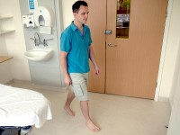](http://www.osceskills.com/resources/Ask-the-patient-to-walk.jpg)Ask the patient to walk

1. Next ask the patient LIE ON THE BED to allow a further general inspection. Look for symmetry, redness, muscle wasting, scars, rashes, or fixed flexion deformities.

[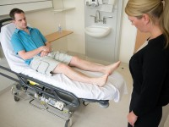](http://www.osceskills.com/resources/Perform-a-general-inspection.jpg)Perform a general inspection

[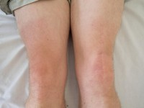](http://www.osceskills.com/resources/Knee-scar.jpg)Note the scar over the left knee of this patient

1. Now PALPATE the knee joint, start by assessing the TEMPERATURE using the back of your hands and comparing with the surrounding areas

[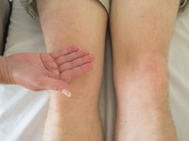](http://www.osceskills.com/resources/Assess-knee-joint-temperature.jpg)Assess knee joint temperature

1. PALPATE the BORDER OF THE PATELLA for any tenderness, behind the knee for any swellings, along all of the joint lines for tenderness and at the point of insertion of the [patellar tendon](http://en.wikipedia.org/wiki/Patellar_ligament).

[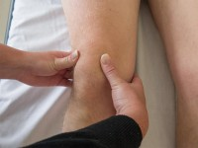](http://www.osceskills.com/resources/Palpate-the-border-of-the-patella.jpg) Palpate the border of the patella

[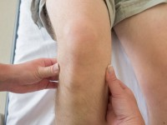](http://www.osceskills.com/resources/Palpate-the-joint-lines.jpg) Palpate the joint lines

[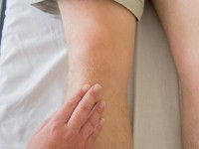](http://www.osceskills.com/resources/Palpate-the-point-of-insertion.jpg) Palpate the point of insertion

1. TAP the patella to see if there is any effusion deep to the patella.

[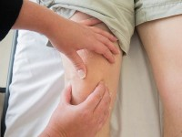](http://www.osceskills.com/resources/Tap-the-patella.jpg)Tap the patella

1. The MAIN MOVEMENTS which should be examined both ACTIVELY and PASSIVELY are:
   * Flexion [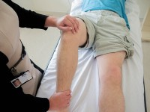](http://www.osceskills.com/resources/Knee-flexion-movement.jpg) Knee flexion movement
   * Extension [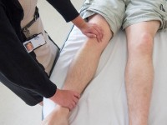](http://www.osceskills.com/resources/Knee-extension-movement.jpg) Knee extension movement

A full range of movements should be demonstrated and you should feel for any **[crepitus](http://en.wikipedia.org/wiki/Crepitus" \t "_blank" \o "Crepitus).**

1. Now perform the SPECIAL TESTS TO ASSESS THE CRUCIATE LIGAMENTS
   * **ANTERIOR DRAWER TEST**: Flex the knee to 90 degrees and sit on the patient’s foot. Pull forward on the tibia just distal to the knee. There should be no movement. If there is however, it suggests ANTERIOR CRUCIATE LIGAMENT damage. Another test for ACL damage is Lachman’s test.

[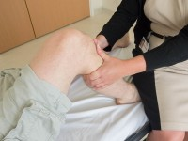](http://www.osceskills.com/resources/Draw-test.jpg)

* + **POSTERIOR DRAWER TEST**: With the knee in the same position, observe from the side for any posterior lag of the joint, this suggests POSTERIOR CRUCIATE ligament damage.

[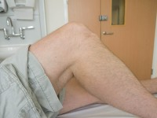](http://www.osceskills.com/resources/Posterior-lag-test.jpg)Posterior lag test

1. Now perform the SPECIAL TESTS TO ASSESS THE COLLATERAL LIGAMENTS.  Do this by holding the leg with the knee flexed to 15 degrees and place LATERAK AND MEDIAL STRESS on the knee. Any excessive movement suggests collateral ligament damage.

[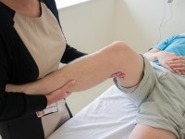](http://www.osceskills.com/resources/Lateral-stress.jpg)Lateral stress

[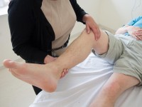](http://www.osceskills.com/resources/Assess-medial-stress.jpg)Medial stress

1. Perform McMURRAY’s TEST to assess for MENISCAL damage.  Hold the knee up and fully flexed, with one hand over the knee joint itself and the other on the sole of that foot.  Stress the knee joint by medially and laterally moving the foot.  PAIN OR A CLICK is a positive test, confirming meniscal damage.

[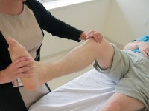](http://www.osceskills.com/resources/McMurrays-test.jpg)McMurray's test

1. Allow the patient to dress and thank them.  Wash your hands and report your findings to the examiner.