**Simple Interrupted Suture:**

|  |  |
| --- | --- |
| **1** | Equipment: |
|  | 1. Needle |
|  | 1. Needle holder |
|  | 1. Forceps |
|  | 1. Gloves |
|  | 1. Scissors |
| **2** | Wear gloves and clean the area |
| **3** | The needle is held by the needle holder, by placing the needle holder two thirds away from the sharp point. |
| **4** | Needle enters the skin at 90 degree angle |
| **5** | Approximately 1-2 mm from the wound edge |
| **6** | After penetration the needle is redirected to the other side of the wound. |
| **7** | Use the forceps to grasp the skin as the needle passes through |
| **8** | Pull the needle out with the forceps |
| **9** | While holding the needle with the forceps rotate it around the needle holder twice |
| **10** | Open the needle holder and hold the tip of the free suture string |
| **11** | Now hold the needle with the needle holder and rotate it around the forceps once hold the free suture string and secure the knot |
| **12** | Keep on doing the instrument tie till you get 5-6 knots. |
| **13** | Cut the suture |
| **14** | Go 1-2mm away from this suture and start again |

**Simple Continuous Suture:**

|  |  |
| --- | --- |
| **1** | Equipment: |
|  | 1. Needle |
|  | 1. Needle holder |
|  | 1. Forceps |
|  | 1. Gloves |
|  | 1. Scissors |
| **2** | Wear gloves and clean the area |
| **3** | The needle is held by the needle holder, by placing the needle holder two thirds away from the sharp point. |
| **4** | Start by doing a simple suture at the end of the wound. |
| **5** | Keep the long end of the suture don’t cut it |
| **6** | Than do another simple suture but don’t lock it |
| **7** | Continue doing simple sutures without locking them till you reach the end of the wound |
| **8** | At the end you will have a loop and a free end |
| **9** | Display the loop between the index finger and thumb of your left hand making it as small as possible by pulling on the other end of the thread with your right hand |
| **10** | Grasp the free end between the index finger and thumb of the left hand through the loop and by pulling it through and releasing the right hand thread, the old loop is eliminated |
| **11** | Once again the new loop is made as small as possible by pulling on the right-hand thread, and the whole process is repeated using a type of 'see saw' movement |
| **12** | The whole process is then repeated about 6 - 7 times |
| **13** | Finally, pass the free end through the loop and tighten down |
| **14** | Cut the thread |

**Continuous Locked Suture:**

|  |  |
| --- | --- |
| **1** | Equipment: |
|  | 1. Needle |
|  | 1. Needle holder |
|  | 1. Forceps |
|  | 1. Gloves |
|  | 1. Scissors |
| **2** | Wear gloves and clean the area |
| **3** | The needle is held by the needle holder, by placing the needle holder two thirds away from the sharp point. |
| **4** | Start by doing a simple suture at the end of the wound. |
| **5** | Keep the long end of the suture don’t cut it |
| **6** | Than do another simple suture but don’t lock it |
| **7** | Keep a loop to that stitch and do another simple suture |
| **8** | Pass the needle through that loop |
| **9** | Continue doing that till you reach the end of the wound |
| **10** | At the end you will have a loop and a free end |
| **11** | Display the loop between the index finger and thumb of your left hand making it as small as possible by pulling on the other end of the thread with your right hand |
| **12** | Grasp the free end between the index finger and thumb of the left hand through the loop and by pulling it through and releasing the right hand thread, the old loop is eliminated |
| **13** | Once again the new loop is made as small as possible by pulling on the right-hand thread, and the whole process is repeated using a type of 'see saw' movement |
| **14** | The whole process is then repeated about 6 - 7 times |
| **15** | Finally, pass the free end through the loop and tighten down |
| **16** | Cut the thread |

**Vertical Mattress Suture:**

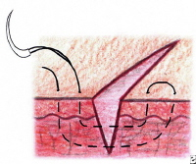

[*http://emedicine.medscape.com/article/1824895-overview#a15*](http://emedicine.medscape.com/article/1824895-overview#a15)

**Horizental Mattress Suture:**

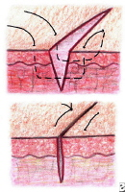

[*http://emedicine.medscape.com/article/1824895-overview#a15*](http://emedicine.medscape.com/article/1824895-overview#a15)

**Wound Care:**

**MATERIALS: Wound dressing (4x4 gauze pad or swab, forceps,** sterile cotton tipped applicators**), aseptic solutions (**0.9% Normal Saline, D/W, Chlorexidine, Povidone Iodine**, clean gloves, soap and water**

|  |  |
| --- | --- |
|  | **STEP/TASK** |
|  | **Preparation** |
| **1.** | Introduce yourself to the patient. |
| **2.** | Confirm patient’s ID. |
| **3.** | Explain the procedure to the patient. |
| **4.** | Get patient’s consent. |
| **5.** | Ask for a assistantance. |
| **6.** | Wash hands and put on clean gloves. |
| **7.** | Prepare the necessary materials. |
| **8.** | Ensure the privacy of the patient. |
| **9.** | Position the patient depending on the location of the wound and ensure that she/he is comfortable. |
| **10.** | Expose the wound area. |
|  | **Procedure** |
| **11.** | Remove the old wound dressing. |
| **12.** | From a distance, assess the wound from any redness, discharges, swelling, and bleeding. |
| **13.** | Remove old gloves. |
| **14.** | Wash hands. |
| **15.** | Put on Sterile Gloves |
| **16.** | Irrigate the wound if needed. |
| **17.** | Clean the wound using selected solutions (0.9% Normal Saline, D/W, Chlorexidine, Povidone Iodine). |
| **18.** | Start from the top of the incision to the bottom. Wipe once and then discard the gauze pad. |
| **19.** | **Continue to work outward from the incision in line running parallel to it. Always wipe from cleanest area toward the dirtiest area (usually from top to bottom).** |
| **20.** | Use each gauze pad or swab for only one stroke. |
| **21.** | Use sterile cotton tipped applicators for efficient cleaning of tight-fitting wire sutures, deep and narrow wounds. |
| **22.** | Clean all areas of the wound to wash away debris, pus, blood. Try not to disturb sutures or irritate the incision. |
| **23.** | Check to make sure the edges of the incision are lined up properly. |
| **24.** | Wash skin surrounding the wound with soap and water and pat dry using sterile 4x4 gauze pads. |
| **25.** | Apply a skin protector if needed. |
| **26.** | Gently place sterile 4x4 gauze pads at the centre of the wound and move progressively outward to the edges. |
|  | ***Continue on next page ->*** |

|  |  |
| --- | --- |
| **27.** | Extend the gauze at least 1” or 2.5 cm beyond the incision in each direction. |
| **28.** | Secure the dressings’ edges to the patient skin. |
| **29.** | Make sure patient is comfortable. |
| **30.** | Properly dispose of the solutions in the trash bag as per hospital policy. |
|  | **After the Examination** |
| **31.** | Cover up the patient. |
| **32.** | Thank the patient and ensure her/his comfort. |
| **33.** | Explain to the patient what has been done and answer any of her/his questions. |
| **34.** | Document the examination. |
| **35.** | Wash hands. |
| **36.** | Summarize your findings. |

**Ultrasound Principles:**

* **Introduction to Ultrasound Machine and How to use it:**

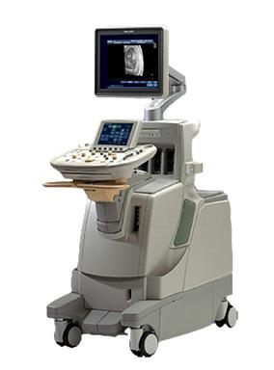 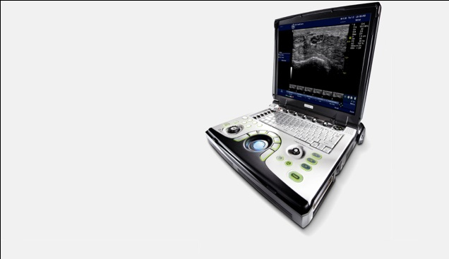

* **Different Types of Ultrasound Transducers :**

**These are a few types of ultrasound transducers**

1- Convex Transducer (Low Frequency)

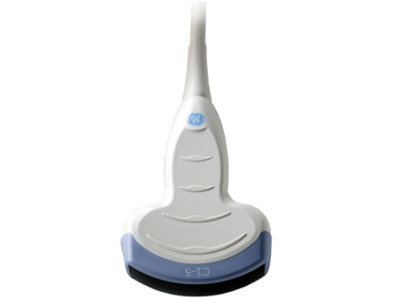

2- Linear Transducer (High Frequency)

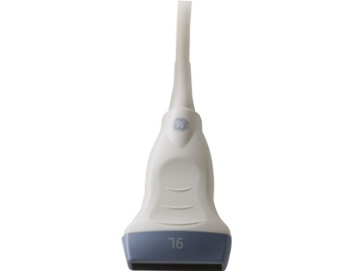

3- Hockey stick Transducer (High Frequency)

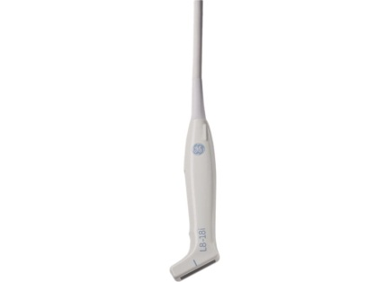

4- Trans rectal/ Trans vaginal Transducers

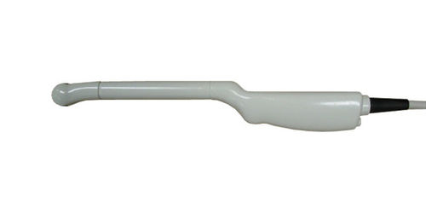

5- 3D/4D transducers

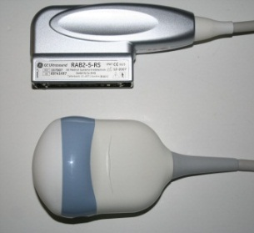

* **Introduction to different types of ultrasound procedures:**
* **How to Scan the Kidneys?**

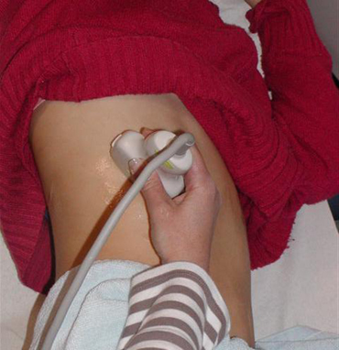 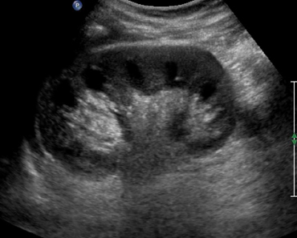Longitudinal: Normal Kidney

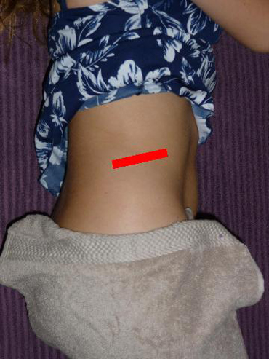 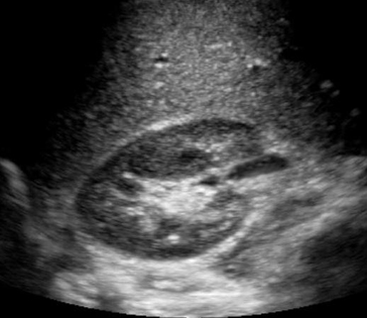 Transverse kidney

* **How to scan the liver?**

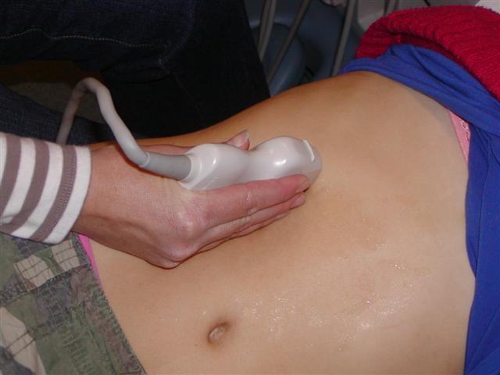 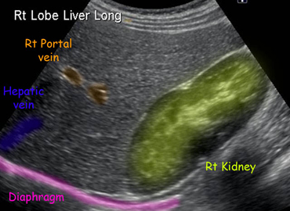

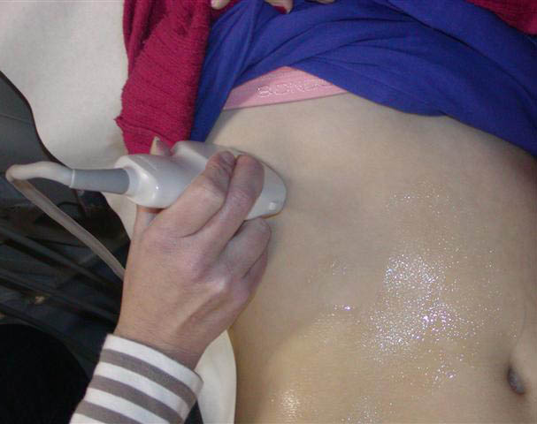 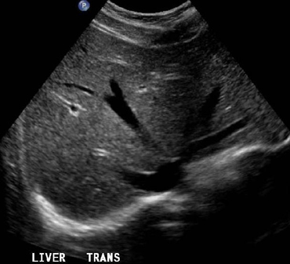

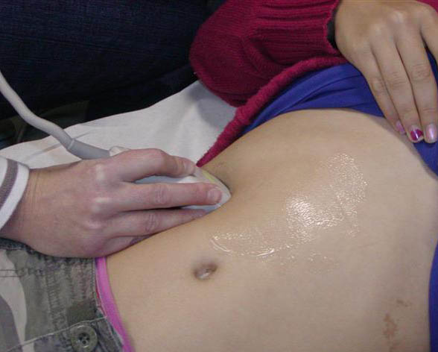 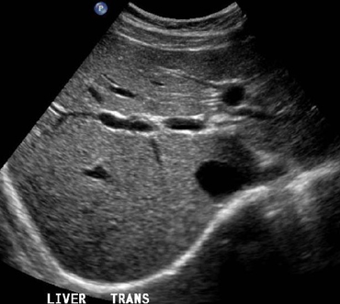

* **How to scan the gallbladder?**

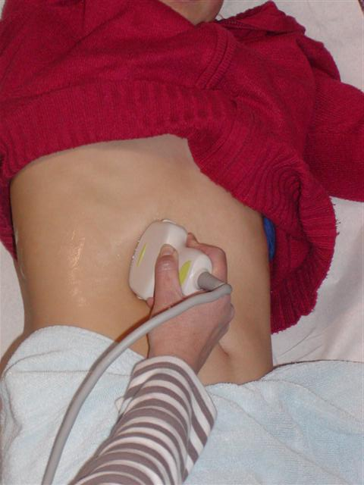 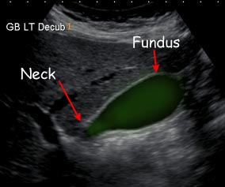

* **How to scan the UB if the patient is full bladder?**

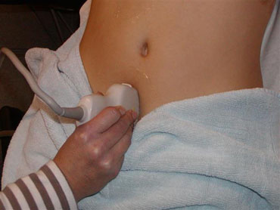 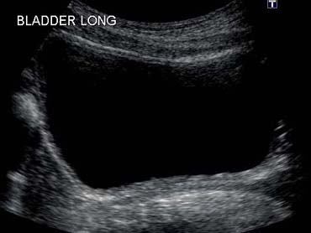

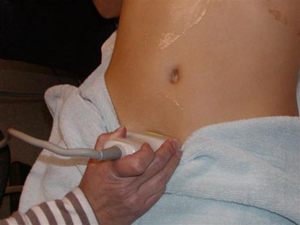 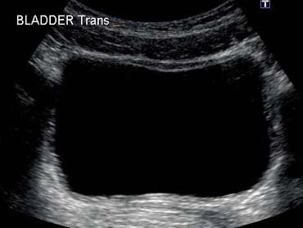

**Defibrillation:**

|  |  |
| --- | --- |
|  | **STEP/TASK** |
|  | **Preparation** |
| **1.** | Defibrillator |
| **2.** | Electrical outlet |
|  | **Procedure** |
| **3.** | Turn the monitor on (manual mode/ AED mode) |
| **4.** | Applies ECG leads correctly ( Negative, Positive, Ground) |
| **5.** | Verbalizes the difference between Monophasic / Biphasic |
| **6.** | Verbalizes correct electrical therapy for appropriate rhythm   * Synchronized cardioversion for unstable SVT, VT with Pulses * Defibrillation for pulseless VT, VF * Difference between Cardioversion/ Defibrillation |
| **7.** | Select correct paddle/ electrode pad for infant or child |
| **8.** | List the different usages of multi function pads |
| **9.** | Demonstrate correct and safe Synchronized cardioversion   * Select sync mode on the monitor * Select appropriate energy adult / pediatric * Charges, clear, shock |
| **10.** | Demonstrate correct and safe Synchronized defibrillation   * Select unsynchronized mode * Select appropriate energy adult / pediatric * Charges, clears, shock |
|  | **After the procedure** |
| **11.** | Clean the monitor |
| **12.** | Keep the monitor connected the electrical outlet |