Health Education In Clinical Settings report

STUDENT NAME | ID NUMBER
LAMEES ABDULLAH FAHAD ALTAMIM | 435202439
KHAWLA ABDUL RAHMAN MOHA | 435202331
OLA MOHAMMED AYAD ALNUHAYER | 435202372
NORAH SULEMAN S ALAKEEL | 435202503
FUTOON SULAIMAN A ALSALEH | 435202576
REEMA MOHAMMED SAUD BIN TUWAIM | 435202635
JAWAHER SAHER M ALHARBI | 435202817
MALAK FAYHAN F ALSHAREEF | 435202876
AlAnoud Ibrahim BinOmair | 435202974
DANIA ALI A ALHINDAWI | 435203395

The Case:
Ms. C is a 42-year-old black American woman with a 7-year history of hypertension first diagnosed during her last pregnancy. Her family history is positive for hypertension, with her mother dying at 56 years of age from hypertension-related cardiovascular disease (CVD). In addition, both her maternal and paternal grandparents had CVD.
At physician visit one, Ms. C presented with complaints of headache and general weakness. She reported that she has been taking many medications for her hypertension in the past, but stopped taking them because of the side effects. She could not recall the names of the medications. Currently she is taking 100 mg/day atenolol and 12.5 mg/day hydrochlorothiazide (HCTZ), which she admits to taking irregularly because “... they bother me, and I forget to renew my prescription.” Despite this antihypertensive regimen, her blood pressure remains elevated, ranging from 150 to 155/110 to 114 mm Hg. In addition, Ms. C admits that she has found it difficult to exercise, stop smoking, and change her eating habits. Findings from a complete history and physical assessment are unremarkable except for the presence of moderate obesity (5 ft 6 in., 150 lbs), minimal retinopathy, and a 25-year history of smoking approximately one pack of cigarettes per day. (1)

Poor adherence:
If hypertension is not controlled or the patients has poor adherence to its medications will lead to:
●heart attack or stroke.
●High blood pressure can cause hardening and thickening of the arteries
(atherosclerosis), which can lead to a heart attack, stroke or other complications.

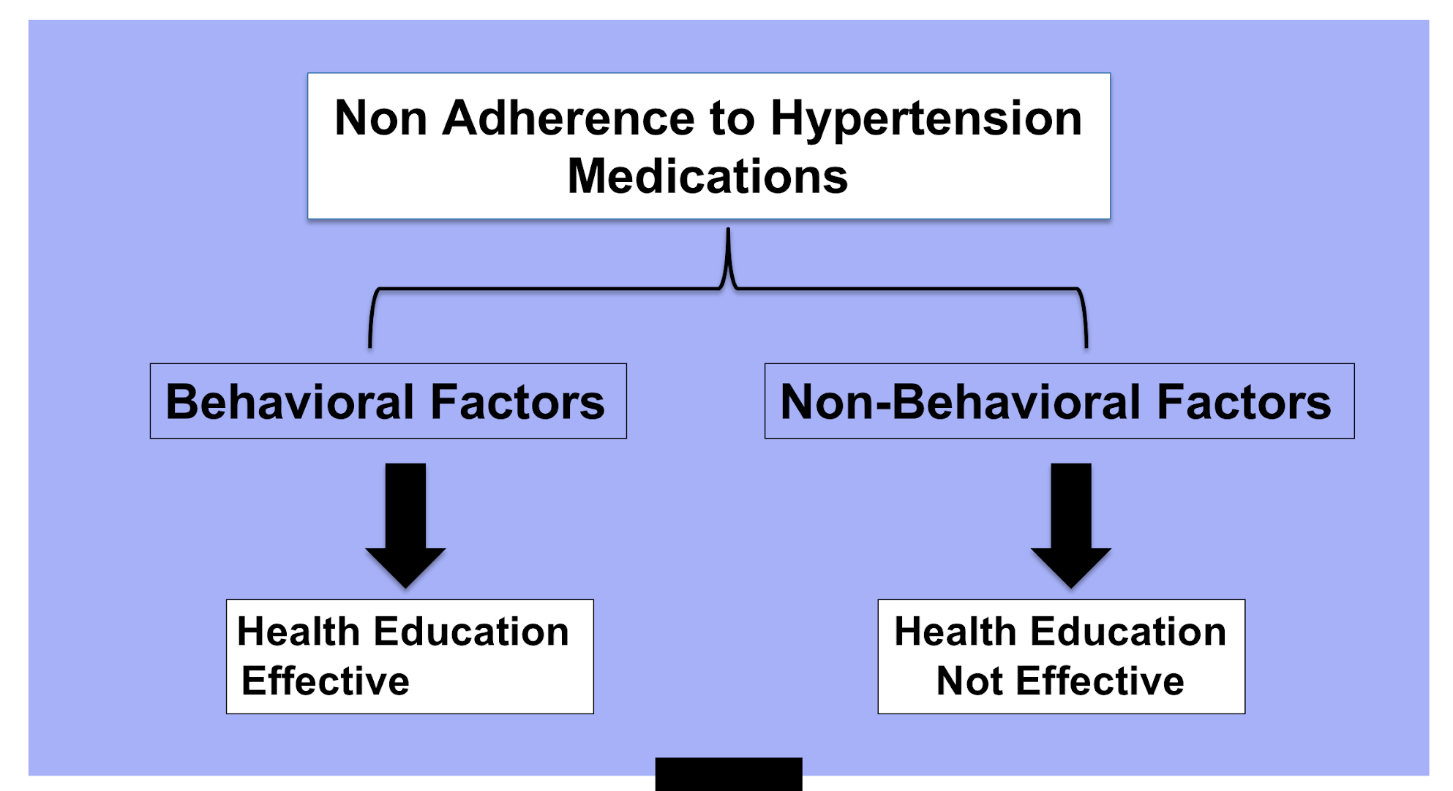

Non Adherence to Hypertension Medications is divided into two parts:
1)Behavioral Factors which is Health Education Effective
2) Non Behavioral Factors which is Health Education Effective

FIRST: Behavioral factors
Factors influencing medication adherence :
- patient views
- Attributes
- Illness characteristics
- Social contexts
- Access and Service issues.

Barriers to the effective use of medicines specifically include :
- poor provider-patient communication
- inadequate knowledge about a drug and its use
- not being convinced of the need for treatment
- fear of adverse effects of the drug
- long term drug regimens
- complex regimens that require numerous medications with varying dosing schedules
- cost and access barriers.

Methods to improve medication adherence
-At Level of prescribing
- collaborative approach with the patient
- Simplify medication taking

-At level of Communicating with the patient
- Explain key information
- Use medication adherence improving aids
- Provide behavioral support

-During follow ups:
- Schedule follow ups to the pateint
- Assess adherence during consequent follow ups
- Identify difficulties and barriers , address the problems
- Inform the patients accordingly how the problems have been addressed

Second: Non-Behavioral factors
Uncontrolled hypertension Could be due to:
- Resistance (refractory) of hypertension
Secondary causes that contribute to resistant hypertension :
- The most common secondary causes of resistant hypertension :
- Drug-induced hypertension
- Obstructive sleep apnea
- Primary aldosteronism
- Chronic kidney disease

Management of resistant hypertension :

- Resistant hypertension is almost always multifactorial in etiology.
- Treatment is predicated on identification and reversal of lifestyle factors contributing to treatment resistance; accurate diagnosis and appropriate treatment of secondary causes of hypertension; and use of effective multi-drug regimens.
- Combination Therapy :
An abundance of studies demonstrate additive antihypertensive benefit by combining 2 agents of different classes. This is particularly true of thiazide diuretics.
Withdrawal of Interfering Medications.

Lifestyle and resistant hypertension :

Resistance to antihypertensive treatment is affected by several lifestyle factors.
Excessive dietary salt intake is common in patients with resistant hypertension and contributes to treatment resistance.
Obesity can also contribute to treatment resistance.
Alcohol consumption is another important factor.
The role of physical inactivity in patients with resistant hypertension has not been adequately studied.

One of the more useful categorizations of learning objectives includes three learning domains

1-cognitive domain:mental skills (knowledge)
2-psychomotor:manual or physical skills (skills)
3-affective domains:growth in feelings or emotional areas (attitude or self)

Cognitive domain categories:
Knowledge: the ability to recall data and/or information.
Example: A child recites the English alphabet.

Comprehension: the ability to understand the meaning of what is known.
Example: A teacher explains a theory in his own words.

Application: the ability to utilize an abstraction or to use knowledge in a new situation.
Example: A nurse intern applies what she learned in her Psychology class when she talks to patients.

Analysis: the ability to differentiate facts and opinions.
Example: A lawyer was able to win over a case after recognizing logical fallacies in the reasoning of the offender.

Synthesis: the ability to integrate different elements or concepts in order to form a sound pattern or structure so a new meaning can be established.
Examples: A therapist combines yoga, biofeedback and support group therapy in creating a care plan for his patient.

Evaluation: the ability to come up with judgments about the importance of concepts.
Examples: A businessman selects the most efficient way of selling products

Objectives of health education falling in learning domains :

- Affective Domain: It is the domain that deals with expression of feelings and acceptance of attitudes, opinions, or values.
-The objectives are:
- Demonstrate a willingness to learn.
- Demonstrate a true concern to use her own therapy correctly.

-As a health educator, it is important to:
- assess a patient’s readiness to learn by talking with the patients and their family and by listening to the their concerns.
- Develop a relationship of trust with the patient.
- Getting patient to see how these skills will benefit the patient is the key to motivation.

-The five major categories of the affective domain are:
- Receiving
- Responding
- Valuing
- Organizing
- Characterizing

-Psychomotor Domain: It is the domain that deals with skills, where the learner is using the physical action to achieve the cognitive objectives.

-The objectives are those specific to:
- Discreet physical functions
- Reflex actions
- Interpretive movements.

-As a health educator:
- Repetition and active involvement are important when teaching
- provide plenty of opportunity for the patient to practice the activity.
- Be sure to provide help and encouragement as needed
- Be patient; not everyone develops skills at the same rate.
-To acquire these skills , the patient needs to have:
- Knowledge
- Physical ability
- Attitude to learn the skills.

Health Messages In Line with the objectives

- Cognitive Domain “Knowledge”

- What does a high blood pressure mean? (what is systolic BP? What is diastolic BP? What is the normal values)
- Risk factors of high blood pressure (concentrate in behavioral risk factors)
- Complications of high blood pressure (how is a persistently elevated blood pressure can affect heart, kidney, brain)
- Methods of treating and controlling high blood pressure
  - Lifestyle changes (Diet, Exercise)
  - Drug treatment (what are the types of drugs that are available, possible drug-drug interaction, side effects)

- Affective Domain “Attitude”

- The susceptibility of the complications (Likelihood): “there are many people who didn’t take the drugs and they have had the complications. You are at risk of having the complications”
- The severity of the complications (seriousness) “these complications are life-threatening!”
- The effectiveness of the drugs in decreasing the chances of experiencing these complications.

- The barriers of taking the drugs (for example: side effects). “Even though they exists, the benefits of the drug is greater than the known side effects”
- Factors that activate readiness to change. “Let her now about applications in which she can set multiple reminders if she was concerned that she might forget to take them regularly. If she was concerned about the side effects let her know that she will always take the drug that has fewer side effects also tell her that once she notice a certain side effect you can change the drug for her”.
- Self-efficacy. “motivate your patient and let her know that she can do it and you are going to help her”

Cognitive Domain “Knowledge”

- Tell her the right consumption method (dose, timing)
- Show her how to set a reminder in her phone
- Tell her what to do when she notice an adverse drug reaction (who to tell? Where to go?)
- Tell her about the different ways to refill the prescription (so instead of coming in person and waiting for some time, she can call or email a certain person to prepare the prescription for her. Some health institution have a website in which the patient can request a medication refill)

Health Education Methods:

What are the appropriate methods of health education are suitable to deliver the health messages for Ms. C?

- Counselling is the best way.
    - Active participation in understanding the problems and selecting a solution.
    - Choices are made based on perception of the situation.
    - Feel that he is in control of his life.
    - Assume more responsibilities.

  - Principles of counseling:
- Greet the person
- Gain trust
- Ask about the problem
- Listen carefully
- Provide background information
- Answer raised questions
- Check understanding
- Assist in reaching a decision
- Clear doubts
- Give appointment for follow up

- Role play (how?) make the patient involved in his condition, e.g.: (how to use sphygmomanometer)
- Community organizations.
- Posters.
- Pamphlets and brochures.

Health Education aids :

Educational aids are materials that help in the success of the education process. As the name implies, they help in simplifying the presented knowledge and skills and not a substitute to the educator.

- The appropriate aids of health education are suitable to deliver the health messages for Ms.C:
- Still pictures. (to reproduce reality)
- Motion pictures and videos.
- Exhibition or display. (arrangement of real objects or models)
- Posters.
- Leaflet and pamphlet. (reminder of information given)
- Charts. (progress of events using graph)

At the end do not choose everything because there will be pressure to the educator and the program. The choice depends on many things for example : the target population age , education state, budget.
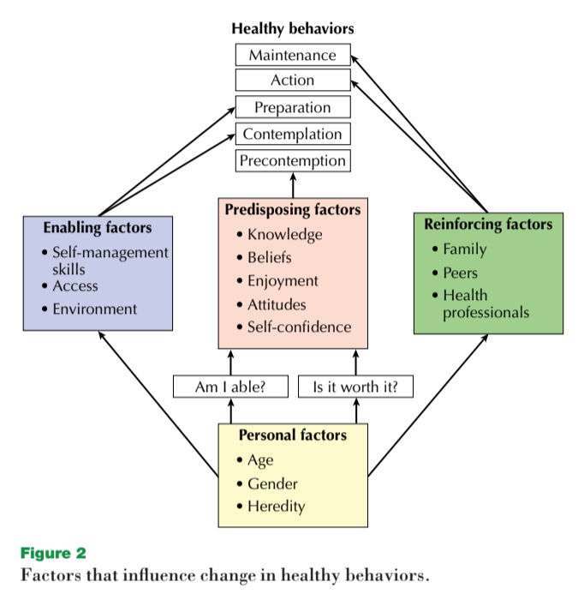
Predisposing, enabling and reinforcing factors to adopt the intended behavior
Reducing illness and promoting wellness and fitness are important goals for all of us. There is evidence that many people are not effective in making lifestyle changes, even when they want to do so. In this concept, factors relating to healthy lifestyle adherence will be described.

Personal factors affect health behaviors but are often out of your personal control.
Your age, gender, and heredity are examples of personal factors. While these factors do not cause differences in behavior, differences in behavior are evident across these factors. For example, there are significant differences in health behaviors among those of various age groups. According to one survey, young adults between the ages of 18 and 34 are more likely to smoke (30 percent) than those 65 and older (13 percent). Gender differences are illustrated by the fact that women are more likely than men to participate in regular health screenings. Heredity plays a role in health behaviors. For example, some people have a hereditary predisposition to gain weight,
and this may affect their eating behaviors. While personal factors should be considered in making
lifestyle changes, there is little you can do about your age, gender, or heredity.

Predisposing factors are important in getting you started with the process of change.

Predisposing factors are associated with two basic questions: “Am I able?” and “Is it worth it?”Am I able to do regular activity? Am I able to change my diet or to stop smoking? People who have “feelings that they are able” are said to have good perceptions of competence. They have the self-confidence and self-efficacy to embark on behavior changes for health improvement. Is it worth it? Making a change in behavior takes effort. You are more likely to make a change in behavior if you think your effort is worthwhile. Some factors that make a behavior change worthwhile are having the belief that the change will have benefits. Part of changing your beliefs is becoming knowledgeable about the behavior and its benefits. Enjoyment is another factor that makes a behavior change worthwhile. If you enjoy doing something, the enjoyment is its own benefit. Finally, attitudes make a difference. Research shows that people who have more positive feelings (attitudes) than negative attitudes are likely to adopt healthy behaviors.

Enabling factors:

Enabling factors are important in moving you from the beginning stages of change to action and maintenance.
1-Self-management skills :
Skills that you can learn to help you adhere to healthy lifestyles such as regular physical activity. Examples include goal setting, time management, and program-planning skills.
2-Access :
Having access to the things you need to make changes in lifestyle is another type of enabling factor. For instance, having access to fitness facilities or cooking facilities would enable you to do regular exercise or cook healthy meals.
3-Environment

Reinforcing factors:
Once a person has reached the action stage, it is important to move on to maintenance. Once a person has reached the maintenance stage, it is important to stay at that stage. Reinforcing factors help people stick with a behavior change . Family, peer, and health professional influence are all reinforcing factors. If your family and friends or a doctor encourage you, it may help you adhere. It is important, however, that support from others does not create unnecessary pressure. Though support from others can be reinforcing, perhaps the most important reinforcing factor is success. If you change a behavior and have success, it makes you want to keep doing the behavior. If you fail, you may conclude that the behavior does not work and give up on it. Planning for success is very important in adhering to healthy lifestyle change.

References :
1-Case study, Oparil S. Case study. 2018.https://academic.oup.com/ajh/article/11/S8/192S/151724
2- The Second Principle. The work of Leslie Owen Wilson, Ed. D. https://thesecondprinciple.com/instructional-design/threedomainsoflearning/
3- Clinicalgate.com https://clinicalgate.com/patient-education-and-health-promotion/#s0020
4- World Health Organization. 2012. Health education: theoretical concepts, effective strategies and core competencies: a foundation document to guide capacity development of health educators. Available from: http://applications.emro.who.int/dsaf/EMRPUB_2012_EN_1362.pdf.
5-https://www.moh.gov.sa/HealthAwareness/HealthDay/2017/Pages/HealthDay-2017-05-17.aspx minstery of health website.
6-Resistant Hypertension: Diagnosis, Evaluation, and Treatment http://circ.ahajournals.org/content/117/25/e510
7-Common Secondary Causes of Resistant Hypertension and Rational for Treatment https://www.hindawi.com/journals/ijhy/2011/236239/
8- Patient Medication Adherence: Measures in Daily Practice https://www.ncbi.nlm.nih.gov/pmc/articles/PMC3191684/
9-Health and Behavior: The Interplay of Biological, Behavioral, and Societal Influences. https://www.ncbi.nlm.nih.gov/books/NBK43744/
10- Resistant Hypertension: Diagnosis, Evaluation, and Treatment http://circ.ahajournals.org/content/117/25/e510

11- Common Secondary Causes of Resistant Hypertension and Rational for Treatment https://www.hindawi.com/journals/ijhy/2011/236239/

