People living with disabilities | March 19  2018
 |  | Report Group (7)

No. | Computer No. | STUDENT'S NAME | Signature
1 | 435201248 | HISSAH ROSHID ABDURHMAN ALM
2 | 435201253 | RAWAN ABDULRAHMAN A ALDHUWAYHI
3 | 435201264 | ASMAA ABDALLAH MOSA ALAMM
4 | 435201316 | REEM ABDULLAH AHMED ALBAHL
5 | 435201332 | REFAN TALAL J HASHIM
6 | 435201373 | AFNAN ABDULLAH ATIAH ALMALK
7 | 435201393 | AMJAD ABDULKAREEM O ALSUWA
8 | 435201438 | SAMAR MSLEH S ALOTAIBI
9 | 435201457 | ALJOHARA MOHAMMAD A ALMAZ
10 | 435201499 | GADIR AHMED MOHAMMED ASSIR

Learning objectives:
1. Distinguish between health and quality of life
2. Portray with a diagram the spectrum of health
3. Develop an understanding to the concept of disability
4. Recognize that the term “handicap” doesn’t exist anymore
5. Compare between the medical model and social model of disability
6. Explain the strengths of the ICF in mapping disabilities, prevention and interventions.
7. Distinguish between capacity and performance
8. State the main health conditions associated with disability
9. List the disabling barriers
10. Outline the interventions for prevention of disabilities and rehabilitation
11. Give an account on CBR

1. Distinguish between health and quality of life

Health definition | Quality of life
Definition of health “State of complete physical, mental, and social well-being, not merely the absence of disease or infirmity"(WHO, 1948). In recent years, this statement has been amplified to include the ability to lead a "socially and economically productive life” | Quality of life “Individual's PERCEPTION OF THEIR POSITION in life in the context of the culture and value systems in which they live and in relation to their goals, expectations, standards and concerns.” (WHO)

2. Portray with a diagram the spectrum of health
The medical model states that disability is caused by the health condition a person has and the nature of this condition will determine what they can and can’t do.
The medical model would say that in order for everyone to participate fully in society, everyone would need a non-disabled body and mind. This makes ‘disability’ the result of the person being different, not of society.
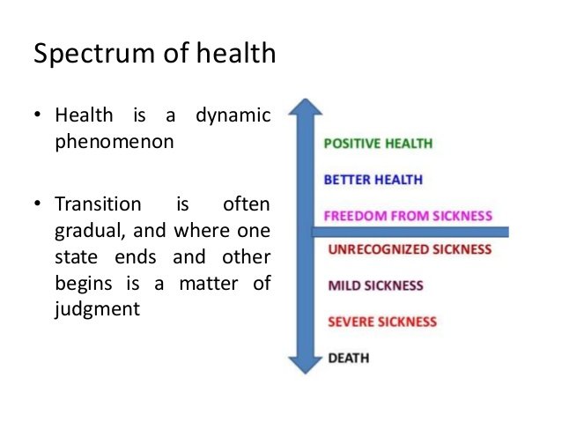

3. Develop an understanding to the concept of disability
What is the true definition of disability ?
A long-term physical, mental, intellectual, or sensory impairment which in interaction with various barriers may hinder their full and effective participation in society on an equal basis with others.
What is the global magnitude of disability ?
- Nearly 10% of the world’s population lives with disabilities (650 millions)
- 80% of persons with disabilities live in developing countries
- Nearly 200 million children are living with disability.
- In any population at least 2.5% of children below the age of 15 years have an overt moderate to severe degree of physical or intellectual impairment and an additional 8% are expected to have learning or behavioral difficulties or a combination of both learning and behavioral difficulties.
- Expected increase in the number of persons with disabilities as a result of population growth, the advances in medical technology and the ageing process.
- In countries with life expectancies exceeding 70 years, individuals spend on average 8 years or 11.5% of their life span living with disabilities.
What has KSA done so far for people living with disability?
Persons living with disability - KSA
- (1987) the legislation of disability (LD) passed as the first legislation for people with disabilities in KSA with provision to warrant equal rights.
- (2000) the disability code was passed by the Saudi government to pledge that people with disabilities have access to free and appropriate medical, psychological, social, educational, and rehabilitation services through public agencies.
How does disability develop?
DISEASE | Departure from health
IMPAIRMENT | loss/damage of a body part or aberration of physiological functions
DISABILITY | Inability to carry out function or activity
HANDICAP | limitation of person’s role

4. Recognize that the term “handicap” doesn’t exist anymore
What does the word handicap mean?
Handicap “Reduction in person’s capacity to fulfill a social role as a consequence of impairment, inadequate training for the role or other circumstances”. Applied to children, the term usually refers to: “the presence of impairment or other circumstances that are likely to interfere with normal growth and development or with the capacity to learn.”
5. Compare between the medical model and social model of disability
Social model | Medical model
- The social model of disability proposes that what makes someone disabled is not their medical condition, but the attitudes and structures of society.  STRUCTURES OF THE SOCIETY ARE SOCIAL THE BARRIERS:  - Community attitudes  - Environmental barriers  - Institutional barriers  It is a civil rights approach to disability. If modern life was set up in a way that was accessible for people with disabilities then they would not be excluded or restricted. The distinction is made between ‘impairments’, which are the individual problems which may prevent people from doing something, and ‘disability’, which is the additional disadvantage bestowed by a society which treats these ‘impairments’ as abnormal, thus unnecessarily excluding these people from full participation in society. The social model of disability says that it is society which disables impaired people.  Some of the key ways people are disabled by society are:  - Prejudice.  - Labeling  - Ignorance  - lack of financial independence  - families being over protective  - Not having information in formats which are accessible to them. | - The medical model states that disability is caused by the health condition a person has and the nature of this condition will determine what they can and can’t do.  The medical model would say that in order for everyone to participate fully in society, everyone would need a non-disabled body and mind. This makes ‘disability’ the result of the person being different, not of society.  The medical model of disability –in sequence:  Handicap: role limitation.  Disability: inability to carry out function or activity.  Impairment: anatomical and physiological changes  Disease: this is considered a departure from health.  .

6. Explain the strengths of the ICF in mapping disabilities, prevention and interventions
What do we mean by ICF?
The International Classification of Functioning, Disability and Health (ICF) advanced the understanding and measurement of disability. It was developed through a long process involving academics, clinicians, and – importantly – persons with disabilities.
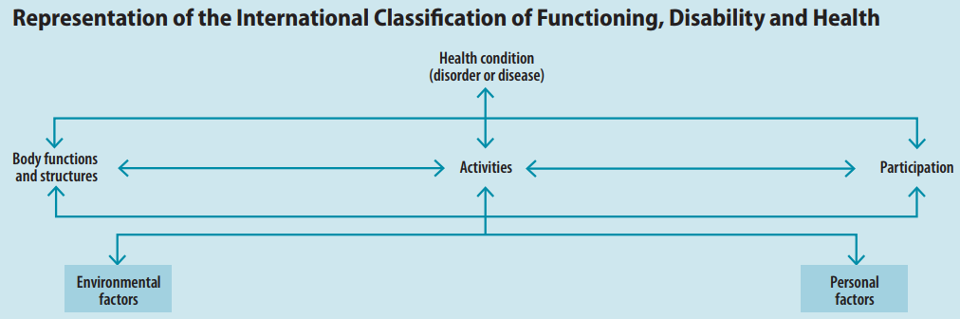
What are the strengths of the ICF in mapping disabilities, prevention and interventions?
- The ICF emphasizes environmental factors in creating disability, which is the main difference between this new classification and the previous International Classification of Impairments, Disabilities, and Handicaps (ICIDH).
- In the ICF, problems with human functioning are categorized in three interconnected areas:
- Impairments are problems in body function or alterations in body structure – for example, paralysis or blindness.
- Activity limitations are difficulties in executing activities – for example, walking or eating.
- Participation restrictions are problems with involvement in any area of life – for example, facing discrimination in employment or transportation.
- The ICF contains a classification of environmental factors describing the world in which people with different levels of functioning must live and act.
- The ICF also recognizes personal factors, such as motivation and self-esteem, which can influence how much a person participates in society.
- The ICF is universal because it covers all human functioning and treats disability as a continuum rather than categorizing people with disabilities as a separate group.
- It is useful for a range of purposes – research, surveillance, and reporting – related to describing and measuring health and disability.

7. Distinguish between capacity and performance
- The performance qualifier is described as what an individual does in his or her current environment. Since the current environment always includes the overall societal context, performance can also be understood as "involvement in a life situation" or "the lived experience" of people in their actual context.
- The capacity qualifier describes an individual’s ability to execute a task or an action. This construct indicates the highest probable level of functioning of a person in a given domain at a given moment, and to assess the capacity it is said that one would need to have a “standardized environment". But again, it has been mentioned that the capacity qualifier assumes a 'naked person' assessment, that is, the person's capacity without personal assistance or the use of assistive devices.
8. State the main health conditions associated with disability
Infectious diseases  • HIV/AIDS  • Malaria  • Poliomyeliti s  • Leprosy  • Trachoma | Non-communicable diseases  - Diabetes  - Cardiovascular  - Mental disorders  - Cancers  - Respiratory illnesses | Children  • learning disabilities (associated with autism, attention deficit)  • Hearing problems  • Vision disorders  • Speech problems  • Dyslexia  • Cerebral palsy
Injuries | Arthritis and back pain

9. List the disabling barriers:
- Inadequate policies and standards which does not consider the needs of people with disabilities, or existing policies and standards are not enforced.
- Insufficient funding for implementation of policies and plans.
- Negative attitudes leading to rejection and marginalization.
- Specialized services: availability, accessibility and quality.
- Lack of accessibility to transport and information system (sign language).
- Lack of consultation and involvement of persons with disability.
What is the effects of disabling barriers?
- Poor health outcomes (preventable secondary and co-morbid conditions).
- Low education attainment.
- Lower economic participation.
- Higher rates of poverty.
- Higher rates of dependency and restricted participation.

10. Outline the interventions for prevention of disabilities and rehabilitation:
Major interventions provided by general services for prevention of childhood disabilities:
- Pre-marital genetic counseling (hereditary conditions).
- Maternal and neonatal care (ante-natal and natal events)
- Screening of neonates for hypothyroidism (cretinism – preventable cause of mental disability)
- Expanded program on immunization.
- School services (growth monitoring and medical evaluation)
“Primary prevention of disabilities entails all interventions required for the prevention of underlying health problems”
Give examples for intervention and prevention:
 | Intervention | Prevention
Health condition | Medical treatment or care | Health promotion, Nutrition, Immunization.
Impairment | Medical treatment or care Surgery | Prevention of the development of further activity limitations.
Activity limitation | Assistive devices Personal assistance Rehabilitation therapy. | Preventive rehabilitation, Prevention of the development of participation restrictions.
Participation restriction | Accommodations, Public education Anti-discrimination law Universal design. | Environmental change, Employment strategies, Accessible services, Universal design, lobbying for change.
Rehabilitation: Prevent activity limitationRehabilitation
Outcome of rehabilitation:
- Prevention of the loss of function.
- Slowing the rate of loss of function.
- Improvement or restoration of function.
- Compensation for lost function.
- Maintenance of current function.

11. Give an account on CBR
What is CBR?
It is a right-based approach (Convention on the Rights of Persons with Disabilities)
- A strategy within general community development for rehabilitation
- Intended to address the needs of people living with disabilities and their families
- Implemented in over 90 countries throughout the world
- CBR aims to:
- Provide rehabilitation
- Reduce poverty
- increase access to rehabilitation services in resource-constrained settings
- improve the equalization of opportunities and social inclusion of people with disabilities while combating the perpetual cycle of poverty and disability.

The implementation of CBR is multi-sectorial involving people with disabilities, their families, organizations, and communities, and the relevant governmental and non-governmental sectors
- The expected outcomes are to provide health, education, vocational, social, and other services.
Community based rehabilitation -found success in challenging negative attitudes in rural communities, leading to greater visibility of and participation by people with disabilities
A three-year project in a disadvantaged community near Allahabad, India, resulted in children with disabilities attending school for the first time, more people with disabilities participating in community forums, and more people bringing their children with disabilities for vaccination and rehabilitation.

All the handout is cited from:
Shakespeare T, Officer A. World report on disability. Disabil Rehabil. 2011;33(17-18):1491.

