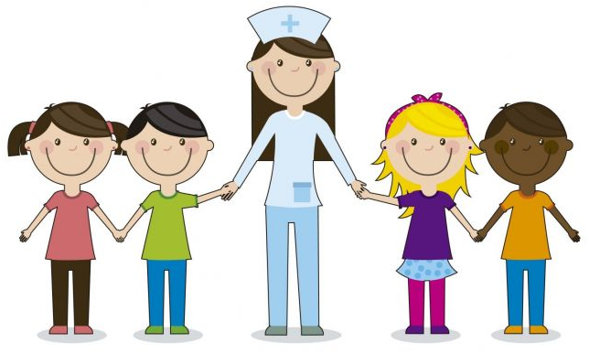

SCHOOL HEALTH PROGRAM
seminar

April 4th, 2018

Supervised by: Dr. Hafsa Raheel

name | student id
Aya Ismael Ghanim | 435202044
Elham Helal Alzahrani | 435201607
Ghadeer Abdullah Alsager | 435201762
Hanan Almoheeb Alabdullah | 435202050
Jawharah Hamed Almalki | 435201538
Lama Raid Alzamil | 435201538
Nojood Essam Alhaidri | 435201625
Nora Ahmed Alsomali | 435201812
Norah Saud Alfehaid | 435201840
Raneem Hamoud Aldubaikhi | 435201684

What Is School Health Program:
A school health program is an organized set of policies, procedures, and activities designed to protect and promote the health and well-being of students and staff which has traditionally included health services, healthful school environment, and health education.

What are the components of a school health program:
- 1. Health education.
- 2. Health services.
- 3. Physical education.
- 4. Nutrition services.
- 5. Healthy school environment.
- 6. Health promotion for school staff.
- 7. Counseling, psychological, and social services. 8. Parent and community involvement.

In more details

- Health Education:
It is:
A K-12 curriculum that addresses the physical, mental, emotional, and social dimensions of health.

Including:
A. motivate students to maintain and improve their health, prevent disease, and reduce health- related risk behaviors.

B. increase student’s health-related knowledge:
Includes a variety of topics, such as personal health, family health, community health, consumer health, environmental health, sexuality education, mental and emotional health, injury prevention and safety, prevention and control of disease, and substance use and abuse.

C. Providing qualified educators.

- Health Services:
It is:
Services provided for students to appraise, protect, and promote health.

Including:
- Ensure access and appropriate use of primary health care services:
By guiding students to access to services they might not seek out otherwise, particularly counseling and family planning services.

B. Provides qualified professionals.

C. Prevents and controls communicable disease and other health problems:
By developing guidelines that every school must follow and have available the exposure control.
Management of Communicable Diseases in a School Setting:
1- Standard precautions: Guidelines recommended by the Centers for Disease Control and Prevention (CDC):
- Hand washing: is the single most effective technique.
- Use of protective equipment, like gloves and masks.
- Proper environmental cleaning.

2- Transmission-based precautions: airborne precautions-droplet precautions-and contact precautions.

3- Personal Hygiene Measures: example: Keep fingernails short and Clean-Avoid touching or rubbing eyes.

4- Immunization Procedures.

5- Reporting of Absence Rates.

D. Provides emergency care during emergencies and disasters:
These emergencies and disasters involve threats of harm to students, personnel, and/or facilities and require immediate and effective responses wither caused by natural events (such as severe weather, earthquakes, fires, floods, and tsunamis) and man-made events (such as acts of terrorism), or even accidents.

Example of emergency management:
- When a fire alarm is heard, schools evacuate buildings and call 911 to report a fire.
- Severe weather warning they to seek shelter.

- Physical Education:
It is:
A planned, sequential K-12 curriculum that provides cognitive content and learning experiences by promoting activities and sports that all students enjoy and can pursue throughout their lives.

Including:
A. Basic movement skills; physical fitness; rhythms and dance; games; team, dual, and individual sports; tumbling and gymnastics; and aquatics.

B. Promotes each student’s development through physical activities.

C. Provide qualified, trained teachers.
Guidelines for Physical education from National Center for Chronic Disease Prevention and Health Promotion -2012:

1- Physical education requirements: The CDC and the Institute of Medicine (IOM) recommend that all student should participate in at least 225 minutes of physical education per week.

2- Physical education curricula and standards: Which offers guidance for teaching physical activity knowledge and skills to students.

3- Physical education instruction Appropriate, evidence-based instructional strategies.

4- Student assessment in physical education.

5- Guidelines for elementary, middle, and high school physical education maintain that physical education should be taught by a qualified teacher with a degree in physical education.

6- Professional development for physical education: for teachers through continuing education and training

- Nutrition Services:
It is:
Provides qualified child nutrition professionals, and access to a variety of meals that accommodate the health and nutrition needs of all students, according to the U.S. Dietary Guidelines for Americans to achieve nutrition integrity.

Including:
A. Healthy meals and snacks.

B. Menu labeling in cafeterias.

C. Outreach to parents about making healthy choices at home.

D. Nutrition education, including school gardens.

E. Physical activity programs.

F. Active play.

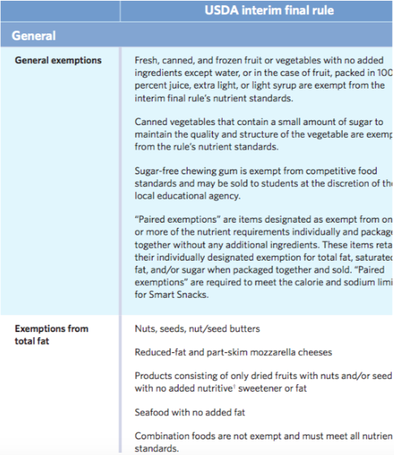
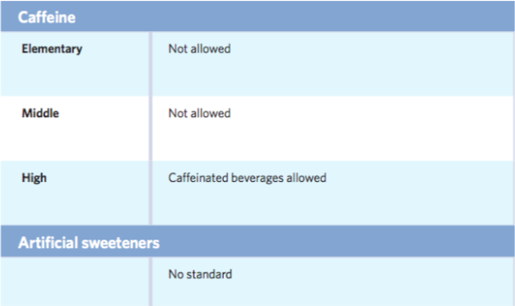
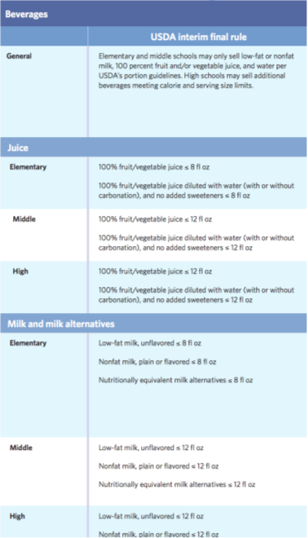
Guidelines according to USDA Food Composition Databases 2013-2014:

- Healthy School Environment:
It is:
The physical and aesthetic surroundings and the psychosocial climate and culture of the school.
The psychological environment includes the physical, emotional, and social conditions that affect the well-being of students and staff.

Including:
A. The school building and the area surrounding it:
- Design and construction of school. (explained in the box below)
- An emergency preparedness plan, examples:
an alarm system, evacuation plans so that students and other occupants are familiar with the closest exit and the appropriate path, emergency drills so that students be familiar of How to manage in such situations.

- Biological or chemical agents that are detrimental to health:
All chemicals in a school need labels that must identify the material, the appropriate hazard warnings.

C. Physical conditions such as temperature, noise and lighting:
- Sound Insulation between Spaces.
- workplace temperatures must be kept 'reasonable' for children.
- Class size and School size: (Two Standards for Class sizes shall be in use):
  - Classroom space shall not be less than 0.7 m2/child
  - 7m x 4.3m for traditional construction/ rural schools
  - 7.5m x 5m for improved construction/urban/peri-urban schools
School size (number of classrooms) shall depend on student capacity and type of school
- Class rooms windows:
  - Area of windows: 20% of floor area
  - Sufficient natural ventilation
  - Natural day lighting, to minimise the dependence on artificial lighting.
  - Blackboard position in relation to window side to minimize Glare.
  - Proportioned for minimum damage in earthquakes.
- Doors:
  - Doors should be easy to open and close. Care should be taken in the design of the door, frame, and opening mechanism to protect against injury to fingers, etc. An adequate glazed viewing panel in the solid core door from all rooms to the corridors should be provided for the benefit of small children.

- Health Promotion For School Staff:
It is:
Opportunities for school staff to improve their health status through such activities as health assessments, health education, and health-related fitness activities.

Including:
A. Encourages school staff to pursue a healthy lifestyle that contributes to their improved health status, improved morale, and a greater personal commitment to the school’s overall comprehensive health program.

B. Improves staff productivity.

C. Decreases staff absenteeism.

Examples:
Faculty and staff at Musselman High School in West Virginia, recently lost a combined 791 pounds in four months as part of a “biggest loser" competition to improve their health. This quest for better health is an integrated part of the positive school culture established by the school’s health educators.

- Counseling, Psychological, And Social Services:
It is:
Services provided to improve students’ mental, emotional, and social health.

Including:
A. Individual and group assessments, interventions, and referrals, for examples:
- counselors may meet with teachers to develop strategies for assisting a student with learning difficulties.
- The counselor may also meet with the child’s parents to discuss ways that they can help facilitate learning in the home and maximize learning outcomes.
- School counselors may also meet with with teachers and parents in cases concerning students with mental health issues or those with severe behavioral issues.

B. Organizational assessment and consultation skills of counselors and psychologists contribute not only to the health of students but also to the health of the school environment.

C. Professionals (such as certified school counselors, psychologists, and social workers) provide these services.
- Parent And Community Involvement:
It is:
An integrated school, parent, and community approach for enhancing the health and well-being of students.

Including:
A. Builds support for school health program efforts through school health advisory councils, coalitions, and broadly- based constituencies for school health.

B. Schools should actively solicit parent involvement and engage community resources.

What are the school health services in schools:

Definition:
An integrated school, parent, and community approach for enhancing the health and well-being of students.

Some of the Health Services Provided in the Schools:
1- Administer first aid.
2- Monitor vital signs.
3- Provide screening (height/weight) vision, hearing.
4- Child abuse evaluation and follow-up (physical or mental).
5- Evaluate emotional or behavioral problems.
6- Administer medication.
7- Clean and change dressings.
8- Case management for chronic health problems.
9- Provide nutritional counseling.
10- Provide mental health counseling (depression, impulsive behavior …).

Who provide the School health services:

Qualified professionals such as:
- School nurses
- Nurse practitioners
- Physicians
- Dentists
- Health educators
- Physician assistants
- Allied health personnel
- School principals

School Health Physician | School Health Nurses
- Ideally, school physicians should be board-certified pediatricians or physicians with expertise in pediatrics. The American Academy of Pediatrics recognizes the important role physicians play in promoting the optimal biopsychosocial well-being of children in the school setting.  - The roles of physicians working in schools are broad.  - Involvement can range from fulfilling mandated services, serving as an advisor to a school health advisory group, or being the leader of a coordinated school health program.  A school health physician can provide:  1- Continuing care of students.  2- Prevention of school-related hazards.  3- Information about hazardous substances in the area of the school.  4- Vaccinations and vaccination counseling at the request of the health authorities.  5- Health education.  6- First aid measures and information. | School Health nurse has to:  - Perform his/her duties directly in the school under the supervision of the SH unit at PHC centers.  - Be Responsible of providing the service for a maximum of (5) schools / a maximum of (1000) students  The role and duties of the School nurses:  1. Inspection of student’s health and detect the sick cases and refer where needed.  2. Perform preventive and sanitary measures for contagious cases and infectious diseases.  3. Perform periodical inspection of the school environment and school canteen and follow the corrective measures.  4. Execute the preventive and Health promotion  5. Recognize the victims of bullying and violence from students and perform the needed measures.  6. Follow up students with chronic disease.  7. Deal with mild cases and emergencies till arrival of special team or refer to hospital  8. Participate in the training of school health teachers within the school health team.

School principal
The role of the principal covers many different areas including leadership, teacher evaluation, student displace, and many others. One of the most important roles of school principals is health promotion and health education.

Some roles of school principals:
1- Distribute smoking banning signs into school
2- Determine the subjects of health education according to the students’ needs
3- Put a plan for health education
4- Run the plan of health education
5- Provide different kinds of food in the canteen
6- Provide protected windows for the building
7- Get sure of water safety used in the school

School health services use different ways to support students:

Acute and Emergency Care | * Urgent situations and medical emergencies can happen at any time.  * Most frequently the school nurse is the one dealing with these events as she might be the only professional trained to act in response to a medical crisis.  * School nurses are also certified to deal with larger emergency events affecting students and staff, e.g. earthquakes.
Care coordination | * Care coordination in schools is organized by school nurses arranging the care of students by providing data and communication among relevant authorities responsible for the needs and care of students with chronic health conditions.  * This integrated health care involves families, health care providers, teachers and school staff (e.g. administration).  * Care coordination benefits:  - - Improvement of medical management  - - Provision of more details  - - Highlighting the need for more resources  * Students with special and individualized needs benefit from care coordination; the school nurse plays a vital role in setting up these plans.
Chronic disease management in schools | * Students with chronic health conditions may suffer from daily difficulties with managing their conditions.  * Examples of chronic health conditions: asthma, diabetes and food allergies.  * Schools can play a major role in supporting those students by providing integrated school health services they need.  * For example, a school nurse can help a student through an asthma exacerbation attack.
Family engagement | * It is important to involve families of students and make sure they are aware of the health services provided at school.  * Families can play a major role in identifying lack of adequate services and demanding better services.  * Families form an important part in the connection between the school and the health care providers which is of great benefit in following the health care plan for the student.  * Benefits of family involvement:  - - Updates in health status  - - Distribution of medication at the right time  - - Monitoring and testing during the school day as  - needed (e.g. blood sugar levels for a diabetic student)  - - Taking care of diet and physical considerations

What is comprehensive school health program?

'What is very clear, is that education and health for children are inextricably entwined. A student who is not healthy, who suffers from an undetected vision or hearing deficit, or who is hungry, or who is impaired by drugs or alcohol, is not a student who will profit optimally from the educational process. Likewise, an individual who has not been provided assistance in the shaping of healthy attitudes, beliefs and habits early in life, will be more likely to suffer the consequences of reduced productivity in later years."

Definition
A comprehensive school health program is an integrated set of planned, sequential, school-affiliated strategies, activities, and services designed to promote the optimal physical, emotional, social, and educational development of students. It is coordinated by a multidisciplinary team and accountable to the community for program quality and effectiveness.
The program involves and is supportive of :
- families
Family involvement implies that the family has knowledge of the CSHP—and participates in community deliberations to determine the needs and the activities, strategies, and services that are to be offered.
- community, based on (needs, resources, standards, and requirements)
The local community refers to the wide range of stakeholders—parents, students, educators, health and social service personnel, insurers, business and political leaders.
program design must consider and be sensitive to the cultures, values, and moral standards of the community.
Approach of comprehensive school health
A comprehensive school health approach includes a broad spectrum of activities and services which take place in schools and their surrounding communities that enable children and youth to enhance their health, develop to their fullest potential and establish productive and satisfying relationships in their present and future lives. The goals of a comprehensive approach are to:
1- Promote health and wellness.
2- Prevent specific diseases, disorders and injury.
3- Prevent high risk social behaviors.
4- Intervene to assist children and youth who are in need or at risk.
5- Help support those who are already exhibiting special health care needs.
6- Promote positive health and safety behaviors.

School Health program in Saudi Arabia
DIRECTOR-GENERAL’S MESSAGE
“School Health General Department (SHGD) will invest to enhance youth health at school, with special focus on preventive measures. To do so, SHGD will improve school environment, monitor school canteens, and ensure receiving all basic vaccines. SHGD will also prepare educational and awareness health programs to enhance healthy diets and regular exercising to prevent diseases and their related risks.”
- Director-General of School Health General Department
Dr. Mahmoud Abdul-Fattah Nahhas
VISION
School health with a leading role in promoting students' health and reducing their exposure to risk factors, to secure top health standards through collaboration with all stakeholders, to boost and develop school health programs and services, to put unified processes in place, and to provide information on health issues as well as required interventions.
MISSION
To enhance students' health and improve their academic performance, through cutting-edge programs, ongoing control of their health condition, and building effective partnerships to ensure quality health services for school community.
OBJECTIVES

- SHGD is the responsible body for planning, implementing, monitoring and assessing school health services.
- SHGD's programs and services depend on collaboration with all stakeholders, both inside and outside MOH, to provide better services, and to engage both the community and families in school health activities.
- Offer unique, creative and favorable health environment to promote students' health, and to boost their academic performance in conjunction with the Ministry of Education.
- Ensure fair access to top-quality school health services and programs
by students across the Kingdom.
- Reduce prevalence of lifestyle-associated diseases by promoting
healthy behaviors among school community members.
- Participate in developing safety and health standards by providing
the health-safe school environment (safe drinking water, safe canteen ...), in collaboration with all stakeholders.

DUTIES

- Develop SHGD's plans, programs and projects in coordination with all stakeholders.
- Design health promotion programs based on the school community's needs.
- Foster safe and healthy behaviors among school community members.
- Detect health and food issues in school communities, determine their priorities, and devise the right solutions with stakeholders.
- Coordinate with School Health Affairs Department at the Ministry of Education in terms of school health programs implementation.
- Design performance indicators for school health activities and programs.
- Monitor and assess school health programs implementation.
- Ensure implementation of all seasonal and emergency vaccination campaigns in schools.
- Participate in developing school health awareness media and messaging, both paper-based and electronic.
- Participate in preparing and implementing school health studies.
- Organize school health training courses for both health and educational staff.
- Develop school health workflow processes and update them periodically.
- Conduct and publish school health research and studies.

The Global Aspects of School Health
1. Health Education
- Linked pages to the CDC on characteristic and standards of school health
- Health education on school level involved suggestions from the Unicef on integrating approximately 20 activities for each of the three subjects of science, math, and social studies in connection to health
- Manifested in the “Rashaqa” initiative
- E.g. The teacher shows a healthy dish and asks students to prepare a meal and discuss the importance of diversification in meals
- 3 periods in total, one for each meal of the day

Rashaqa Initiative
- General goal: Reduce rate of obesity
- Mechanism:
  - Raising awareness
  - Recording height, weight, and BMI
  - Canteen adherence to health regulations
  - Periodic Reporting
- Roles of:
  - Principal
- Formation of a local Rashaqa team
- Develop a plan for implementation
- Linking certain schools to the closest Primary Care Centre
- Field visits
  - Organizer of Rashaqa
- Attend the regular meetings
- Participate in training personnel
  - Health Advisor
- Accompany the medical team with the measurements taken in the school.
- Communicate with the student's family and explain the student's health status
- Raise Awarness by learning activities in accordance with school stage
  - Nurses
- Responsible for the preparation of orders for inspection and follow-up insurance of deficiencies
- Take measurements (height, weight, body mass) for students in document in the health files
  - Physicians
- Participate in the preparation of initiative plan within the center and coordinate with the school administration
- Provide curative and preventetive measure

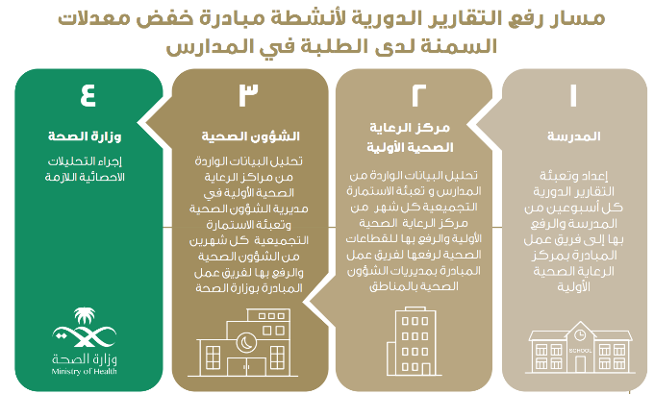

2. Health Services
- Divided into Curative, Preventive, and Promotive
- Curative: Periodic Fitness Examination, Curative Care, School First Aid Clinic
- Preventive: Vaccinations
- Promotive: A list of health promoting services and programs
- No indication of how it’s implemented
- Key challenges: Shortage of medical staff particularly nurses (the standard is 1 nurse for 5 schools, Administrative and logistic burden and short time frame for transferring the Directorate from MOE to MOH, Denial or resistance of some steps of change

Preventative - Vaccinations
- The Expanded Programme on Immunization (EPI) in the Kingdom was launched in 1976
- Targets 15 infectious diseases

Tuberculosis | Tetanus | Mumps
Hepatitis B | Pneumococcus | Rubella
Polio | Rotavirus | Hepatitis A
Diphtheria | Measles | Varicella
Pertussis | Meningococcal | Haemophilus influenzae (B)

3. Physical Education
- Prevention and management of obesity: Saudi guideline update
- Done in 2016
- Encourage children gradually to perform at least 60 minutes of moderate to vigorous exercise daily
- Encourage children to lead active daily life such as walking, cycling, etc.
- Discourage sedentary behavior of more than 2 hour for children particularly of screen time
- Encourage family approach to physical exercise (e.g., walking and cycling to school and shops, going to the park or swimming)
4. Nutrition Services
- States the importance of a balanced diet
- Canteen regulations including:
- Building and location e.g. good lighting, well secured windows
- Equipment and furnishing e.g. availability of tables, fridges in operating condition
- Instructions for operating canteens e.g. daily cleaning, use of antiseptics
- Requirements for food and beverages in schools e.g. Milk, fresh fruits and vegetables
- Prohibited foods and beverages e.g. soft drinks, chips
- Canteen workers e.g. personal hygiene, using gloves
- Procedure to follow in case of breach or food poisoning

5. Healthy School Environment
6. Health Promotion for School Staff
7. Counseling, psychological, and social services
8. Parent and Community Involvement

Suggestions for improvement
school health in kingdom of Saudi Arabia
- Provide healthy food with nutritional benefits and delicious taste
- Implement Physical education programs and daily sport activities
- Activate Child protection system and spread awareness of children rights
- Studies were gathered by reviewing published papers in the Medline and Google Scholar databases reporting the prevalence of child abuse and neglect in SA over the past 15 years.
  - In 2007, the prevalences of physical abuse, sexual abuse, and neglect in previous studies were 70%, 15%, and 15%, respectively. Between 2000 and 2008, the prevalence of child physical abuse and neglect was greater than other forms of abuse. Additionally, the annual report of the National Family Safety Registry noted the same findings. In 2014, a study in Al-Kharj found that psychological abuse was most prevalent among teenagers.
- A cross-sectional study was conducted to examine the prevalence of smoking and habits of smoking among male secondary school students in Jeddah, Kingdom of Saudi Arabia (KSA)
    - Of the studied group, 258 (37%) currently smoked, and of these, 83.7% had started smoking at the age of 14 years or less
- Involve Doctors in health education to educate student and improve their health knowledge

References

- Guidelines for Comprehensive School Health Programs - Schools & Health - NCBI Bookshelf: Adapted from the American School Health Association, Kent, Ohio Second Edition, November 1994
- Virginia Department of Health, Division of Child and Adolescent Health-VIRGINIA SCHOOL HEALTH GUIDELINES 1-May 1999. Available from: http://www.doe.virginia.gov/support/health_medical/virginia_school_health_guidelines/components.pdf
- Institute of Medicine (US) Committee on Comprehensive School Health Programs in Grades K-12; Allensworth D, Lawson E, Nicholson L, et al., editors. Schools & Health: Our Nation's Investment. Washington (DC): National Academies Press (US); 1997. 1, Introduction.
- School Health Services | Healthy Schools | CDC [Internet]. Cdc.gov. 2018 [cited 22 March 2018]. Available from: https://www.cdc.gov/healthyschools/schoolhealthservices.htm
- Whole School, Whole Community, Whole Child (WSCC) | Healthy Schools | CDC [Internet]. Cdc.gov. 2018 [cited 30 March 2018]. Available from: https://www.cdc.gov/healthyschools/wscc/index.htm
- Expanding the Coordinated School Health Approach | Whole School, Whole Community, Whole Child (WSCC) | Healthy Schools | CDC [Internet]. Cdc.gov. 2018 [cited 30 March 2018]. Available from: https://www.cdc.gov/healthyschools/wscc/approach.htm
- ASCD Whole Child Initiative [Internet]. Ascd.org. 2018 [cited 30 March 2018]. Available from: http://www.ascd.org/whole-child.aspx
- Health.gov. 2018 [cited 17 April 2018]. Available from: https://health.gov/dietaryguidelines/2015/resources/2015-2020_Dietary_Guidelines.pdf
- U.S. Department of Health and Human Services and U.S. Department of Agriculture. 2015–2020 Dietary. Guidelines for Americans. 8th Edition. December 2015.Available from: https://health.gov/dietaryguidelines/2015/resources/2015-2020_Dietary_Guidelines.pdf
- https://www.ncbi.nlm.nih.gov/pmc/articles/PMC2920968/
- School Safety Regulations and Guidelines
- Health.gov. 2018 [cited 17 April 2018]. Available from: https://health.gov/dietaryguidelines/2015/resources/2015-2020_Dietary_Guidelines.pdf American School Health Association
- Defining a Comprehensive School Health Program: An Interim Statement.
- Management of Infectious Disease in Schools Public Health Medicine Communicable Disease Group October 2014. Available at: https://www.healthpromotion.ie/hp-files/docs/HPM00406.pdf
- Emergency and Safety Alliance-Schools and Facilities-Section 2: Unit 1- Critical Incident Response Planning - 1 Approved 9/1/06. Available from: https://www.bcps.org/safety/pdf/Section2-Critical-Inc-Response.pdf
- National Center for Chronic Disease Prevention and Health Promotion Division of Population Health-Physical Education Profiles Physical Education and Physical Activity-2012. vailable from: https://www.cdc.gov/healthyschools/physicalactivity/pdf/PE_Profile_Book_2014.pdf
- Institute of Medicine (US) Committee on Nutrition Standards for National School Lunch and Breakfast Programs; Stallings VA, Taylor CL, editors. Washington (DC): National Academies Press (US); 2008. Available from:https://www.ncbi.nlm.nih.gov/books/NBK214994/
- National Research Council (US) Subcommittee on the Tenth Edition of the Recommended Dietary Allowances.
- Washington (DC): National Academies Press (US); 1989. Available at https://www.ncbi.nlm.nih.gov/books/NBK234938/.
- Federal Register, 2013, 7 CFR Parts 210 and 220, National School Lunch Program and School Breakfast Program: Nutrition Standards for All Foods Sold in Schools as Required by the Healthy, Hunger-Free Kids Act of 2010; Interim Final Rule, U.S. Department of Agriculture, 78 (125) (June 28, 2013). 19-Federal Register, 2014, 7 CFR Parts 210 and 220, Local School Wellness Policy Implementation under the Healthy, Hunger-Free Kids Act of 2010: Proposed Rule, U.S. Department of Agriculture, 79 (38) (February 26, 2014).
- Schulte-Körne, G. (2018). Mental Health Problems in a School Setting in Children and Adolescents. [online] PubMed Central (PMC). Available at: https://www.ncbi.nlm.nih.gov/pmc/articles/PMC4850518/ [Accessed 30 Mar. 2018].
- K-12, I., Allensworth, D., Lawson, E., Nicholson, L. and Wyche, J. (2018). School Health Services. [online] Ncbi.nlm.nih.gov. Available at: https://www.ncbi.nlm.nih.gov/books/NBK232689/ [Accessed 30 Mar. 2018].
- Superhands.at. (2018). [online] Available at: https://www.superhands.at/fileadmin/content/files/SchulaerzteBerufsbild_engl_.pdf [Accessed 30 Mar. 2018].
- Pediatrics.aappublications.org. (2018). [online] Available at: http://pediatrics.aappublications.org/content/pediatrics/131/1/178.full.pdf [Accessed 30 Mar. 2018].
- ThoughtCo. (2018). These Are the Essential Qualities of an Effective School Leader. [online] Available at: https://www.thoughtco.com/how-school-administrator-can-be-effective-leader-3194569 [Accessed 30 Mar. 2018].
- Eujournal.org. (2018). [online] Available at: https://eujournal.org/index.php/esj/article/viewFile/1056/1090 [Accessed 30 Mar. 2018].
- Healthy schools campaign https://healthyschoolscampaign.org/food/
- The national family safety program https://www.nfsp.org.sa/ar/Pages/default.aspx
- Fida, Hashim R., and Ismail Abdelmoneim. “Prevalence of Smoking among Male Secondary School Students in Jeddah, Saudi Arabia.” Journal of Family & Community Medicine 20.3 (2013): 168–172. PMC. Web. 31 Mar. 2018. [online] Available at: https://www.ncbi.nlm.nih.gov/pmc/articles/PMC3957170/
- Meaad Mogaddam-Iman Kamal-Leena Merdad-Najlaa Alamoudi-Omar Meligy-Douaa El-Derwi - “Prevalence Of Child Abuse in Saudi Arabia from 2000 To 2015: A Review Of The Literature https://www.omicsonline.org/open-access/prevalence-of-child-abuse-in-saudi-arabia-from-2000-to-2015-a-reviewof-thet-literature-.php?aid=64212
- Wake Forest University - 5 Responsibilities of the School Counselor https://counseling.online.wfu.edu/blog/5-responsibilities-of-the-school-counselor/
- Health.gov. 2018 [cited 17 April 2018]. Available from: https://health.gov/dietaryguidelines/2015/resources/2015-2020_Dietary_Guidelines.pdf
- Health.gov. 2018 [cited 17 April 2018]. Available from: https://health.gov/dietaryguidelines/2015/resources/2015-2020_Dietary_Guidelines.pdf
- Health.gov. 2018 [cited 17 April 2018]. Available from: https://health.gov/dietaryguidelines/2015/resources/2015-2020_Dietary_Guidelines.pdf
- Health.gov. 2018 [cited 17 April 2018]. Available from: https://health.gov/dietaryguidelines/2015/resources/2015-2020_Dietary_Guidelines.pdf
- Health.gov. 2018 [cited 17 April 2018]. Available from: https://health.gov/dietaryguidelines/2015/resources/2015-2020_Dietary_Guidelines.pdf
- Health.gov. 2018 [cited 17 April 2018]. Available from: https://health.gov/dietaryguidelines/2015/resources/2015-2020_Dietary_Guidelines.pdf
- Health.gov. 2018 [cited 17 April 2018]. Available from: https://health.gov/dietaryguidelines/2015/resources/2015-2020_Dietary_Guidelines.pdf
- Health.gov. 2018 [cited 17 April 2018]. Available from: https://health.gov/dietaryguidelines/2015/resources/2015-2020_Dietary_Guidelines.pdf
- Al-Shehri FS, Moqbel MM, Al-Khaldi YM, Al-Shahrani AM, Abu-Melha WS, Alqahtani AR, Sabbahi AA, Alkaud AM, Alfalah H, Alqumaizi KI, Saeedi MY, Alharbi MY, Elmourad M, Mustafa MS, Alobaid OA, AlRajhi SM, Alomary SA, Al Eid AJ, Hussain SA, Alsa YH, Ibrahim ME, Alamri FA, Almalki MZ, Almoreished TF. Prevention and management of obesity: Saudi guideline update. Saudi J Obesity [serial online] 2016 [cited 2018 Apr 1];4:25-40. Available from: http://www.saudijobesity.com/text.asp?2016/4/1/25/184970
- Health.gov. 2018 [cited 17 April 2018]. Available from: https://health.gov/dietaryguidelines/2015/resources/2015-2020_Dietary_Guidelines.pdf
- Health.gov. 2018 [cited 17 April 2018]. Available from: https://health.gov/dietaryguidelines/2015/resources/2015-2020_Dietary_Guidelines.pdf
- Health.gov. 2018 [cited 17 April 2018]. Available from: https://health.gov/dietaryguidelines/2015/resources/2015-2020_Dietary_Guidelines.pdf
- Policy Guidelines & Technical Specifications for School Construction, July 2006, Ministry of Education, Islamic Republic of Afghanistan.
- Planning Guidelines for National Schools, Department of Education & Science, Ireland.
- Musselman staff, faculty lose 791 pounds, By MATTHEW UMSTEAD, April 02, 2009.

