Demography Tutorial

Exercise 1:

Consider the following two population pyramids

Population pyramid A

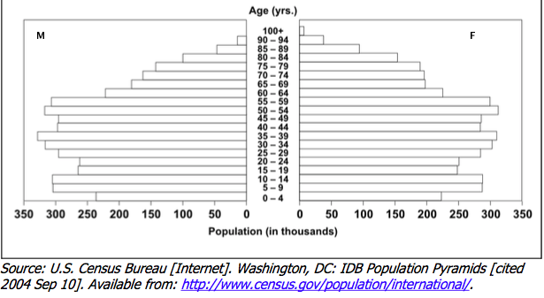

Population pyramid B

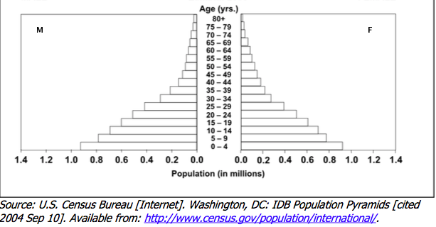

1. Describe the shape of each of these two pyramids. What are the most striking features in each?

Pyramid A:
-Height: The apex is high, which suggests high life expectancy in this population.
-Base: is narrow, suggesting a low fertility rate in this population
-Side: suggests a fairly equal distribution of all age groups in this population (although the elderly population are still fewer)
-Type of pyramid: Stationary population

Pyramid B:
-Triangular in shape
-Height: Life expectancy is until 80+
-Base: wide, suggestive of high fertility rate.
-Side: concaved on the sides (most of the population is below the age of 25 y)
-Type of pyramid: Expansive

2. What are the main difference in population composition between pyramid A and Pyramid B?

The fertility rate and the life expectancy

3. Based on the pyramid shapes, can you guess the level of development of each of these two countries?

Country A is most probably a highly developed country. Country B is most probably a developing country.

4. What are the possible stages of demographic transition is each of country A and country B in?

Country A: Low stationary

Country B: Late expanding

Exercise 2:

During which stage of demographic transition is population growth the highest? Explain why.

Stage 3 (late expanding stage). Because during this stage the birth rates are greater than the death rates.

Exercise 3:

The following data shows the population distribution of Saudi Arabia in 2000 and 2015.

Age groups (years) | Year 2000 | Year 2015
< 15 | 8000000 | 7000000
15 - < 65 | 12000000 | 19000000
65+ | 500,000 | 900,000

1. Calculate the dependency ratio in each of these two years.

Dependency ratio =
(# of people below 15 y + # of people > 65) / (# of people 15 - 65 y)

Dependency ratio 2000= 0.71

Dependency ratio 2015= 0.42

2. During which year was it higher? Provide a plausible explanation.

2000. Between 2000 and 2015 the population that is between 15 and 65 years of age has grown compared to the dependent age groups.

Exercise 4:

Consider the following hypothetical data.

Age groups | No. of females  (mid-year) | Live births | -------
15-19 | 100 | 8
20-24 | 250 | 80
25-29 | 200 | 96
30-34 | 300 | 84
35-39 | 200 | 40
40-44 | 150 | 24
45 – 49 | 250 | 20
Total | 1450 | 352

1. Calculate the crude birth rate from this table.

It cannot be calculated because we do not have information about the mid-year population size (for both males and females)

2. Calculate the general fertility rate from this table.

General fertility rate = (# of live births / # females reproductive age mid-year)*1000

GFR = 242.8 live births per 1000 women

3. Calculate the age-specific fertility rate for women from 20 to 34 years of age.

Age-specific fertility rate =
(# of live births among women within a specific age group/ # of females in that same age group) * 1000

Age-specific fertility rate for 20 - 34 years =
(# of births for women between 20 to 34 years / # of women between 20 - 34 year ) * 1000

Age-specific fertility rate for 20-34 y=

[(80 + 96 + 84) / (250 + 200 + 300) ] *1000 = 346.7 live births per 1000 women

