TUTORIAL
Noncommunicable Diseases (NCDs)
Course COMM 311

By the end of this tutorial you should be able to:
- Describe the burden of four main Noncommunicable Diseases (NCDs) in Saudi Arabia. (10 minutes)
- Find the prevalence of four main risk factors of NCDs in Saudi Arabia. (10 minutes)
- Calculate and interpret the risk of having Atherosclerotic Cardiovascular Disease. (10 minutes)
- Calculate the BMI, measure the WC and interpret them. (5 minutes)
- Assess the physical activity stage of change and identify main strategies based on the stage. (10 minutes)
- Provide primary prevention advice regarding physical activity and healthy eating. (5 minutes)

Resources needed:
- Laptop or tablet
- Active internet connection
- A friend sitting next to you

Exercise 1: Use the following website to determine the burden of disease of the 4 main NCDs in your country: http://www.who.int/nmh/countries/en/index.html (10 minutes)

- What are the 4 main NCDs in Saudi Arabia?

- What is the proportion of all deaths that NCDs are estimated to account for in Saudi Arabia?

- Which NCD is causing the most deaths in Saudi Arabia?

Exercise 2: Find the prevalence of four main risk factors of NCDs in Saudi Arabia. (10 minutes).
Use the following link: https://www.who.int/gho/ncd/risk_factors/en/ (find “View Data”)
Prevalence of risk factor 1 (males, females):

Prevalence of risk factor 2 (males, females):

Prevalence of risk factor 3 (males, females):

Prevalence of risk factor 4 (males, females):

Exercise 3: Calculate and interpret the Atherosclerotic Cardiovascular Disease risk (10 minutes)

As a primary prevention you need to calculate the risk of having a cardiovascular event for a 52-year-old white man. His blood pressure is 140/80 mm Hg. The total cholesterol is 6.99 mmol/L, HDL cholesterol is 0.83 mmol/L, and LDL cholesterol is 4.37 mmol/L. He does not have diabetes, but he is a current smoker. He does not receive any medication. Weight: 105; Height: 172; WC = 105.

Use the following tool to calculate his cardiovascular risk (change the units to SI):
http://tools.acc.org/ASCVD-Risk-Estimator-Plus/#!/calculate/estimate/

- What is the estimated 10-year Atherosclerotic Cardiovascular Disease risk (ASCVD)?

- What is the lifetime ASCVD risk?

- What will be the estimated 10-year risk with smoking cessation, Statin Therapy, and blood pressure medication?

Exercise 4: Calculate the BMI, measure the WC and interpret it (use the scenario above). (5 minutes)

- Calculate and interpret the BMI

- Interpret the WC

- Measure, calculate and interpret your or your friend’s BMI and WC

https://www.moh.gov.sa/en/HealthAwareness/MedicalTools/Downloads/SugarGuideMain.pdf

See page 16.

Exercise 5: Assess the physical activity stage of change of your friend sitting next to you, using the attached assessment tool (10 minutes)

- What is his stage of change?

- What will be your goal?

- What kind of strategies will you use?

Exercise 6: Provide primary prevention advice regarding physical activity and healthy eating. (5 minutes)

https://www.moh.gov.sa/OCP/Documents/001.pdf

See chapter 1 pg 6-9

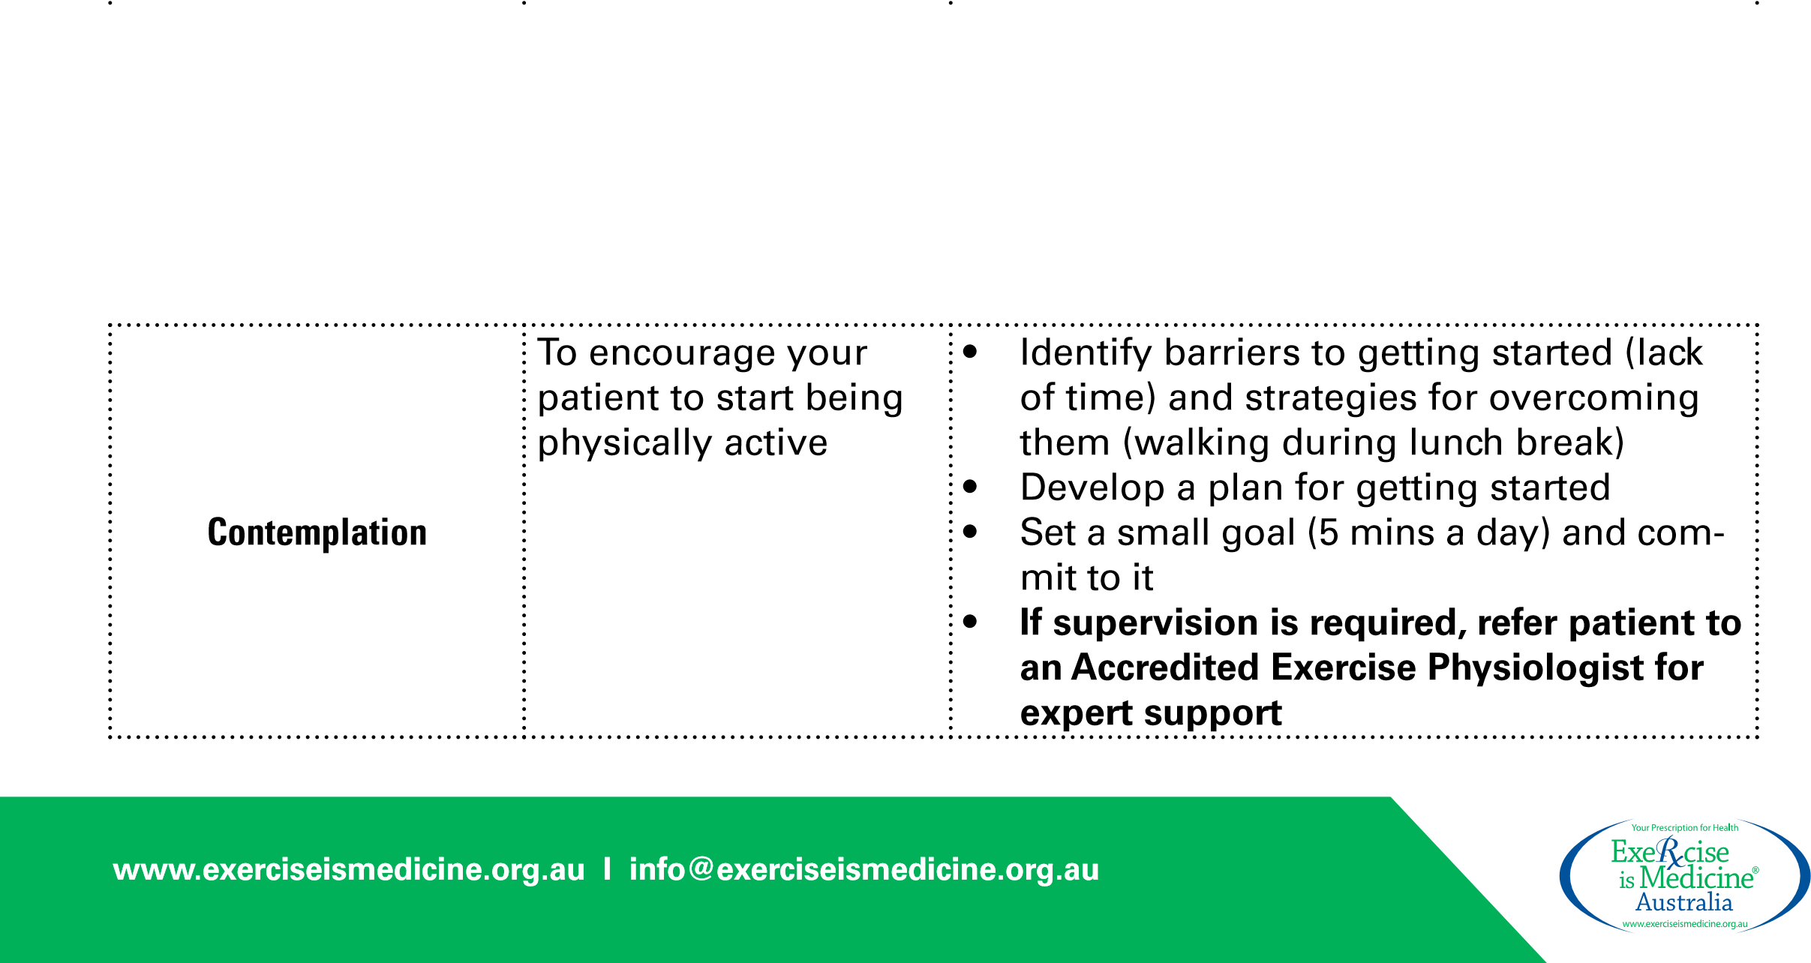
Once the patient’s stage of change has been determined, it is possible to take appropriate action using the tailored strategies outlined in the table below.
PHYSICAL ACTIVITY STAGE OF CHANGE:
ASSESSMENT TOOL
Patient readiness to participate in a physical activity program can be assessed using a brief series of questions
New flow chart please!
NO
NO
NO
NO
YES
YES
YES
YES
ARE YOU REGULARLY PHYSICALLY ACTIVE?
DO YOU INTEND TO IN
THE NEXT THIRTY DAYS?
DO YOU INTEND TO
IN THE NEXT SIX
MONTHS?
PREPARATION
ACTION
PRECONTEMPLATION
CONTEMPLATION
MAINTENANCE
HAVE YOU BEEN DOING SO
FOR MORE THAN SIX MONTHS?
Note:
For activity to be
regular, it must add up to a
total of 30 minutes or more
per day and be done at least
5
days per week.
STAGE OF CHANGE | GOAL |  | SPECIFIC STRATEGIES
Pre-contemplation | To get your patient thinking about physical activity | •  • | Encourage your patient to learn more about physical activity  Read articles, watch videos, and talk to others about physical activity
 |  | • | Make a list of potential benefits to becoming physically active then assess how important these benefits are to him or her
