CMED 305 Course
Practical Exercise on : Designing Questionnaire
It is necessary to always keep in minds that design of questionnaire influences data quality and thereby the results. Hence it is vital to design a good questionnaire.
Necessary details to know before the designing of questionnaire:
- Clear objectives and research question
- Target population
- Precise definitions of all measurement variables
Types of questions
A Questionnaire may be open or closed ended and be presented in various formats.
Closed questions are questions which limit the response to a specified list of answers. The use of closed questions offers a number of advantages to the researcher, including providing a set of standard responses that enable researchers to produce aggregated data quickly. In contrast, open questions allow the respondent to answer freely. However, if opened ended questions are used, then the methods for analyzing these responses should be considered during the design of the questionnaire.
Example of open question:
1.How do you rate Madagascar as an exotic destination?
Answer : ________________________________
Example of closed question:
2.Do you feel that every case of domestic violence must be reported?
- Strongly agree b. agree c. disagree d.strongly disagree e.not sure f. refused to answer
Categorization of questions
Normally the questions of large survey instruments are grouped into headings or categories for convenience.
- Title, purpose and confidentiality details
- Soiodemographic details
- Medical history
- Habits and personal details
- Measurements-clinical/biochemical
- And other title related questions
Pilot or pre-testing
Piloting the questionnaire among a representative sample of the target population in the same way that it will be administered in the main study is essential and will help identify potential problems with the design or layout of the questionnaire.
Point to remember: It is preferred to keep the questions short and specific.
Clear instructions on how to fill the questionnaire must be given.
Consent should be clearly mentioned on top of the questionnaire.

Samples of questionnaires
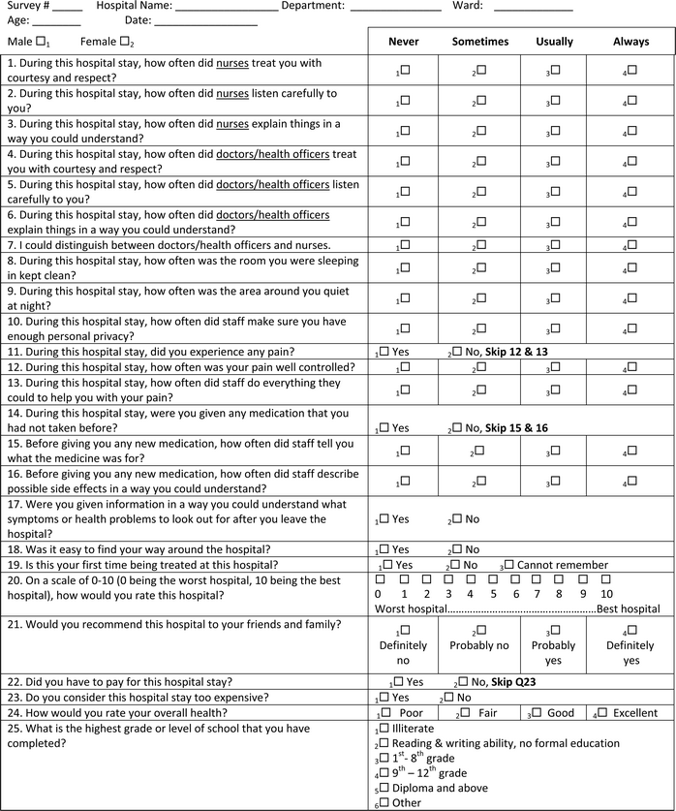

Sample 2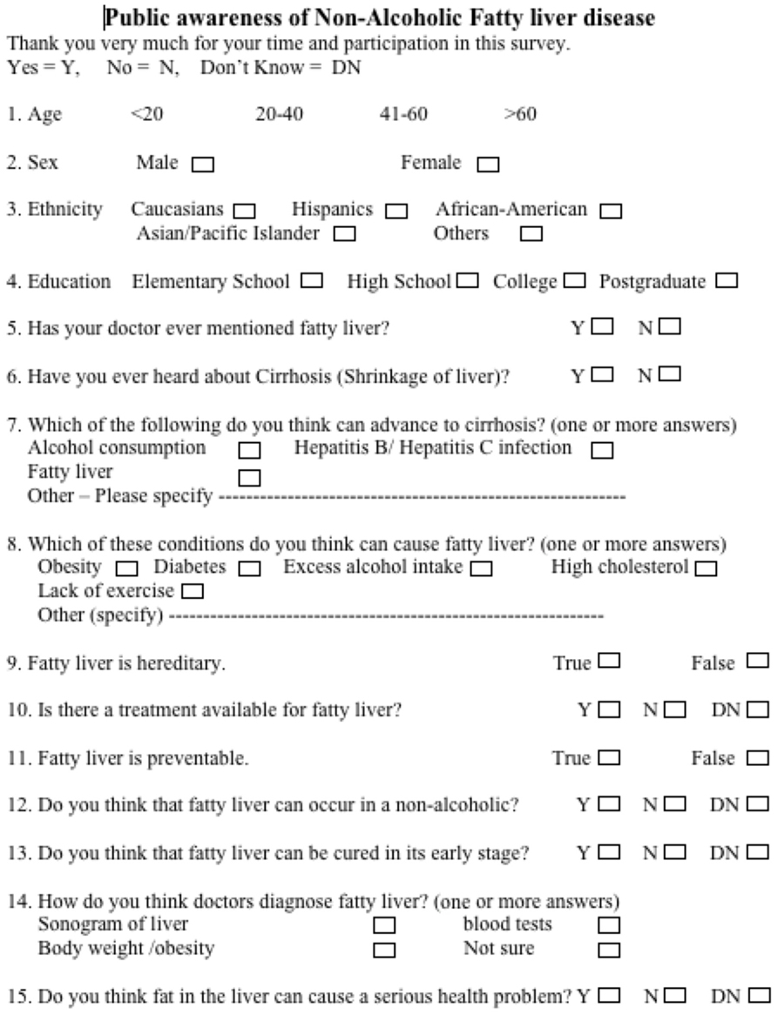

- Now let us construct simple questionnaire to determine the prevalence of anemia among female third year medical students of KKUH
Aim: To determine the prevalence of anemia
Target population: third year female medical undergraduate students
Measurement variable - hemoglobin

Students are requested to volunteer and complete the questionnaire.
Consent details

Socio demographic information

Medical history

Clinical and Biochemical investigations

- Questionnaire to determine the prevalence of overweight and obesity among adolescent school children.
Aim: To determine the prevalence of overweight and obesity
Target population: Adolescent school children aged 13 years to 18 years
Measurement variable – height, weight

Consent

Socio demographic details

Anthropometric measurements

