**Question 1**

Assume you work in a region in which none of the following conditions is on the list of notifiable diseases. For each condition;

a. List at least one existing source of data that you need for conducting surveillance on the condition.

b. What factors make the selected source or data system more appropriate than another?

1. **Listeriosis:** A serious infection can result from eating food contaminated with the bacterium Listeria monocytogenes. The disease affects primarily pregnant women, newborns, and adults with weakened immune systems. A person with listeriosis has fever, muscle aches, and sometimes gastrointestinal symptoms (e.g., nausea or diarrhea). If infection spreads to the nervous system, such symptoms as headache, stiff neck, confusion, loss of balance, or convulsions can occur. Infected pregnant women might experience only a mild influenza-like illness; however, infections during pregnancy can lead to miscarriage or stillbirth, premature delivery, or infection of the newborn. In the United States, approximately 800 cases of listeriosis are reported each year. Of those with serious illness, 15% die; newborns and immunocompromised persons are at greatest risk for serious illness and death.
2. **Spinal cord injury:** Approximately 11,000 persons sustain a spinal cord injury (SCI) each year in the United States, and 200,000 persons in the United States live with a disability related to an SCI. More than half of the persons who sustain SCIs are aged 15–29 years. The leading cause of SCI varies by age. Motor vehicle crashes are the leading cause of SCIs among persons aged <65 years. Among persons aged ≥65 years, falls cause the majority of spinal cord injuries. Sports and recreation activities cause an estimated 18% of spinal cord injuries.
3. **Lung cancer among nonsmokers:** A usually fatal cancer of the lung can occur in a person who has never smoked. An estimated 10%–15% of lung cancer cases occur among nonsmokers, and this type of cancer appears to be more common among women and persons of East Asian ancestry.

**Question 2**

During the previous 6 years, 10 to 15 cases per year of tuberculosis had been reported to a region health department. During the past 3 months, 25 cases have been reported. All but 4 of these cases have been reported from one sector.

Describe the possible causes of the increase in reported cases.

**Question 3**

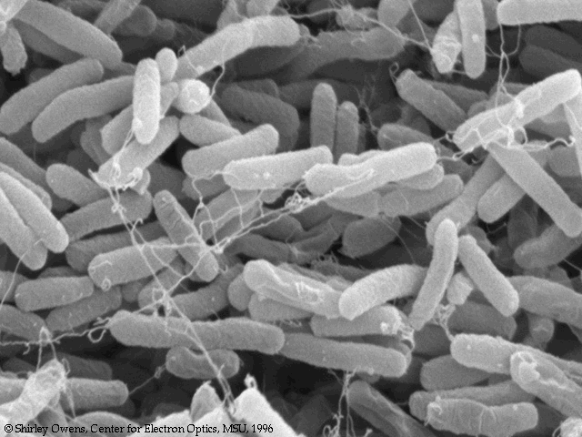

By 1993, E. coli O157:H7 (O157) has been recognized as an important foodborne pathogen that can cause serious illness. Numerous outbreaks across the country have been attributed to ground beef, roast beef, water, apple cider, and unpasteurized milk. Human infection occurs primarily through ingestion of food or water contaminated with bovine fecal material, but person­to­person transmission also occurs. The organism can survive for extended periods in water, meat stored at subfreezing temperatures, soil, and acidic environments, but can be destroyed by thorough cooking or pasteurization.

Patients infected with O157 typically present with severe abdominal cramps, bloody diarrhea, and low grade fever. Children and the elderly are at greatest risk for complications such as hemorrhagic colitis, hemolytic uremic syndrome, and death.

In 1990, Region A added E. coli O157:H7 to its reportable disease list. The region requires reporting by health care providers, health care facilities, and laboratories. The Laboratories must also send isolates to the central Laboratory.

You are an epidemiologist assigned to the region A Health Division, and are responsible for reviewing surveillance data on a regular basis.

**Question 3.1:** What basic descriptive epidemiology would you like to see to characterize the occurrence of E. coli O157:H7 in the region?

Following are several tables of E. coli O157:H7 August 1990 through December 1992.

**Question 3.2:**

1. Graph the data in Table A in two different formats (e.g., line graph, bar graph, or pie chart).
2. On the basis of the data graphed, what are two interpretations you can make? Was one type of graph easier to interpret? Why or why not?



**Question 3.3:** As a class, chart the previous information on *E. coli* O157:H7 outbreaks on a map.



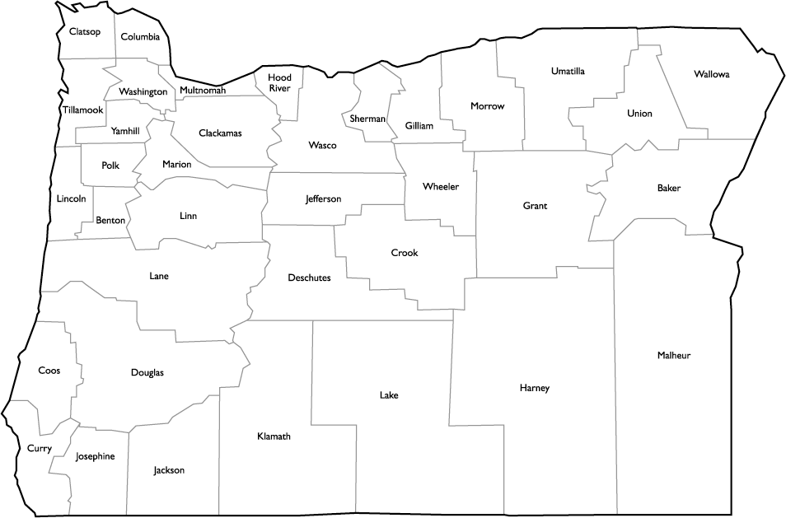





**Question 3.4:** On the basis of this new population data, why do you think Multnomah County has the highest number of reported cases of *E. coli* O157:H7 infections?

**Question 3.5:** Which age groups reported the highest incidence of *E. coli* O157:H7? On the basis of the population data, can you make a hypothesis about which age group was most at risk for *E. coli* O157:H7 infections? Why do you think that age group is at higher risk to the infection?

The end of the exercise!