Case-1: Infective Endocarditis
Student Handout

Ali is a 46-year-old gentleman known to have cardiac valvular lesion presented with Fever & lower limbs swelling for 3 weeks. weakness of left upper and lower limbs for 1 day. His family members also noticed that his speech was slurred.
He was diagnosed to have cardiac valvular lesion (?RHD) when he consulted a private practitioner 1 yr back for reduced exercise tolerance and was evaluated for cardiac causes. Echo picked up mitral regurgitation and patient was put on penicillin prophylaxis along with oral lasix.

On examination:
General Examination
Conscious, Oriented
Temp: 39.3
There are skin lesion

CVS:
◦ S1, S2 heard,
◦ A pan-systolic murmur with a musical quality heard in the mitral area,
◦ P2 loud.

 RS:Normal vesicular breath sounds heard

 abdominal Examination: Soft, no organomegaly

Investigations
ECG was performed outside which is shown below:
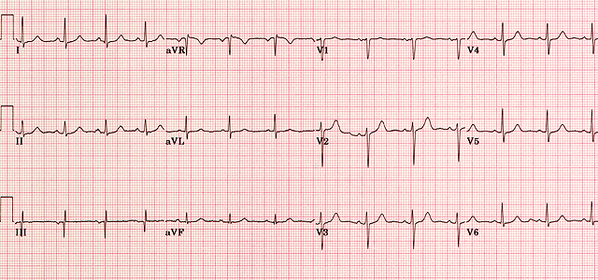
CXR: normal
CBC
◦ Hb 11.2g/dl, Platelets 1.8, Sr. creatinine 0.9

ESR: 68 mm/hr (0-20)
Blood culture: Staphylococci (2 x)
Echo: Mitral regurgitation – moderate ◦ Rupture of chordae tendinae + Valvular vegetation+

CT Brain:
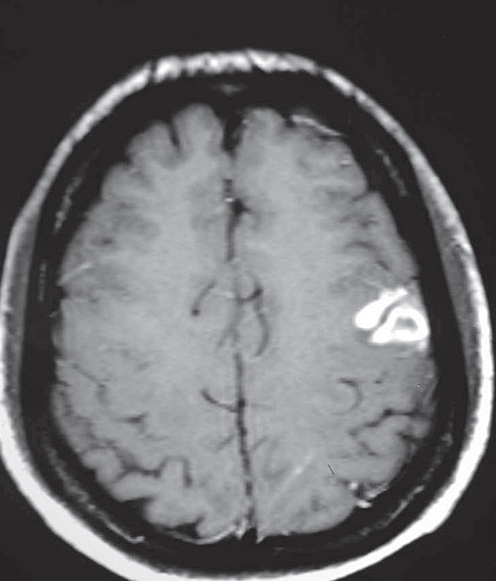

Learning Objectives:
At the end of the session, the student should be able to:
- Enlist the differential diagnosis of the fever in patient with cardiac valvular lesion.
- Identify the causes of fever under most likely & less likely categories.
- Identify the important questions he need to ask the patient while taking the history.
- Identify the most likely diagnosis of this patient.
- Explain the abnormal findings in the history and clinical examination.
- what are the clinical manifestations of IE
- what are the common pathogens causing IE
- what are the predisposing conditions ? Who are at higher risk
- what are procedures predispose patients to develop IE
- Duke’s criteria
- Determine any required further investigations.
- Describe the management of this patient during and after the attack (i.e. prophylactic and long term treatment)
- Describe some medications used in such condition, modes of action and side effects.
- Describe the non-drug advices the treating physician has to give to the patient

INSTRUCTION TO STUDENTS:
Please, read the case carefully, individually or in the group, before you are coming to the "Case Based Learning" (CBL) session. Look at the objectives and try to fulfill these objectives. Prepare for the case by refer to some suggested reading list. Prepare the case well, the tutor in CBL session will ask you to go through the case, and answer to his some stimulating and specific questions related to the case to ensure that you have fulfill these objectives.

