CASE-3: shortness of breath
Case-3 Cough: Student Handout
A 30-year-old man banker nonsmoker, has epilepsy on tegretol, has shortness of breath for 3 weeks, progressive over three weeks, till he is unable to do minimal effort. associated with pleuritic chest pain that increased with inspiration no fever or weight loss
There is no other relevant medical or family history. He lives with his family, married, has one child

Examination revealed:
He looks in distress. He has decrease chest expansion in the right side with dullness
JVP not raised, NO lower limb swelling

Investigation

His chest X-ray is shown below:
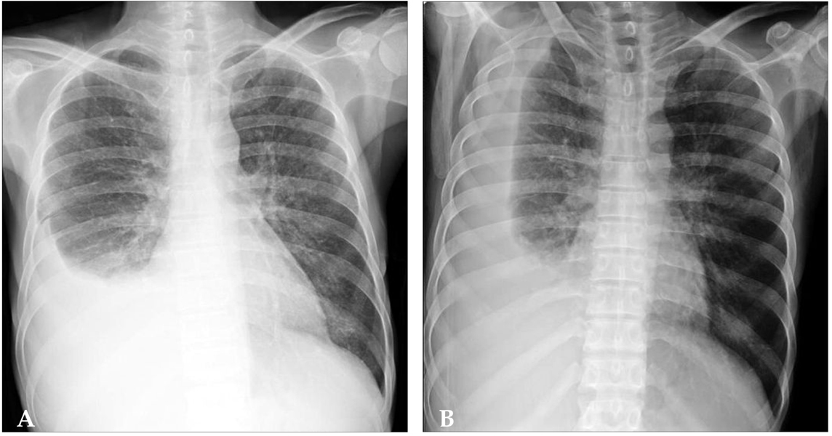

Learning Objectives:
At the end of the session, the student should be able to:
- Determine the basis on which the shortness of breath is classified?
- Identify the alarm symptoms associated with shortness of breath that will alert a physician for a serious underlying pathology.
- Identify the important questions a physician won’t miss out to ask from the patient while taking the history.
- Describe the diagnostic approach while evaluating a patient with shortness of breath?
- Enlist the differential diagnosis of the shortness of breath experienced by the patient.
- Establish the most likely diagnosis of this patient.
- Explain the abnormal findings in the history and clinical examination of this patient.
- a management plan for his condition

INSTRUCTION TO STUDENTS:
Please, read the case carefully, individually or in the group, before you are coming to the "Case Based Learning" (CBL) session. Look at the objectives and try to fulfill these objectives. Prepare for the case by refer to some suggested reading list. Prepare the case well, the tutor in CBL session will ask you to go through the case, and answer to his some stimulating and specific questions related to the case to ensure that you have fulfill these objectives.
Suggested Reading:

- Clinical Medicine: Parveen Kumar. Updated edition.

- Clinical methods by McLeod

Important Information to students:
- The students are expected to read the case and related question carefully, try to answer them before they come case-based learning session.
- Every student must bring the following book to the session:
Lawrence M Tierney & Mark C Henderson, The Patient History, Evidence-Based Approach, LANGE

