Case-6 : Achalasia: Student Handout
Part 1
Omar a 25 years old businessman from Riyadh comes to Dr. Khalid with the complaints of difficulty in swallowing. Omar explains that the problem started 2 years back and troubles him occasionally. At times, he feels that his food is stuck in retrosternal area and takes times to get into the stomach. His complaint is for both solid foods and liquids. Sometimes he feels that food comes up into his throat at night when he lies down. He lost about 10 kg in last 6 months. Omar has been ignoring his condition for quite a while but now he has decided to seek medical help. He has bad mouth smell. There is no pain associated with swallowing; No nausea, vomiting, fever, chest pain, or bleeding.
Past medical history
No history of angina, past surgery or any hospital admissions.
Allergy and Medication
Nil
Family history
His parents are alive and healthy. His two elder sisters are healthy and have no similar complaints
Alcohol and smoking
No history of smoking or alcohol drinking.
Social history
Omar is married for the last 10 years and he has two girls aged 7 and 5 years.

Part 2
He is 170 cm tall and his body weight is 80 Kg.
His vitals are as follows:
Pulse: 77 beats /min
Blood pressure: 120/80
Respiratory rate: 16 breaths /min
Temperature: 37.2 °C
Chest, Heart and Abdominal Examination: Normal
Part 3
Omar’s physical examination was normal. However, to aid in the diagnosis of his complaint of difficulty in swallowing the following investigations were done.
Barium Swallow:
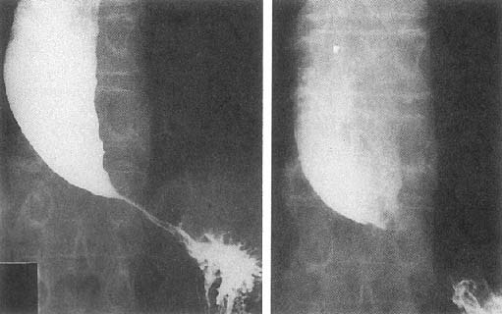
Adapted from: http://www.patient.co.uk/doctor/Achalasia.htm
Report: the esophageal body is dilated and the distal esophagus shows a narrow GEJ. The image resembles a bird's beak appearance.
Questions to help discussion:

- Discuss the difference between oropharyngeal dysphagia and esophageal dysphagia in terms of patient symptoms. What are the clinical characteristics that favor oropharyngeal dysphagia?

- Discuss differential diagnosis of esophageal dysphagia (Mechanical vs Motility disorders). Identify the causes under most likely & less likely categories for this particular patient.

- What are the clinical characteristics that would favor a motility problem vs a mechanical cause (liquid dysphagia or/and solid dysphagia)?

- What else do you want to know about this patient?
- Considering the history and investigation findings, what would be the likely diagnosis?
- What is “Esophageal Manometry study”?
- What is the 1st next step in evaluating this patient: Gastroscopy or Esophageal Manometry study.
- Discuss the treatment options for a patient with achalasia.
- Discuss the risk factor of developing a cancer associated with achalasia.

Instruction to the students:
Please read the case carefully, individually or in the group before you come to the “Case based learning” session. Look at the objectives and try to fulfill them. Prepare for the case well by referring to some suggested reading list. The tutor in CBL session will ask you to go through the case and answer some of his stimulating questions to ensure that you have achieved the objectives

Suggested Reading:

- Clinical Medicine: Kumar P and Clark M. Clinical Medicine. 7th ed. Edinburgh: WB Saunders, 2009..

- Clinical examination: Nicholas J. Talley and Simon O'Connor. Clinical examination: A Systematic Guide to Physical Diagnosis. 6th Revised edition, 2009

Important Information to students:

- The students are expected to read the case and related question carefully, before they come case-based discussion session.

