A2 (428 ) Optha & ENT
OPTHA OSCE
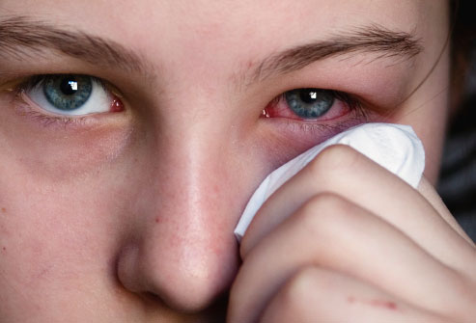

Not same pic but similar to it

Diagnosis ?
Bacterial conjunctivitis ( Viral ? the discharge wasn't clear but most likely its bacterial )
Treatment ?
The mainstay of treatment of bacterial conjunctivitis is topical antibiotic therapy. Systemic antibiotics are indicated for Neisseria gonorrhoeae and chlamydial infections. Surgical intervention is required only when indicated for the treatment of causative conditions, such as hordeolum, nasolacrimal duct obstruction, or sinusitis.( from medscape.com )

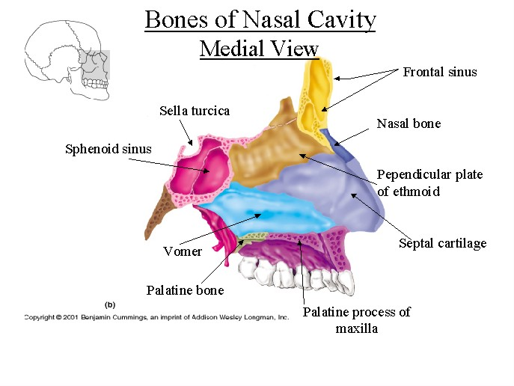

Not same pic but similar to it
Bones ?
- frontal - nasal
- vomer - ethmoid
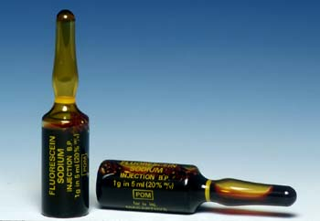

Not same pic but similar to it
What is this eye drop ?
Fluorescein dye
Uses ?
diagnosis of corneal abrasions, corneal ulcers and herpetic corneal infections.
ENT OSCE
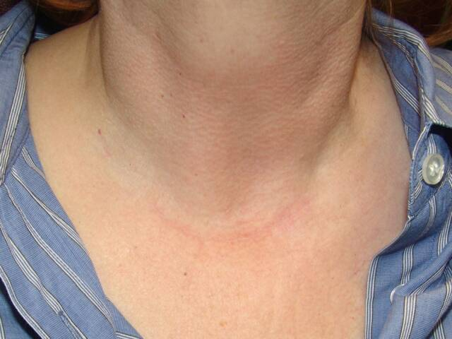

Not same pic but similar to it
I don't really remember the exact Q But I think it was a female which developed hoarseness ( stridor ) after thyroid surgery
What is the nerve involved ?
Recurrent laryngeal N
What is the diagnosis ?
Bilateral recurrent nerve injury ( iatrogenic ) which lead to vocal fold paralysis
Imp. Notes :
Other pics came the same as in OSCE's CD so study them carefully .
In optha osce u will have the Q's written on the paper so some Q's u will know their answers just by looking to paper & before they show the pic whereas in ENT osce they will note write the pic on the paper so u should be more careful .
Good Luck ,
Mo3ath
In optha osce u will have the Q's written on the paper so some Q's u will know their answers just by looking to paper & before they show the pic whereas in ENT osce they will not write the Q's on the paper so u should be more careful .

