EXAMINATION OF THE FOOT AND ANKLE
Anatomy
Bone and joints:
Hind foot :1-calcaneuse 2- talus
Mid foot
Fore foot
Soft tissues:
Ligaments
Muscles:1-intrinsic 2-extrinsic
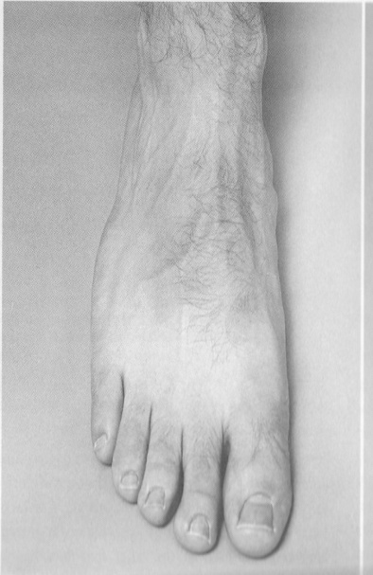 | 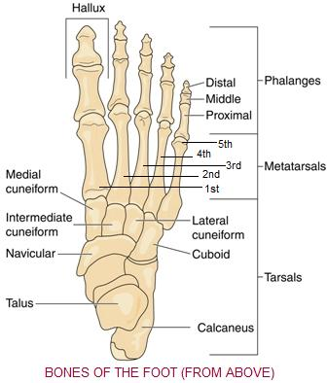 | 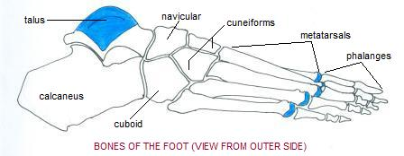
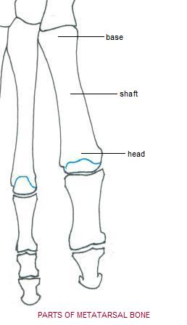 | 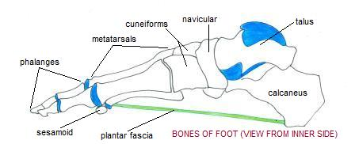 | 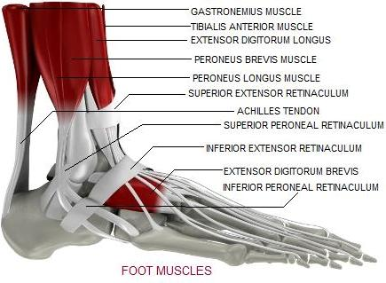
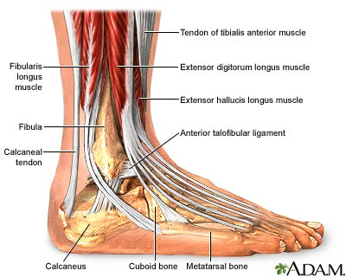 | 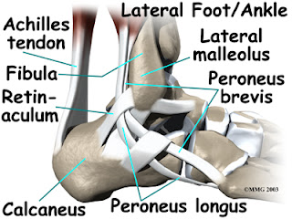 | 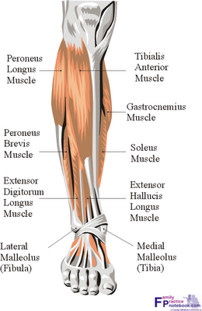

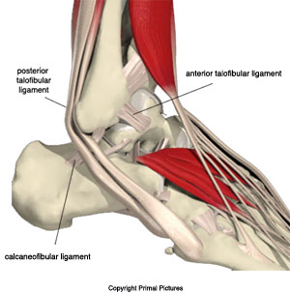 | 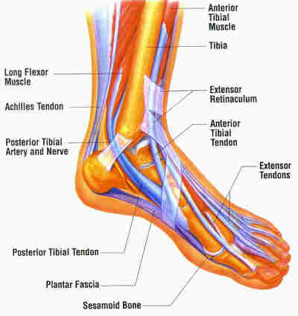 | 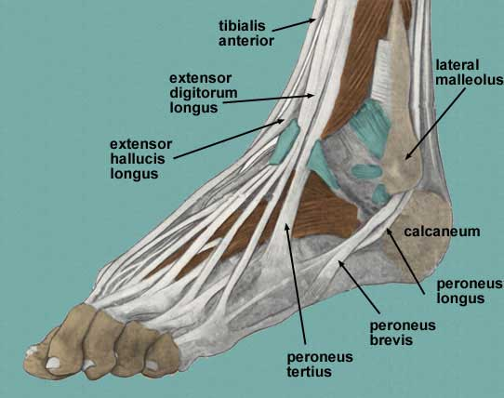
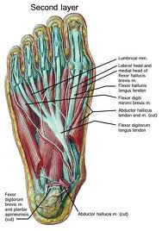 | 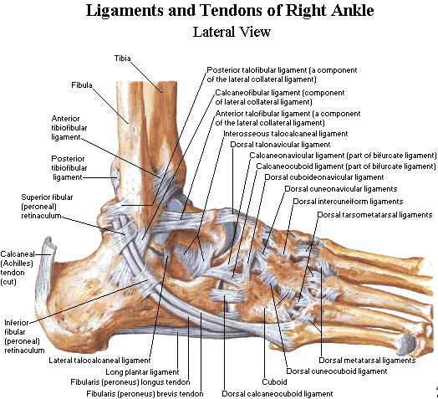 | 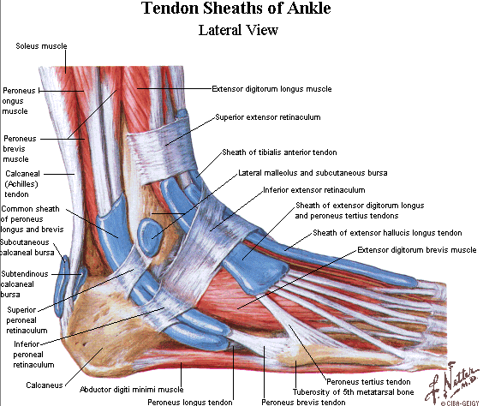

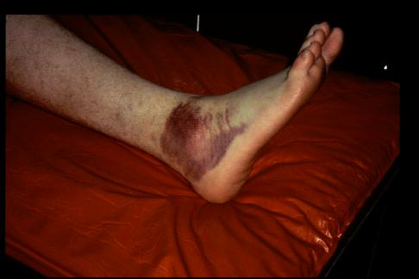
History
- Onset
- Duration
- Mechanism
- Swelling / Ecchymosis
- Ambulation
- Hx of previous injury
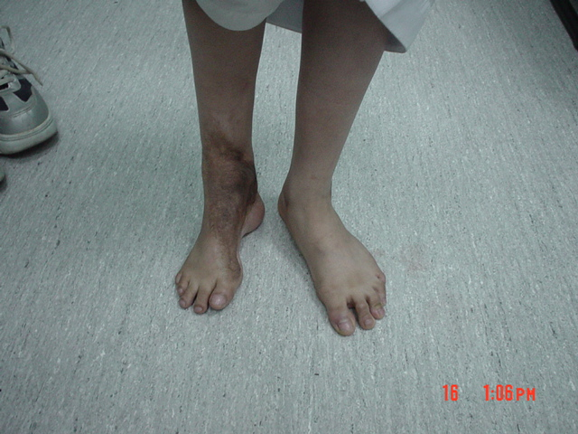
Examination:
*2 PARTS:
-ERECT POSITION. -SUPINE POSITION.
*4things should be do it :
-Inspection. -Palpation. -Movements. -Special tests.
1- INSPECTION OF THE PATIENT’S GAIT: very imp. Don’t forget in OSCE
Evaluation of the walking cycle
Gait ANALYSIS: is imp. In knee and ankle examination
- STANCE PHASE 65%-->longer
  - Contact Period heel strike to forefoot loading كعب الرجل يلامس الأرض
  - Midstance Period forefoot loading to heel raiseكعب الرجل يرتفع عن الأرض
  - Propulsive Period heel raise to toe offالكعب ثم أصابع القدم ترتفع عن الأرض
- SWING PHASE 35%--> shorter – the foot not touch the floor
The most common is short heel strike because tightness of achilus tendon
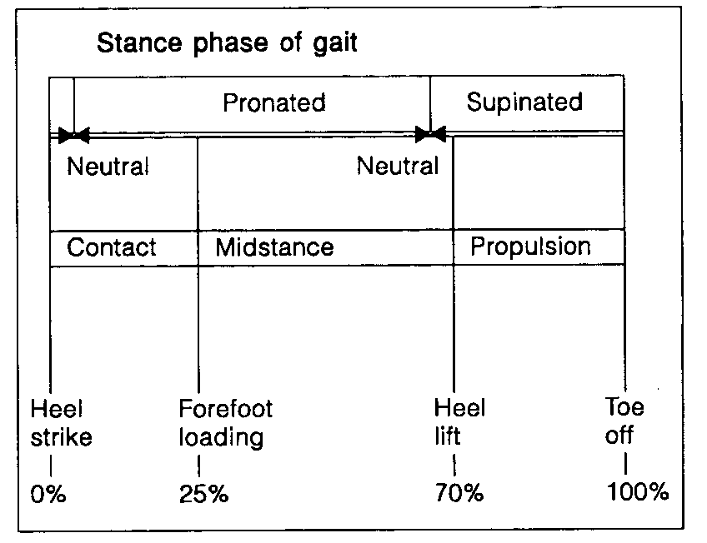

STANCE PHASE :
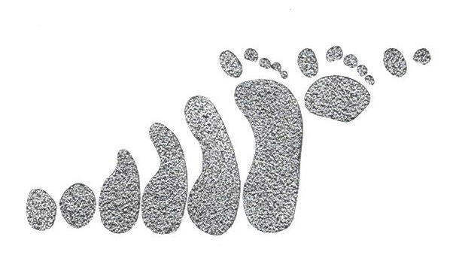
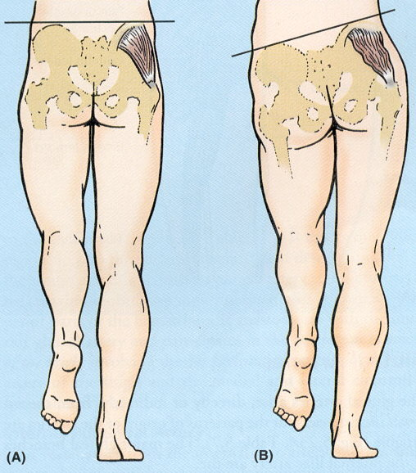
Trendelenburg gait(the pelvis is not transverse)
The Trendelenburg gait pattern (or gluteus medius
lurch) is an abnormal gait (as with walking) caused
by weakness of the abductor muscles of the lower limb
and joint of hip, gluteus medius and gluteus minimus.
People with a lesion of superior gluteal nerve have weakness of abducting the thigh at the hip. This type of gait may also be seen in L5 radiculopathy and after poliomyelitis, but is then usually seen in combination with foot drop.
During the stance phase, the weakened abductor muscles allow the pelvis to tilt down on the opposite side. To compensate, the trunk lurches to the weakened side to attempt to maintain a level pelvis throughout the gait cycle. The pelvis sags on the opposite side of the lesioned superior gluteal nerve.
Tip-toe walking Shortcut of contact and mid phases
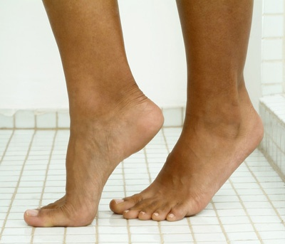
Toe walking refers to a condition where a person walks
on his or her toes without putting much weight on the
heel or any other part of the foot. Toe-walking in toddlers
is common. These children usually adopt a normal
walking pattern as they grow older. If a child continues to walk on his or her toes past the age of three, he or she should be evaluated by a doctor.
Toe walking can be caused by different factors. One type of toe walking is also called"idiopathic" toe walking, where the cause is unknown. Other causes include a congenital short Achilles tendon, muscle spasticity (especially as associated with cerebral palsy)
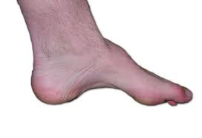
Foot drop walkingproblem in dorsiflexion
Foot drop is the dropping of the forefoot due to weakness,
damage to the peroneal nerve or paralysis of the muscles in
the anterior portion of the lower leg. It is usually a symptom of a greater problem, not a disease in itself. It is characterized by the inability or difficulty in moving the ankle and toes upward (dorsiflexion). It can occur unilaterally or bilaterally. In walking, while stepping forward, the knees are slightly bent so the front of the foot can be lifted higher than usual to prevent the foot from dragging along the ground.
10%of dorsiflextion in the normal walking
Spastic gait
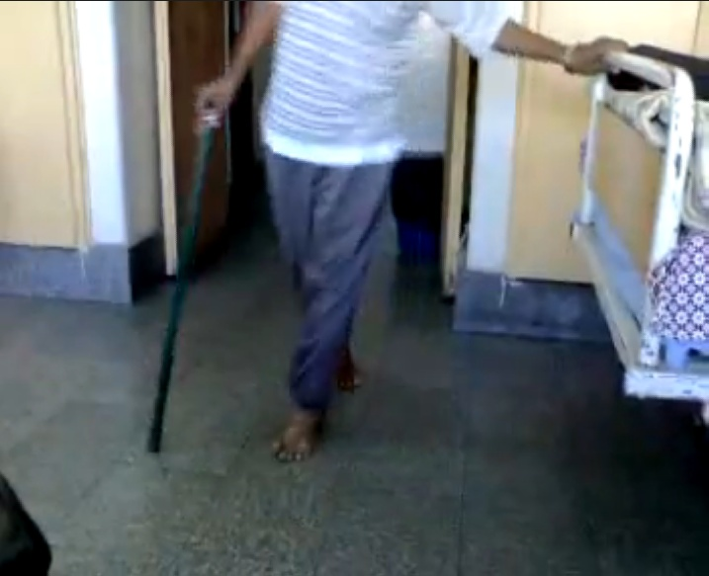
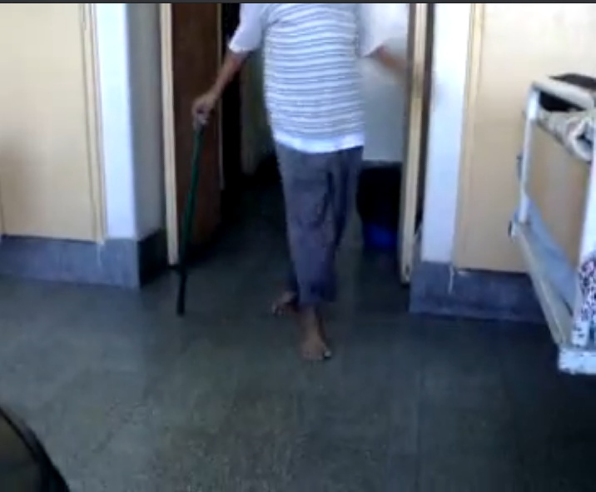
The legs are typically weak and
abnormally stiff. As he walks, he holds his
legs closer together than normal, drags his
feet or toes, and lacks the typical flexibility in his ankles and knees. Often, people with cerebral palsy (effect the flexor ms of the hip and knee humstring ms and adductor ms )exhibit this type of walking. Other conditions, including brain tumors and multiple sclerosis, may also contribute to this type of walk, however; it may even develop after a person has a stroke.
Intoeing/Out toeng gaitwalk in straight line
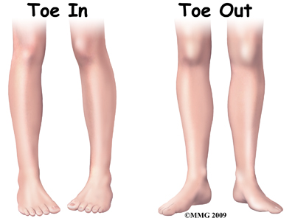
Intoeing means that when a child walks or runs, the feet turn
inward instead of pointing straight ahead. It is commonly
referred to as being “pigeon-toed.”
Out toeing gait is where the feet are pointed outwards when
walking. This is often described as similar to a penguin walking.
Normally 20 degree outside between the long axis of foot and walking line
In foot progression of angel 0 degree or minus degree
In outoeing increase the degree
Antalgic gait
Antalgic gait is a form of gait abnormality where the stance phase of gait is abnormally shortened relative to the swing phase. It can be a good indication of pain with weight-bearing.
Pain in hip
2-Inspection in standing position
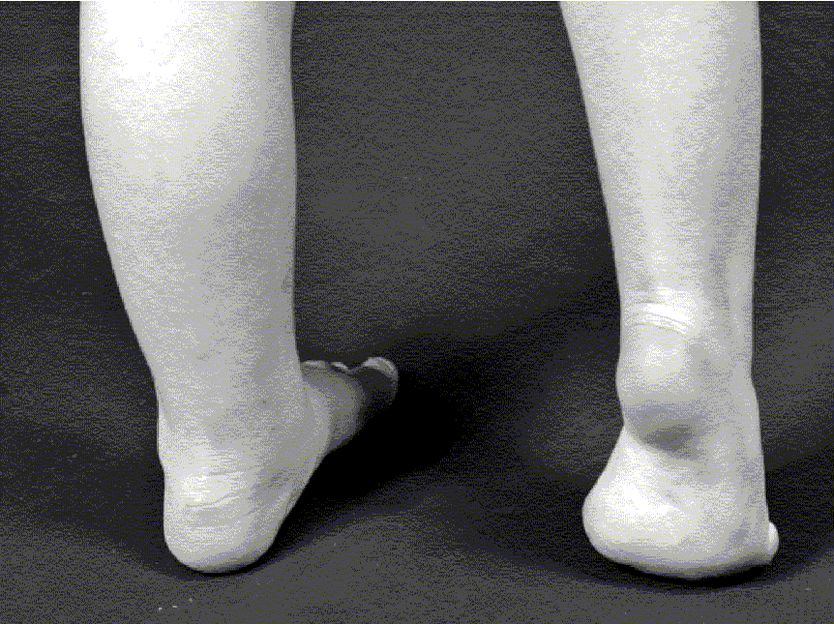 | 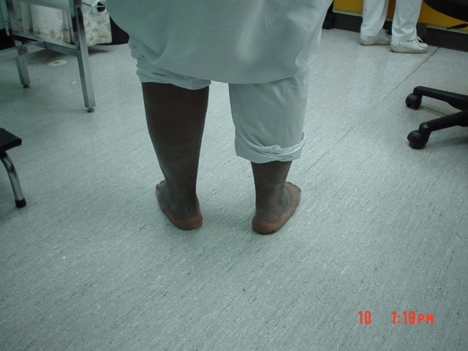 | 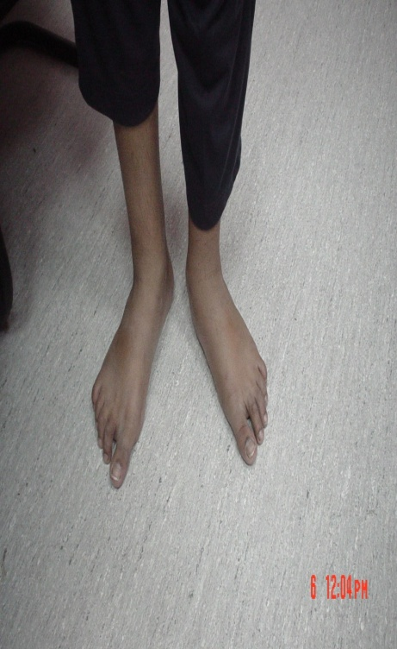
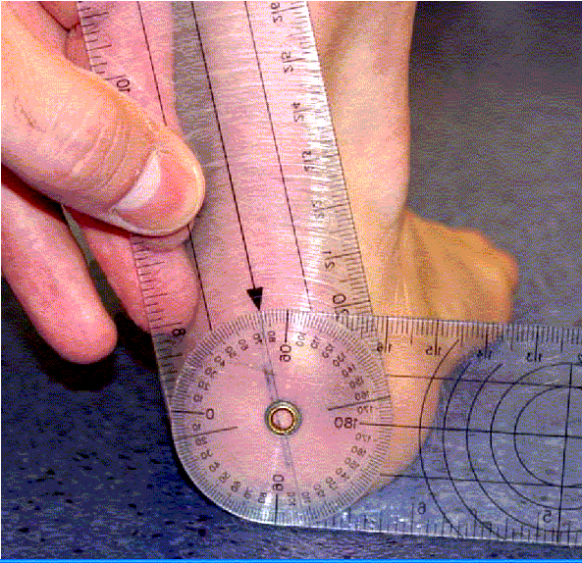 | 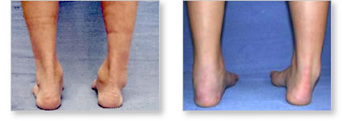 | 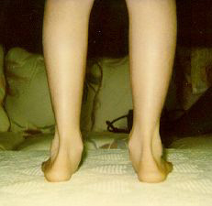
POSTERIOR HEEL STANDING
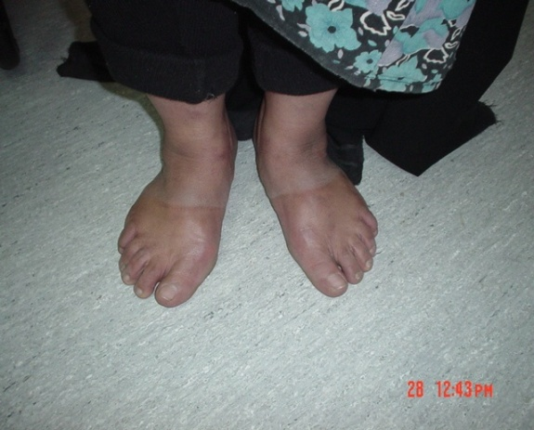 | 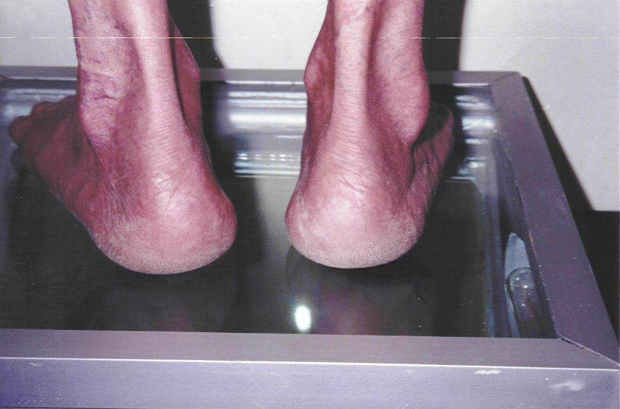 | 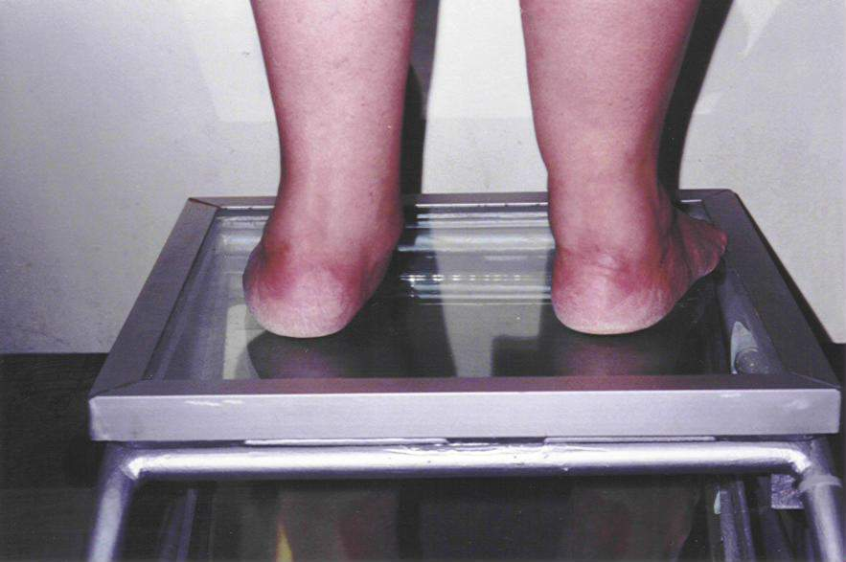  podoscope
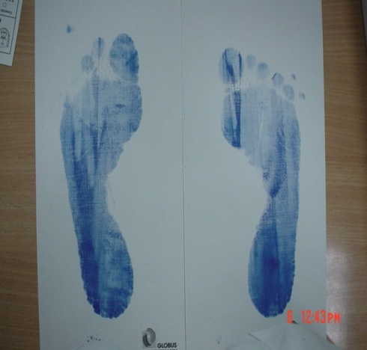 | 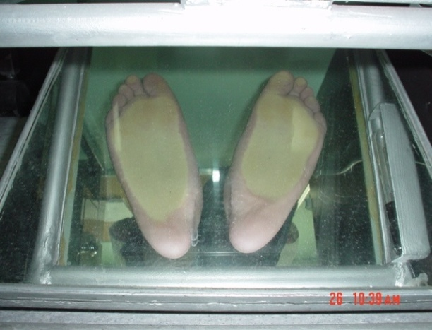 | 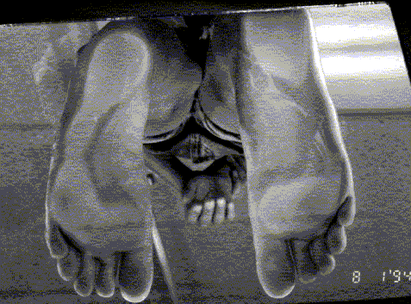
FOOT SHAPE
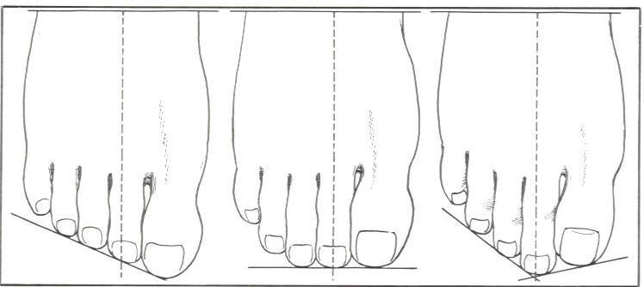
-all the toes should be in ground contact in w.b.(stability of the foot on the ground)
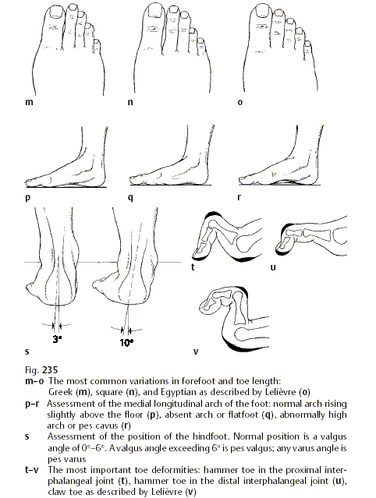
Claw toeextension of tarsophalangeal joint ,flexion of proximal interphalanges , flexion of distal interphalanges
Hammer toe natural of tarsophalangeal joint ,natural of proximal interphalanges , flexion of distal interphalanges
The toe
Hummer tose : flexion of proximal and distal IPJ
Clawing:flexion in proximal IPJ and extention of metatarsphalangeal joints

INSPECTION: of the lower limb
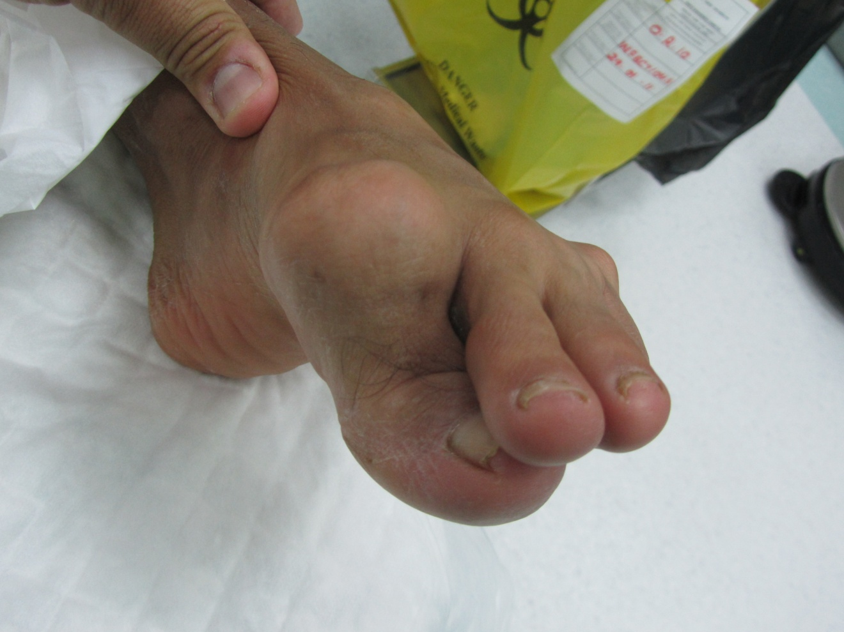
-Any asymmetry of length, rotational problem,
or mal alignment of the lower limbs.
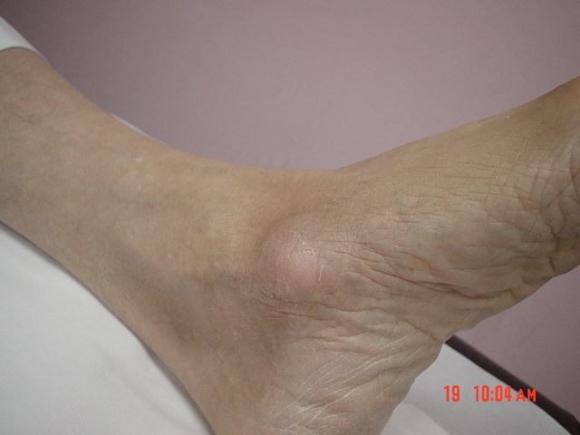
- scar ,deformity, swelling, skin changes, muscle wasting,
asymmetry of length, abnormal position….
-inspect all arround
PLANTAR SKINin supine postion look for sole
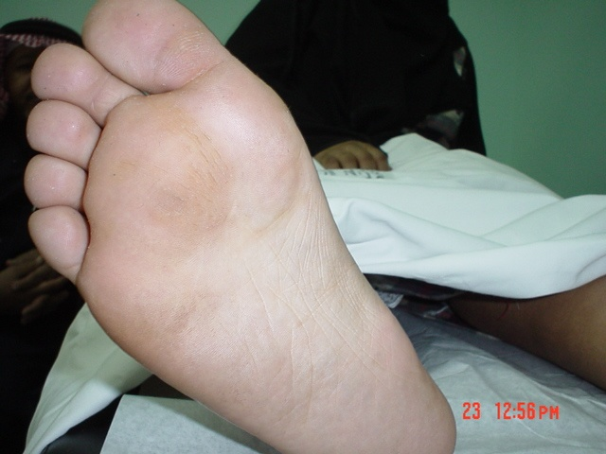
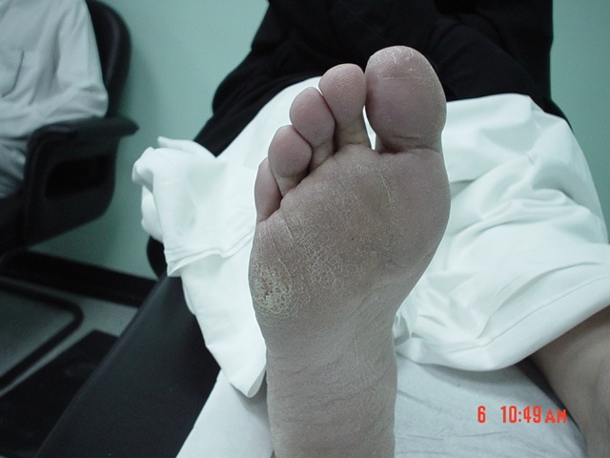
Callosity thickening and roughness of skin of sole arise from hyperkeratosis,
a normal physiological response to chronic excessive
pressure (excessive wt)or friction on the skin. mostly in the
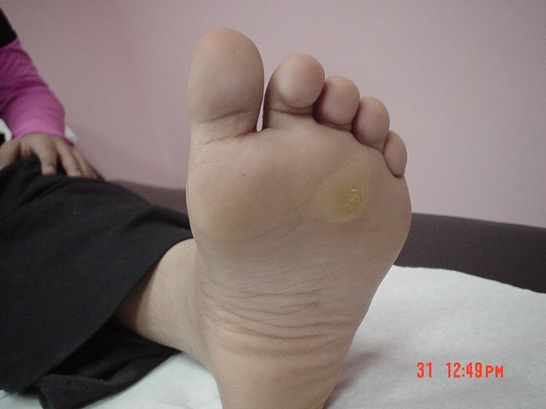
head of metatarsal
3-Palpation:
-Bone - joints -Soft tissues
-Tempreture ,tenderness, swelling, deformity
Anatomical landmarks:
-Medial malleolus, lateral malleolus, Achilles tendon, calcaneal tuberosity, peroneal tendon, tibialis posterior tendon, tibialis anterior tendon, plantar fascia, base of 5th metatarsal, 1st MP joint, metatarsal heads……..etc
tibialis posterior tendon in posterior to medial malleolus
useful for arthroscopy and aspiration
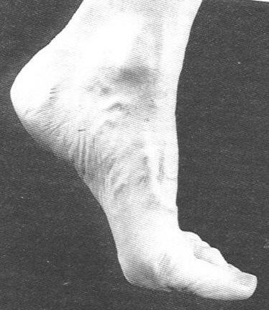 | 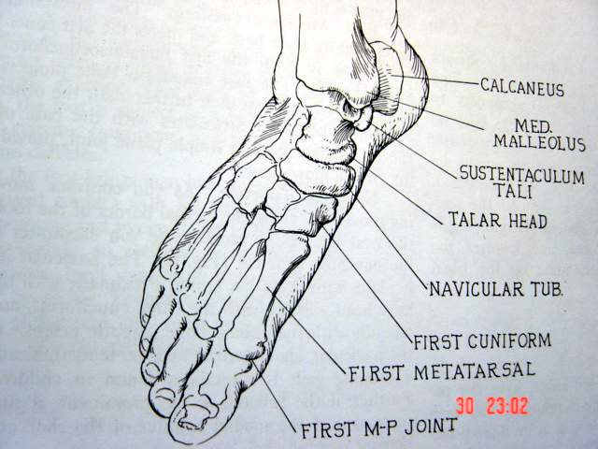 | 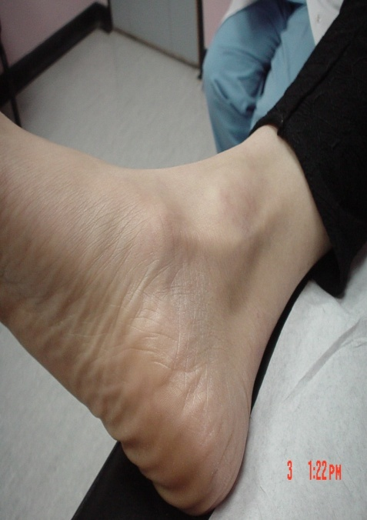
4-MOVEMENTS: lateral malullus inferior and posterior
Will started by active movement (by pt)then passive (by dr)

Ankle movements:  -dorsiflection -plantar flection.  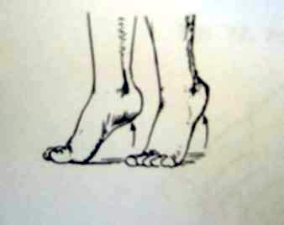  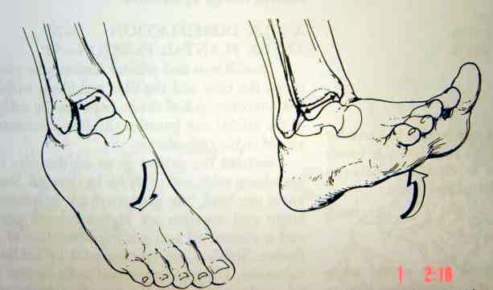 | -Subtalar:  move the heel inversion -eversion.  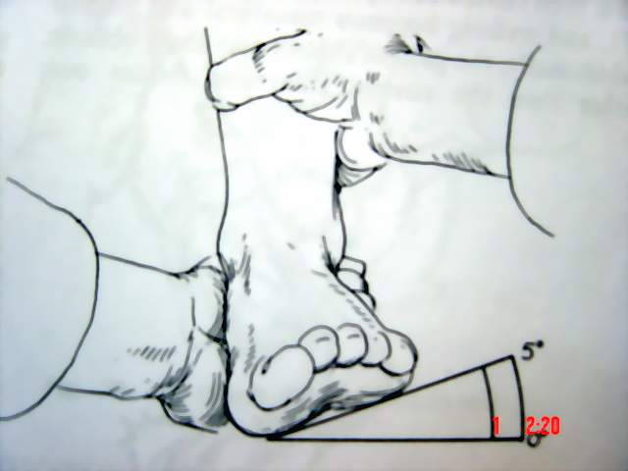  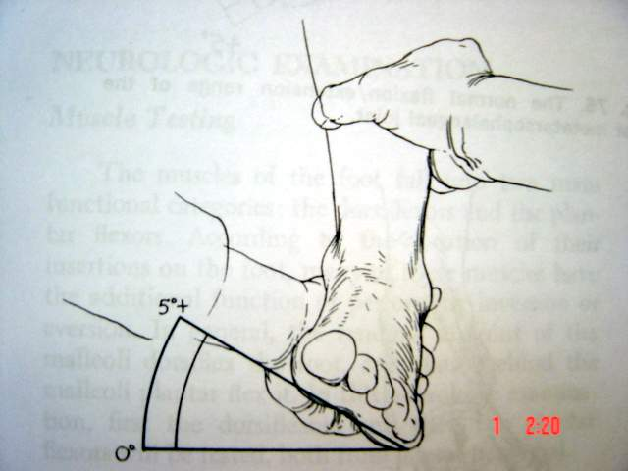 | -Midtarsal:  pronation -supination  -Tarso-metatarsals: move the metatarsals one by one.  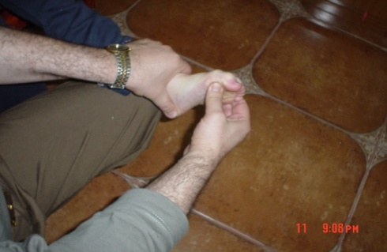  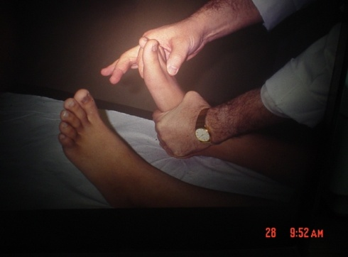  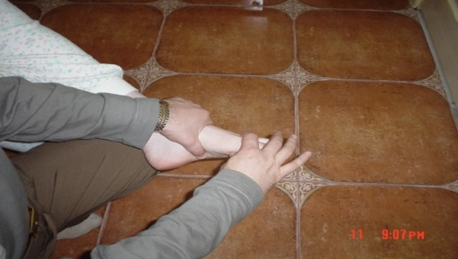
Toe:  -importance of the big toe (running, jumping)  -Problem of hallux rigidus | We need 65 degree of big toe dorsiflection is minimal range necessary for movment

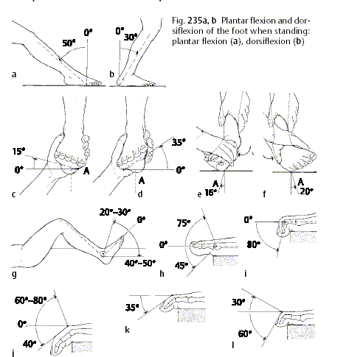
EXAMINATION OF THE SHOES
Good shoes are rigid,heal (2cm),rocker button shoes (the last one is for walking person)
Bad shose : too lax,too loose,to flat
5-Special tests
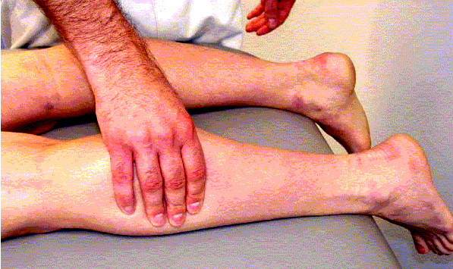
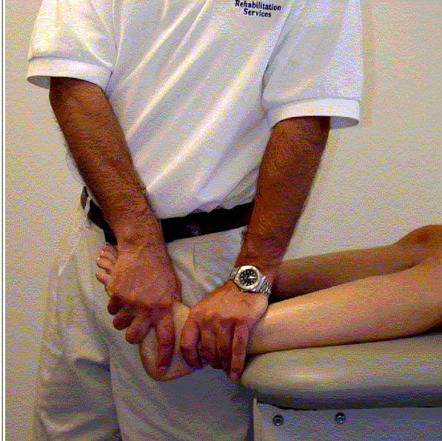

Ankle sprain:
Lateral ligament. | Stress view.  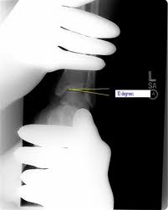  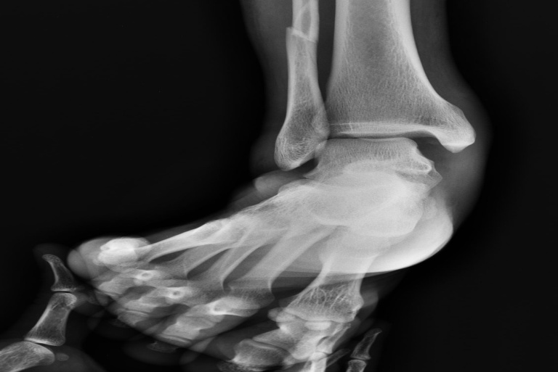
Anterior drawer.-->to Chiekfor instability of ankle  Need AP and lateral X-ray  Pt can not walk un flat floor  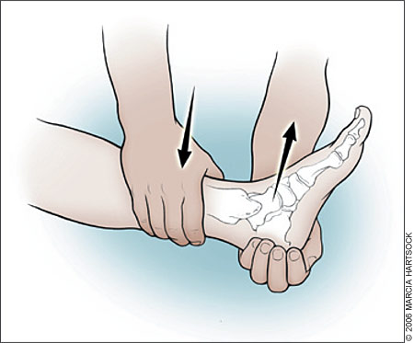  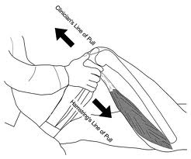 | Varus stress test.  Need AP and lateral X-ray  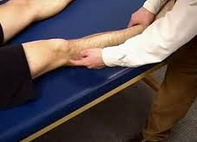
SPECIAL PATHOLOGIES:
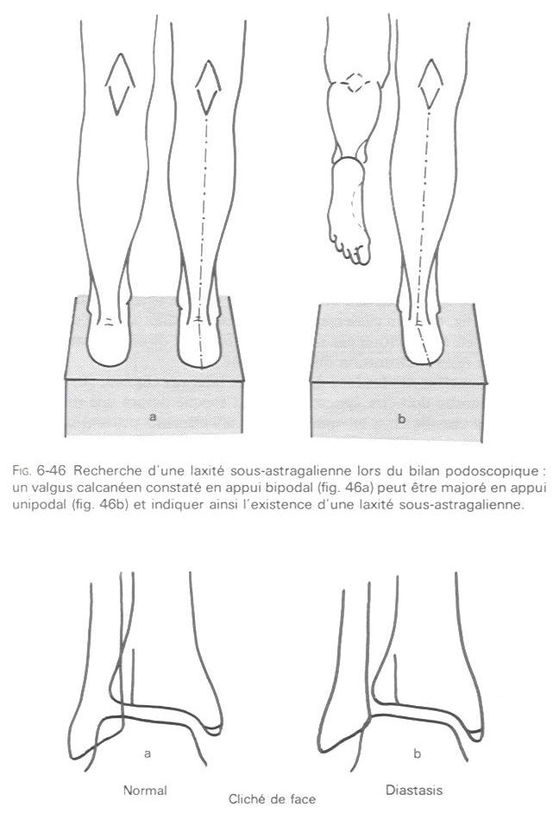
Ligaments injuries:
Lateral collateral ligament(LCL) to maintain the alignment of the
ankle
-Lateral collateral ligament of the ankle: varus stress view AP.
And it is the most common ligament to be injured
-Subtalar ligaments: increased valgus by standing on one leg.
Treatment of LCL immobilization-ice –good analgesia
Syndosmosis lig inj :x-ray

ACHILLES TENDON:
Tight :equinus when the foot is fixed in planter flexion due to tight tendon
-RUPTURE:(signs in prone position)
~depression.
~absence of rest plantar flexion.
~no plantar flection by squeezing the calf muscles.
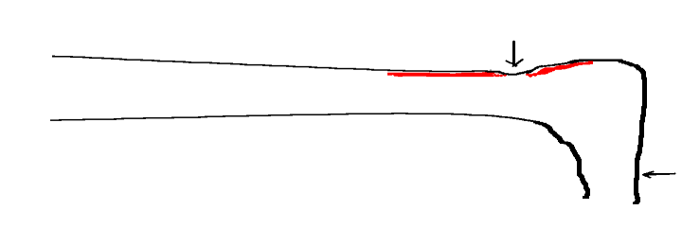 | 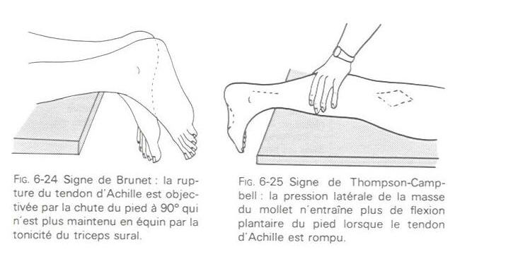
 | 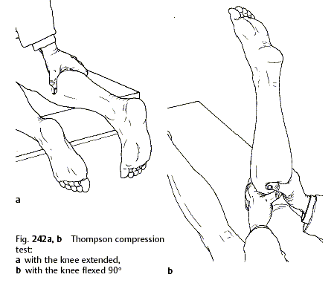
THOMPSON TEST do it in prone positionnormally the planter flexion will occur
Pes planus: common 20% -idopathic-flexable flat foot
-gait: ugly.
-inspection standing: heel, arch, forefoot.
-generalize ligament laxity
-move the heel and the 1st metatarsal.
-examin the tendo achilles
-may be asymptomatic not need to treatment only good shoes but some pt has fatigue (in excessive valgus )here we have to treat it
Mild valgus is normal but its become varus in standing in toes
Rigid foot heal or toe (valgus )should be do investigation
Pain and fatigue during walking corrected by foot insoles with rising the heel
Tibialis posterior is the main dynamic protectors of medial arch
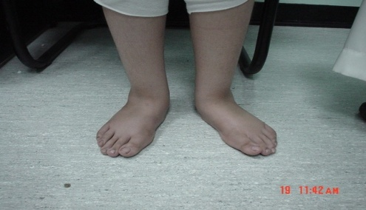 | 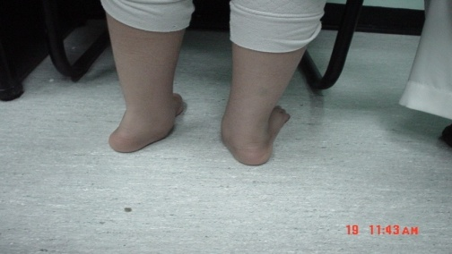 | 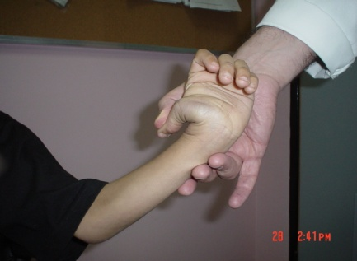
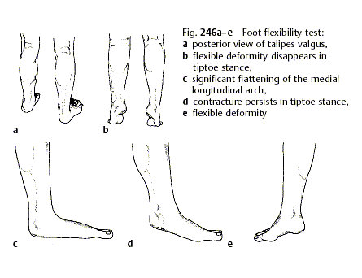
Pes cavus
High arch -Varus (heel)
Cause :
Congenital clup foot –generalize neurological disease –charcot manitooth(the last one is the most common one )
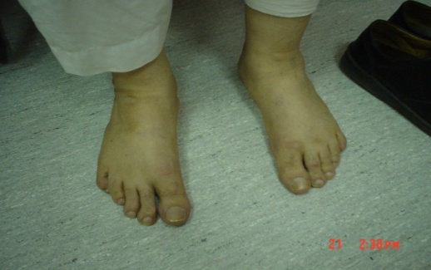 | 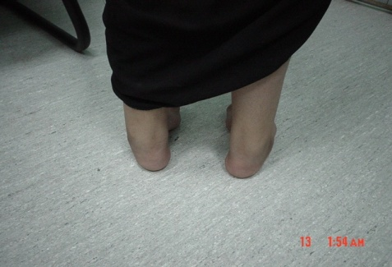 | 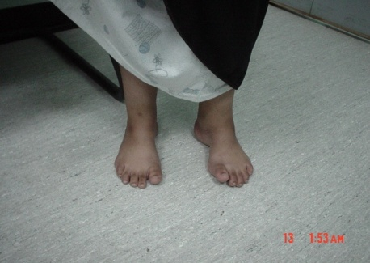
TARSAL COALSION: مثل الكبري او الجسر
The most common cause of spasticity of calcaneo-navicular then talus calcaneous
Painful stiff flat foot
Symptoms in adulthood
Usually bilateral, can be unilateral
-Stiff subtalar.
MORE COMMON:calcaneo-navicular and subtalar.
-Request CT scan to see stiff subtalar
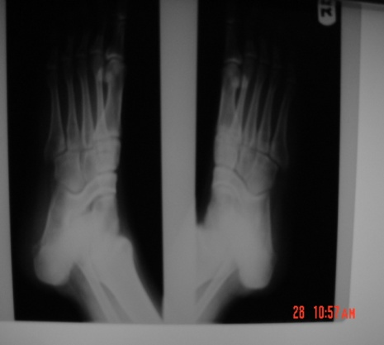 | 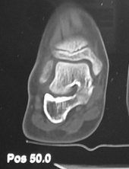 | 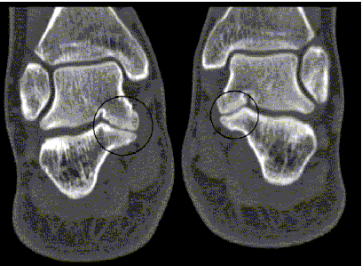
INTOING GAIT:
Very common
-Internal femoral torsion: exaggerated anteversion normaly 10-15
-Internal tibial torsion.
-Forefoot adduction.
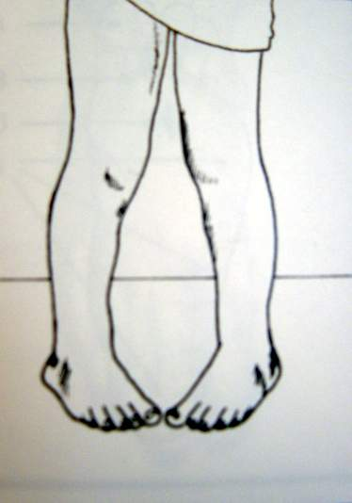
-PLANTAR FASCIITIS: مثل المسمار heel pain syndrome
Inflammation of calcaneal insertion of planter fascia
~Any tightness of Achilles tendon ~Any mechanical foot disorder.
~Any use of bad shoes
Pain increase in the morning -biomechanical displacement –can not put his wt in his foot –treat it by local physiotherapy and course of non steroidal and correct the mechanical problem and treat inflammation
Calcaneal spear is result not cause of disease
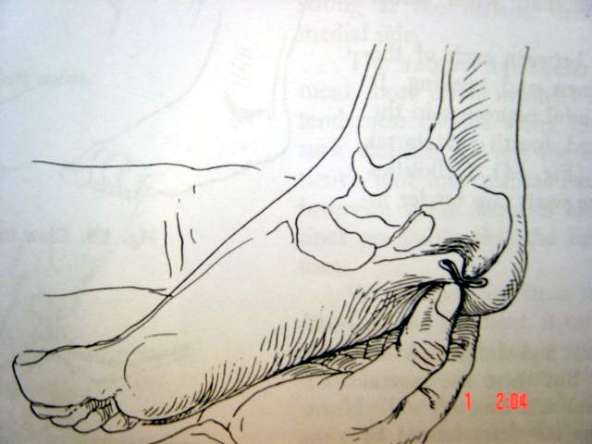 | 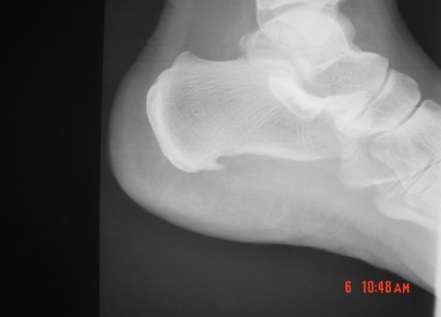
Metatarsalgia
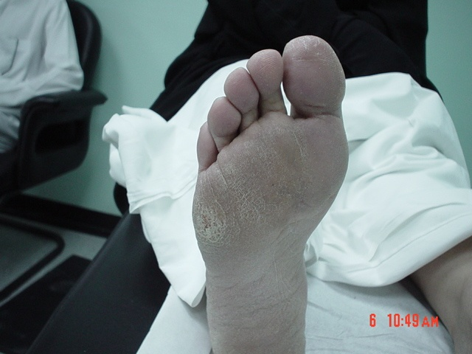
Pain of metatarsal head most is 2nd because it is rigid
Metatarsalgia is a general term used to denote a painful
foot condition in the metatarsal region of the foot
May cause Callosity

Hallux valgusthe big toe in prone and out position-idiopathic or family history if its mild is asymptomatic ,if its sever cause pain especially with tight shoes here will treat the function not the shape
3 deformity :
Medial deviatin of the 1st metatarsal joint
Lateral deviation of big toe
Bunion(prominent head of 1st metatarsal
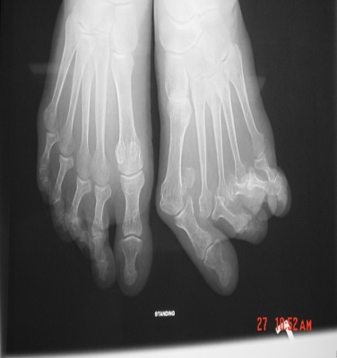 | 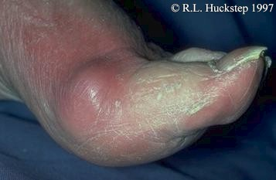 | 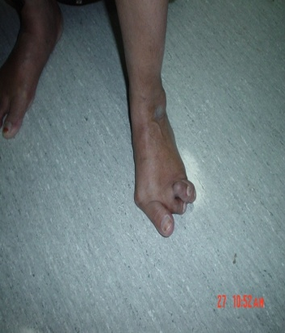 | 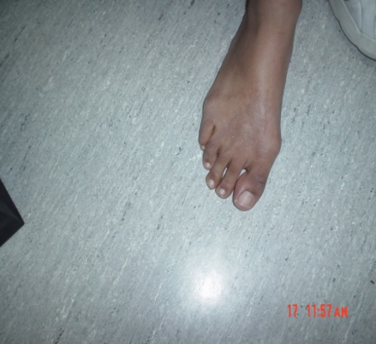

Hallux rigidus:
Osteoarthritis 1st MPJdegenerative change in joint of big toe or dorsal ossified of big toe
Can not extend the big toe espically while walking , sever pain
Tx: rigid shose with curved front and back
OA in KSA in knee and 1 metatarsal
In west in hip
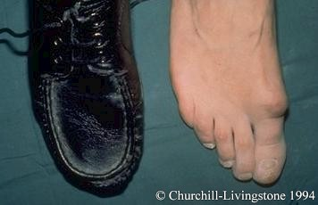 | 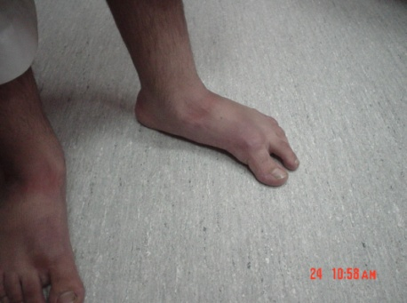 | 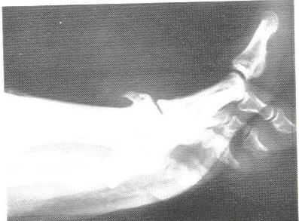

NOTE:
-Foot 10 compartment , Hand 9 compartment (for that the foot is more complicated )
-The normal person can walk on all part of sole and toes except the medial arch
-podo= foot
-normal children have flat foot –middle arch well complete develop after 2-3 years in really pt come to hospital at 9-13years complaining of pain because development
-if the joint away from midline varus 3-7 degree
-if the joint toward the midlin valgus =glue
-if the pt walk in his toe will become varus (medial tarsal joint )

Done by
Rahmah ALariyani
Elaf Ahmad

