Hypertension
Hypertension is one of the most common worldwide diseases afflicting humans. hypertension is an important public health challenge. Hypertension means high blood pressure.
Blood pressure is a measurement of the force against the walls of your arteries as your heart pumps blood through your body.
· Normal blood pressure is when your blood pressure is lower than 120/80 mmHg most of the time.
· High blood pressure (hypertension) is when your blood pressure is 140/90 mmHg or above most of the time.
· If your blood pressure numbers are 120/80 or higher, but below 140/90, it is called pre-hypertension
There are different types of hypertension varying on the cause of activity.
- Primary hypertension:
is diagnosed blood pressure condition in majority of people with cases in hypertension.
- Secondary hypertension:
is often curable and caused by changeable factors.
Kidney impaired function
Abnormal activity of the adrenal gland
Thyroid dysfunction
Pregnancy-related conditions like preeclamsia
Recreational drugs, foods, drinks and other medications
- Malignant Hypertension is the most severe type of hypertension. Progressive condition is usually fatal to vital organs of the body resulting to heart failure, kidney damages and brain aneurysm. Patients usually common in ages above 40 years old and more on men.
- Isolated Systolic Hypertension is usually occurring when the systolic blood pressure is above 160mmHg and 90mm Hg or below with diastolic blood pressure. This is prevalent to old people due to arteriosclerosis.
- White Coat Hypertension also known as anxiety-induced hypertension. Patients are deceptively calm
Epidemiology:

- Hypertension is a serious public health challenge affecting approximately 30% of adults ( >18).
- It increase the risk for heart disease and stroke.

Research in KSA:

- A community-based study conducted by examining subjects in the age group of 30-70 years of selected households during a 5-year period between 1995 and 2000.
- The total number of subjects included in the study was 17,230. The prevalence of hypertension was 26.1%

Risk factor:
- Old age
- Race (black people)
- Obesity
- Gender (men more that women….. but after women become menopause they have equal chance
- Unhealthy life style
- Others:
Smoking
Alcohol
Family history

- - MALIGNANT HYPERTENSION
also called hypertensive crisis, is the most severe form of hypertension featuring high blood pressure with target-organ damage (e.g., central nervous system, cardiovascular, renal) in association with papilledema. In these conditions, the blood pressure (BP) should be lowered aggressively over minutes to hours.
Causes:
- Collagen vascular disease, such as scleroderma
- Kidney disease
- Spinal cord injuries
- Tumor of the adrenal gland
- Use of certain medications, including birth control pills and MAOIs
- Use of illegal drugs, such as cocaine
Risk factors:
Malignant hypertension is rare. About 1% of people who have a history of high blood pressure develop this life-threatening condition.
You are at greater risk of developing it if you are a man, African-American, or someone of lower economic status. Poor access to health care increases the risk
Symptoms:
- Blurred vision
- Change in mental status
- Confusion
- Fatigue
- Headache and numbness
- Nausea and vomiting
- Shortness of breath
- Reduce urine output

Complications:
- Brain damage
- Heart damage
- Kidney failure
- Permanent blindness
- Pulmonary edema

Management:
-Non pharmacological
Admission to an intensive care unit.
Limitation of activity and bed rest.
Patient education
Pharmacological:
Intravenous antihypertensive drug as nitroprusside
Labetalol is another common alternative
Intravenous calcium blockers (eg, nicardipine)
CASE 1:
A 25 year old male of African heritage presented to the ER with shortness of breath and blurred vision for 3 days, with a history of hypertension diagnosed 3 months ago, not on treatment . He gave history of recurrent headaches. After further inquiry it appears that the patient is a cocaine addict.
Examinations:
Vital signs:
BP: 206/160 mmHg
RR:20 breath/min
HR: 80 beat/min
Temp: 37
Cardiovascular, respiratory and abdominal
exam were normal
examination of the eye reviled retinopathy and papilloedema. Investigation:
increase urea and creatinine level
Do the following test to exclude other causes
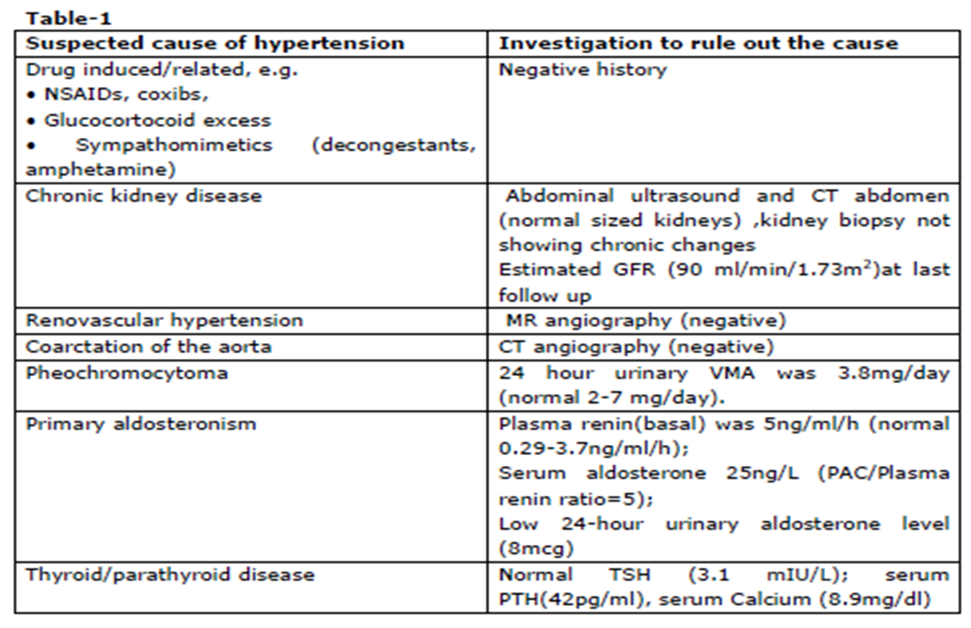Preeclampsia:
Case2
History:
19 year old primigravida came to the primary care clinic, complaining of blurred vision, headache and epigastric pain, for the past 3 days. She is in her 26th week of pregnancy and she has been told in her previous visit that she is pregnant with twins.
The physical examination of preeclampsia:
- Both the mother and fetus should be evaluated thoroughly.
- Inspection
- palpation
- Evaluation of the fetus:
- Biophysical profile, non-stress test and ultrasound should all be done.
Investigations:
CBC : vasoconstrictors were increased
LFTS : were elevated
Creatinine clearance: decreased
Uric Acid serum creatinine and BUN: were elevated
Urine dip stick : 3-4 on urine dipstick
Pathogenesis:
It cause by
1-diffuse vasospasm: with elevated blood pressure the vessels will narrowed which reduces the perfusion to systemic organs such as kidney and the result will be decrease creatinine clearance an elevated level of creatinin, uric acid and BUN
2-endothelial capillary wall injury: which will lead to decrease the intravascular fluid and elevates the extra vascular fluid and it will lead to edema an weight gain because of accumulation of protein extra vascular space.
We shouldn't give pregnant woman in this stage diuretics because it will lead to further decrease in intra vascular space.
Definition:
Preeclampsia is a condition that typically starts after the 20th week of pregnancy and is related to increased blood pressure and protein in the mother's urine. Preeclampsia affects the placenta, and it can affect the mother's kidney, liver, and brain. When preeclampsia causes seizures, the condition is known as eclampsia. There is no proven way to prevent preeclampsia. The way to "cure" preeclampsia is to deliver the baby.
Risk factors:
1-Primigravda
2-Women with chronic hypertension (high blood pressure before becoming pregnant).
3-Women who developed high blood pressure or preeclampsia during a previous pregnancy, especially if these conditions occurred early in the pregnancy.
4-Women who are obese prior to pregnancy.
5-Pregnant women under the age of 20 or over the age of 40.
6-Women who are pregnant with more than one baby.
7-Women with diabetes, kidney disease, rheumatoid arthritis, lupus, or scleroderma.
Complication may include:
- Lack of blood flow to the placenta
- Abruption of the placenta
- HELLP syndrome
- Eclampsia
- Cardiovascular risk
Management:
Non pharmacological
.Rest and lie on her left lateral side to increase blood flow to placenta and avoid complications that results from decrease blood flow to placenta such as IUGR.
.Monitoring blood pressure every 4 hours
.Every day dipstike to check protein level
.Weekly liver function test
.Twice weekly 24 hour urine collection
Pharmacological:
- Hydralazine - to reduce blood pressure
- Labetalol -to reduce blood pressure
- Magnesium sulfate - for the prevention of seizures
- Antidote to magnesium toxicity is calcium gluconate
- Corticosteroids - for lung maturation of the fetus.

Complications of hypertension:
Case3
A 65-year-old male a known case of hypertension diagnosed 20 years ago, on B-blockers. He came to the clinic complaining of leg swelling that appeared 2 days ago and orthopnea for 3 months. He has found that using a couple of pillows at night makes it easier to breathe. He also feels fatigued on minimal exertion. He has dyslipidemia and diabetes mellitus type 2 . He has been a smoker for 40 years and has stressful life style
- Hypertension can affect on Brain, Eye, Heart, Kidney and Arteries:
Heart complication of hypertension :-
Hypertensive heart disease is the result of:
1-Structural and functional adaptations.
2-Abnormalities of blood flow due to atherosclerosis
- Hypertension >LVH >disturbances of myocardial blood flow > diastolic dysfunction>CHF
- Congestive Heart Failure :
Investigation:
Echocardiography , ECG, chest x-ray, blood tests including electrolytes and B-type natriuretic peptide (BNP) which is a specific test indicative of heart failure
-Treatment:
Pharmacological:
First-line therapy is angiotensin-converting enzyme (ACE) inhibitor (e.g. enalapril).
loop diuretics
beta-blockers
In severe cardiomyopathy aldosterone receptor antagonists
Non-pharmacological:
Behavioral modifications:
weight reduction.
reduced salt intake.
Gradually increasing exercise can significantly improve quality-of-life.
EBM:
HYPERTENSION CONSIDER the most common risk factor for premature cardiovascular disease

Brain complications of hypertension:
1-hypertensive encephalopathy.
2-Cerebrovascular accident.
3-Hypertension-related cognitive impairment and dementia
- Hypertension has a key role in two major brain pathologies, stroke and dementia. Stroke can result from occlusion of a major cerebral artery or rupture of intracerebral arterioles (hemorrhage). avscular cognitive impairment (VCI) is caused by occlusion of small arterioles in the white matter, which interrupt neural connections sub serving cognition and memory. Hypertension is a risk factor for Alzheimer's disease
Kidney complications of hypertension
Diagnosis:
Certain laboratory tests can indicate whether your kidneys are eliminating waste products properly. These tests include:
• serum creatinine
• blood urea nitrogen (BUN)
•Proteinuria, an excess of protein in the urine, is also a sign of kidney disease
What Are The Effects Of Hypertension On The Kidney?
•Kidney failure.
• Kidney scarring (glomerulosclerosis).
•artery aneurysm.
What Are the Symptoms of Kidney Disease?
•High blood pressure
•Decrease in amount of urine or difficulty urinating.
•Edema (fluid retention), especially in the lower legs
•A need to urinate more often, especially at night
How Is Kidney Disease Treated?
•control your blood pressure.
•ACE inhibitor and angiotensin II receptor blocker (ARB) drugs lower blood pressure and protect the kidneys from further damage.
How Can I Prevent Kidney Disease?
• keep your blood pressure controlled
•.Make sure you get your blood pressure checked on a regular basis.
•Eat a proper diet.
•Take the medication your doctor prescribes
How can high blood pressure affect the eyes?
•Eye blood vessel damage (retinopathy); This condition can lead to bleeding in the eye, blurred vision and complete loss of vision.
•Fluid buildup under the retina (choroidopathy).
•Nerve damage (optic neuropathy).
Symptoms of hypertensive retinopathy may include:
•Headaches
•Vision problems
Treatment options for hypertensive retinopathy include:
•High blood pressure treatment
•Regular eye exams for hypertensive retinopathy: As directed by your doctor
•Laser surgery: Repairs damage to the retina, caused by hypertension

HTN treatment:
Major classes of antihypertensive drugs:
-Thiazide diuretics
-Calcium channel blockers
-ACE inhibitors
-ARB (angiotensin receptor blocker)
-Beta blockers

NICE guidelines
Treatment:
- Patient education:

Educate the patient about the life intervention treatment

- Life style intervention
- Relaxation therapy
- Salt diet restriction
- Stop smoking
- Reduce alcohol intake
for choosing antihypertensive treatment
Step1
< 55 years: offer step 1 antihypertensive with ACE inhibitor or low-cost ARB.
Do not combine ACE with ARB.
> 55 years and to black people of African or Caribbean family origin of any age: offer step 1 antihypertensive with calcium channel blocker or thiazide-like diureticin cases of oedema or intolerance, or if there is evidence of heart failure or a high risk of heart failure.
(we don’t recommend ACEI for black people cause it cause anaphylactic shock for them )

If diuretic treatment is to be initiated, offer a thiazide-like diuretic, such as chlortalidone.
Beta-blockers are not a preferred initial therapy for hypertension, except in young patients with contraindications to other drugs in which we use it in combination with CCB.
Step2
If blood pressure is not controlled by step 1 treatment, offer step 2 treatment with a CCB in combination with either an ACE inhibitor or an ARB.
Offer thiazide-like diuretic instead of CCB in cases of oedema or intolerance, or evidence of heart failure.
For black people of African or Caribbean family origin, consider an ARB in preference to an ACE inhibitor, in combination with a CCB.
Step3
- First ensure step 2 treatment is at optimal or best tolerated doses.
- Combination of ACE inhibitor or angiotensin II receptor blocker, calcium-channel blocker and thiazide-like diuretic should be used.
Step4
-If clinic blood pressure remains higher than 140/90 mmHg after treatment with the optimal or best tolerated consider adding a fourth antihypertensive drug and/or seeking expert advice
For persistent Hypertension at Step 4:
- Consider further diuretic therapy with low-dose spironolactone
- If the therapy is not tolerated, or is contraindicated or ineffective, consider an alpha- or beta-blocker.
- If blood pressure remains uncontrolled with the optimal or maximum tolerated doses of four drugs, seek expert advice if it has not yet been obtained.
Why do we have to control hypertension?
- One of the most common chronic medical problems in our community.
- Risk factor for:
    - Cardiovascular disease and mortality
    - Cerebrovascular disease and mortality
    - End stage renal disease
Prevention
- Hypertension Prevention includes mainly maintaining a healthy weight; being physically active; and following a healthy eating plan.
- Hypertension Prevention In 6 Simple Steps:
Step 1: Following a Healthy Eating Pattern.
Step 2: Reducing Salt and Sodium in Your Diet.
Step 3: Maintaining a Healthy Weight.
Step 4: Being Physically Active.
Step 5: Limiting Alcohol Intake.
Step 6: Quitting Smoking .
- DASH diet:
  - It stands for “Dietary Approaches to Stop Hypertension.”.
  - You can reduce your blood pressure by eating foods that are low in saturated fat, total fat, and cholesterol, and high in fruits, vegetables, and low fat dairy foods.
  - The DASH eating plan includes whole grains, poultry, fish, and nuts, and has low amounts of fats, red meats, sweets, and sugared beverages. It is also high in potassium, calcium, and magnesium, as well as protein and fiber.
Follow up for hypertensive patients:
- Uncontrolled hypertension should be followed up every month.
- Controlled hypertension should be followed from 3-6 months
- Hypertensive patients should be referred to an ophthalmologist every year.
- Fasting blood sugar should be checked every 6 months.
- Lipid profile should be checked every 6 months
- Kidney function should be tested every follow up.
- When to refer?
1-Accelerated hypertension, that is, blood pressure usually higher than 180/110 mmHg
2-Consider the need for specialist investigations in people with signs and symptoms suggesting a secondary cause of hypertension.
-Summary;
Hypertension is a serious disease.
Early diagnosis is the key to better prognosis
It affects about a quarter of the Saudi population
Systematic approach is essential to prevent organ damage

