Approach to Obesity
- Introduction and definition
Overweight may come from muscle, bone, fat and/or body water, obesity is considered when the overweight is due to fat. It is an abnormal accumulation of body fat, usually 20% or more over an individual's ideal body weight causing adverse effects on health.
Methods of estimating body fat
  - Body Mass Index (BMI= weight in kg/height in meters2) that is 40 and above, but is only useful in adults above 20 who are not athletes.
Classification of obesity by Body Mass Index (BMI)
Classification | BMI (Kg/m²)
Underweight | Less than 18.5
Normal weight | 18.5–24.9
Overweight | 25.0–29.9
Mildly obese (class I) | 30–34·9
Moderately obese (class II) | 35–39·9
Morbidly obese (class III) | Greater than or equal to 40

  - For children and young adults (2-19), BMI interpretations are age and gender-specific; depends on the corresponding percentile on BMI-for age growth charts.
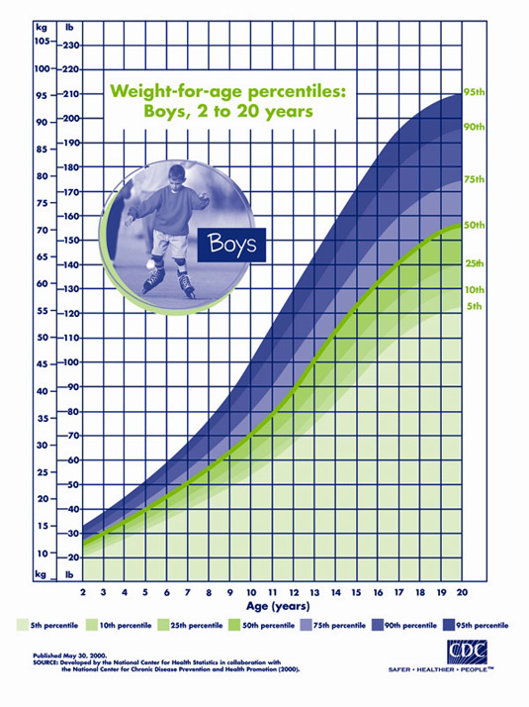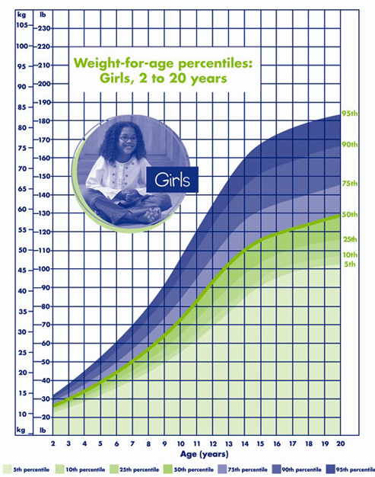
Percentile Range | Weight Status Category
Less than the 5th percentile | Underweight
5th percentile to less than the 85th percentile | Healthy weight
85th to less than the 95th percentile | Overweight
Equal to or greater than the 95th percentile | Obese

  - Based on waist-to-hip ratio (WHR), there are 2 types of adiposities; android (visceral fat type, apple shaped) vs. gynoid (pear-shaped). Android constitutes a severely increased health risk compared to the gynoid adiposity, with increased comorbidities, due to the direct effect of the fat on portal circulation.
  - Measurements of skin-fold thickness.
  - Waist circumference.
  - Techniques such as ultrasound, computed tomography, and magnetic resonance imaging (MRI).

- Prevalence
Overweight and obesity are the fifth leading risk for global deaths. 65% of the world's population lives in countries where overweight and obesity kills more people than underweight.
Saudi Arabia is considered one of the most developed countries in regards to obesity, as 28.8% of adults female are overweight and 23.6% are obese, while 30.7% of adults male are overweight and 14.2% are obese. In adolescents (aged between 13-18), 26.6% are overweight, 10,6% are obese, while 2.4% are extremely obese. In children (aged between 5-12), 19.6% are overweight, 7.9% are obese, while 1.5% are extremely obese.
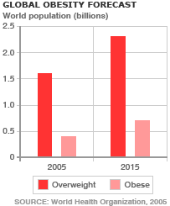

- Etiology
Lack of physical activity; technologies including transportation, and entertainment (video games, TV, and internet); and highly processed food and fast food, which contains addictive chemicals that is loaded with sugar and saturated fats are the main risk factors in Saudi
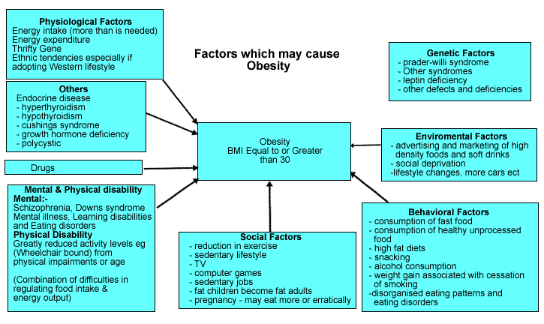

- Pathophysiology
Energy imbalance due to calories consumed not equal to calories used, over a long period of time.
Center for hunger and satiety lies in the hypothalamus, controlled mainly by Leptin and Ghrelin.
  - Leptin is a hormone secreted primarily by adipocytes, circulating leptin is directly proportional to the total amount of fat in the body, and it acts to reduce hunger and to stimulate energy expenditure.
  - Ghrelin is a hormone secreted by P/D1 cells lining the fundus of stomach, levels peak just before meals and drop afterward, and acts by stimulating appetite.

- Comorbidities and complications
Obesity increases the risk on a range of conditions involving every system in the body of adults and children, increasing the over-all mortality rate and decreasing life span.
Metabolic syndrome (syndrome X): is not a disease per se, rather a cluster of conditions which constitutes central obesity; high blood pressure; glucose intolerance and/or insulin resistance; dyslipidemia (↑triglycerides, ↓HDL), making the patient at very high risk for cardiovascular diseases and type II diabetes.
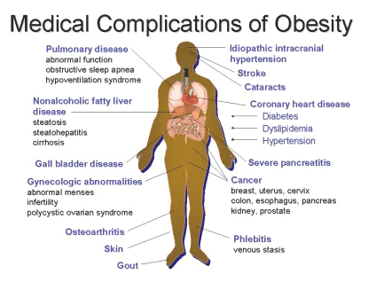

- Management
Main goals, according to WHO
- At a minimum, prevent further weight gain.
- Reduce body weight.
- Maintain a lower body weight over the long term.
- Improve pre-existing obesity-related comorbidities.
- Reduce the future risk of obesity-related comorbidities.
- Improve physical, mental and social well-being.
- History
When did your weight problems start?
Since childhood; sudden; gradual; after certain disease; medication; surgery; or after pregnancy.
Duration.
Progression
Constant; improving (decreasing); or worsening (increasing).
Eating habits
Appetite; orophagic (Binge Eating Disorder); type of food; number of meals and snacks/day; and last meal before bedtime.
Prior attempts to lose the weight?
When? How? How much weight was lost? How long to lose the weight? How long was it maintained? If successful or not, and why? Maximum weight loss and gain? An event in the future for which weight loss would liked to be achieved?
Risk factors.
Complications and comorbidities
Daily exercise or physical activity.
Social history
Activity and lifestyle adjustments; or depression.
Menstrual history.
Not to forget in the primary health care setting is the 5 As approach
  - ASK: Ask all patients about smoking; nutrition; alcohol or physical activity, and ASSESS: readiness to change; dependence (smoking and alcohol).
  - ADVISE: Brief, nonjudgmental with patient education materials (such as brochures) and motivational interviewing
  - ASSIST: By providing motivational counseling and a prescription (pharmacotherapy if indicated for nicotine or alcohol dependence).
  - ARRANGE: Referral telephone support services; group lifestyle programs; or individual provider (e.g., dietician or exercise physiologist); and a regular follow up visit.
- Physical examination
  - Attention to details and complications specific for obesity is essential.
  - On general examination: general appearance; vital signs (especially blood pressure); BMI; body habitus; and WHR must be calculated and assessed.
  - Skin: acanthosis nigricans; intertrigo (both usually associated with hyperinsulinaemia and insulin resistance); bruising; or thinning.
  - Fat distribution: lipodystrophy (manifestation of insulin resistance and is associated with hypertriglyceridaemia and hepatic steatosis).
  - Cardiovascular system: Evidence left ventricular hypertrophy; varicose veins; peripheral edema; or venous stasis should be sought.
  - In young patients: features of monogenic forms of obesity (adrenal insufficiency or disturbances of the hypothalamic–pituitary–gonadal axis) should be sought.
  - Associated conditions: hypothyroidism; PCO; cushing’s syndrome.
- Investigations
  - The role of laboratory and other investigations is to exclude possible underlying causes of obesity and its complications.
  - Biochemical profile (renal, bone, and liver) and complete blood count (CBC) as baseline.
  - Fasting lipid profile and fasting plasma glucose to exclude diabetes and dyslipidemia.
  - Serum free thyroxine (FT4), and thyroid stimulating hormone (TSH) to exclude hypothyroidism.
Further investigations depending on clinical picture
  - 24 hours urine free cortisol for cushing’s syndrome.
  - Respiratory function tests in respiratory dysfunction.
  - Plasma leptin in severe lipodystrophy, or leptin deficiency (morbid obesity, increased appetite and hyperphagia, and hypogonadotropic hypogonadism).
  - Electrocardiogram (ECG) in high prevalence of hypertension and cardiovascular disease.
- Treatment

Children
Treatment programs for managing childhood obesity should incorporate
  - Behavioral changes.
  - Be family-based, involving at least one parent/carer.
  - Aim to change the whole family’s lifestyle.
The following groups should be referred to hospital or specialist pediatric services before treatment is considered:
  - Children with a suspected underlying medical cause of obesity, including all children under 24 months of age who are severely obese.
  - Children who may have serious obesity-related morbidity that requires weight loss.
Pharmacological and surgical treatment
Orlistat should only be prescribed for severely obese adolescents (12 and older) with comorbidities, or those with very severe to extreme obesity attending a specialist clinic. Bariatric surgery can be considered for post pubertal adolescents with very severe to extreme obesity and severe comorbidities.

Adults
Weight loss targets should be based on the individual’s comorbidities and risks, rather than solely their weight
- Dietary programs should be tailored to the dietary preferences of the individual patient.
  - Mediterranean diet
High consumption of fruits and whole grains, moderate of fish, and low of meats.
  - Dietary Approaches to Stop Hypertension (DASH)
High consumption of Calcium; Magnesium; Potassium, and fibers, moderate of Sodium, and low of fat, especially saturated.
  - Low-calorie diet
Energy deficit of 500–1,000 calories/day.
  - Low-carbohydrate diet
Such as Atkins and Protein Power, and it’s usually high in protein.
  - Low-fat diet
- Physical activity
The amount and type of physical activity is of paramount importance. Overweight and obese individuals should be prescribed a volume of physical activity equal to approximately 1,800-2,500 kcal/week = 225-300 min/week of moderate-intensity physical activity.
- Psychological/behavioral interventions
Psychological interventions should be tailored to the individuals and their circumstances.
  - Self monitoring of behavior and progress.
  - Stimulus control (where the patient is taught how to recognize and avoid triggers that prompt unplanned eating).
  - Cognitive restructuring (modifying unhelpful thoughts/thinking patterns)
  - Goal setting.
  - Problem solving.
  - Assertiveness training.
  - Slowing the rate of eating.
  - Reinforcement of changes.
  - Relapse prevention.
  - Strategies for dealing with weight regain.
- Pharmacological
It should be considered as an adjunct to lifestyle changes in the management of weight loss. Patients with BMI 28 kg/m² (with comorbidities) or BMI 30 kg/m² should be considered on an individual case basis following assessment of risk and benefit.
Orlistat was approved in 1998 by the FDA, and is currently the only one. It is a potent and reversible pancreatic and gastric lipase inhibitor, preventing dietary fat absorption by 30%. The beneficial effect on body weight is improving several cardiometabolic parameters, and the most common side effects are gastrointestinal.

- Surgical
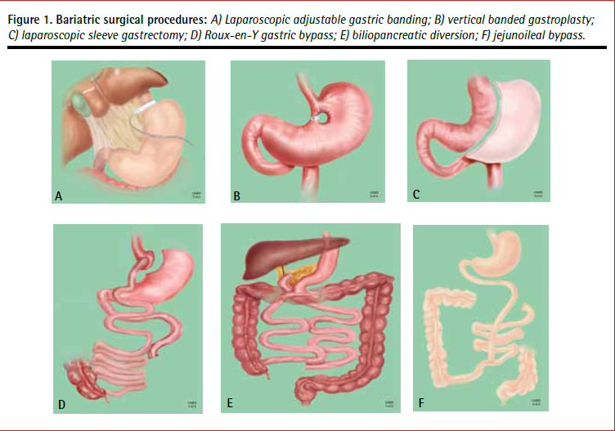

Laparoscopic adjustable gastric banding (LAGB): Restrictive procedure that involves making a small proximal gastric pouch by inserting a gastric band around the superior end of the stomach. This band is linked to an injection port in the skin through a tube, which gives its adjustability.

Sleeve gastrectomy (SG): Restrictive with malabsorptive (combined) effect, decreasing Ghrelin level. Surgeons resect 75% of the stomach, resulting in a sleeve-like structure extending from the esophagus until the duodenum.

Gastric bypass (GBP): Restrictive with malabsorptive effect. Splitting the stomach into smaller, proximal; and larger, distal pouches. It connects both ends to the anatomically manipulated small intestines in different ways, depending on each case. Most effective surgical intervention for obese patients.

Biliopancreatic diversion with or without duodenal switch: Unlike GBP, BPD with duodenal switch (BPD/DS) is mainly a malabsorptive with slight restrictive effect.
It comprises SG with redirection of the small intestine forming 2 distinct route-shorter route collects food from the stomach; and longer route transfers bile from the liver, both routes using 1 shared canal.

- Prevention
Prevention is aimed at targeting 2 populations- the elderly and the young. In children, prevention is more important than in adults, because it is more effective and easier. Moreover, it should not start by losing weight, but by preventing weight gain, because these children will grow out of their weight with height. Prevention in this population involves a plan to target the children and their surrounding environment (community, school, and parents).
Adapt a strategy
  - Express your unconditional love.
  - Be good role model.
  - Set realistic roles.
  - Don’t use food as reward.
  - Forget the clean plate obsession!
  - Schedule yearly well-child clinic.
Screening in children is done by BMI and its relations to growth percentile. Please note that Obesity in adolescence is the strongest predictor of obesity in adulthood.
Screening in adults is used to test for the likely presence of undetected disease. In the case of obesity, BMI functions as both a screening and diagnostic method. However, RCTs proved that screening alone (which includes BMI measurement), provided no improved health outcomes in adults.
Prevention in adults is not as effective as it is in children, the aim is to lead a healthy life and the approach is as follows
  - Selecting low-energy dense food (e.g., whole grains, cereals, fruits, vegetables, salads).
  - Increase water intake; eat to satisfy craving, not to fill your stomach.
  - Keep a gap of 3 hours between sleeping and your last meal!
  - Regular exercise to avoid a sedentary life style (e.g., watching television).
  - Regular self-weighing.

