Common Psychiatric Problems In PHC
Anxiety:
It is a normal human feeling of apprehension in certain threatening situations.
Is it normal to have some degree of anxiety in certain occasions?

Types of anxiety disorders:
- Generalized anxiety disorder.
- Panic disorder.
- Phobic disorders.
- Obsessive compulsive disorder.
- Acute and posttraumatic stress disorder.
- Anxiety disorder secondary to general medical condition.
- Substance- induced anxiety disorder.

Epidemiology of Anxiety Disorders:
- Anxiety disorders are the most common class of mental disorders, affecting nearly 1 in 5 adults in the U.S.
- The National Comorbidity Survey (NCS) found that lifetime prevalence rates for any anxiety disorder were:
    - 30.5% for women.
    - 19.2% for men.
Generalized Anxiety Disorder (GAD):
- Pts with GAD have persistent, excessive worry about number of events & circumstances with hyperarousal for at least 6 months.
- They worry about general daily events.
- Their anxiety is difficult to control.
- Not due to medical disease, substance abuse or personality disorder.
Epidemiology:
- (GAD) is a common and often chronic disorder, with an estimated lifetime prevalence rate of 5.7% in the general population
- Women > Men by 2 times.
- Onset is usually before the age of 20, but may occur for the first time in middle age.
Etiology:
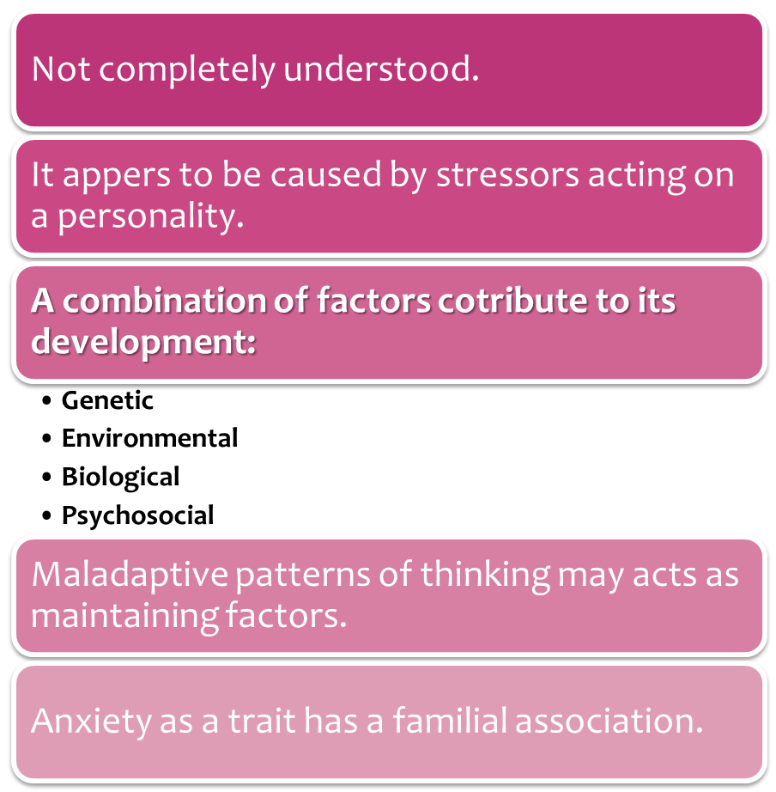

Diagnosis & DSM-IV Criteria:
- excessive anxiety & worry about daily events & activities for at least 6 months.
- It is difficult to control the worry.
- Must be associated with at least 3 of the following:
  - Restlessness
  - Fatigue
  - Difficulty concentrating
  - Irritability
  - Muscle tension
  - Sleep disturbance
Clinical Presentation:
- Physical & psychological features.
- Those features cause clinically significant distress or functional impairment (social, occupational…)
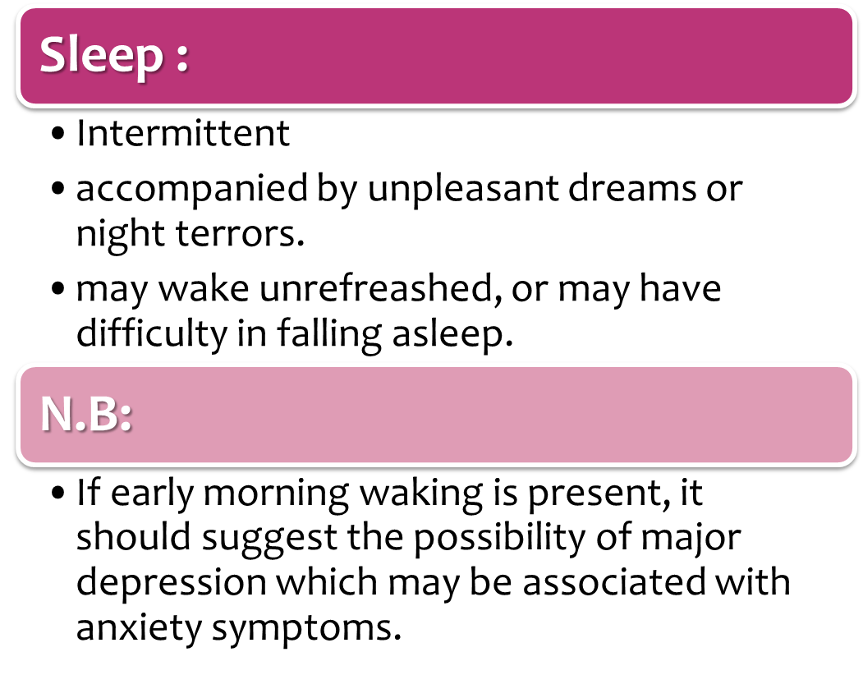
- The anxiety is free floating, as it does not involve a specific person, event or activity.

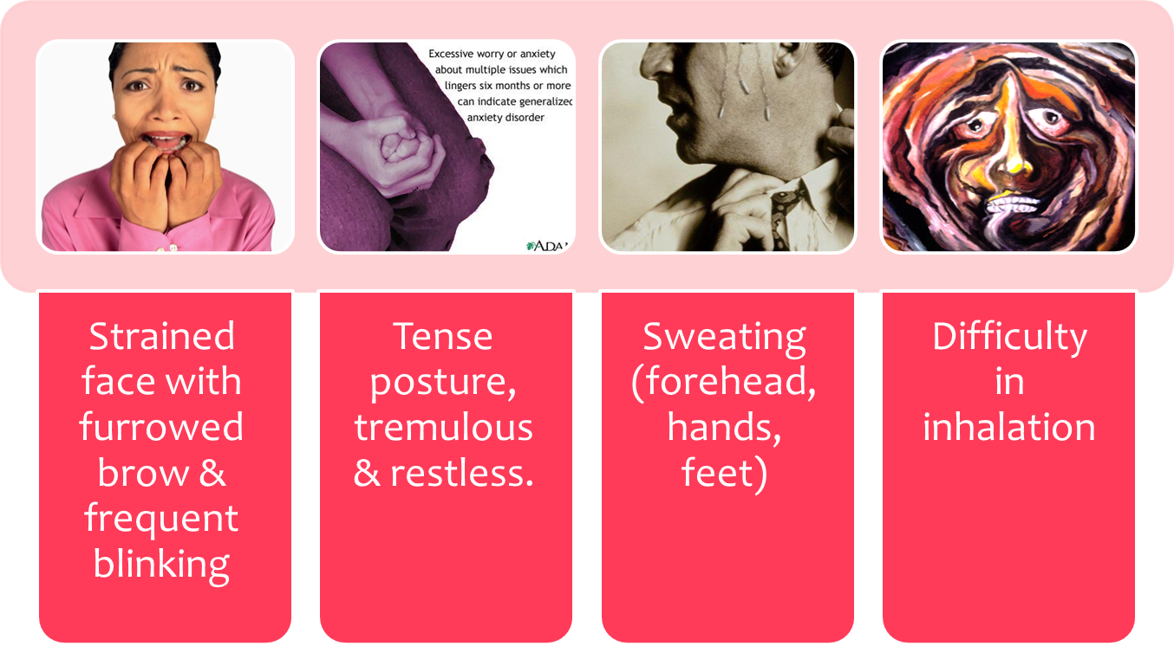
Mental State Examination:

Differential Diagnosis:
- Anxiety disorder due to medical condition/ medications.
- Depressive disorders.
- Substance- induced anxiety disorder.
- Panic disorder.
- Adjustment disorders.
- Psychotic disorder (e.g. mania)
Anxiety In PHC Settings:
- Recent clinical guidelines for common disorders published by the National Institute for Health and Clinical Excellence (NICE) state that just 1 in 10 people with an anxiety disorder is identified in the primary care (PC) setting (compared with 1 in 3 for depressive disorder).
- It is often overlooked and undertreated.
- Why should this be so??
  - These symptoms may be viewed by the patient as a personality trait rather than evidence of a disorder requiring treatment.
  - Patients' fear to express their anxious feelings due to the stigma, and lack of GP education in mental health issues.
  - Moreover, GPs work under extreme time pressure.

Management:
Two important points should be considered before starting treatment:
- The physician should discuss the different options of treatment with the patient, and come up with a shared decision about the method of treatment.
- The physician should provide information on the nature, course and treatment of the disease, including information on the use and likely side-effects of the medication.
Generalized anxiety disorder are mainly treated by medications and psychotherapy

- Medical treatment:
Benzodiazepines are usually started initially, and used for a short period of time (not usually used beyond 2–3 weeks) then is switched to antidepressants – mainly SSRI (Paroxetine or venlafaxine) - which is used for the long term treatment

- Psychotherapy:
Cognitive behavioral therapy is found to be a very effective type of treatment for generalized anxiety disorder, it focuses on identifying and dealing with negative thoughts and behaviors and replacing them with positive ones, an example for this type of therapy is: relaxation training and anxiety management training.
The physician should also advice the patient to reduce caffeine intake, support and assist him in dealing with any stresses or problems he’s facing , encourage him to exercise regularly and eat a balanced diet, and get a good night sleep.

Unconventional therapy:
Some studies have shown that there are herbs and nonmedical methods that can actually help and improve anxiety such as:
- Kava: This herb is reported to have a relaxing effect although some studies have linked kava to liver problems, which is why it is contraindicated on patients who have liver condition, drink alcohol daily or take medications that are hepatotoxic.
- Valerian: it is most commonly used as a sleep aid because of its sedative effect.
- Exercise: a lot of studies have shown that exercise is a powerful stress reducer and can improve anxiety symptoms.

When to refer to a psychiatrist:
When the patient still has significant symptoms after two interventions using a combination of methods (any combination of psychological or medical treatment) then the patient should be referred to a psychiatrist for further assessment.

.

- Types of MOOD disorder
- Major Depressive Disorder .
- Dysthymic Disorder .
- Bipolar 1 Disorder.
- Bipolar2 disorder.
- Cyclothymic Disorder.

Severity of mood disorder
- Detremining the 'degree' or 'severity' of depression requires an extensive medical judgement that involves the number, type, and severity of the symptoms
- Mild depression usually causes symptoms that are detectable and impact upon our daily activities
- Mild depression often goes undiagnosed
- less interested in doing things previously enjoyed,
- unusual irritability,
- reduced motivation in work,
- home or social activities are common
- continue to function
- treatment options available for mild depression.
- Lifestyle changes
- Natural therapies
- Moderate depression : Simple things start to require real effort or just get neglected.
- usually a detectable reduction in self confidence and/or self
- become less motivated
- excessive worries about such performance at work, even if things controlled
- more sensitive within personal relationships.

- Treatment
- Cognitive Behavioural Therapy
- Lifestyle improvements
Major depressive disorder
- Severe or Major depression
- Suicide is a distinct and major danger
- MAJOR DEPRESSIVE DIAGNOSTIC CRETERIA
- 1 ≥ of major depressive episode per year.
- Lasting for at least 2 weeks of loss of interest + low mood .
- Accompanied by at least 4 of following symptoms :
- Death wishes .
Feeling of worthlessness .
- Psychomotor retardation .
- Significant weight loss .
- Insomnia .
- Fatigue .
Clinical features
- Mood changes
- Appearance and behavior
- Biological features
- Cognitive functions & thinking
- Psychotic features associated with sever depression
Appearance & behavior
- Neglected glamour and good dressing
- Tearfull eyes , down cast gaze , down corner of mouth, forward tilting of head ,
- Psychomotor retardation : lack of motivation ,
- Slow motion , delay their tasks and decision,
- Social withdrawal
Mood changes
- Feeling low
- Anhedonia
- Irritabilty
- Frustration
- Tension : internal feeling of anxity
Cognitive functions and thinking
- Subjective poor attention ,concentration & memory .
- Depressive cognition as suggested by beck :
- Past : self blame
- Present : loses the confidence , discounts any success in life .
- Future : hopeless ,helpless, worthless end by (suicide ideation and attempt ) 60 % of depressed pt have suicidal ideation
- 15% of depressed pt die by suicide
Biological features
- Loss of appetite
- Terminal insomnia
- Change in weight
- Low energy
- In females ,have amenorrhea
- High risk of infection
Biological correlates
PET scan : abnormally high glucose metabolism in amygdala in depressed people
- Smaller hippocampus , atrophy greater if depression is longer .
- Linked to abnormally high levels of glucocorticoids .
- Psychotic
- Delusion ( guilty, poverty ,persecutory, nihilistic )
- Hallucination ( 2nd person, mood-congruent, visual type )
DDX
- Psychiatric disorder :
- Adjusment disorder with depressed mood
- Anxiety disorder
- Somatization
- Schizophrenia , schizoaffective disorder .
- Dysthymic disorder
2nd to medical disease
- Terminal disease:,CANCER , ,STROKE ,
- Chronic disease : DM ,THYROID
- Some infectious disease : HIV , TB ,
- Disabilities & Neurological disease : MS , parkinson’s disease
- Serious disease : stroke
- Vitamin deficiencies : vit D
2nd to medication
- Antihypertensive
- Chemotherabiest
- OCP ( progesterone )
- Steroid
- Tamoxifen
- Indomethacin
- Antipsychotic

Etiology of Depression
The causative factors are multifactorial

- 1-Biological differences.
People with depression appear to have physical changes in their brains. The significance of these changes is still uncertain, but may eventually help pinpoint causes.

- 2-Neurotransmitters.

- These naturally occurring brain chemicals linked to mood are thought to play a direct role in depression

- 3-Hormones.
- Changes in the body's balance of hormones may be involved in causing or triggering depression. Hormone changes can result from thyroid problems, menopause or a number of other conditions.

- 4-Inherited traits.
Depression is more common in people whose biological family members also have this condition. Researchers are trying to find genes that may be involved in causing depression
- 5-Life events.
- Certain events, such as the death or loss of a loved one, financial problems, and high stress, can trigger depression in some people.

- 6-Early childhood trauma.

- Traumatic events during childhood, such as abuse or loss of a parent, may cause permanent changes in the brain that make you more susceptible to depression
- Epidemiology of Depression
- More in women
- Life time risk is in the range of 10-15%
- Life time prevalence is in the range of 15-25%
- The mean range of onset is about 40 years (25-50)
- It may occur in childhood or in the elderly
- In adolescents it may be precipitated by substance abuse.

Management of depression:
It depends on the initial assessment:
- History
- MSE
- Physical exam
- Baseline investigation
Assessment of suicidal intent
Risk factors
- Female>male
- Age 40-60 yrs
- Living alone
- Divorced > widowed>single>married
- Unemployment
- Chronic physical illness
- Past psychiatric history
- Recent admission to psychiatric hospital
- History of suicide attempt/self harm
- Alcohol/drug misuse
Initial treatment:
Once a positive diagnosis has been made, possible treatment should be discussed with patient ,there is a wide range of effective treatments ,both psychological and pharmacological
Psychotherapy:
- Exercise in mild / moderate depression
- Behavioral therapy, cognitive therapy, supportive therapy , simple problem solving strategies and family therapy.
- May be used in conjunction with pharmacotherapy.
Things I should tell the patient
- Give him information to increase compliance
- When starting antidepressant drugs explain the reason for prescribing: timescale of action- unlikely to have any effects for 2 wks, effects build up to maximum effect at 4-6 wk ; and likely side effects including possible exacerbation of anxiety in the first 2 wk of treatment.
Pharmacotherapy:
Antidepressant medication
Selective serotonin reuptake inhibitors (SSRIs): (e.g., fluoxetine , paroxetine )
First choice Safer and better tolerance
Side effect:
Headache, gastrointestinal disturbance , sexual dysfunction , and rebound anxiety.
Serotonin and norepinephrine reuptake inhibitors (SNRIs): (e.g.; venlafaxine, duloxetine)
Avoid in uncontrolled hypertension, venlafaxine is also contraindicated if high risk of arrythmia
Tircyclics antidepressants(TCAs)
Most lethal in over dose (avoid in suicidal patient because of cardiotoxicity in overdose)
Side effect:
Sedation ,weight gain , orthostatic hypotension , and anticholinergeic effects.
Follow up
review patient every 1-2wks until stable , assessing response, compliance and side effects ,and suicidal risk .continue treatment for >6 months .after remission as this greatly decrease risk of relapse. Patient with >=2 past episode of major depression should be advised to continue for 2 yrs. reassure patient that antidepressant medication is not addictive.
Discontinuation reaction:
Occur once a drug has been used >=8wk, decreased by tapering dose over >=4wk. warn about possible reactions :
- Withdrawal of SSRIs _ headache, nausea, parasthesia, dizziness, and anxiety.
- Withdrawal of other antidepressants _ nausea, vomiting , anorexia, headache ,'chills' ,insomnia, paraesthesia ,anxiety , panic, and restlessness .
Hospitalization:
Indicated for patients at risk for:
- Suicidal or homicidal patient
- Patient with sever psychomotor retardation who is not eating or drinking
- Diagnostic purpose (observation , investigation)
- Drug resistant cases
- Sever depression with psychotic features
Electroconvulsive therapy (ECT):
Indicated if patient is unresponsive to pharmacotherapy , if patient cannot tolerate pharmacotherapy , or if rapid reduction of symptoms is desired (suicide risk, etc)
ECT is safe and may be used alone or in combination with pharmacotherapy.
In pregnant depressed patient ECT is safer than antidepressants.
Referral to specialist psychiatry
- High suicide risk
- Psychotic major depression
- History of bipolar disorders
- Atypical symptoms
- Failure or partial response following >= 2 attempts to treat
- Recurrent depression

Step 4
Specialist/
crisis team
resistant recurrent,
psychotic or atypical depression medication+
specialist, non-drug treatment

Step 5
Inpatient/
Crisis team

Risk to self/others:
Medication, combined treatment
ECT
Step3
PHCT/
CMHT
Moderate or sever depression:
Medication +non-drug treatment e.g.CBT
Step 2
PHCT/
CMHT
Mild depression: watchful waiting , non-drug treatments
Step 1
GP/practice nurse

Recognition and assessment of severity

PHCT= primary health care team
CMHT= community mental health care

Other psychological therapy:

Somatoform Disorders
Unexplained symptoms
25-50% No serious medical cause found
30-75% Remain medically unexplained
16-33% “bothered the patient a lot”
but remain unexplained
Multiple unexplained physical symptoms
- Major Depression and Dysthymia
- Panic Disorder
- GAD
- OCD
- Somatoform Disorders
- Substance abuse
Brown 1990
Gain!
- Primary gain: internal motivations. (a patient might feel guilty about being unable to perform some task. If he has a medical condition justifying his inability, he might not feel so bad)
- Secondary gain: external motivator. If a patient's disease allows him/her to miss work, gains him/her sympathy, or avoids a jail sentence, these would be examples of secondary gain.
Brown 1990
Somatoform Disorders
Somatization
Definition
Experiencing and reporting bodily symptoms that have no pathological basis, attributing them to disease and seeking medical attention for them
Lipowski 1988
Epidemiology
Etiology
Clinical features
Criteria for Dx (DSM-IV)
- Symptoms begin before age 30
  - 4 pain
  - 2 GI
  - 1 sexual
  - 1 pseudoneurological
Course and Prognosis
- Chronic
- Fluctuating course (worse when under stress)
- Risk of multiple unnecessary operations and possible complications.
Barsky 1997
Major Somatization
- Chronic
- Multiplicity of symptoms
- Refractory to reassurance
- Absence of discrete stressor
- Disproportionate disability and role impairment
- Pursuit of medical care
Barsky 1997
Undifferentiated Somatoform Disorder
Symptom Amplification
Hypochondriasis
Clinical features
- Over concern and preoccupation with physical health and/or excessive worry about having a serious physical disease.
Epidemiology
- At any age but most common between 25-45 years.
- Men > woman.
- People closely associated with a sick person.
- True prevalence is uncertain.
Etiology
- Not known, theories:
  - Obsessional / anxiety personality traits
  - Psychodinamic defense mechanism
  - Learning the sick role (family, doctors attention)
Criteria for Dx
- Misinterpretation or amplification of bodily symptoms
- Unreasonable fears or expectations of disease
- 6 months duration
- Impairment of functioning
Course and Prognosis
- Chronic
- Fluctuating
- Complete recovery especially if there is underlying depression or anxiety.
- Unfavorable prognosis:
  - Secondary gain (sick role)
  - Personality problem
Conversion Disorder
Clinical Features
Subconscious conversion of psychological conflict into an acute loss of physical functioning suggesting a neurological disease.
Criteria for Dx (DSM-IV)
- 1 or more symptom affecting motor or sensory functioning that suggests a neurological or general medical disorder
- Association with psychological stressor
- Unconscious defense
Course and Prognosis
- Short time (hours, days)
- Recurrence is common
- Minority have a chronic cause
Course and Prognosis
- Good prognosis if associated with:
  - Acute onset
  - An obvious stressful trigger
  - Good premorbid personality
  - Above average intelligence
  - Short interval b/w onset and treatment
  - No other psychopathology
  - Blindness, aphonia, paralysis
Malingering
Malingering
- Intentional production of exaggerated or false symptoms
- Motivated by secondary gain
- Conscious
DSM-IV
Criteria of Dx (DSM-IV)
- Intentional production of exaggerated or false symptoms
- Motivated by secondary gain
- Conscious
Factitious Disorder
Criteria of Dx (DSM-IV)
- Intentional production or feigning of symptoms
- Motivation is to assume the sick role
- No obvious secondary gain
DDx,
- True Medical Problem
- Depression (usually chronic symptoms > 6 moths)
- Anxiety (usually acute symptoms < 6 moths)
Barsky 1999
Six-steps strategy
- Rule out major medical problem
- Rule out major psychiatric problem
- Build collaborative alliance
Barsky 1999
Six-steps strategy
- Improved functioning and coping are the goals
- Provide limited reassurance
- CBT* if no success from above measures
*Cognitive behavioral therapy
Barsky 1999
Rule out medical problem
- “Reasonable” work up
- Explain how the test results change the treatment (if they do at all)
- Avoid “well if we don’t find anything then I’ll refer”
Barsky 1999
Rule out psychiatric disorder
- MAPS-O is helpful in getting the spectrum of symptoms (MDD, Panic)
- Symptom focus as opposed to disorder focus
Collaborative alliance
- Somatizing patients want medical care
- Fear rejection or invalidation of symptoms
- Validate dysfunction and suffering
Functioning is the goal
Shift Expectations
- Symptom reduction
- Improved functioning
NOT
- Diagnosis
- Eradication of symptoms
Limited Reassurance
- Instill hope
- Acknowledge that we may miss something, but this is very unlikely
- More frequent non-emergent visits
CBT
- Good evidence supports its usage in the major somatization group or highly impaired functional disorders
- Can be applied individually but groups are very effective and efficient
Role of Psychotherapy in Primary Care settings
Why is psychotherapy important in primary care?
(1) Primary care patient populations have significant psychological needs.
(2) Access to specialty mental health care is limited.
(3) More services would be delivered to more people.
(4) Mental health treatment in primary care may help improve physical problems.

Psychotherapy
Definition:
A group of non-pharmacological non-invasive techniques employed by a therapist to treat mental illness, emotional difficulties, or behavioral problems.
- Classification of Psychotherapy
According to concept:
- Counselling.
- Supportive.
- Cognitive.
- Behavioral.
According to participants:
- Individual therapy.
- Group therapy.
- Couple (marital) therapy.
- Family therapy.
- A- Counselling
Definition:
An interactive learning process contracted between counsellor(s) and client(s), which approaches in a holistic way, social, cultural, economic and emotional issues.
- Goal: - Information.
- Education.
- Understanding.
- Indication:
Any presenting difficulty.
-Techniques:
- Listening.
- Discussion.
- Problem solving.
- Enable decision making.
- Enable Learning.
- B- Supportive therapy
- Goal: - Support.
- Maintain or re-establish the usual level of functioning.
- Indication:
Overwhelming problem.
- Techniques:
- Building a reasonable doctor-patient relationship.
- Careful listening.
- Reassurance.
- Empathy.
- Facilitating emotional ventilation.
- Giving explanations and advice.
- Suggestion, reinforcement.
- Instillation of hope and improving self-esteem.
- C- Cognitive therapy
- Goal:
Modify thoughts.

- Indication:
- Depression , -GAD , - Phobias , - Panic.
- Techniques:
- Identify negative thoughts.
- Alternatives.
- Clarify mechanisms.
- D- Behavioral therapy
- Goal:
Modify behavior.
- Indication:
Any distressing behavior e.g.
1. Phobias.
2. Obsessions.
3. Compulsions.
- Techniques:
- Relaxation.
- Exposure.
- Response prevention.
- Thought stopping

