D
one by:
Mona Al Shehri

Team Leader: Nada Al
-
Madhi

From
slides
Doctor's Notes

Team's Not
es From the book Important

The main recommended reference is anesthesia book designed by anesthesia department for both final and OSCE exam .

Overview

- The preoperative visit
- Anaesthetic history
- Examination
- Special investigations
- Medical referral
- Risk assessment
- Informing the patient
- Premedication

Stages of the Peri-Operative Period
1- Pre-Operative • From time of decision to have surgery until admitted into the OR theatre.

2- Intra-Operative
• Time from entering the OR theatre to entering the Recovering Room or Post
Anesthetic Care Unit (PACU)

3- Post-Operative
• Time from leaving the RR or PACU until time of follow-up evaluation (often as outpatient)

The anesthetic plan
1-Type of anesthesia
1-General | 2- Sedation | 3-Local
Airway management | Supplemental Oxygen | Technique
Induction | Agents | Agents
Maintenance
Muscle relaxation
*Sedation=Analgesia
*Local or regional anesthesia including nerve block or skin infiltration. * regional anesthesia is always better than general anesthesia unless contraindicated.
*give muscle relaxant if you are going to intubate
*all peripheral nerve block are guided under ultrasound.

2- Intraoperative management | 3- Postoperative management
Monitoring | pain control ex: thoracic surgery
Positioning | Intensive care
Fluid management | postoperative ventilation
Special techniques | Hemodynamic monitoring

Preoperative Visit :

The preoperative visit of all patients by an anesthetist is an essential requirement for the safe and successful conduct of anaesthesia
Anesthetist must not provide any information or details about the surgery by itself
" this is the surgeon responsibility"
- Main aim is to assess the patient's fitness for anaesthesia
- The Best to be performed by an anaesthetist
- Preferably the one who is going to administer the anaesthetic

Visit allows
- Best anaesthetic technique
- Any potential interactions between concurrent diseases
- Anaesthesia anticipated
- Provides an explanation
- Reassurance for the patient

Coexisting Illness
- Improve the patient's condition prior to surgery by referring him to specialist if needed "ex: cardiologist" to assure him and to be fully prepared and fit for the surgery
- Seeking advice from other specialists
- Optimise treatment
- Final decision

Three situations where special arrangements are usually made
1-Patients with complex medical or surgical problems "
- patient is often admitted several days before surgery admitted 5 days before for example
• anaesthetist is actively involved in optimising their condition prior to anaesthesia and surgery
2-Surgical emergencies
- only a few hours separates admission and operation in these patients urgent investigations or treatment
3-Day-case patients
- These are patients who are planned
- Generally ‘fitter’ ASA1 or ASA 2 " ASA is a grading system (American society of Anesthesiologist) to assess general condition for the patient prior to anesthesia"
- Assessment in anesthesia clinic

Anesthetic history & Examination

Anesthetist should take a full history & Examine each patient ..

1- PREVIOUS ANAESTHETICS AND OPERATIONS

- Previous Hospitalization
- Enquire about inherited or 'family' diseases
- sickle-cell disease
- porphyria
- Difficulties with previous anaesthetics
- nausea
- vomiting
- dreams
- Awareness " if he says I hear you talk during surgery that means he is AWARE!"
- postoperative jaundice

• 2- Present & past medical history

- all the aspects of the patient's medical history
- relating to the cardiovascular and respiratory systems and its severity

3-Cardiovascular system
*Specific enquiries must be made about:
- Angina
- incidence
- precipitating factors
- duration
- use of anti-anginal medications, e.g. glyceryl trinitrate (GTN) oral or sublingual )
- Previous myocardial infarction and subsequent symptoms
- Symptoms indicating heart failure
- myocardial infarction are at a greater risk of perioperative reinfarction
- Elective surgery postponed until at least 6 months after the event
- Untreated or poorly controlled hypertension (diastolic consistently > 110 mmHg) may lead to exaggerated cardiovascular responses
- Both hypertension and hypotension can be precipitated which increase the risk of myocardial ischemia

- Heart failure will be worsened by the depressant effects impairing the perfusion of vital organs

- valvular heart disease
- ? prosthetic valves may be on anticoagulants --
- need to be stopped or changed prior to surgery " warfarin must be stopped 5 days before surgery and heparin must be stopped 4 hours after surgery" • Antibiotic prophylaxis

Active Cardiac Conditions

• Unstable coronary syndromes
- Unstable or severe angina
- Recent MI
- Decompensated HF
- Significant arrhythmias
- Severe valvular disease
• Any patient with DM or HTN>> ASK ABOUT CHEST PAIN.
Patient with HTN >> risk of MI after induction of anesthesia > vasodilatation > low cardiac output > ischemia.

Minor Cardiac Predictors

- Advanced age (>70)
- Abnormal ECG
- LV hypertrophy " all Hypertensive pts have LV hypertrophy"
- LBBB
- ST-T abnormalities
- Rhythm other than sinus
- Uncontrolled systemic hypertension more than 140/90
For patient with Aortic stenosis > general not spinal anesthesia is indicated " spinal anesthesia causes vasodilatation , bradycardia and hypotension and subsequent low cardiac output"
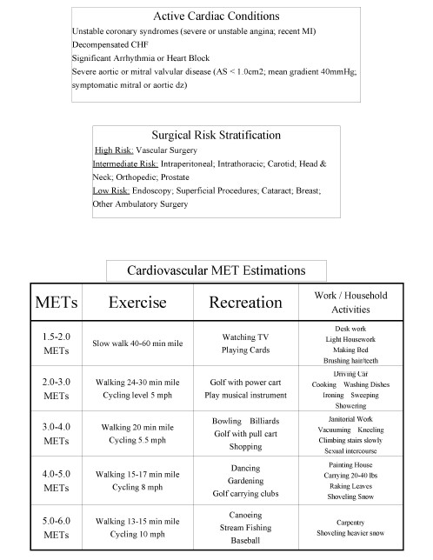
The doctor did not mention anything of MET estimation.

Surgical Risk Stratification " CLASSIFIED ACCORDING TO THE SURGERY TYPE"
- High Risk
– Vascular (aortic and major vascular)
• Intermediate Risk
- Intraperitoneal and intrathoracic, carotid, head and neck, orthopedic, prostate • Low Risk
- Endoscopic, superficial procedures, cataract, breast, ambulatory surgery

Respiratory system

• Patients with pre-existing lung disease
- prone to postoperative chest infections if they are obese or undergoing upper abdominal or thoracic surgery
- chronic obstructive lung disease production of sputum (volume and color) All COPD patients should be admitted 5 days before surgery and must be given ABx+ aggressive respiratory therapy.
- Dyspnoea
- asthma, including precipitating factor
- upper respiratory tract infection anaesthesia and surgery should be postponed unless it is for a life-threatening condition

Other conditions in the medical history
- Indigestion • heartburn
- reflux " so you give PPI and Antacid for reflux"
- may indicate the possibility of a hiatus hernia
- Rheumatoid disease " don't manipulate the head after giving muscle relaxant+ steroids affect renal function so check for renal function before"
- chronically anaemic " in Sickle cell disease Hb must be > 8 to avoid Sickle cell crisis"
- severely limited movement of their joints
- makes positioning for surgery and airway maintenance difficult.
- Tendency for dislocation of atalnto-occiptal joint

-Diabetes " any pt with DM , suspect any cardiac problem "
- Patients have an increased incidence of ischaemic heart disease
- renal dysfunction
- autonomic and peripheral neuropathy " not compensating at all , avoid inhlation agents that decrease blood pressure , choose IV anesthesia" • intra- and postoperative complications

-Neuromuscular disorders
- Care with muscle relaxants
- Coexisting heart disease
- restrictive pulmonary disease

-Chronic renal failure"check urea , creatinine ,k,Hb,Na,Coagulation profile if on renal dialysis , hypervolemia may predispose to pulmonary edema"
- anaemic
- electrolyte abnormalities
- altered drug excretion
- restricts the choice of anaesthetic agents

-Jaundice
Typical smoker

patient
:

*blue lips *congested nose
*
tachycardic*hypertensive*

Tendency for CAD*productive cough

- infective or obstructive liver disease " don't go for surgery unless infection is treated otherwise patient will end up with fulminant hepatic failure"
- Drug metabolism altered • coagulation must be checked

-Epilepsy " ask about the first and recent attack and any recent status epilepticus , confirmed by EEG"
- well controlled or not
- avoid anaesthetic agents potentially epileptogenic (e.g. enflurane)
- anesthesia by itself may induce seizure.

Family history
- inherited conditions in the family
- history of prolonged apnoea
- unexplained death
- malignant hyperpyrexia "always ask about family history of malignant hyperthermia" rare but critical condition!
- Surgery postponed

DRUG HISTORY AND ALLERGIES
• Identify all medications – Prescribed
- self-administered
- Allergies to drugs " Ex: penicillin , Aspirin , ACE inhibitors "
- topical preparations (e.g. iodine)
- adhesive dressings
- foodstuffs

SOCIAL HISTORY
• Smoking
– number of cigarettes – amount of tobacco
* nicotine stimulates the sympathetic nervous system causing tachycardia ,hypertension ,coronary artery narrowing
• Alcohol
- induction of liver enzymes " pt might be still awake during surgery due to alcohol ( liver inducer ) by decreasing the effect of anesthetic agents "
- tolerance
- Difficulty with venous access "check for drug abuse" – Thrombosis of veins
- Withdrawal syndromes " tachycardia for example"
- Look for tattooing also " check for HIV , Hep B,C"

Pregnancy
– increased risk of regurgitation and aspiration – Elective surgery is best postponed until after delivery.

THE EXAMINATION :

Cardiovascular system
- dysrhythmias
- atrial fibrillation
- heart failure " SIGNS of heart failure : basal crepitations , lower limb edema , central cyanosis "
- heart murmur
- valvular heart disease
- blood pressure is best measured at the end of the examination

Respiratory system " request CXR "
- cyanosis
- pattern of ventilation
- respiratory rate
- Dyspnoea
- Wheeziness
- signs of collapse
- consolidation and effusion

Nervous system " document all neurological diseases "
- Chronic disease of the peripheral and central nervous systems
- evidence of motor or sensory impairment recorded
- dystrophic myotonica

Musculoskeletal
- restriction of movement and deformities
- reduced muscle mass
- peripheral neuropathies
- pulmonary involvement
- Particular attention to the patient's cervical spine and temporomandibular joints
"This assessment to check for the airway patency and risk of intubation" The airway
- Try and predict difficult intubation
- Assessment is often made in three stages

1. Observation of the patient's anatomy
- Look for limitation of mouth opening, receding mandible position, number and health of teeth, size of tongue.
- Examine the front of the neck for soft tissue swellings, deviated larynx or trachea.
- Check the mobility of the cervical spine in both flexion and extension.

2. Simple bedside tests

- Mallampati criteria "imp MCQ"
- Thyromental distance - < 7 cm suggests difficult intubation "so it must be > 7 cm to avoid complications"

3. X-rays
- lateral X-ray of the head and neck
- reduced distance between the occiput and the spinous process of C 1 (< 5 mm) and an increase in the posterior depth of the mandible (> 2.5 cm)
- None of these tests, alone or in combination, predict all difficult intubations • For difficult intubation , don't give muscle relaxant.
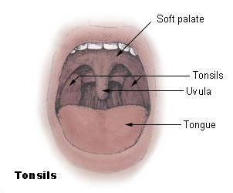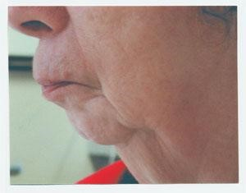

Receding mandible.
Airway Evaluation:
- Jaw Movement
- Both inter-incisor gap and anterior subluxation
- <3.5cm inter-incisor gap concerning
- Inability to sublux lower incisors beyond upper incisors
- Receding mandible
- Protruding Maxillary Incisors (buck teeth " the picture of the car above" )
- Oropharyngeal visualization
- Mallampati Score
- Sitting position, protrude tongue, don’t say “AHH”
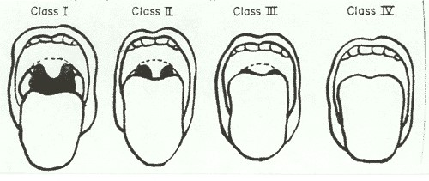
MALLATAPI SCORE..
UNIVERSAL STANDARD INVESTIGATION

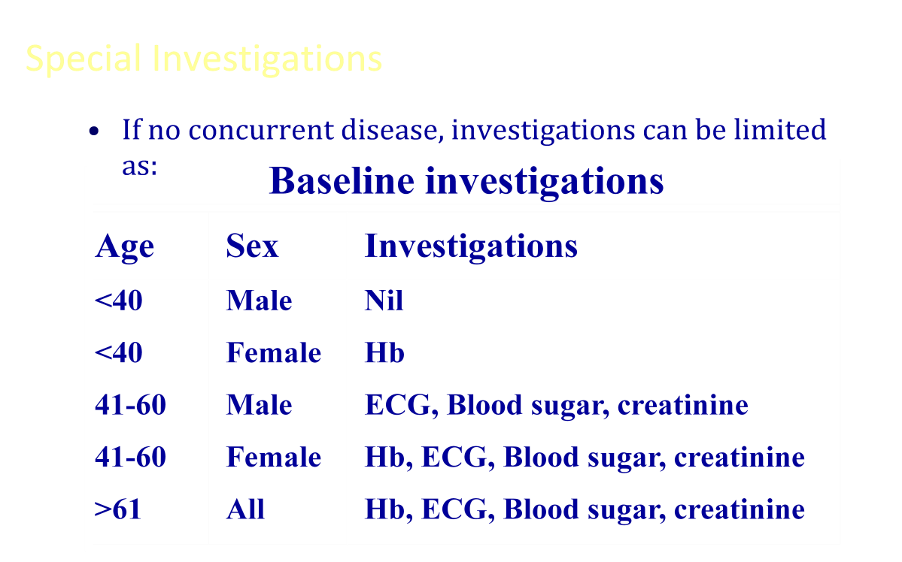

ADDITIONAL INVESTIGATIONS:
- Urea and electrolytes in patients taking digoxin diuretics diabetes, renal disease vomiting diarrhoea " any patient with vomiting or diarrhoea , request ABG to check for acidosis

- Liver function tests hepatic disease high alcohol metastatic disease
evidence of malnutrition

*Blood sugar Diabetes peripheral arterial disease
taking long-term steroid

  - Electrocardiogram (ECG) hypertensive " suspect LVH"
with symptoms or signs of heart disease

  - Chest X-ray " rule out metastasis"
*Pulmonary function tests
*Coagulation screen
*Sickle-cell screen

- Optimization of coexisting medical (or surgical) problems may mean postponing surgery

Medical referral: for whom?

CARDIOVASCULAR DISEASE
- Untreated or poorly controlled hypertension or heart failure. o Symptomatic ischaemic heart disease, (unstable angina). o Dysrhythmias: uncontrolled atrial fibrillation, paroxysmal supraventricular tachycardia, second and third degree heart block.
- congenital heart disease or symptomatic valvular heart disease

RESPIRATORY DISEASE
- Chronic obstructive airways disease, if dyspnoeic at rest.
- Bronchiectasis o Asthmatics o unstable
- taking oral steroids or
- have a FEV₁ % 60% predicted

ENDOCRINE DISORDERS
- Insulin and non-insulin dependent diabetics o ketonuria
- random blood sugar > 12mmol/L o Hypo- or hyperthyroidism o Cushing's o Addison's disease
- Hypopituitarism

RENAL DISEASE o Chronic renal failure
- Patients undergoing chronic dialysis

HAEMATOLOGICAL DISORDERS o Bleeding diatheses o haemophilia o thrombocytopenia o Therapeutic anticoagulation o Haemoglobinopathies o Polycythaemia o Haemolytic anaemias
- Leukaemias

FACTORES INCREASED RISK OF MORTALITY

- Inadequate preoperative preparation including resuscitation
- Lack of and inappropriate monitoring during surgery
- Poor postoperative care, including lack of intensive care beds
- Inadequate supervision of trainees

Mortality related to anaesthesia
- Approx 1:26,000 anaesthetics
- One third of deaths are preventable
- Causes in order of frequency
- inadequate patient preparation
- inadequate postoperative management
- wrong choice of anaesthetic technique
- inadequate crisis management

ANAESTHETIC ASSOCIATED DEATHS

- Increasing age: >60 years
- Sex: male > female
- Worsening physical status
- Increasing number of concurrent medical conditions, in particular:
- myocardial infarction
- diabetes mellitus
- renal disease
- Increasing complexity of surgery:
- intracranial
- major vascular
- intrathoracic
- Increasing length of surgery
- Emergency operations

ASA PHYSICAL STATUS SCALE : "IMP"

Class : Physical status

- : A healthy patient with no organic or psychological disease process. The pathological process for which operation is performed is localized and causes no systemic upset
- : A patient with a mild to moderate systemic disease process caused by the condition to be treated surgically or other pathological process which does not limit the patient's activities in any way, e.g. treated hypertensive, stable diabetic. Patients aged >80 years are automatically placed in class II
- : A patient with severe systemic disease from any cause which imposes a definite functional limitation on activity, e.g. ischaemic heart disease, chronic obstructive lung disease
- : A patient with a severe systemic disease which is a constant threat to life, e.g. unstable angina
- : A moribund patient, unlikely to survive 24 hours with or without surgery

Note:'E' maybe added to signify an emergency operation
EXAMPLE : ASA I E : NORMAL PATIENT CONDITION COMING FOR APPENDECTOMY

ASA CLASS | ABSOLUTE MORTALITY | CRUDE MORTALITY FOR 100000 ANESTHETICS
I | 0.1 | 7.2
II | 0.2 | 19.7
III | 1.8 | 115.1
IV | 7.8 | 766.2
V | 9.4 | 3358.0

Informing the patient :
Anaesthetist has only a brief time Explain the events to the patient (preoperative period )
Most patients will want to know how long starved prior to surgery in terms of eating and drinking
The choice of anaesthetic technique rests with the anaesthetist, but most patients appreciate some details of what to expect
- patients will ask about their immediate recovery
- Finally
- informed of the technique
- Consent for anaesthesia

Premedication: The 6 As of premedication

- Anxiolysis – the best anxiolytic is the anesthetist who visits the patient and listens to the patient
  - benzodiazepines
  - phenothiazines
  - B-blockers
- Amnesia " lorazepam reduces anterograde amnesia "
- Anti-emetic
  - dopamine antagonists
  - antihistamines
  - anticholinergics
  - phenothiazines
  - 5-hydroxytryptamine antagonists
  - a₂- agonists: clonidine, Dex

- Antacid "loratidine is preferable" Patients who have received opiates present as emergencies If in pain
delayed gastric emptying hiatus hernia
- Oral sodium citrate
- Ranitidine , Proton inhibitors
- Metoclopramide
- naso- or orogastric tub
- Anti-autonomic
Parasympathetic reflexes
Excessive vagal activity causing profound bradycardia halothane suxamethonium surgery
traction on the extraocular muscles handling of the viscera
during elevation of a fractured zygoma

- Analgesic

*Consent must be obtained for : surgery , anaesthesia , blood transfusion

