10. Venous Access and Medication Administration

Team Leader: Nada Al-Madhi
Anesthesiology
From slides Doctor's Notes Team's Notes From the book Important

Safety Considerations
- Five patient “rights” of drug administration
  - Drug
  - Dose
  - Patient
  - Route
  - Time
  - Correct and thorough documentation (sixth patient right of drug administration)
- Read drug label and compare it to the order three times before administration:
  - When removing the drug from the drug kit
  - When preparing the drug for administration
  - Just before giving it to the patient (before the container is discarded)
- Verify route of administration
- Be sure medication label matches the order
- Never give a drug from an unlabeled container
- If unsure of your drug calculation, have a coworker or medical direction recheck
- Handle multidose vials with aseptic technique so that medicines are not wasted or contaminated
- When preparing multiple injections, always label the syringe immediately
  - Keep the medication container with the syringe
  - Do not rely on memory
- Never administer unlabeled medication prepared by another person
- Never give medication that is:
  - Outdated
  - Discolored
  - Cloudy
  - Tampered with
- If anyone expresses concern about a medication or dose
  - Recheck to be certain that there is no error
  - Patient has right to refuse medication
- Monitor patient for any adverse effects for at least 5 min after administration
  - Longer observation time may be need for intramuscular and oral medications
- Document medications given:
  - Name of drug, dosage, time, and route
  - Note injection site of parenteral drugs
  - Record patient's response
    - Adverse as well as intended
- For return and disposal of unused medication, follow:
  - Governmental guidelines
  - Local EMS policies

Medication Errors:
- Common causes
  - Wrong dose ordered by the prescriber
  - Drug calculations in error
  - Drugs administered by wrong route
  - Wrong patient received drug
- If a medication error occurs:
  - Accept responsibility for your actions
  - Immediately advise medical direction
  - Monitor patient for effects of drug
  - Document the medication error as required:
    - State guidelines
    - Medical direction
    - Employer
- If a medication error occurs:
  - Modify practice to avoid a similar error
  - Follow EMS agency policy for documentation and quality improvement
- Removal or destruction of disease-causing organisms or infected material
- Sterile technique (surgical asepsis)
- Clean technique

Antiseptics and Disinfectants
- Chemical agents used to kill specific microorganisms
- Disinfectants
  - Used on nonliving objects
  - Toxic to living tissue
- Antiseptics
  - Applied to living tissue
  - More dilute to prevent cell damage
- Some chemical agents have antiseptic and disinfectant properties
- Universal precautions on every patient
  - When administering drugs, observe hand washing and gloving procedures if indicated
  - Face shields indicated during administration of endotracheal drugs

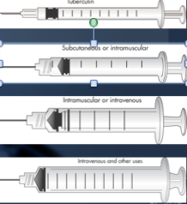
Syringes and Needles
- Choice of syringe and needle depends on:
  - Route of administration
  - Characteristics of the fluid
    - (e.g., aqueous, oil based)
  - Volume of medication
- Range from 1 mL tuberculin and insulin syringes to 60 mL irrigation syringes
- Tuberculin syringes
  - 0.01 mL gradients
- Insulin syringes
  - 1 unit increments
Needles
- Vary in length and gauge
  - Larger gauge means a smaller needle
Parenteral Medication Containers
- Single-dose ampules
  - Glass containers
  - Hold one dose of a medication for injection
- Multidose vials
  - Glass containers with rubber stoppers
  - Hold several medication doses
- Prefilled syringes

Preparing Medication for Injection
- Assemble equipment
- Compute volume of medication to be administered
- Using a vial:
  - Clean stopper with alcohol
  - Inject air into the vial equal to amount of solution to be withdrawn
- Withdraw volume required
- Remove syringe from vial
- Advance plunger of syringe to expel air from solution
Intravenous Therapy
- Used for access to body's circulation
- Indications:
  - Administer fluids
  - Administer drugs
  - Obtain laboratory specimens
- Route of choice for fluid replacement is peripheral vein in an extremity

- IV solution
- Infusion set
- Macrodrip or microdrip
- Tubing clamp
- Injection port

Type of IV catheters
- Hollow needles
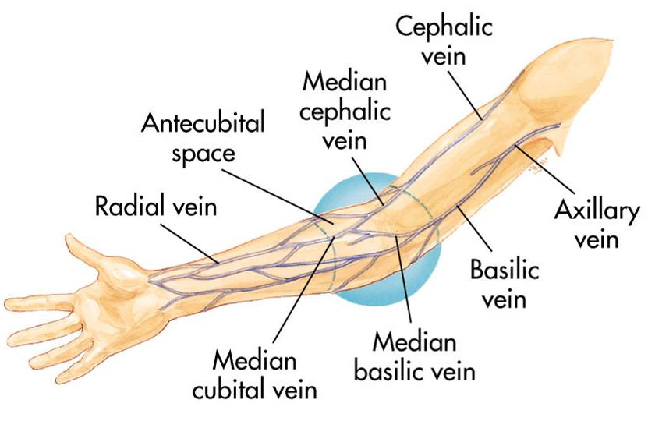
  - Butterfly type
- Indwelling plastic catheter over hollow needle
- Indwelling plastic catheter inserted through a hollow needle
  - Intracath

Peripheral IV insertion
- Common sites:
  - Hands and arms
  - Antecubital fossa (AC space)
  - Alternate sites: long saphenous veins, external jugular veins embolism rate and infection higher

- On insertion Avoid sites that have injury or disease:
  - Trauma
  - Dialysis fistula
  - History of mastectomy

- Explain procedure
- Assemble equipment
- Inspect fluid for contamination, appearance, and expiration date
- Prepare infusion set
  - Attach infusion set to bag of solution
- Clamp tubing and squeeze reservoir on infusion set until it fills half way
- Open clamp and flush air from tubing
- Close clamp
- Maintain aseptic techni
- Select catheter:
- Large-bore catheter used for fluid replacement 14 to 16 gauge
- Smaller bore catheter used for “keep open” lines 18 to 20 gauge
- Prepare other equipment
- Put on gloves
- Select site
- Apply tourniquet above antecubital space
- Prepare site
- Cleanse area with alcohol or iodine wipes (per protocol) Check for iodine allergy
- Stabilize vein
- Apply pressure and tension to point of entry
- Bevel of the needle up in adults
  - May be down in infants and children
- Pass needle through skin into vein from side or directly on top
- Advance needle and catheter about 2 mm past point where blood return is seen in hub of needle
- Slide catheter over needle and into vein
- Withdraw needle while stabilizing catheter
- Lock in protective sheath if present
- Apply pressure on proximal end of catheter to stop escaping blood
- Obtain blood samples if needed
- Release tourniquet
- Attach IV tubing
- Open tubing clamp and allow fluid infusion to begin at prescribed flow rate
- Cover puncture site dressing
- Antibiotic ointment if indicated by protocol
- Anchor tubing
- Secure catheter
- Document procedure
- Monitor flow

Central Venous Access
- Within scope of paramedic practice in some EMS systems
- Requires special training
- Authorization from medical direction
- Not for rapid fluid replacement in prehospital setting
- Sites include:
Femoral vein Internal jugular vein Subclavian vein
- Prepare as for peripheral veins
- Success depends on:
- Patient's body position
- Paramedic's knowledge of anatomy
- Familiarity with the procedure

- Advantages:
- Available when peripheral vessels collapse
- Access to central pressure measurements In-hospital procedure
- Safer vasopressor administration

- Disadvantages
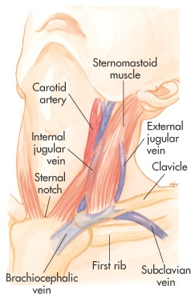
  - Excessive time for placement
  - Sterile technique
  - Special equipment
  - Skill deterioration
  - High complication rate
    - Pneumothorax, arterial injury, abnormal placement
  - Chest x-ray should be obtained immediately
  - Can’t initiate during other patient care activities
  - Not generally considered to be a useful prehospital technique
  - Lower flow rates than peripheral IV

Complications

Local:
- Pain and irritation
- Infiltration and extravasation
- Phlebitis
- Thrombosis and thrombophlebitis
- Hematoma formation
- Venous spasm
- Vessel collapse
- Cellulitis
- Nerve, tendon, ligament, and limb damage

Systemic:
- Contamination and infection
- Hypersensitivity reactions
- Sepsis
- Septic shock
- Emboli (blood clot, air, and catheter)

Infiltration—Causes

- Dislodgement of catheter or needle cannula during venipuncture
- Puncture of vein wall during venipuncture
- Leakage of solution into surrounding tissue from insertion site
- Poorly secured IV
- Poor vein or site selection
- Irritating solution inflames vein’s intima
- Improper cannula size
- High delivery rate or pressure

Signs & Symptoms

- Cool skin around IV site
- Swelling at IV site
  - With or without pain
- Sluggish or absent flow
- Infusion flows when pressure is applied to vein above tip of cannula
- No backflow of blood into IV tubing when clamp is fully opened and solution container is lowered below IV site
Management
- Lower fluid reservoir to check for presence of backflow of blood into the tubing
  - Absence of backflow suggests infiltration
- Discontinue IV infusion
- Remove needle or catheter
- Apply a pressure dressing to the site
- Choose new site
- Initiate IV therapy with new equipment
- Document

Air Embolism
- Uncommon but can be fatal
- Air enters bloodstream through catheter tubing
- Risk greatest with catheter in central circulation
  - Negative pressure may pull air in
- Air can enter circulation
  - During catheter insertion
  - If tubing is disconnected
- If enough air enters the heart chamber:
  - Blood flow is impeded
  - Shock develops
- Signs and symptoms:

  - Hypotension
  - Cyanosis
- Management
  - Close the tubing
  - Turn patient on left side with head down
  - Check tubing for leaks
  - Administer high-concentration oxygen
  - Notify medical direction

  - Weak and rapid pulse
  - Loss of consciousness

Complications central vein
- Femoral vein
  - Local complications
  - Systemic complications
- Internal jugular and subclavian veins
  - Local complications
  - Systemic complications

Rest of the slides weren’t mentioned in the lecture.

