D
one
by:
Sara
Alkhelb

Team
Leader:
Nada
Al
-­‐
Madhi

From
slides
Doctor's
Notes

Team's
Notes
From
the
book
Important

Definition:
v Pain: “An unpleasant sensory and/or emotional experience associated with actual or potential tissue damage or expressed in such terms”
v Sensory means that this pain is due to actual involvement of the sensory nerves by trauma, inflammation, ischemia, mechanical or direct injury to the nerve
v While emotional experience refers to the psychological element of pain experience *From slid notes!

Classification of Pain:
-According to the “Duration”
- Acute pain
- Subacute pain
- Chronic Pain
-According to the “Cause”
- Postoperative pain, most postoperative pain result from tissue damage and inflammation of serosa from surgical incision .
- Labor pain.
- Trauma.
- Sickle cell crisis , due to infarction and ischemia
- Cancer,
- LBP= Low back pain
- Musculoskeletal pain,
- Others.

Assessment of Acute Pain:
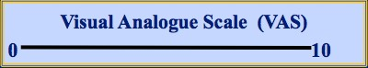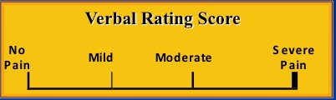
1
-
Pain measurement

-
Used for adul
t patients, easy to assess pain
.

-
There are some roles for proper assessment of pain e.g.

-

Timing:

-

Before & after analgesia.

-

Before & after incident e.g. change of cast, dressing, physiotherapy ect.

-

On regular basis like the other vital signs

-

The Same score should be used every time for the same patient

-

Lastly it should be Recorded like a
ny vital signs or other patient’s data

=>
from slid notes
!

2
-
Pediatric Scores “Facial expression”

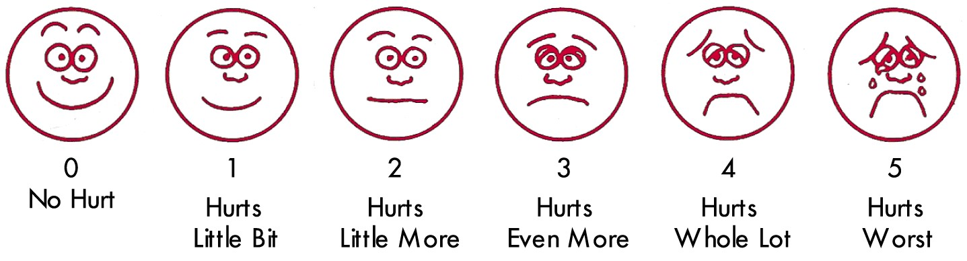

Facial expression for children and when there is a communication barriers between the pt
and the physician: e.g young age, geriatric pt, language, ect.

Management of Acute Pain:
Pharmaco – Therapy
- Non Opioid Analgesics usually as over the counter drugs v Paracetamol, can be with caffeine, codeine, or alone v NSAIDs, like ibuprofen, voltaren, diclofenac
- Opioids v Weak Opioids. v Strong Opioids. v Mixed agonist-antagonists
- Adjuvants like antidepressant and other antipsychotic medications

Regional Anesthetic Techniques
- Local infiltration for the wound
- USG-RA = US guided regional anesthesia, for pain in extremities : hand , knee … etc.
- Neuraxial: v Epidural: v Spinal v CSE

Acute postoperative management tools:
Pharmaco - Therapy
- Non Opioid Analgesics v NSAIDs
v Analgesic /Antipyretic v Analgesic/Anti-inflam/Antipyretic
v NSAIDs v Non-selective COX inhibitors v Selective COX-2 inhibitors
- Opioids v Weak Opioids. v Strong Opioids. v Mixed agonist-antagonists
- Adjuvants
v α-2 Agonists v LA= local anesthesia v SP inhibitors = substance P inhibitors , like paracetamol v NMDA inhibitors such as ketamine v Anticonvulsant / Antidepressants v Calcitonin for sever osteoporosis
v Relaxants to reduce muscle spasm , not the one used in OR. v Cannabinoids v Others

Regional Techniques
- Local infiltration
- Wound perfusion
- Intra-abdominal inj. of LA/Analg.
- Intercostal & Interpleural
- Paravertebral
- USG-RA: e.g. TAP =transversus abdominis plane block
- Neuraxial:
v Epidural: Thoracic, Lumbar v Spinal: Single shot , CSA=continues spinal anesthesia v CSE=combined spinal epidural WHO Ladder Updated:

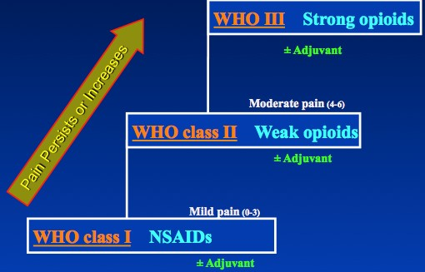

WHO (I) Non Opioid Analgesics
1. Non Opioid Analgesics v NSAADs
v Analgesic / Anti-inflam / Antipyretic / Anticoagulant v ASA
v Analgesic /Antipyretic v Paracetamol
v NSAIDs v Non-selective COX inhibitors: v Diclofenac & Ketoprofen
v Selective COX-2 inhibitors v Celecoxib & Rofecoxib

-­‐You
can
give
combined
paracetamol
with
any
other
NSAID
-­‐Give
it
in
regular
way
,
don’t
give
the
patient
a
chance
to
feel
the
pain!
-­‐Paracetamol
Q-­‐6
hourly
and
NSAIDs
Q-­‐8
hourly
Shift
the
patient
to
oral
analgesia
just
when
they
start
to
eat
.

Scientific Evidence – Nonopioid analgesia :
- Paracetamol:
  - is an effective analgesic for acute pain; the incidence of adverse effects comparable to placebo (Level I [Cochrane Review]).
  - Paracetamol / NSAIDs given in addition to PCA Opioids ⇒ ê⬇ Opioid consumption (Level I). To reduce its side effects.
  - Given routinely for at lest 24 hours with anesthesia in the OR to prevent pain from patient position.
- NSAIDs:
  - are effective in the treatment of acute postoperative (Level I ).
  - With careful patient selection and monitoring, the incidence of renal impairment is low (Level I [Cochrane Review]).
- NSAIDs + Paracetamol improve analgesia compared with paracetamol alone (Level I).
-NSAIDs are contraindicated in:
Renal impairment, GI bleeding, coagulopathy, Bronchial asthma

WHO Ladder II - Weak Opioids:
- Tramadol:
  - Tramadol : Morphine: its potency compared to morphine
    - Parenteral = 1 : 10 & Oral = 1 : 5
    - Dose: 200 – 400 mg/d

- Codeine:
  - Metabolized to morphine In liver.
  - Codeine : Morphine = 1 : 10
- Dextro-propoxyphene:
  - Methadone Derivative
  - Prolongation of Q-T interval.
Scientific Evidence – WEAK OPIOIDS
- Tramadol:
v has a lower risk of respiratory depression & impairs GIT motor function < other opioids (Level II).
v is an effective treatment for neuropathic pain (Level I [Cochrane Review]).
- Dextropropoxyphene:
v has low analgesic efficacy (Level I [Cochrane Review]).
v Usually given in combination with paracetamol as distalgesic

WHO Ladder III - Strong Opioids
- Morphine:
  - Sedation
  - PONV (post operative nausea and vomiting)
  - Respiratory Depression
  - Routinely order antiemetic drugs with morphine like zofran or granisetron.

- Fentanyl:
  - Rapid action, Short duration.
  - Fentanyl : Mophine = (1:100)
  - Induce sever respiratory depression and shouldn't given I.V, so give it in PCA machine or as patches.
- Pethidene:
  - Active metabolite: é⬆ t½ .
  - Prolongs Q-T interval.
  - Pethidine : Mophine = (1:10)
- Hydromorphone:
  - Powerful, rapidly acting.
  - Release is in distal gut.
  - Hydromorphone : Morphine = 1 : 5

WHO Ladder IV – Regional Anesthetic Techniques
1- Local infiltration 2- Wound perfusion 3- Intra-abdominal LA 4- Intercostal 5- Interpleural 6- Paravertebral 7- USG - RA: e.g. TAP 8- Neuraxial:
v Epidural: v Thoracic v Lumbar
v Spinal v Single shot v CSA
v CSE

Neuraxial (Spinal / Epidural):

- Advantages:
  - Provide prolonged & effective analgesia
- Side effects, (patient will not consume morphine, so less side effects) – Respiratory depression.
  - N/V.
  - Pruritus, due to fentanyl or morphine used for local anesthesia
  - Urinary retention, so insert folly catheter
When we block sympathetic NS centrally, parasympathetic NS will be dominant and GI motility will enhance, so the patient will not complain of abdominal destination.

WHO Algorithm for Management of Pain:
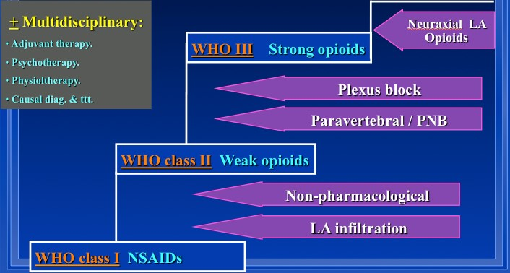

Routes of Administration: v Oral v Rectal for pediatrics v S.C. v Intranasal v Sublingual v IM v IV v Neuraxial v Spinal
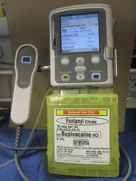
v

Epidural

its superior to all analgesia

v

Others

Patient Controlled Analgesia “PCA”
:

v

Systemic: IV & SC

v

Regional: Neuraxial
, Plexus & PNB.

v

Sitting:

v

Pre
-
set by the physician.

v

Activated by the patient.

v

Programming modalities.

v

The idea of PCA is to allow the pt to deliver his own analgesic
requirement independent on other hospital staff

v

This can be applied with some safe
ty precautions

v

For more information:
http://en.wikipedia.org/wiki/Patient
-
controlled_analgesia

Side Effects in Opioids: v Sedation / Dizziness v Nausea / Vomiting v Respiratory depression v Itch / Rash v Tolerance v Urinary retention v Drug interactions v Constipation (30-70%) v Dependence v Addiction v Opioid induced pain

Other common side effects are:
Constipation: due to inhibition of gastro-intestinal motility and slowing of gastrointestinal transit, that permits more absorption of water, with increased viscosity. Treatment is encourage water drinking, and osmotic laxatives as Lactulose.
Nausea and vomiting: due opioid central effect on chemoreceptor trigger zone, tolerance to this side effect appears early Dizziness: not common, appear in moving patients. Treatment is adjustment of dosage.
Pruritus: it is not due to histamine release, it is due to irritant central effects of opioid.
=> from slid notes!

Summary:
-WHO Ladder System should be followed
-Analgesia should be selected depending on the initial Pain Assessment.
-If the disease is not controlled on a given step è➔ Move directly to the Next Step.
-For continuous pain:
-Analgesics should be prescribed on a Regular Basis.
-Only one strong opioid should be ordered at a given time.

