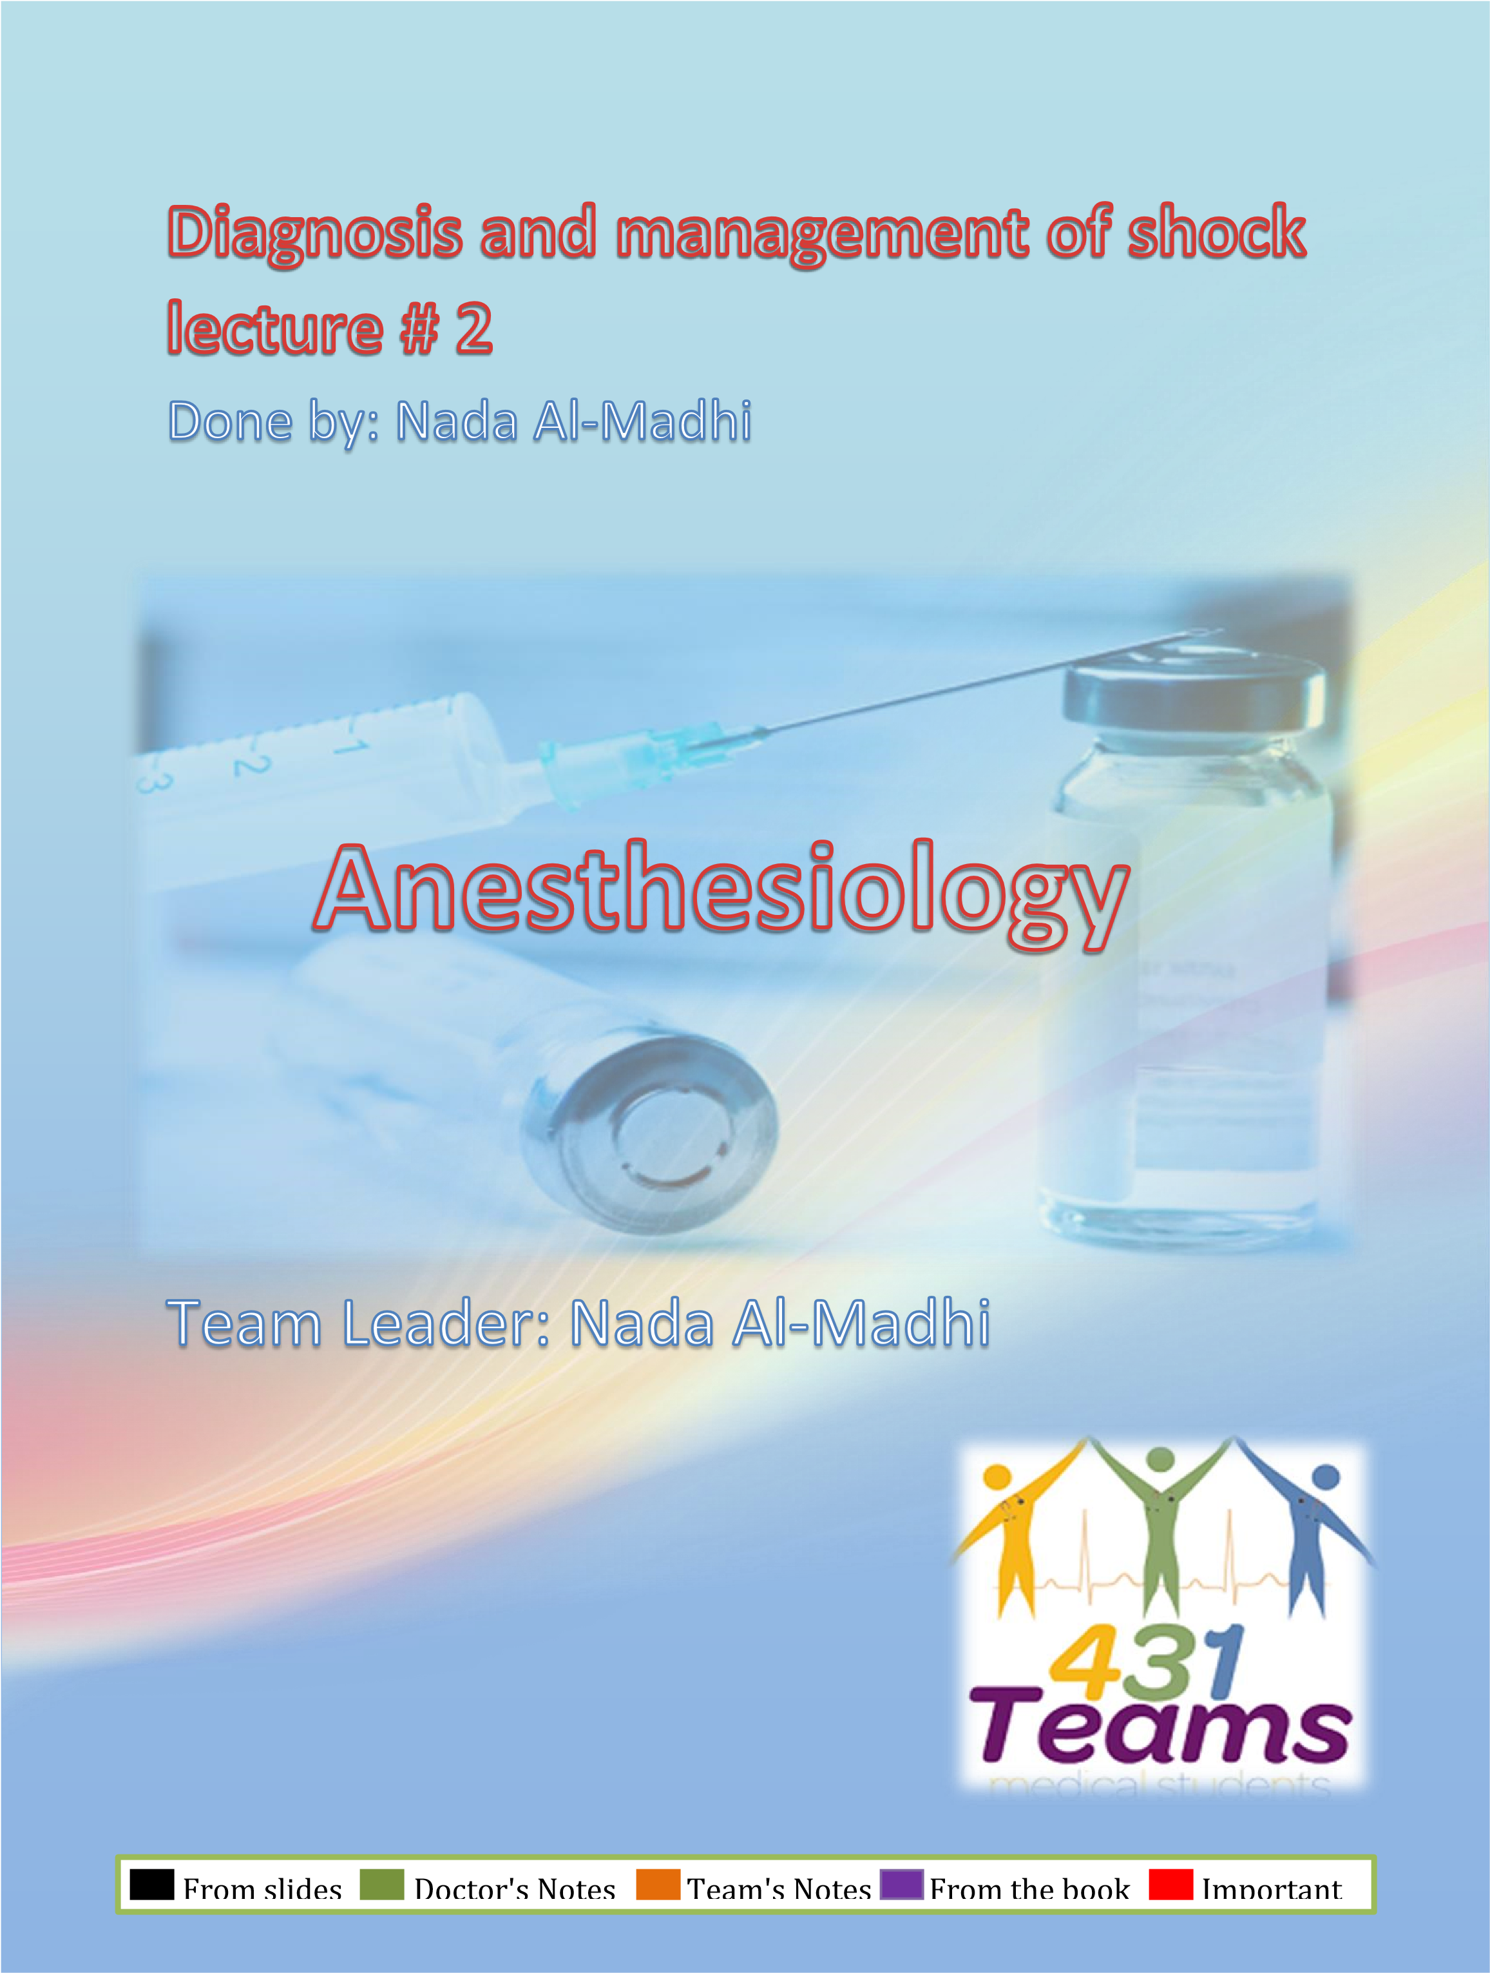
CASE STUDY:
A 25 Years old lady with no prior history of any chronic disease presented to the emergency department complaining of a productive cough of greenish yellow

sputum
VITAL SIGNS:
- Temp.38.8
- Ht.Rate 129/Min
- R.R 27/Min
- BP 112/68

- Where do you triage this Pt.?
- What information do you need to determine if this Pt. is in shock?
- What initial interventions are needed to stabilize that Pt.?

Triage is the process of determining the priority of patients' treatments based on the severity of their condition
We use the Canadian triage system:
Category I: critically ill patient must be see the patients immediately, presented with seizures, cardiac arrest patients, multiple trauma patients. YOU CANT TELL THEM TO WAIT!!
Category II: patient can wait for couple of minutes up to 15 mins
Category III: should see them within 30 mins.
Category IV: 1-2 hours
Category V: should not be seen in emergency, simple primary care clinic cases, triage outside the ER.
Triage system is different during disasters (building collapse or fire) → a lot of patients will come → choose the most salvageable one (1st with severe skull fracture, RR 30, BP 60/40. 2nd SOB, RR 30, BP 60/40 with engorged neck veins, diminished air entry on one side of chest) which one will you choose first to treat?? 2nd one cause by using simple maneuver (needle inserted in 2nd intercostal space) you can save his life (tension pneumothorax) the 1st one will die regardless whatever you do to him.

The Canadian Triage and Acuity Scale (CTAS) has five levels:
- Level 1: Resuscitation – Conditions that are threats to life or limb
- Level 2: Emergent – Conditions that are a potential threat to life, limb or function
- Level 3: Urgent – Serious conditions that require emergency intervention
- Level 4: Less urgent – Conditions that relate to patient distress or potential complications that would benefit from intervention
- Level 5: Non-urgent – Conditions that are non-urgent or that may be part of a chronic problem

Is the patient in the case critically ill or she can wait?? This patient is febrile, tachycardic and tachypnic→ manifestation of Sever inflammatory response syndrome SIRS:
- Body temperature < 36°C (96.8°F) or > than 38°C (100.4°F)
- Heart rate (pulse rate) > 90 beats per minute
- Tachypnea (high respiratory rate), with > 30 breaths per minute; or arterial blood pressure of CO2 <
30 mmHg
- Leukocytes (white cell count) < 4 x 10⁹ cells/L OR > 12 x 10⁹ cells/L
If you do not treat this patient early he might go into shock → if not treated early → he might go to intractable shock → he will then end with Multiple Organ Failure and die.
So we triage this patient category III OR II SIRS patients are never IV. Monitor the patient and start antibiotics early → why do we start it early → what’s the difference between starting it in 1 hour or 36 hours?? → Mortality is 100% after 36 hours → patient will die what ever you do to him, each hour will increase the mortality by 8% → so each hour without antibiotics you are compromising the life of the patient How do you determine if this patient is in shock or no?
- Serum lactate > 4
- Urine output < 0.5ml/kg/hour
- If patient is having severe hypotension not responding to IV fluids

What is the first intervention to stabilize the patient??
First thing to do is early antibiotics and IV FLUID → the mainstay of management of shock

    - Shock: is a syndrome of impaired tissue oxygenation and perfusion due to a variety of etiologies
    - If left untreated → Irreversible injury, Organ dysfunction And finally death

4 categories for shock:
- Hypovolemic shock (hemorrhage, BURN..)
- Obstructive shock (cardiac tamponade, PE)
- Distributive shock 4 types (septic shock) most common cause of shock in ER, Neurogenic shock (cns or spinal cord injury leading to loss of vascular tone, anaphylactic shock and adrenal crisis.
- Cardiogenic shock (massive MI, arrhythmias, pump failure, cardiomyopathy, or mechanical valve injury)

Clinical ulterations in shock
    - The presentation of patients with shock may be Subtle(mild confusion,tachycardia)
    - Or easily identifiable (profound hypotesion.anuria)
So you role as an emergency physician is to diagnose shock in the early stage don't wait for him to have profound hypotension, anuria and not responding to IV fluids. Any R1 can diagnose a shock at that stage→ react early, react fast.
    - The clinical manifestation of shock result
    - inadequate tissue perfusion and oxygenation
    - Compansatory respnses
    - the specific etiology: from the cause (infection → manifestation of infection or pneumothorax→ manifestation of pneumothorax)
Classification of shock:
  - Hypovolemic
  - Hemorrhagic
  - nonhemorrhagic
  - Cardiogenic
  - Ischemic
  - Myopathy
  - Mechanical
  - Arrhythmia

  - Distributive
  - Septic
  - Adrenal crisis (manifestations: hypotension, hypoglycemia, fatigue, dehydration, investigation findings: hypoglycemia, hyponatremia, hypotension, hyperkalemia) → indications to give steroids cause some of sepsis patients will not respond to IV fluids and antibiotics therefore we suspect adrenal insufficiency and give steroids → only indication to give steroids
  - Neurogenic (spinal shock)
  - Anaphylactic
All this black area is air.
Is it tension pneumothorax or not? You must always diagnose tension pneumothorax clinically not radiologically → considered a crime if you do
that → THEY WILL ARREST IN X RAY DEPARTEMENT!
Clinical findings:
- Tracheal deviation
- Engorged neck veins
- Absent or diminished air entry on one side
- Hyperresonance on percussion noted on the side of pneumothorax
- Hypotension
Imidiatly insert a needle in 2nd intercostal space to release the tension, leave it in place and prepare chest tube even if its not pneumothorax → because we already induced pneumothorax by inserting the needle
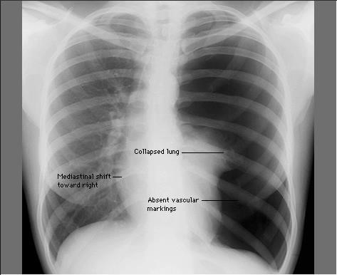
● Obstructive
- Massive Pulmonary embolism
- Tension pneumothorax
- Cardiac tamponade
- Constrictive pericarditis

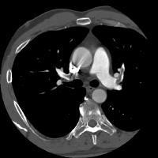 | A CT with sudden severe chest pain, SOB and tachypnic, pregnant 30 weeks. Is it safe to do CT for her? Yes it is acceptable to do it if suspecting PE, you can expose patient to 2 rads and CT Chest is only 0.5 rads → can be done is safe and essential for diagnosis.  Filling defect → major thrombus  Indication to give fibrinolytics→ to patient with PE and SHOCK → only indication is shock → hemodynamically unstable→ if stable only heparin is given  This patient was hemodynamically unstable → given fibrinolytics →risk of massive/ antepartum/ consealed hemorrhage in pregnancy.
CT was done for a pateitn presented with hypotension and tachypnea and tachycardia, muffled heart sound on chest examination → cardiac tamponade
Tamponade can be diagnosed by bedside echo examination → if you have more than 1cm around the pericardium this is cardiac tamponade and you should treat the patient on the spot → pericardiocentesis → needle under the xephoid process up and leftwards → withdraw until you have blood → gush of blood comes it will release the tension withdrawing as small as 50cc will improve the patient condition dramatically

HYPOVOLEMIC SHOCK:
  - It occure when the intra vascular volume is depleted relative to the vascular capacity as a result of:
  - hemorrhage.
  - G.I.T loss
3-urinary loss
4-dehydration
  - Management: The goal is to restore the fluid lost (burns→ parklands formula: 4xbody weight % of burn, replace half of fluid calculated in the 1st 8 and the 2nd half in the next 16 hours) patient with dv hypovolemic shock bolus of IV fluid until he’s stabilized
  - Vasopressors are used only as a temporary method to restore B.P untill fluid resuscitation take place. We never start using vasopressors we always have to assume that patient is fluid depleted. Alone it will not improve the tissue perfusion. We should fill the tank first → if not responding → give vasopressors
Distributive shock:
  - It is characterized by loss of vascular tone
  - The most common form of distributive shock is septic shock
  - The hemodynamic profile of septic shock include:
    - Cardiac output normal or increased but at the end will decrease
    - Ventricular filing pressure normal or low
    - SVR low
    - Diastolic pressure low
    - Pulse pressure wide

Management of septic shock:
    - The initial approach to the patient with septic shock is the restoration and maintenance of adequate intravascular volume
    - Prompt institution of appropriate antibiotic and early GS consultation for treatable cause (abscess→ cant treat the patient without drainage)
    - So in septic shock: early ANTIBIOTICS and early GS CONSULTATION.
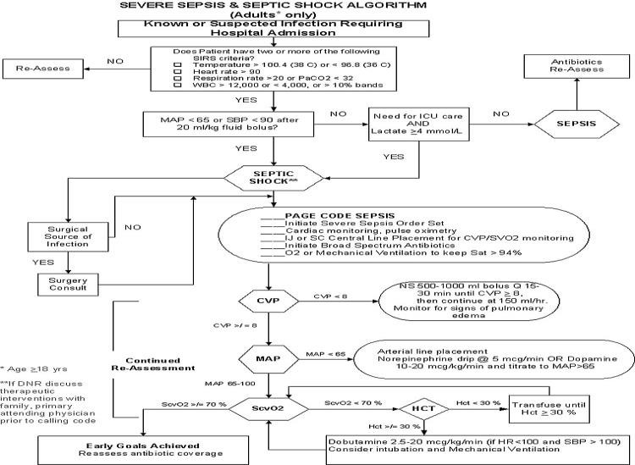

Standard pathway of care for patients with septic shock:
If having 2 of the SIRS Criteria → look Mean Arterial Blood pressure
If patient doesn't need ICU and serum lactate is 4 or below → sepsis → give antibiotics and admit to ward.
If patient needs ICU and serum lactate > 4 → treat septic shock → if surgical cause --> treat → if not a surgical cause → start workup for sepsis ”page code sepsis” (urine culture, cbc, septic screen, blood cultures, chest x ray, URS, put the patient into cardiac monitor and pulse oximetry to check O2 saturation, insert central line either Internal jugular IJv or subclavian, femoral line wont be helpful to measure the atrial pressure or central venous pressure. Then initiate blood spectrum antibiotics as early as you can. O2 through mechanical ventilation→ you intubate the patient → it will improve O2 oxygenation by increasing O2 saturation in blood and reduce the O2 demand of tissue by relaxing the patient (not using his muscles)
Then we look at central venous pressure → we need CVP between 8-12 if < 8 it means we need more fluid to give → give until reach 8-12 → then look at the MAP → if still< than 65 → give vasopressors, add norepinephrine > dopamine → dopamine will be converted to norepinephrine to work → takes time + arrythmogenic induce tachycardia liable to arrhythmia.
1st goal to have CVP between 8-12. 2nd goal is to have MAP > 65 (65-100) → IF MAP reached l→ look at mixed venous saturation → take blood from central line → send for ABG→ IF O2 sat venous < 70→ need to increase O2 carrying capacity of blood → look at hemtcrt → if > 30 → give inotropes (dobutamine). If < 30 hct → give packed RBC to patient. If mixed venous o2 saturation > 70 → it means we reached 3rd goal!!!
Early goal directed therapy ARE 3 to reach (CVP 8-12. MAP > 65. MV O2 sat > 70) → you are fine and you can now admit him to ICU
CARDIOGENIC SHOCK:
- Forward flow of blood is inadequate bec. Of pump failure due to loss of functional myocardium
- It is the most severe form of heart failure and it is distinguished from chronic heart failure by the presence of hypotension,hypoperfusion and the need for different therapeutic interventions  Hemodynamic characteristics:
- Cardiac output low
- Ventricular filing pressure high
- SVR High
- Mixed venous o2 sat low
MANAGEMENT OF CARDIOGENIC SHOCK:
if patient presented to you with pulmonary edema and cardiogenic shock → treat with inotropes → don't give dobutamine if patient is hypotensive. it will worsen the problem (hypotensive agent) → so increase blood pressure by vasopressors then give dobutamine.
Never give Lasix if he’s hypotensive he will collapse → lower BP more. Also can give
(nitroglycerine) NTG IV →Will cause hypotension --> never give it if syst. BP < 90. Lasix can be given by infusion 5mg/ hour and need to give him assisted ventilation to help by augmenting his respiratory muscles → fatigued from tachypnea. We can also give IV FLUID (when severely hypotensive and can’t give NGT or Lasix) → before intubation you should give IV fluids to increase blood pressure cause all meds for intubation will decrease BP but etomodate (new sedative) can maintain BP → so give etomdate and IV fluids and connect him to ventilator and you’ll start phenylephrine (alpha 1 adr agonist) → increase BP → then you can add dobutamine to increase heart contractility and HR (Beta 1 agonist) → of BP goes above > 90 systolic → give NG and Lasix
- The main goal is to improve myocardial function
- Arrhythmia should be treated
If patient is having cardio shock due to acute myocardial infarction STEMI with hypotension → only treatment here is to take patient to cath lab to open the artery directly and if needed you can insert the intraaortic balloon pump while inserting cath
→ contraindication to give fibrinolytics
- Reperfusion PCI is the treatment of choice in ACS
- Inotropes and vasopressor
Treatment of cause (pneumothorax→ needle in 2nd intercostal space, tamponade→ needle in the xiphisternal joint, PE hypotensive hemodynamically unstable → fibrinolytics and IV FLUIDS → stable→ heparin, pericarditis complication (pericardial effusion)→ needle in xiphisternal joint )

Obstructive shock: →
- Obstruction to the outflow due to impaired cardiac filling and excessive after load
- Cardiac tamponade and constrictive pericarditis impair diastolic filling of the Rt.ventricle
- Tension pneumothorax limit Rt.ventricular filing by obstruction of venous return
- Massive pulmonary embolism increase Rt.ventricular afterload
- Hemodynamic profile in obst. Shock:
  - Cardiac output low
  - Afterload high
  - Lt.Vent.filling pressure variable
  - Pulsus paradoxicus in Tamponade
  - Distended Jugular veins

GENERAL Principles of shock management:

- The overall goal of shock management is to improve oxygen delivery or utilization in order to prevent cellular and organ injury
- Effective therapy requires treatment of the underlying etiology

- Restoration of adequate perfusion, monitoring and comprehensive supportive care
- Interventions to restore perfusion center on achieving an adequate B.P, increasing cardiac output and optimizing oxygen content of the blood.
In Summery: 1- Monitoring
- Fluid Therapy
- vasoactive agents
- Treat the cause

