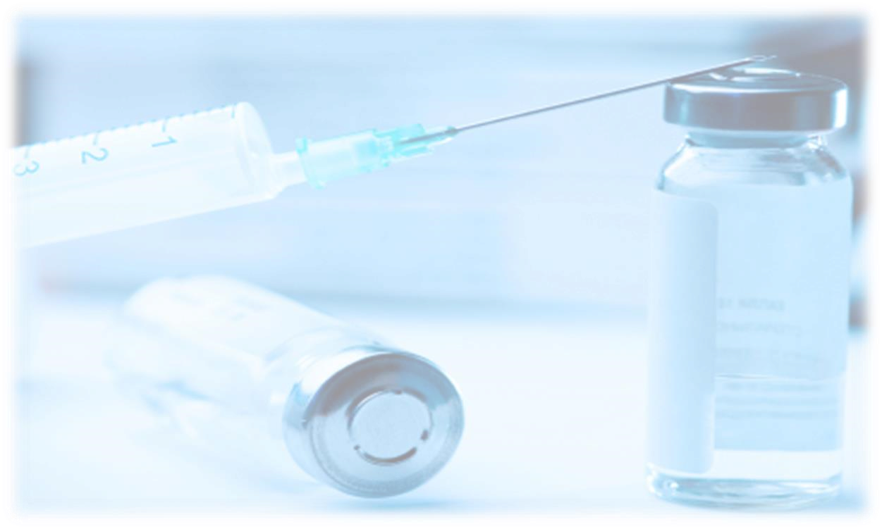
D
one by: Nouf Aboalsamh

Team Leader: Nada Al
-
Madhi

From
slides
Doctor's Notes

Team's Notes From the book Important

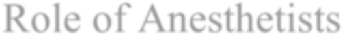
Role of Anesthetists

- Preoperative evaluation and patient preparation (Example: if a patient is going to do a surgery, we don’t just admit him/her directly. Preoperative assessment must be done. we check if the patient has uncontrolled comorbidities which needs to be optimized and refer them accordingly to make their condition as optimal as possible for surgery)
- Intraoperative management

General anesthesia

- Inhalation anesthesia
- Total IV anesthesia

Regional anesthesia & pain management

- Spinal, epidural & caudal blocks
- Peripheral never blocks
- Pain management (acute and chronic pain)

Post anesthesia care (PACU management) + Anesthesia complication & management

History of Anesthesia: General anesthetics have been used since 1846 when Morton demonstrated the first anesthetic (using ether) in Boston, USA. Local anesthetics arrived later, the first being scientifically described in1884.
General anesthesia is described as a reversible state of unconsciousness with inability to respond to a standardized surgical stimulus. (This basic definition has been used for years)
In modern anesthetic practice, this involves the triad of: unconsciousness, analgesia (Pain free), muscle relaxation.

General anesthesia

All this planning must be done before taking the patient to the Operative room
- Assessment ( History ,examination & comorbidities )  - Planning I: Monitors  - Planning II: Drugs  - Planning III: Fluids  - Planning IV: Airway  Management (LMA , Endotracheal tube or sedation) |  | - Induction: putting the patient to sleep  - Maintenance: keeping the Patient is asleep & hemodynamically stable during the surgery  - Emergence : waking the patient up after the surgery  - Postoperative care  Example: regular postoperative care unit, HTU or ICU

Objectives of Anesthesia

!!
- Unconsciousness
- Amnesia (the patient should not remember anything during the surgery)
- Analgesia
- Oxygenation
- Ventilation
- Hemostasis
- Airway Management
- Reflex Management
- Muscle Relaxation
- Monitoring

Preoperative anesthetic evaluation
- Risks of Anaesthesia:
It’s important to identify if the patient is at risk of developing intraoperative/ postoperative complications or if the patient is bound to be referred to the ICU after surgery
- Physical status classification (Important!) “ASA = American society of anaesthesiologists “

- Class I: A normal healthy patient.
- Class II: A patient with mild systemic disease e.g. asthma and don’t frequently visit the hospital (no functional limitation)
Patients with drug allergies are categorized in this
Class
- Class III: A patient with severe systemic disease e.g. an obese patient with COPD and feels dyspnic after climbing the stairs (some functional limitation)
- Class IV: A patient with severe systemic disease that is a constant threat to life e.g. Unstable Angina (functionality incapacitated)
- Class V: A moribund patient who is not expected to survive with or without the operation they may or may not survive within 24 hours impending ruptured aortic aneurysm with multiple comorbidities. at that time you have to decide whether the surgery is really needed
- Class VI: A brain-dead patient whose organs are being removed for donor purposes
- Class E: Emergent procedure added after the ASA class if it is an emergency

Example: if a patient with ASA II with controlled bronchial asthma that came with acute appendicitis (emergency) = ASAII E
Or a patient with uncontrolled diabetes and comorbidities presented with perianal bleeding (needs urgent intervention) = ASA IV E

- Airway examination - Mallampati classification (Important!)
The patient must be seated and you align your eyes with the level of patient’s mouth, and ask the patient to protrude their tongue “without making any sounds
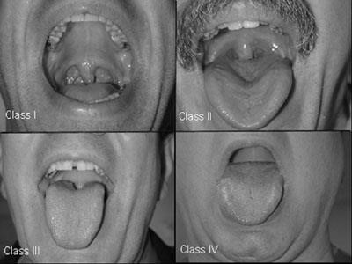
Class I: uvula, faucial pillars, soft and hard palate visible (4 structures are visible) anticipate easy intubation
Class II: faucial pillars, soft and hard palate visible (3 structures) anticipate easy intubation
Class III: soft and hard palate visible (2 structures) anticipate difficult intubation
Class IV: hard palate visible (1 structured) anticipate difficult intubation

- NPO (Nill per Os ) status
All patients undergoing any kind of anesthesia should be NPO
- NPO, Nil Per Os, means nothing by mouth
- Solid food: 8 hrs before induction
- Liquid: 4 hrs before induction
- Clear water: 2 hrs before induction
- Pediatrics: stop breast milk feeding 4 hrs before induction (formula milk should be stopped 6-8 hours before because it is thicker than the mother’s milk)

5. Anaesthetic plan:
- Premeds: Example: if the patient is anxious (anxiolytics)
Patients with bronchial asthma (Ventolin nebulization 30 minutes before
the procedure) History of regurgitation (Ranitidine & antiemetic agents)

- Intraoperative management :

General:  1. Airway management  If patients with (Obese, History of regurgitation, Diabetes or pregnant) they are considered as full stomach  even if they are NPO due to delayed  gastric emptying | Monitoring:  - Positioning (avoid nerve damage according to the patient’s position)  - Fluid management  - Special technique ( Regional block along with GA for pain relief , epidural or central line )
- Induction
- Maintenance
- Muscle relaxation

✓ Postoperative management Pain Control:
- PONV (postop. Nausea and vomiting)
- Complications anything that can occur in the recovery room e.g.: Hypotension, lung collapse
- Post-operative ventilation whether you should extubate the patient or kept on mechanical ventilation and shifted to the SICU
- Hemodynamic monitoring

General anesth
esia

- Monitor
- Pre-oxygenation(Important!): A 100% pure Oxygenated mask on the patient face “slightly away” for 3 minutes or (3 deep breaths) before administering any medication which will help increase the time apnea period (the pause where the patient stops breathing after administering the medication and intubating ) the lung will be saturated with oxygen preventing hypoxia during this period
- Induction : in children: if there is no IV cannulation → inhalation induction is used
(sevoflurane)
In adults or if there is an IV line → induction is by IV anesthetics
Including RSI (Rapid sequence induction): used in emergencies or with patients who are considered as “full stomach” by apply cricoid pressure + administering medication and preoxygenation all at once without bagging to immediately intubate within (30-60 seconds)
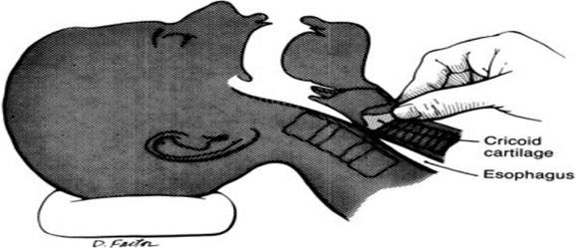
Cricoid pressure: the cricoid cartilage is the only ring shaped cartilage. When compressing the cricoid by applying pressure, it will result in closing the esophagus which will prevent any regurge

Example: If a pregnant patient is scheduled for an elective cesarean section, a cricoid pressure will be inserted. Because of the distended abdomen they have the tendency to regurge and aspirate the food contents
Normal induction & intubation : pre oxygenation → IV Propofol + Fentanyl → ask if the patient is breathing then ventilate the patient by bagging and add on the muscle relaxant to paralyze the muscles→ you should keep on ventilating for 3 minutes till the muscle relaxant starts affecting → intubate the patient
- Mask ventilation
- Muscle relaxants
- Intubation & ETT position confirmation
How to confirm that the endotracheal tube is in the right place?
  - by visualizing the tube (Seeing the tracheal tube passing through the vocal cords is the best clinical method of confirming tracheal intubation)
  - after connecting the tube to the circuit the chest will be moving
  - 5 point auscultation: by auscultating the apices, bases of the lungs and the stomach to make sure that the endotracheal tube wasn’t inserted through the esophagus (starting with the stomach first)
  - End Tidal CO2 = 5% Six breaths of CO2 must
- Maintenance tracheal intubationbe seen to confirm
- Emergence
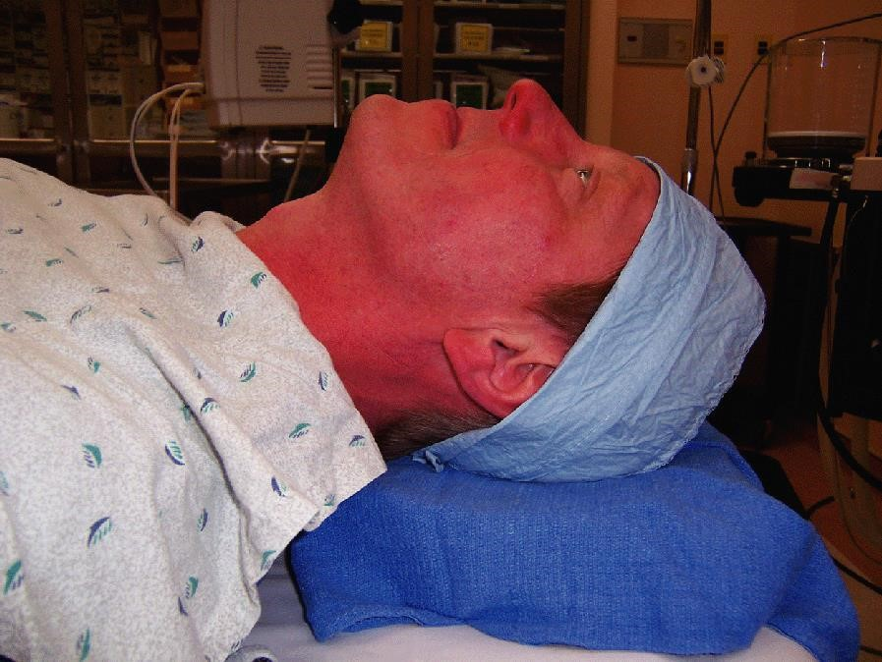
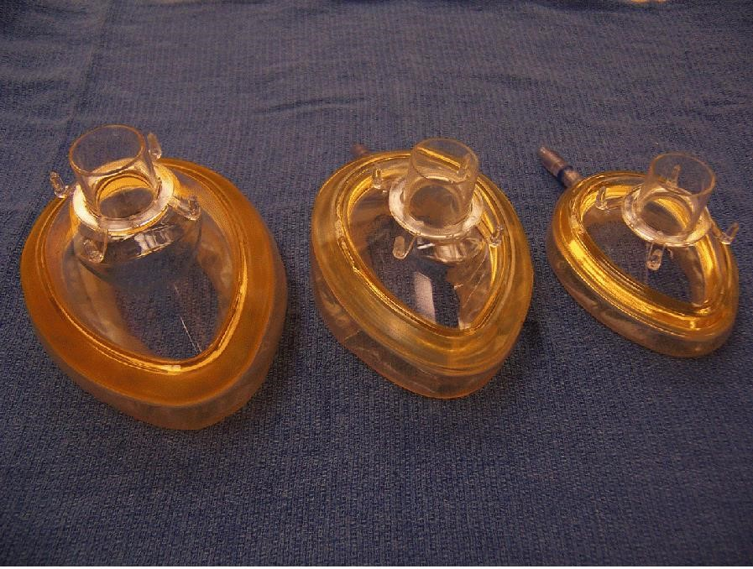
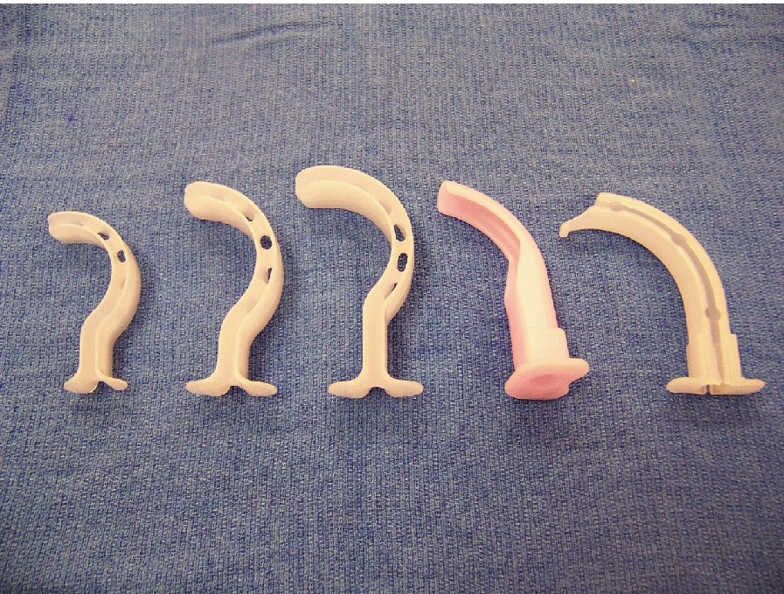
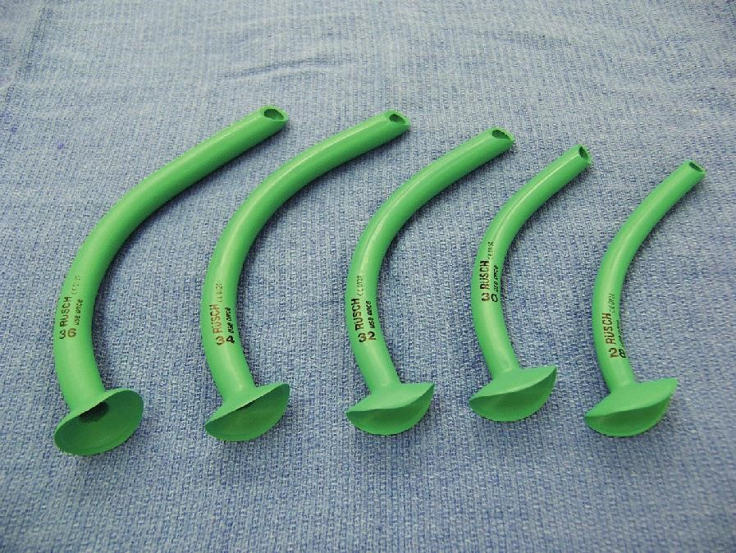
Oropharyngeal airways:

is used in
unconscio
us patients to avoid tongue
swallowing

Size Measuring: from the angle of the
mouth

and the mandible

Nasopharyngeal airway:

used in
partially consci
ous patients with intact
gag reflexes that

will not tolerate
oropharyngeal
airways

Size measuring: from the nostril to the
tragus of the ear

Placing
a pillow under the patient’s head.

Flexion of the neck & Extension of the head

at
the cervical
spine (
as if the person is taking a deep breath on a good
day
☺
)

this

position
will make it easier for doctors to visualize the airway and will become in line

Function:

to make the airway patent

Mask ventilation: 2 Techniques

Sniffing position
(
Golden Position) MCQ

Extension of
the head

Flexion of
the Neck

Mask and airway tools

Airway

Mask

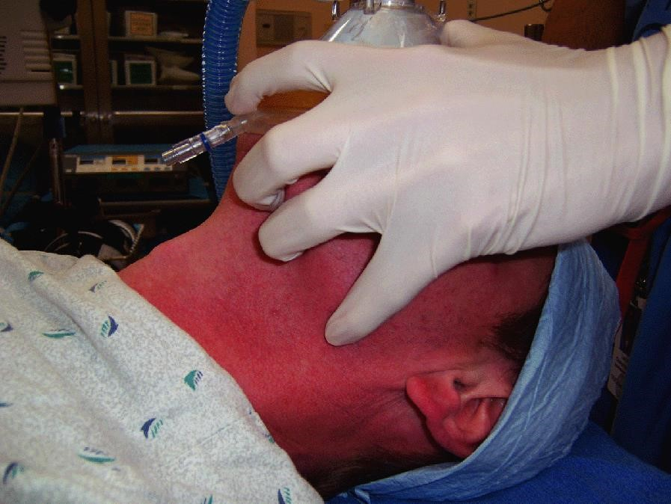
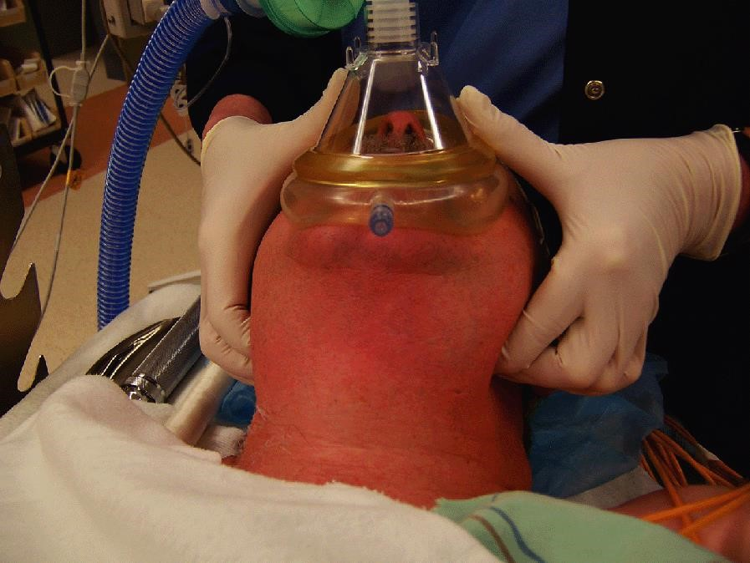

Mask ventilation and intubation

2. Single handed : by making a C shape with the thumb
and index on the mask and E shape on the jaw with the remaining 3 fingers

Intubation: is done in 2 ways

1. Double handed : Using both hands place the thumb on the mask by pushing and lifting the jaw forward to open the airway

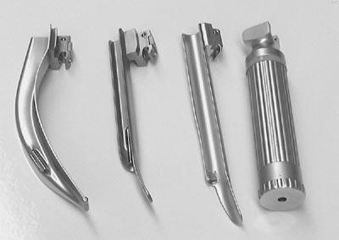
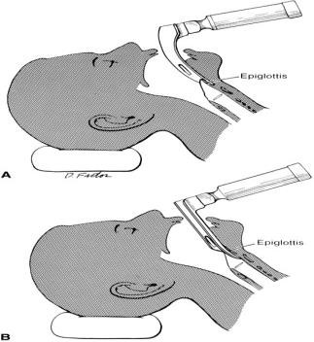
Different types of blades (they
will not ask about it)

  - Regular laryngoscope: by Holding the Laryngoscope with the left hand go from the right side of the mouth with the laryngoscope blade pushing the tongue to the left side → going deeper the epiglottis will be visualised at the back of the tongue. at this point lift your handle and up you will see the glottic opening and you will be able to intubate
  - Glidescope

Laryngeal opening (the upper one is the trachea and the lower is the esophagus)

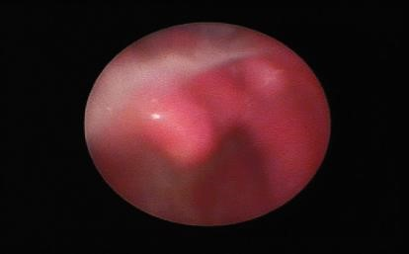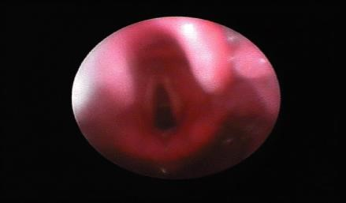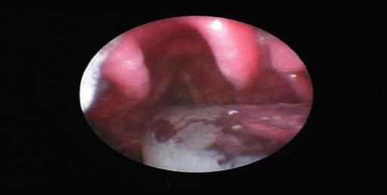

Laryngeal view scoring system (Cormack-Lehane grading system)

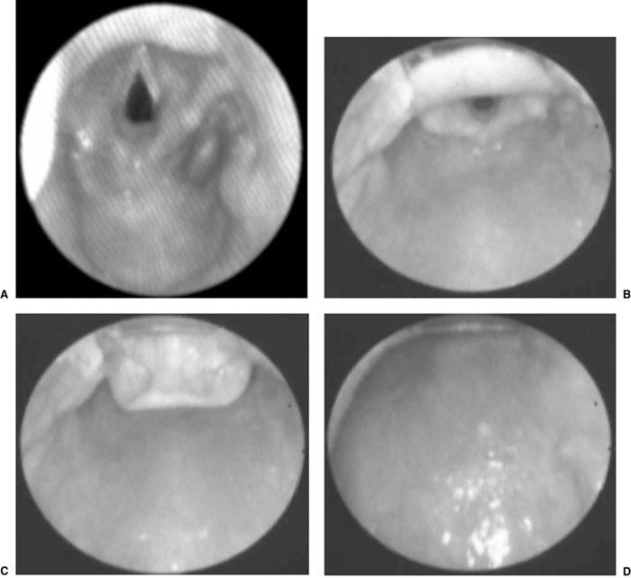
- Grade I: you can see the epiglottis at the top and the glottic opening. easy intubation
- Grade II: the Posterior edge of the epiglottis (posterior commissure of the glotic opening)
C.

Grade III: only the tip epiglottis. Difficult intubation

D.

Grade IV: no structure can be seen. Difficult intubation

Anticipated
Mallampati
III or
IV

Difficult airway

This is an obese patient with no head extension or neck flexion
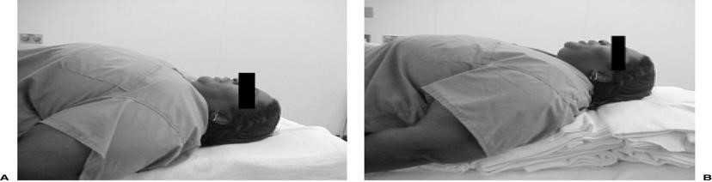

Example:

Morbid obesity you place a wedge under the shoulder to create a thyromental distance (≥6.5cm) +
Sternomental distance (≥12.5) to have an ample space for intubation

Glidescope

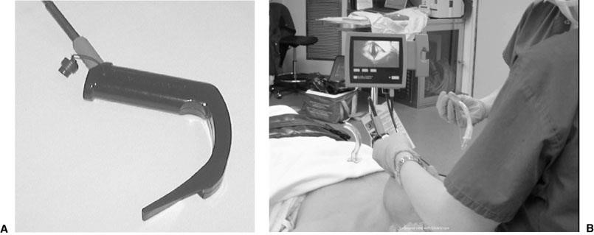
Has a blade like the laryngoscope. It is connected to a video screen to see the glotic opening. Under vision you’re able insert the scope from the center to visualize the structures and easily intubate unlike the laryngoscope
It is very beneficial for patients with anticipated difficult intubation e.g. obese patients and patients with cervical injury → no neck mobilization

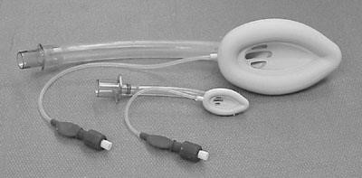

LMA (Laryngeal mask airway):
comes in various sizes and shapes

Indicated when you are not able to intubate or for short procedures (1:30 -2 Hours)
Example: A patient with bronchial asthma scheduled for a hand surgery or removal of foreign body (short procedure)
Not used in emergencies or laparoscopic surgeries like laparoscopic cholecystectomy because the abdomen will be distended so there is high chance of regurgitation and aspiration
✓ Advantages: ✓ Disadvantages:
Avoids trauma to the trachea Aspirations and regurgitation. Because it lies over the laryngeal opening not inside the
trachea

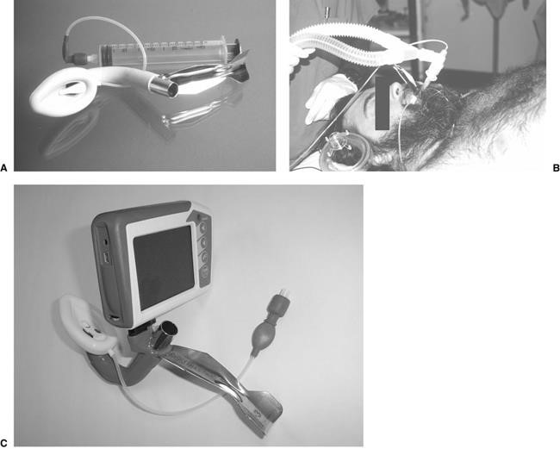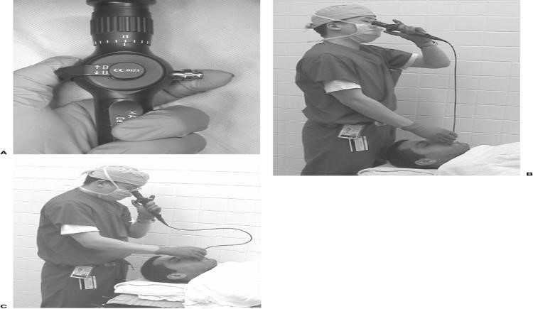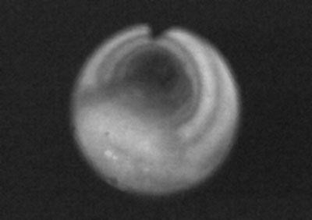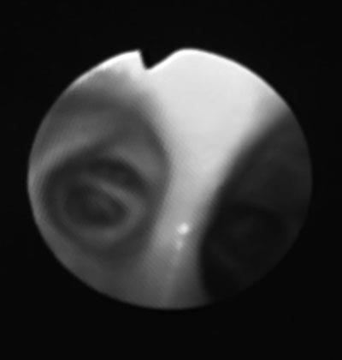
✓

Fast track LMA

It is used when there is a pathology in the

airway and difficult intubation

The patient is in an awake state. Using local
anesthesia insert the apparatus and
ask the
patient to swallow like a nasogastric tube and it will go through the trachea

There is a camera attached at the end of the fiberopetic bands which allows the
anesthetic

to
visualize

the tracheal & carenia

It is

used

in one lung ventilation &
in masses located in

the mediastinum (if the patient
s
tops breathing after administering

the medication. The mass will compress the trachea)

I
t is made in such shape to be able to slide an
endotracheal tube through the hole in
between. There is a flap

and

once you put the
ETT the flap goes up → No risk of Aspiration

Fiberoptic intubation
(
They will not ask about it
)

Trachea view

Carina view

Induction agents (in a separate pharmacology lecture)

Opioids – fentanyl (to reduce the requirement of anesthetic induction and inhalation agents)
If used in high dose it will result in chest wall rigidity hence difficulty ventilating the patient.
Induction - Propofol (mostly used), Thiopental and Etomidate (Etomidate is used in hemodynamically unstable patients & in patients with cardiac diseases. because It prevents hypotension) all are IV induction agent Muscle relaxants:
Depolarizing – Succinycholine used in Rapid sequence induction & Pregnant ladies (No reversal Agent)
Nondepolarizing → Antagonist: Neostigmine
- Long Acting
- Intermediate acting: takes 3-5 minutes to start affecting
Rocuronium. If given in high doses (from 0.6 to 1.1 you can intubate the patient in 1 minute) Rocuronium Antagonist: Sugammadex
- Short acting:
Optimal Condition for intubation:
- Patient is not moving
- Sleeping
- Muscles are relaxed

Induction
- IV induction used in most patient _{Mainly used in}
- Inhalation induction: Isoflurane, sevoflurane(mainly used) , Desflurane ^{the maintenance} phase (Pungent smell causing spasms) & Halothane not used anymore due to Hepatotoxicity
Inhalation induction Indication:
- Pediatrics without IV lines
- Patients with anticipated cessation of breathing (Patient with tracheal stenosis if you give them IV induction and Muscle relaxants the trachea will be more stenosed.
Therefore you must keep the patient in a much physiological state as possible →make him/her sleep with an inhalational agent and intubate without using muscle relaxants)
General anesthesia

- Reversible loss of consciousness
- Analgesia
- Amnesia
- Some degree of muscle relaxation Intraoperative management
- Maintenance : the aim is to achieve a balanced anesthesia
Inhalation agents: N2O (No Longer used) Used O2 40% and air60%, Sevoflurane, Desflurane, Isoflurane
TVA (Total IV agents): Propofol (when you don’t use inhalation agents!!)
Opioids: Fentanyl, Morphine
Muscle relaxants

Balance anesthesia
- Monitoring depending on the patient’s condition ( ECG ,End tidal CO₂, pulse oximeter , Blood pressure cuff , urine output , temperature measurement & blood loss measurement )
- Position – supine, lateral, prone, sitting or lithotomy (in Lithotomy position all the structures will go up which might cause some lung injuries if not careful )
- Fluid management
  - Crystalloid vs colloid
  - NPO fluid replacement: (MCQ) 4, 2, 1 Rule formula 1st 10kg weight-4ml/kg/hr.
2nd 10kg weight-2ml/kg/hr. and 1ml/kg/hr. thereafter - Intraoperative fluid replacement:
Minor procedures 1-3ml/kg/hr.
Major procedures 4-6ml/kg/hr.
Major abdominal procedures 7-10/kg/ml
Example: A patient is 40kg. The 1st 10kg = 10X4 = 40ml/hr
2nd 10kg = 10X2 = 20ml/hr 3rd 10kg = 10X1 = 10ml/hr 4th 10kg = 10X1 =10ml/hr
A 5kg pediatric patient’s fluid replacement will be: 5X4 = 20 ml/hr
Intraoperative management
–

Emergence
_{“waking the patient up”}

General Anesthesia
-

Complications

1.

Turn off the agent (inhalation or IV agents)

2.

Reverse the muscle relaxants

3.

Return to spontaneous ventilation with adequate ventilation and oxygenation

4.

Suction upper airway when the patient response to you and reverse muscle relaxant
→
Neostigmine

5.

Wait for patient to wake up and follow command

6.

Hemodynamically stable

7.

Then you ca
n extubate

the patient
and shift them to the post anesthesia care unit or
the HDU “Hight dependency unit” or

you can

keep the patient intubated and lessen
the agent’s concentration without reversing

or antagonizing

the muscles
relaxant
→
shift them to the

SICU intubated/ventilated ( e.g. craniotomy ending up with
respiratory depression of any surgical

complication
)

→ Usually planned beforehand

8.

Postoperative management the recovery room

If the patient was shifted to ICU he/she is no longer your problem

9.

Post
-
anesthesia care unit (PACU)

-

Oxygen supplement

-

Pain control

-

Nausea and vomiting

-

Hypertension and hypotension

-

Agitation

10.

Surgical intensive care unit (SICU)

-

Mechanical ventilation

-

Hemodynamic monitoring

•

Respiratory complications

-

Aspiration
–

airway obstruction and pneumonia

-

Bronchospasm

-

Atelectasis
→
if the endotracheal tube was inserted in
the right bronchus
and you miss
ed it
, the left lung’s alveoli

will eventually stop

functioning resulting
in atelectasis

(
collapse
)

of the left lung

-

Hypoventilation →
central

nervous system

or analgesia wasn’t adequate
over dosage of competitive relaxants or cholinesterase deficiency

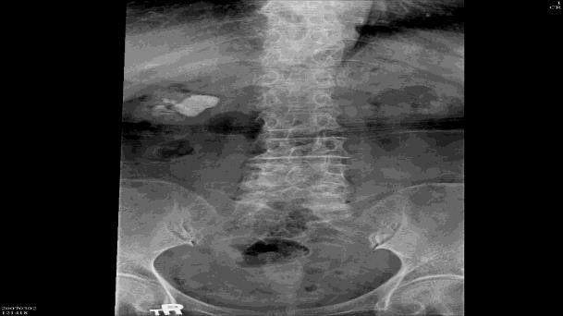
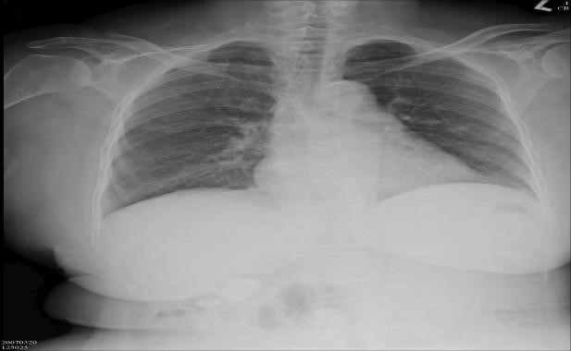
• Cardiovascular complications
2.

Preoperative

diagnosis
:

Right

renal stone (3.2 cm)

Operation
planned
:

Right
PCNL

(
Percutaneous

nephrolithotomy)

Pre
-
Operative Chest X
-
ray

  - Hypertension and hypotension
  - Arrhythmia
  - Myocardial ischemia and infarction → especially with diabetic patients that cannot tolerate the surgical stress
  - Cardiac arrest
• Neurological complications
  - Slow wake-up
  - Stroke
• Malignant hyperthermia: a rare life-threatening condition that is usually triggered by exposure to certain drugs used for general anesthesia, specifically the volatile anesthetic agents and the neuromuscular blocking agent, succinylcholine. Resulting in an unexplained rise of the temperature(Hyperpyrexia) 1-2º per hour + ↑End tidal CO₂ although ventilating (60-65) the normal=45 usually patients don’t survive treatment : dantrolene
Case Report - Arterial oxygen desaturation following PCNL (Percutaneous nephrolithotomy)
1. Patient: 73 y/o Female (BW 68 kg, BH 145 cm (BMI
32_{→ Obese})) Chief complaint:
Right flank pain (stabbing, frequent attacks)
General malaise and fatigue
Past history: Hypertension under regular control
Senile dementia (mild) ASAII
- Pre-anesthetic Assessment EKG: Normal sinus rhythm
CXR: Borderline cardiomegaly & tortuous aorta Lab data: Hb 10.5 / Hct 33.2
Within BUN 24 / Creatinine 1.1 the GOT 14
normal
range PT, aPTT WNL

- Anaesthetic Technique

General anesthesia with endotracheal intubation. Standard monitoring apparatus for
ETGA
Induction: Fentanyl 1ug/kg
Propofol 2mg/kg
Succinylcholine 80 mg
Atracurium 25 mg
Endotracheal tube reinforced (ID 7.0-mm) @ 19cm
Maintenance: Isoflurane 2~3% in O2 0.5 L/min
Position: prone
Blood loss: 300 mL → PRBC 2U
5. Intra-operative Events Stable hemodynamics
Abnormal findings 30 minutes after surgery started
Increased airway pressure 35~40 mmHg (normal.18-20mmHg)

SpO2 dropped to 90~95% (suspect that the ventilator cannot push air because there is an
obstruction e.g. Bronchospasm, one lung ventilation)
ABG data:
Bilateral breathing sounds were still audible then
Management: Solu-cortef 100 mg IV stat Bronchodilators
Aminophylline 250 mg IV drip ^{assuming that the} patient suffered from Bricanyl 5 mg inhalation bronchospasm

6. Post-operative Course
The patient’s condition continued until the end of surgery
SpO₂ 90~92% after the patient was placed in the supine position again with diminished breathing sound over right lower lung
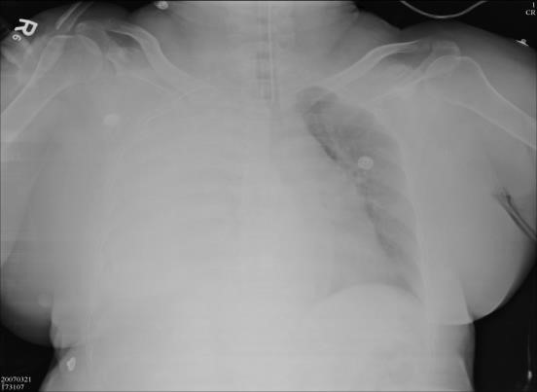
The patient was transferred to SICU for further care (*) Chest X-ray was followed in SICU

Postoperative Course: Immediate post-
operative
Heamothorax
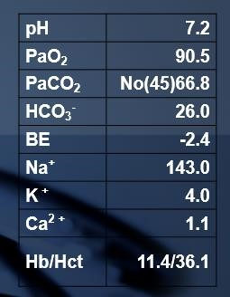

Pigtail drainage in SICU
Pleural effusion: bloody
RBC numerous
WBC 7800 (Seg 94%)
Gram stain (-)
Impression: Right hydrothorax and hemothorax
- Extubation and transfer to ordinary ward
- Pigtail removed

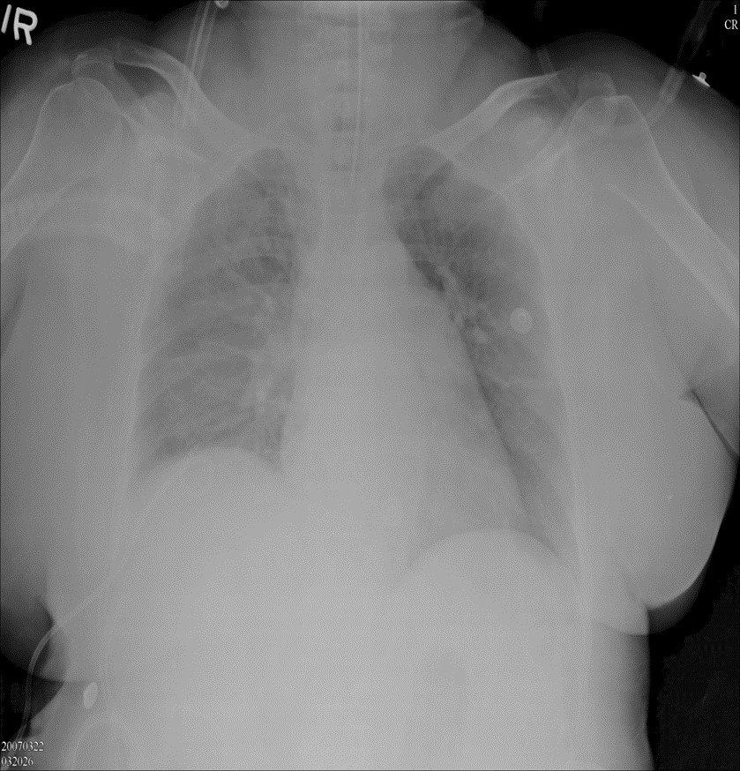
Remember! Patients die from improper ventilation not faulty intubation – Dr.Sadia
S/P Pigtail drainage

