Title and # of the lecture

Done by: your name

Team Leader: Nada Al-Madhi

Anesthesiology
Airway Management and
Equipment
Ghaida AlSugair
Indications of intubation:
Resuscitation (CPR)
Prevention of lung soiling
Positive pressure ventilation (GA) - administering artificial respiration for a prolonged period, in case of inadequate spontaneous ventilation or respiratory paralysis.
Pulmonary toilet - by clearing mucus and secretions from the airway, in case of impaired mucociliary clearance which is linked to poor lung function in a broad range of diseases and disabilities in order to prevent atelectasis and pulmonary infections.
Patent airway (coma or near coma) Respiratory failure(CO2 retention ) !
Requirement of successful intubation:
- 1-Normal roomy mandible
- 2-Normal T-M, A-O , and C-spine 3-Alignment of 3 axes or Assuming sniffing position !
Airway Evaluation:
Take very seriously history of prior difficulty
(Review prior anesthetic records. Ask the patient about the problems prior to anesthesia such as jaw pain, hoarseness of voice ,dental injury etc. that may suggest difficult intubation, or If the patient was informed by the anesthtetist that he was difficult to ventilate or intubate…) !
!
!
!
!
!
Cass and James’s 6 common anatomical anomaly:!
Examination: • Short muscular neck with
LEMON OR MELON PHYSICAL SIGN full set of teeth
Look externally: • Receding jaw with an
- Look for any obvious anomaly obtuse mandibular angle
- Morbid obesity(BMI) • Protruding upper incisor
- Skull • Poor mobility of the mandible
- Face • Long and high arched palate
- Jaw Movement • Increased alveolar mental
- Mouth and teeth ridge distance requiring wide
-- NeckFacial hair opening of the mandible for _{insertion of laryngoscope}
(facial hair can mask other signs of a difficult airway- like short thyromental distance. This is why you need to physically touch your patient’s neck when determining thyromental distance) !
Predictors of difficulty to intubate (OBESE):
- Obese (body mass index > 26 kg/m2)
- Bearded
- Elderly (older than 55 y)
- The Snorers
- Edentulous (Toothless) !
Evaluate 3-3-2-1 rule:
The 3-3-2 rule holds that in patients with normal relative anatomy the following apply: normal mouth opening is three (of the patient's) fingerbreadths; a normal mandible dimension will likewise allow three fingerbreadths (about 7 cm, and if less than 6 cm = difficult airway) between the mentum and the hyoid bone; and the notch of the thyroid cartilage should be two fingerbreadths below the hyoid bone and subluxation one finger.
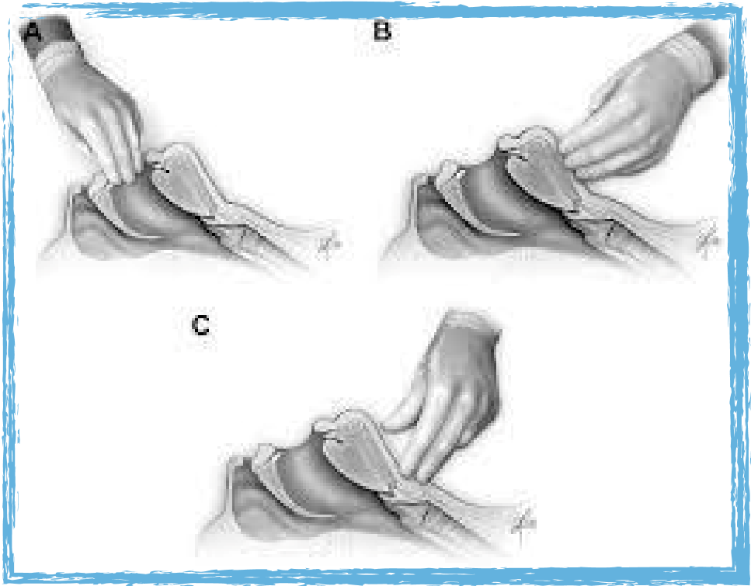

Mallampati score:
To perform a Mallampati evaluation, with the patient seated, have the patient extend his neck, open his mouth fully, protrude his tongue, and say "ah." Visualize the airway, looking for the tongue, soft and hard palate, uvula, and tonsillar pillars.
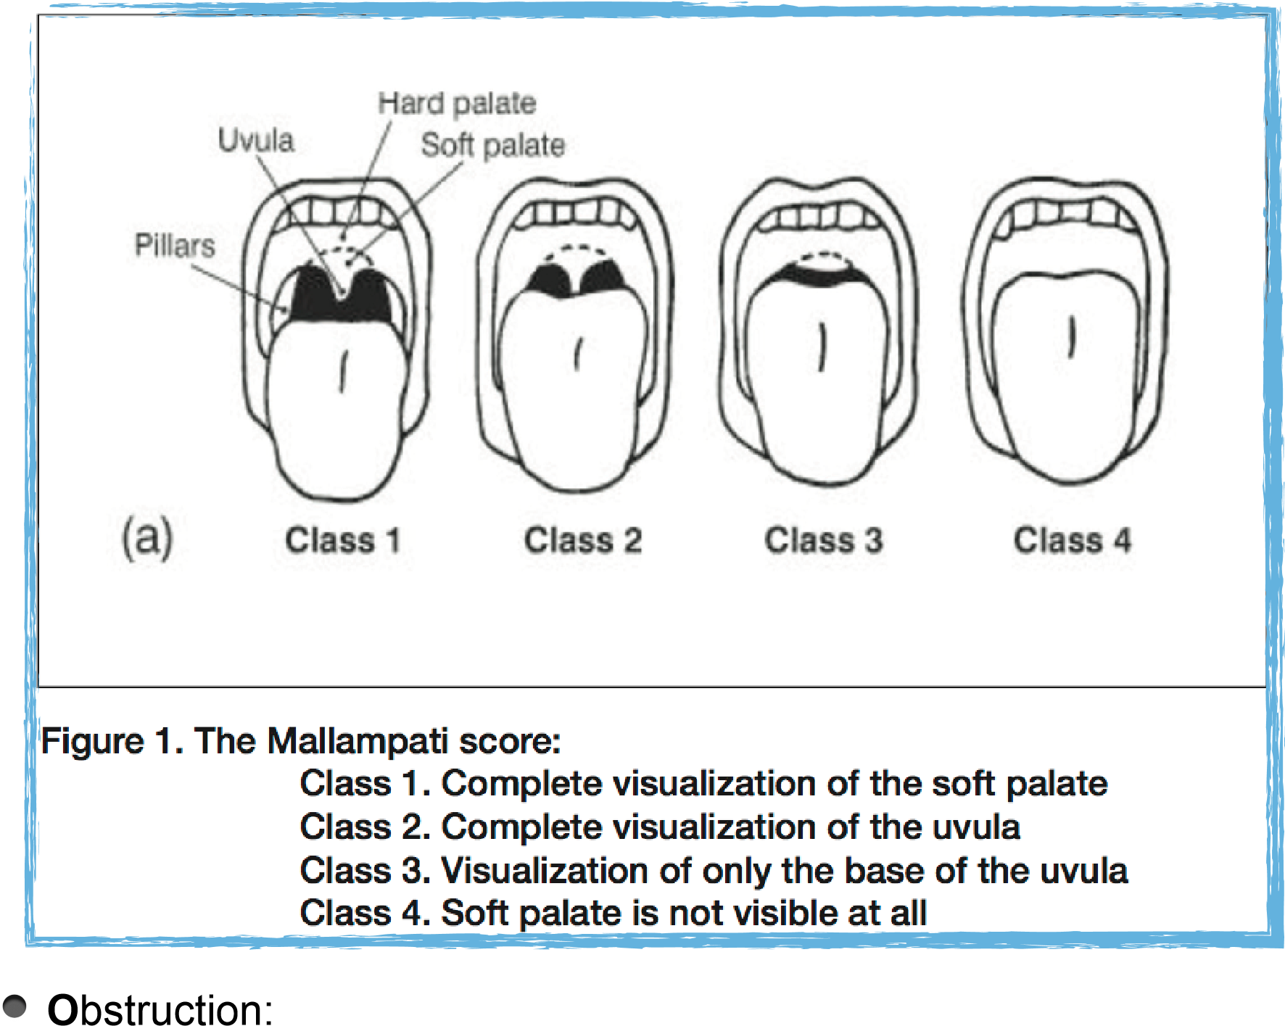
Evaluation for stridor, foreign bodies, and other forms of sub- and supraglottic obstruction should be performed in every patient prior to laryngoscopy. !
Neck mobility: (range>90)
Patients with degenerative or rheumatoid arthritis may have limited neck motion, and this should be assessed to assure the ability to adequately extend the neck during laryngoscopy and intubation. Patients in whom traumatic cervical spine injury is suspected, and in whom the cervical spine has been immobilized by a cervical collar have limited neck mobility by definition. However this factor in isolation is typically not a significant hindrance to peroral direct laryngoscopy and intubation.
Evaluation by Laryngoscopy: !
-Simple easy test,correlates with what is seen during laryngoscopy or Cormack-Lehene grades, but … !
1-moderate sensitivity and specificity(12% false +ve)
2-Inter observer variation
3-Phonation increases false negative view
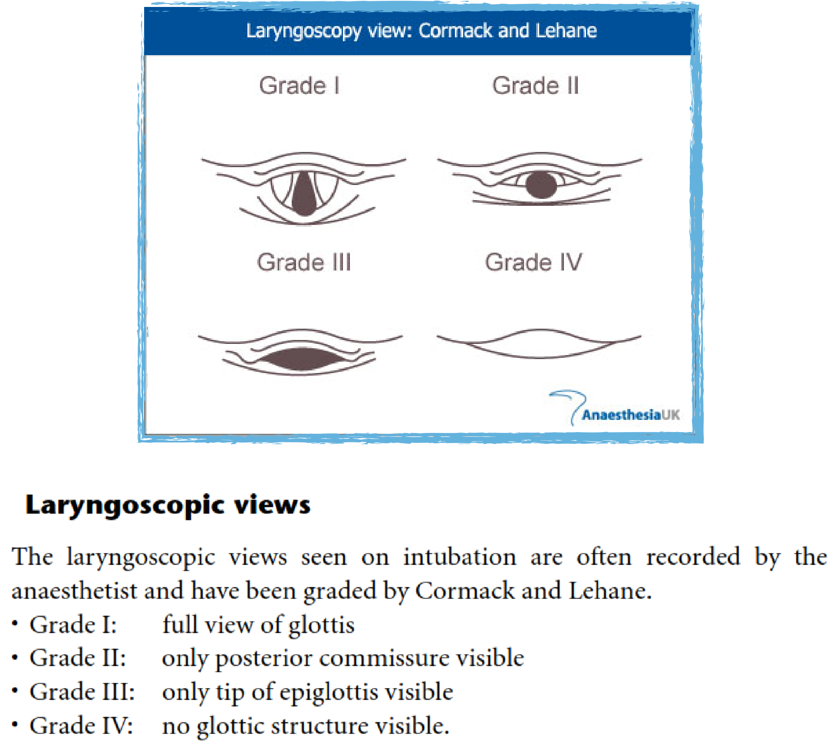
Wilson’s Score:
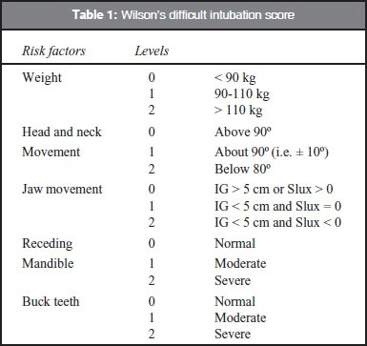
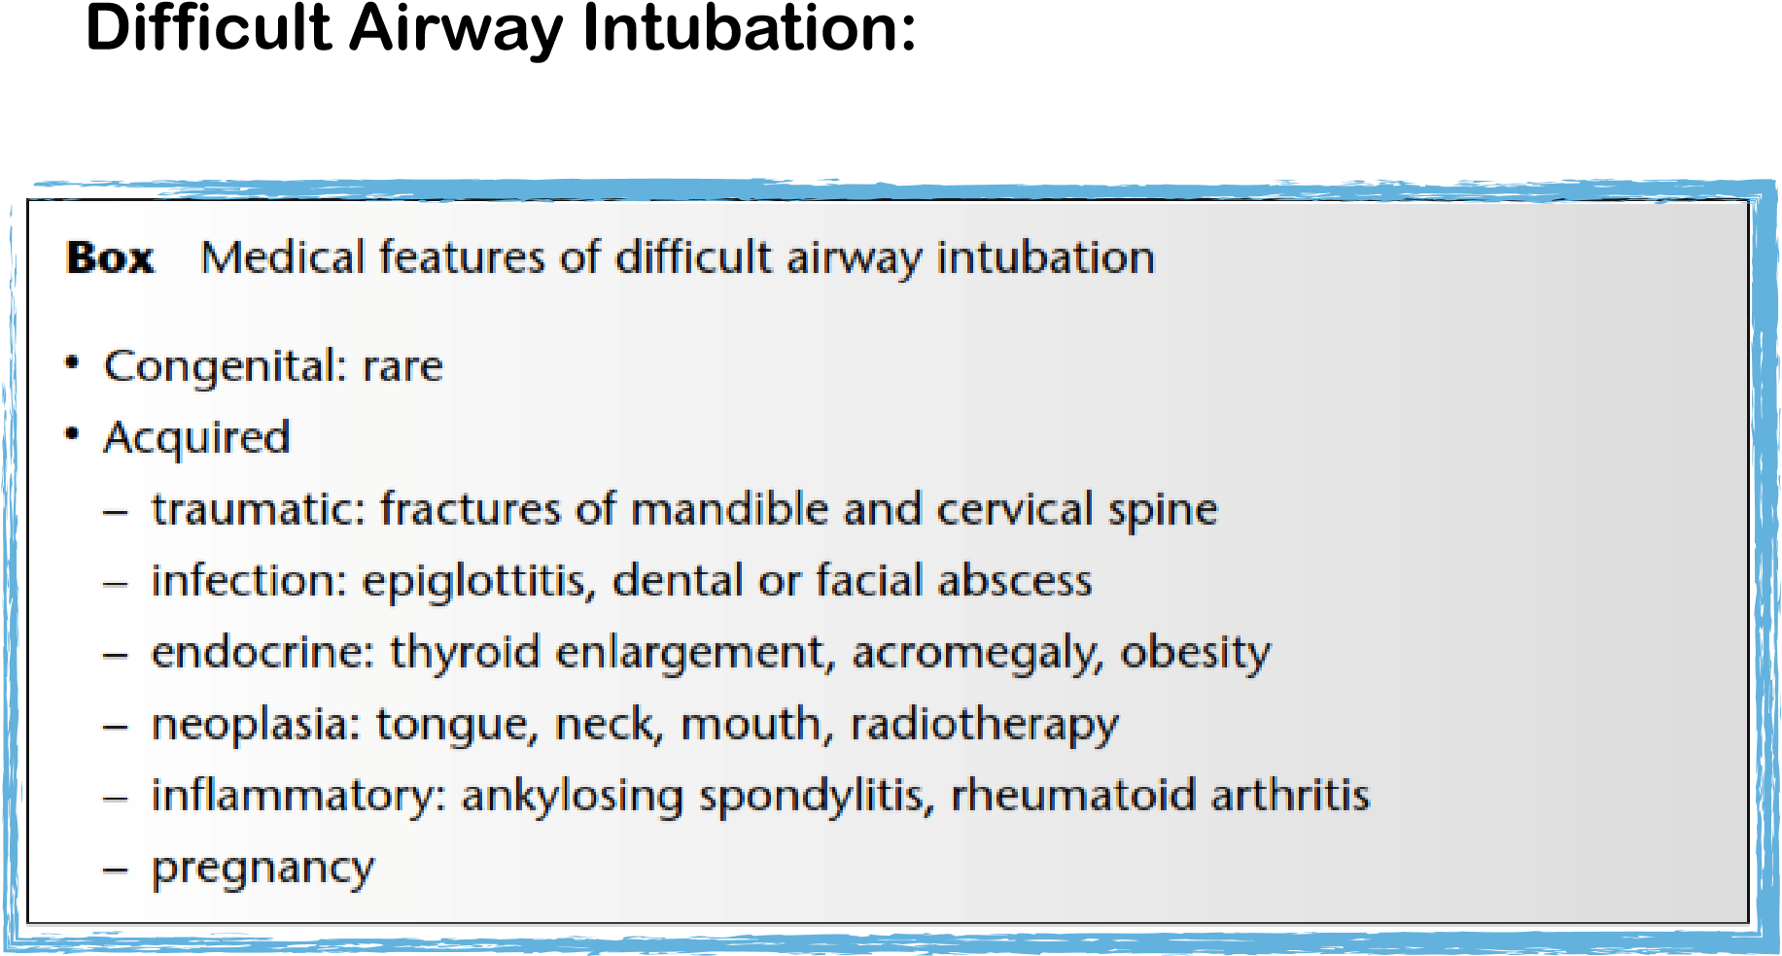
!
1. Facemask | 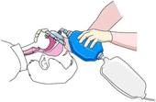
2. Guedel Airway | !!!!!!!!!! 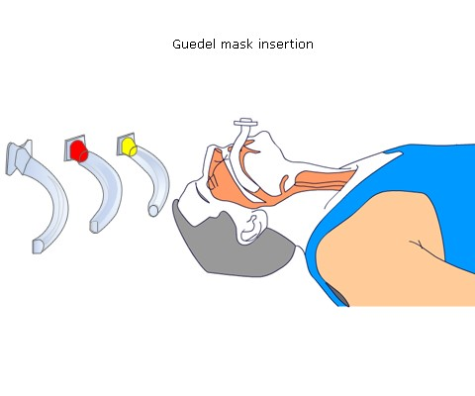
3. Laryngeal Mask | 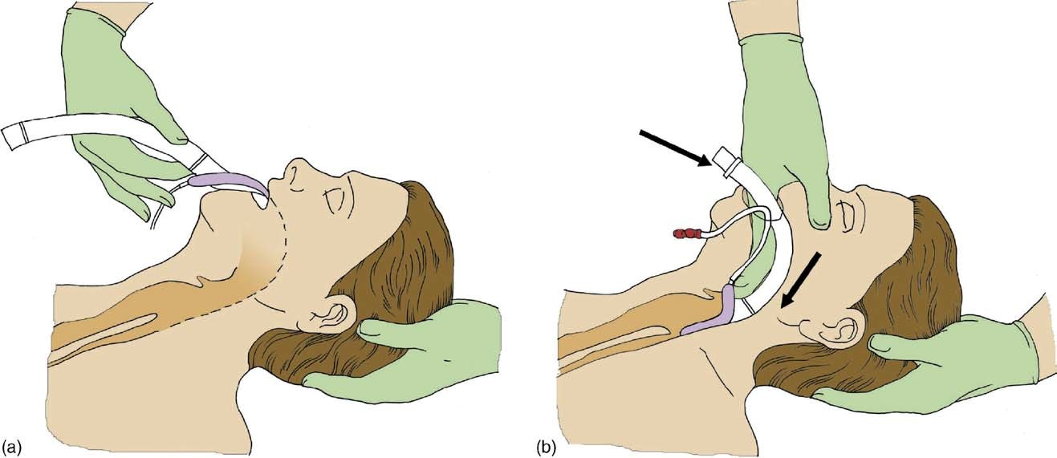  !  !  !  !  !  !  !  !  !
4. Endotracheal Tube | !!!!!!!!!! 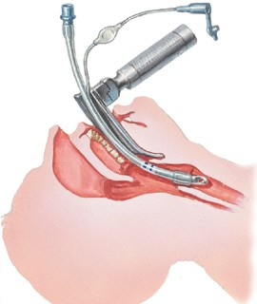
5. Tracheostomy | !!!!!
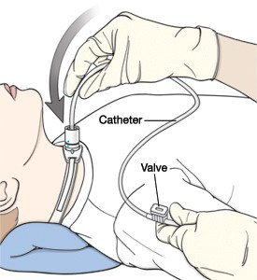
Methods of Airway Control:
How to Confirm Tube Position? !
- 1. Direct visualization of ETT between cords
- 2. Indirect visualization using the Bronchoscopy
- 3. Continuous trace of capnography
- 4. Three point auscultation (with a properly positioned tracheal tube, equal bilateral breath sounds will be heard upon listening to the chest with a stethoscope, and no sound upon listening to the area over the stomach.)
- 5. Esophageal detector device (a disposable tool used to verify proper endotracheal tube placement by utilizing the anatomical differences between the trachea and esophagus. Because the trachea has cartilaginous rings, it is a rigid structure. As vacuum is applied the device will refill easily if the ET tube is in the trachea. If the ET tube is in the esophagus, the device will not retract because the esophagus will have collapsed against the distal end of the ET tube)
- Other; as bilateral chest movement,mist in the tube (a small amount of water vapor will also be evident within the lumen of the tube with each exhalation and there will be no gastric contents in the tracheal tube at any time),CXR… !
Rapid Sequence Induction: !
RSI is the preferred method of endotracheal intubation in the emergency department (ED) because it results in rapid unconsciousness (induction) and neuromuscular blockade (paralysis). This is important in patients who have not fasted and are at much greater risk for vomiting and aspiration. !
!
!
!
RSI Technique:
- Preoxygenation
Administer 100% oxygen via a nonrebreather mask for 3 minutes. Studies have shown this can prevent apneainduced desaturation for 3-5 minutes by increasing O₂reservoir in the lung.
- IV induction with Suxamethonium chloride
Rapidly-acting induction agent to produce loss of consciousness and neuromuscular blocking agent immediately after the induction agent.
!
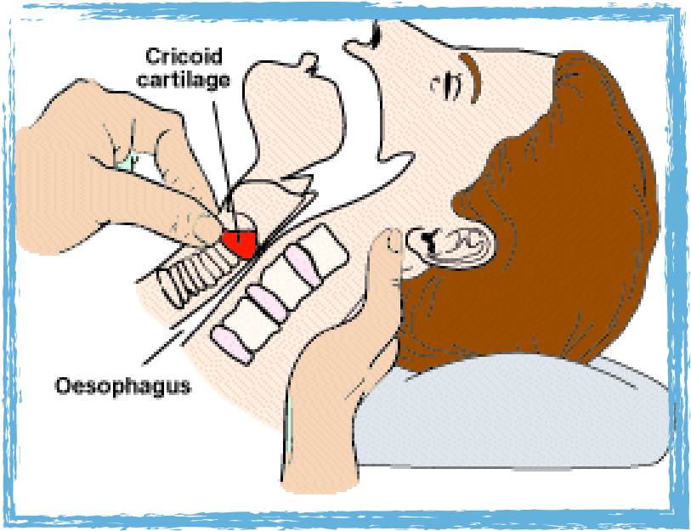
- Cricoid Pressure !
Used to either prevent regurgitation, or to assist with visualisation of the glottis by a practitioner attempting intubation. !
!
!
!
- Intubate, inflate the cuff, and confirm the tube position. 5. Release cricoid pressure and fix the tube.
!
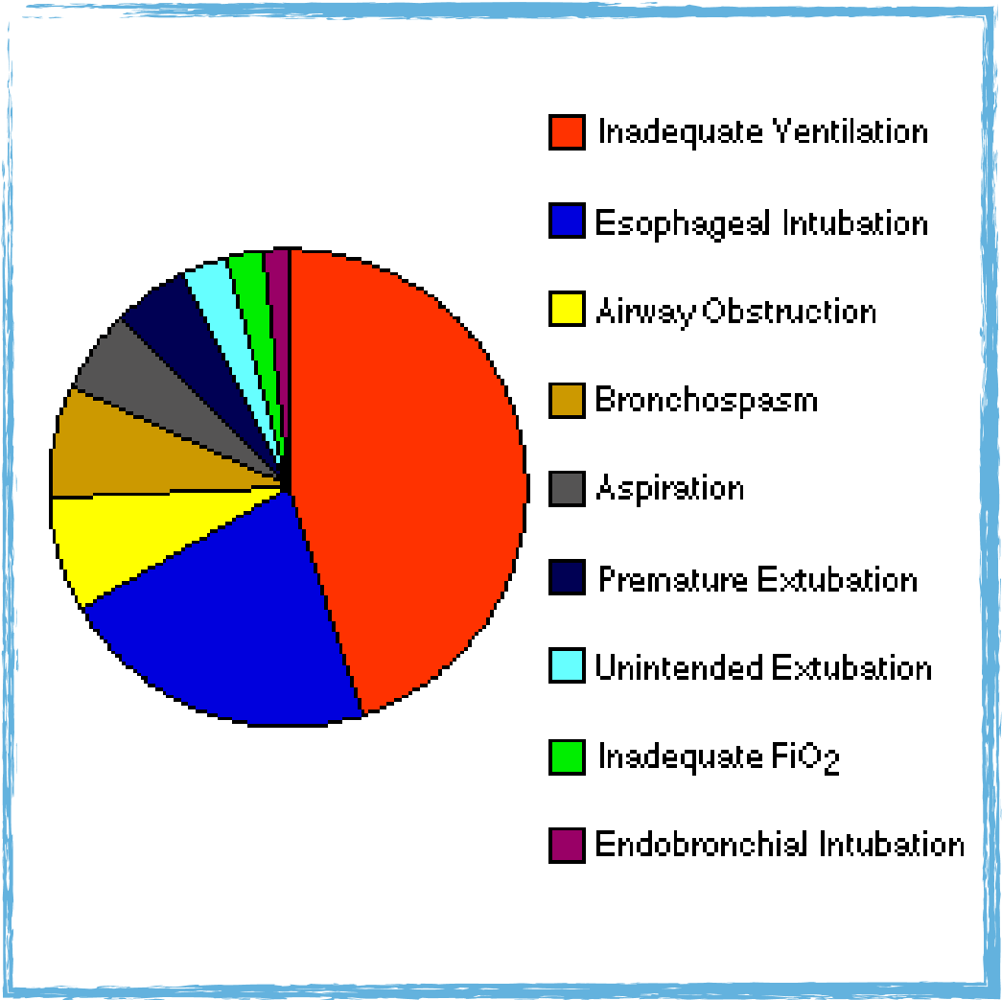
Complications of Intubation:
1-Inadequate ventilation.
2-Esophageal intubation.
3-Airway obstruction.
4-Bronchospasm.
5-Aspiration.
6- Trauma.
7-Stress response.
Failed Intubation Management:
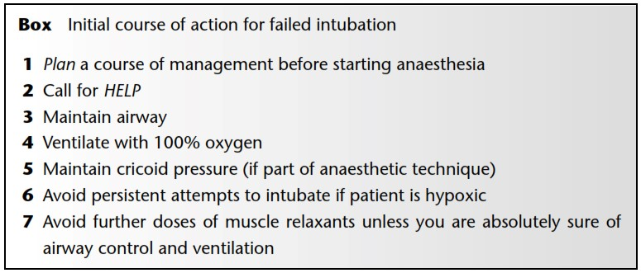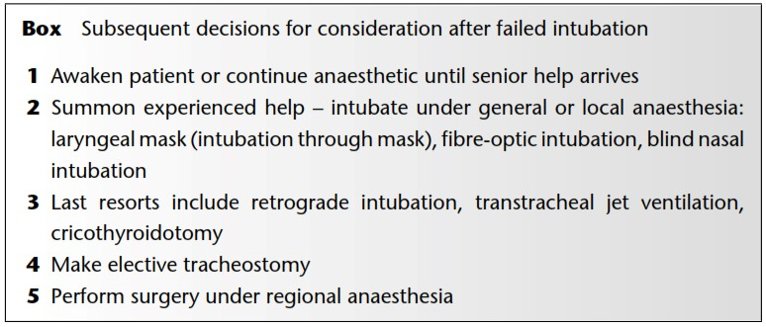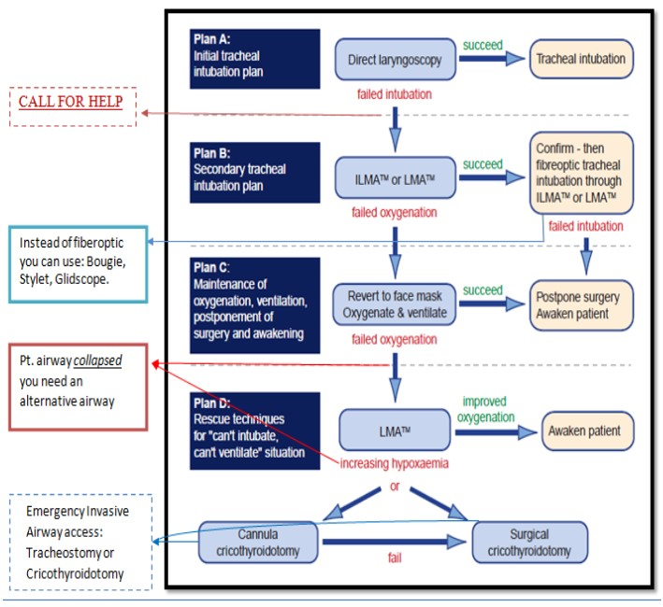
Fiberoptic Laryngoscope Intubation:



