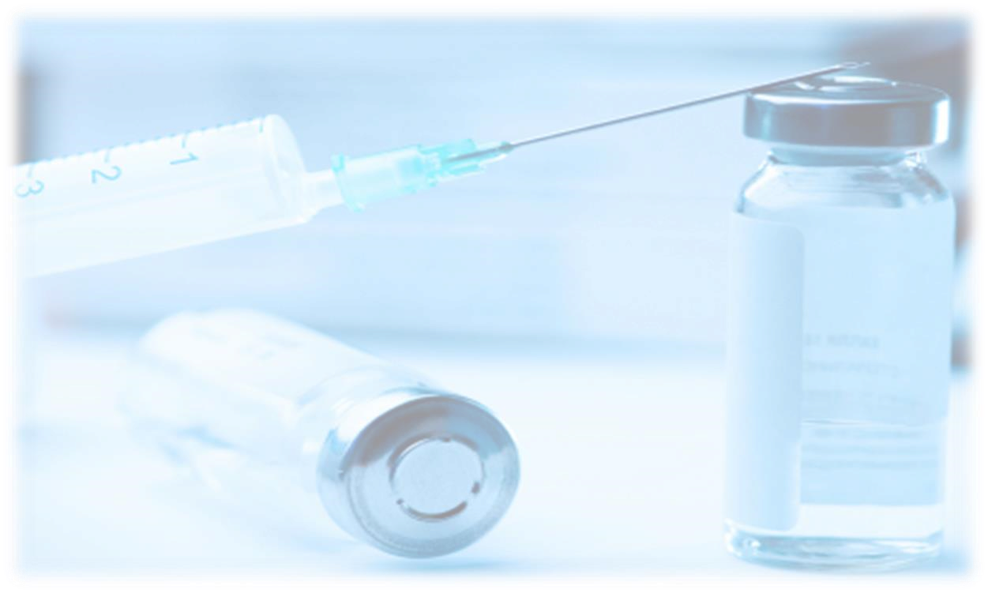
D
one by:
Sarah Al
-
M
utairi

Team Leader: Nada Al
-
Madhi

From
slides
Doctor's Notes

Team's Notes From the book Important

- Perioperative concern : before surgery and during surgery mainly
- most of the anesthetic drugs are depressant drugs which cause low blood pressure -> hypovolemia will be enhanced .
- Fluid and blood mostly ordered by anesthetist.
- Patient is NPO for 10 hrs, 8hrs, minimum 6hrs

Total Body Water (TBW)
- Varies with age, gender
- 55% body weight in males
- 45% body weight in females
- 80% body weight in infants
- Less in obese: fat contains little water
Body mainly formed of fluid, Fluid = blood, electrolytes, … etc.
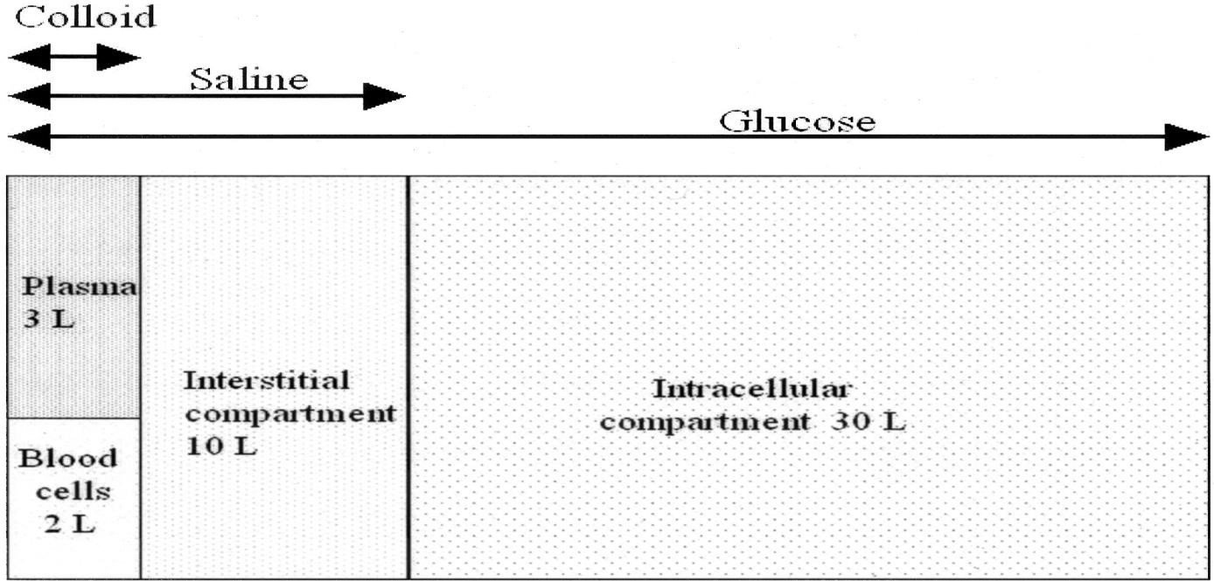

- 2 main body water compartments : Intracellular and extracellular
- Intracellular water: 2/3 of TBW ( major : 30 L)
- Extracellular water: 1/3 TBW
- Extravascular water OR interstitial ( in between the cells : collagen fibrous tissue ): 3/4 of extracellular water
- Intravascular water: 1/4 of extracellular water : Plasma and Blood cells - Example : 76 kg male, his total body fluid will be 45

Final Goals of Fluid resuscitation
- Achievement of normovolemia & hemodynamic stability = Good HR and BP
- Correction of major acid-base disturbances dehydration leads to acidosis
- Compensation of internal fluid fluxes fluxes means the flow ( in and out )
- Improvement of microvascular blood flow microvascular = perfusion
Perfusion is good -> CVS is good -> microvascular will be good ( end part of the body :finger tips, arterioles, microcirculation …etc)
- Prevention of cascade system activation Internal coagulation system
- Normalization of O2 delivery microvascular circulation and perfusion
- Prevention of reperfusion cellular injury : is the tissue damage caused when blood supply returns to the tissue after a period of ischemia or lack of oxygen. blood vessel obstruction or embolus > tissue hypoxia > when surgeon remove the cause and blood flows > the tissue will not take it easy! > need fluid to avoid reperfusion injury
- Achievement of adequate urine output urine output tells you about the perfusion and it is the easy indicator . Normal urine output : 0.5 – 1 ml\Kg\hour ,so 60 Kg lady must pass 30-60 per hour

Desirable outcome of fluid resuscitation Not over hydration signs
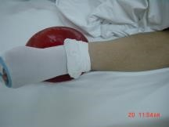
- No peripheral edema

- No ARDS Acute respiratory distress syndrome
if over hydration the fluids will leak out to the tissue especially to the lungs causing ARDS. Patient will complain of breathlessness, desaturation… etc.
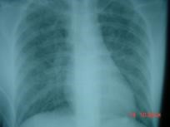

Fluid and Electrolyte Regulation • Volume Regulation
- Antidiuretic Hormone Retain fluid up to certain limit ( produce less urine )
- Renin/angiotensin/aldosterone system vascular constriction and dilatation
- Baroreceptors in carotid arteries and aorta sense the amount of circulating volume
(sensory neuron that is excited by stretch of the blood vessel.)
- Stretch receptors in atrium and juxtaglomerular apparatus
- Cortisol

Preoperative Evaluation of Fluid Status • Factors to Assess:
- h/o Hx intake and output
- blood pressure: supine and standing hemodynamic stability (dehydration) - skin
- Urinary output low if dehydrated
- mental status confused and irritated if dehydrated
+ Tachycardia if dehydrated

Orthostatic Hypotension
- Systolic blood pressure decrease of greater than 20mmHg from supine to standing
postural hypotension : adoption is lost
- Indicates fluid deficit of 6-8% body weight Orthostatic Hypotension is a Rough indicator of fluid loss
- Heart rate should increase as a compensatory measure
- If no increase in heart rate, may indicate autonomic dysfunction or antihypertensive drug therapy

Perioperative Fluid Requirements
The following factors must be taken into account:
- Maintenance fluid requirements
- NPO and other deficits: NG suction leads to dehydration>hypovolemia(it's usually 8 hrs before abdominal procedures ) , bowel prep enema procedure (1000 ml OR 1L) .
- Third space and invisible losses
the first space is intracellular, the second space is intravascular, and both are contributing in metabolism and regulation. Third space is an abnormal spaces as in ascites, plural effusion, …etc > dehydration invisible or insensible losses (as in suction, gloves and pads during surgery…etc)
- Replacement of blood loss
- Special additional losses: diarrhea

1- Maintenance Fluid Requirements
Insensible losses such as evaporation of water from respiratory tract, sweat, feces, urinary excretion. Occurs continually. All body cavities and functions, even breathing
Adults: approximately 1.5 ml/kg/hr 1.5 x Kg x hrs ( Surgery duration )
“4-2-1 Rule”
- 4 ml/kg/hr for the first 10 kg of body weight
- 2 ml/kg/hr for the second 10 kg body weight
- 1 ml/kg/hr subsequent kg body weight
- Extra fluid for fever, tracheotomy, denuded surfaces example : 40 kg : 1st 10 x 4 ml\hr, 2nd 10 x 2ml, 3rd 20 x 1 ml

2- NPO and other deficits
- NPO deficit = number of hours NPO x maintenance fluid requirement. 1.5 x Kg x hrs - Bowel prep may result in up to 1 L fluid loss.
- Measurable fluid losses, e.g. NG suctioning, vomiting, ostomy output, biliary fistula and tube.

3- Third Space & invisible Losses
- Isotonic transfer of ECF from functional body fluid compartments to non-functional compartments.
- Depends on location and duration of surgical procedure, amount of tissue trauma, ambient temperature, room ventilation. small incision loss (Dermoid cyst 2 inchs) LESS THAN thigh abscess loss LESS THAN open nephrectomy loss ( exposed for long duration )
Replacing invisible Losses
- Superficial surgical trauma: 1-2 ml/kg/hr
- Minimal Surgical Trauma: 3-4 ml/kg/hr : head and neck, hernia, knee surgery
- Moderate Surgical Trauma: 5-6 ml/kg/hr : hysterectomy, chest surgery
- Severe surgical trauma: 8-10 ml/kg/hr (or more) : AAA repair, nehprectomy
AAA = abdominal aortic aneurysm

4- Replacement of blood loss
- Replace 3 cc of crystalloid solution per cc of blood loss (crystalloid solutions leave the intravascular space) example : 800ml blood loss -> 800x3= 2400ml= 2.4L Ringer's
- When using blood products or colloids replace blood loss volume per volume Ringer's 1:3 blood 1:1

5- Other additional losses
- Ongoing fluid losses from other sites:
  - gastric drainage
  - ostomy output
  - diarrhea
- Replace volume per volume with crystalloid solutions

Example
- 62 y/o male, 80 kg, for hemicolectomy
- NPO after 10 PM, surgery at 8 AM,
- Received bowel preparation
- 3 hours long procedure with blood loss of 500 ml
- What is his estimated intraoperative fluid requirement?
80kg , NPO 10 hrs , 3 hrs major surgery, bowel prep ( fixed between : 800 ml –1000ml (1L))
NPO = 1.5 x Kg x NPO hrs
Maintenance = 1.5 x Kg x surgery duration
Fluid requirement of this patient
- Fluid deficit (NPO): 1.5 ml/kg/hr x 10 hrs = 1200 ml + 1000 ml for bowel preparation = 2200 ml is total deficit: (Replace 1/2 first hour, 1/4 2nd hour, 1/4 3rd hour).
- Maintenance: 1.5 ml/kg/hr x 3hrs = 360mls
- invisible Losses: 6 ml/kg/hour x 3 hours =1440 ml invisible major surgery's loss 6- 8ml
- Blood Loss: 500ml x 3 Ringer's = 1500ml (if pure blood 500 ml)
- Total = 2200+360+1440+1500=5500mls

Intravenous Fluids:
- Conventional Crystalloids
- Colloids Albumin, gelatin products, blood ( large molecular weight prevent leak out)
- Hypertonic Solutions Hypo\hyper tonic : the difference is Plasma (normal osmolality: 282-300). Hypo example : dextrose (osmolality less than plasma). Isotonic (same as plasma : osmolality, Na, K, Cl) : Ringer's Lactate which known as : Physiological saline - Blood/blood products and blood substitutes

Crystalloids
Combination of water and electrolytes
- Balanced salt solution: electrolyte composition and osmolality similar to plasma; example: lactated Ringer, Normal saline (0.9 tonicity)
- Hypotonic salt solution: electrolyte composition lower than that of plasma; example: D5W. Dextrose water
- Hypertonic salt solution: 2.7% NaCl.
Crystalloids in trauma Advantages:
-Balanced electrolyte solution
-Easy to administer + minimum injury
-No risk of adverse reactions No anaphylactic shock as in gelatin for example there will be an immunological reaction (type 1,2) because it is a bovine proteins and consider as foreign bodies. All colloids will cause reaction except: Albumin which is the safest(5%, humane origin)
-No disturbance of hemostasis bleeding control
-Promote diuresis
-Inexpensive
Disadvantages:
-Poor plasma volume support
-Large quantities needed because it leaks out from vessels ( small molecular weight)
-Risk of Hypothermia if you give large volume
-Reduced plasma oncotic pressure (oncotic pressure keeps the fluid inside the vessels) -Risk of edema

Hypertonic Solutions
- Fluids containing sodium concentrations greater than normal saline. tonicity above plasma
- Available in 1.8%, 2.7%, 3%, 5%, 7.5%, 10% solutions.

Hyperosmolarity creates a gradient that draws water out of cells; therefore, cellular dehydration is a potential problem.
hypertonic fluid will pass osmotic membrane to the hypotonic fluid to equalize the tonicity Hypertonic saline Advantages:
- Small volume for resuscitation. you don't have to give 8 L,10L ! 500ml is enough
- Osmotic effect
- Inotropic effect ( increase calcium influx in sarculima ) increase heart contractility + increases the BP
- Direct vasodilator effect
- Increase MAP, CO
- Increase renal, mesenteric, splanchnic, coronary blood flow.
Disadvantages:
- increase hemorrhage from open vessels.
- Hypernatremia - Hyperchloremia.
- Metabolic acidosis.

Crystalloids : Lactated Ringer's most commonly used
Composition: Na 130 (plasma is 132) , cl 109 (plasma is 120) , K 4 (plasma 3.5), ca 3,
Lactate 28, Osmolarity 273 mosmol/l So as good as plasma and that's why they call it Physiological saline
- Sydney Ringer 1880
- Hartmann added Lactate=LR - Minor advantage over NaCl Disadvantages:
- Not to be used for dilution of blood (Ca citrate)

Crystalloids: Dextrose 5% hypotonic
Composition: 50 gm /liter, provides 170 kcal /liter Disadvantages:
- enhance CO2 production
- enhance lactate production

Composition ( you don't have to remember these numbers)
Fluid | Osmo-lality | Na | Cl | K
D5W | 253 hypo | 0 | 0 | 0
0.9NS | 308 | 154 | 154 | 0
LR | 273*iso | 130 | 109 | 4.0
Plasma-lyte | 294*iso | 140 | 98 | 5.0
Hespan | 310 | 154 | 154 | 0
5% Albumin | 308 | 145 | 145 | 0
3%Saline | 1027 hyper | 513 | 513 | 0

Colloids
- Fluids containing molecules sufficiently large enough to prevent transfer across capillary membranes.
- Solutions stay in the space into which they are infused.
- Examples: hetastarch (Hespan), albumin, dextran.
Advantages:
-Prolonged plasma volume support
Moderate volume needed
-minimal risk of tissue edema -enhances microvascular flow Disadvantages:
- Risk of volume overload Over infusion -> edema + anaphylactic
- Adverse effect on haemostasis
- Anaphylactic reaction
- Expensive

Crystalloids VS colloids
Character | Crystalloids | Colloids
In the vein | Poor | Good
Hemody. Stability | Transient | Prolong
Infusion volume | Large | Moderate
Plasma COP | Reduced | Maintain
Tissue edema | Obvious | Insignificant
Anaphylaxis | Non-exist | low-mod
Cost | Inexpensive | Expensive

Clinical Evaluation of Fluid Replacement
- Urine Output: at least 1.0 ml/kg/hour
- Vital Signs: Blood pressure and heart rate
- Physical Assessment: texture of skin and mucous membranes (tongue, lips, conjunctiva ); thirst in an awake patient
- Invasive monitoring; CVP may be used as a guide
- Laboratory tests: periodic monitoring of hemoglobin and hematocrit

Summary
- Fluid therapy is critically important during the perioperative period.
- The most important goal is to maintain hemodynamic stability and protect vital organs from hypo-perfusion (heart, liver, brain, kidneys).
- All sources of fluid losses must be accounted for.
- Good fluid management goes a long way toward preventing problems.

Transfusion Therapy
- 60% of transfusions occur perioperatively.
- responsibility of transfusing perioperatively is with the anesthesiologist.

Blood Groups
 | Antigen on | Plasma |  | Incidence
Blood Group | erythrocyte | Antibodies | White |  | African-  Americans
A | A | Anti-B | 40% |  | 27%
B | B | Anti-A | 11 |  | 20
AB | AB | None | 4 |  | 4
O | None | Anti-A  Anti-B | 45 |  | 49
Rh | Rh |  | 42 |  | 17
- Antigens = in the cells ( RBCs) , Antibody = in the plasma
- The name of the blood group comes from the antigen : Group A carries A antigen
- Antigen of the first man reacts with the Antibody of the plasma of other man
- Suppose one person have Antigen A, So which antigen should be in the recipient ? Choose the blood group that doesn't contain Anti A , So A or AB

Cross Match
- Major: Donor’s erythrocytes incubated with recipients plasma
- Minor: Donor’s plasma incubated with recipients erythrocytes
- Agglutination: Occurs if either is incompatible
Type Specific: Only ABO-Rh determined;
- Suppose patient is coming for a nephrectomy or Aortic aneurism, we know that we are going to do blood transfusion. So we add some orders : please cross match ( something more than screening) , they take plasma(antibody) from donating blood and from the patient the RBCs (antigen) > mix > in 5 min if agglutinations occur that means it is not compatible (Recipient red cells are tested against donor serum to detect donor antibodies directed against a patient's antigens.)

Type and Screen
Donated blood that has been tested for ABO/Rh antigens and screened for common antibodies (not mixed with recipient blood).
- Used when usage of blood is unlikely, but needs to be available (hysterectomy).
- Chance of hemolytic reaction: 1:10,000.
- Screen type : A person coming for an operation , may receive blood may not. So we have to determine the blood group.(safe side)

Blood Components ♥
- Prepared from Whole blood collection
- Whole blood is separated by differential centrifugation
  - Red Blood Cells (RBC’s)
  - Platelets
  - Plasma o Cryoprecipitate o Others
- Others include Plasma proteins— Coagulation Factors, albumin, Growth Factors, Colloid volume expanders
- If you donate a blood, it will go to the lab and they will make two part of it; Cells and plasma( in different bags). Blood cells are called Packed RBCs : concentrated RBCs with minimal plasma. Plasma can be used for cryoprecipitate and Fresh Frozen Plasma.

Transfusion Complications
- Acute Transfusion Reactions (ATR’s)
- Chronic Transfusion Reactions
- Transfusion related infections

Acute Transfusion Reactions
- Hemolytic Reactions (AHTR)
- Febrile Reactions
- Allergic Reactions minor : skin rashes and itching
- TRALI transfusion related acute lung injury ( congested lung looks like pulmonary edema, ARDS, hypoxia)
- Coagulopathy with Massive transfusions
- Bacteremia
- ATR’s can be minor (chills, Rigors, fever): common and also known as Febrile reaction. Or major : Acute hemolytic reaction which mostly occur because of human mistake as wrong labels or blood type !.
- Blood shouldn't be out of refrigerator more than 30 min
- Double check labels : Name, File No., blood group

Hemolytic:
- Wrong blood type administered (oops).
- Activation of complement system leads to intravascular hemolysis, spontaneous hemorrhage.
Signs:
  - hypotension,
  - fever, chills
  - dyspnea, skin flushing,
  - substernal pain , Back/abdominal pain why? acute injury to the kidney • Oliguria Dark urine Pallor
- increase heart rate, low BP, oozing

Complications of Blood Therapy Signs are easily masked by general anesthesia.
- Free Hgb in plasma or urine
- Acute renal failure
- Disseminated Intravascular Coagulation (DIC)

Transmission of Viral Diseases:
- Hepatitis C; 1:30,000 per unit
- Hepatitis B; 1:200,000 per unit
- HIV; 1:450,000-1:600,000 per unit
- Parasitic and bacterial transmission very low (malaria and typhoid)

Treatment of Acute Hemolytic Reactions
- Immediate discontinue transfusion and send blood bags to lab.
- Maintenance of urine output with crystalloid infusions
- Administration of mannitol (osmotic diuretic) or Furosemide for diuretic effect

What to do?
If an AHTR occurs
- STOP TRANSFUSION
- ABC’s support
- Maintain IV access and run IVF (NS or LR)
- Monitor and maintain BP/pulse
- Give diuretic
- Obtain blood and urine for transfusion reaction workup
- Send remaining blood back to Blood Bank
ABC's for example if hypotension give fluids if tachycardia give beta blocker if kidney injury give fluid , cortisol , antihistamine.

Monitoring in AHTR
- Monitor patient clinical status and vital signs
- Monitor renal status (BUN, creatinine)
- Monitor coagulation status (DIC panel– PT/PTT, fibrinogen, D-dimer/FDP, Plt, Antithrombin-III)
- Monitor for signs of hemolysis

if you donate blood, they take blood into a bag that contains already fluids > blood gets diluted in that fluid ( CPD : Citrate, Phosphate, Dextrose) > blood bank > separate it into cells and plasma by centrifugation

Massive Blood Transfusion
- Massive transfusion (treatment) is generally defined as the need to transfuse one to two times the patient's blood volume (5L\24hrs OR half of patient blood volume replaced in one hour as in obstructed hemorrhage). For most adult patients, that is the equivalent of 10–20 units

Problems of massive transfusion
- Dilutional thrombocytopenia and coagulopathy we give more RBCs> exceed the normal level of thrombocytes and platelets, so blood gets diluted !
- Citrate toxicity injured the liver
- Hypothermia
- Metobolic alkalosis Citrate
- Hyperkalemia ( stored blood ) (K normal: 4 ) it comes out from broken cells
- DIC in obstructed hemorrhage and vascular surgery up to 30 unit blood > 8 hrs after the surgery patient will bleed from everywhere ! ( All the clotting factors are consumed) A Major and bad complication

How to avoid problems of massive transfusion
- Use autologous blood transfusion
Pre-donation of patient’s own blood prior to elective surgery
1 unit donated every 4 days (up to 3 units)
Last unit donated at least 72 hrs prior to surgery
- Cell saver technology
need high organization , not available
Allows collection of blood during surgery for re-administration ( reuse your blood in 30 min ) . RBC’s centrifuged from plasma
Effective when > 1000ml are collected
- Substitute to blood
artificial blood ( perflurocarbons ) mimic the blood in oxygen carrying capacity, used in Military (give blood then transfer to the hospital). Blood color : White

Blood Substitutes (cont.)
Potential Advantages:
- No cross-match requirements No antigen No antibody so no need
- Long-term shelf storage can be used for months
- No blood-bourne transmission
- Rapid restoration of oxygen delivery in traumatized patients
- Easy access to product (available on ambulances, field hospitals, hospital ships)

SUMMARY
- Most of the anesthetic drugs are depressant drugs which cause low blood pressure
- Total Body Water (TBW) : 55% in males , 45% in females, 80% in infants
- 2 main body water compartments : Intracellular ( major : 30 L) and extracellular
- Goals of Fluid resuscitation :hemodynamic stability, acid-base correction, perfusion, Prevention of reperfusion cellular injury
- Urine output tells you about the perfusion and it is the easy indicator . (Normal urine output : 0.5 – 1 ml\Kg\hour )
- Desirable outcome of fluid resuscitation : No peripheral edema+ No ARDS - Preoperative Evaluation of Fluid Status :
o h/o intake and output o blood pressure: supine and standing o heart rate o skin o Urinary output o mental status
- Orthostatic Hypotension : Systolic blood pressure decrease of greater than 20mmHg from supine to standing. Indicates fluid deficit of 6-8% body weight (Rough indicator) - Perioperative Fluid Requirements :
- Maintenance fluid requirements: 1.5 ml/kg/hr + “4-2-1 Rule” (1.5 x Kg x hrs ( Surgery duration ))
- NPO and other deficits: NG suction, bowel prep : 1 L fluid loss (1000ml) , 8 hrs (1.5 x Kg x hrs)
- Third space and invisible losses : o Replacing invisible Losses:
- Superficial surgical trauma: 1-2 ml/kg/hr
- Minimal Surgical Trauma: 3-4 ml/kg/hr : head and neck, hernia, knee surgery
- Moderate Surgical Trauma: 5-6 ml/kg/hr : hysterectomy, chest surgery
- Severe surgical trauma: 8-10 ml/kg/hr (or more) : AAA repair, nehprectomy
4- Replacement of blood loss
- Replace 3 cc of crystalloid solution per cc of blood loss
- When using blood products or colloids replace blood loss volume per volume
5- Special additional losses: diarrhea - Intravenous Fluids:
- Conventional Crystalloids
- Colloids o Hypertonic Solutions
- Blood/blood products and blood substitutes Crystalloids:
- Combination of water and electrolytes
- E.g:
- lactated Ringer: isotonic, same as plasma, known as : Physiological saline
- Normal saline: 0.9 tonicity
- Dextrose water 5% D5W : Hypotonic salt solution:
- electrolyte composition lower than that of plasma - Disadvantages: enhance CO2 production & lactate production
Crystalloids Advantages:
-Balanced electrolyte solution
-Easy to administer
-No risk of adverse reactions
-No disturbance of hemostasis
-Promote diuresis
-Inexpensive
Disadvantages:
-Poor plasma volume support
-Large quantities needed
-Risk of Hypothermia
-Reduced plasma oncotic pressure
-Risk of edema

Hypertonic Solutions
- Fluids containing sodium concentrations greater than normal saline.( tonicity above plasma)
- Available in 1.8%, 2.7%, 3%, 5%, 7.5%, 10% solutions.
- E.g: 3% Saline
Advantages:
- Small volume for resuscitation.
- Osmotic effect
- Inotropic effect ( increase calcium influx in sarculima )
- Direct vasodilator effect
- Increase MAP, CO
- Increase renal, mesenteric, splanchnic, coronary blood flow.
Disadvantages:
- increase hemorrhage from open vessels.
- Hypernatremia
- Hyperchloremia.
- Metabolic acidosis.

Colloids:
- Large molecular weight > prevent leak out
- E.g : Albumin, gelatin products, blood
- All colloids will cause reaction except: Albumin which is the safest(5%, humane origin)
Advantages:
-Prolonged plasma volume support
-Moderate volume needed
-minimal risk of tissue edema -enhances microvascular flow Disadvantages:
- Risk of volume overload
- Adverse effect on haemostasis
- Anaphylactic reaction
- Expensive

Crystalloids VS colloids
Character | Crystalloids | Colloids
In the vein | Poor | Good
Hemody. Stability | Transient | Prolong
Infusion volume | Large | Moderate
Plasma COP | Reduced | Maintain
Tissue edema | Obvious | Insignificant
Anaphylaxis | Non-exist | low-mod
Cost | Inexpensive | Expensive

Blood Groups
 | Antigen on | Plasma |  | Incidence
Blood Group | erythrocyte | Antibodies | White |  | African-  Americans
A | A | Anti-B | 40% |  | 27%
B | B | Anti-A | 11 |  | 20
AB | AB | None | 4 |  | 4
O | None | Anti-A  Anti-B | 45 |  | 49
Rh | Rh |  | 42 |  | 17
- Antigens = in the cells ( RBCs) , Antibody = in the plasma
- The name of the blood group comes from the antigen : Group A carries A antigen
- Suppose one person have Antigen A, So which antigen should be in the recipient ? Choose the blood group that doesn't contain Anti A , So A or AB
- Type and Screen : determine the blood group either you will do blood transfusion or not e.g hysterectomy .(safe side)
- Cross match : for elective surgeries which needs transfusion , e.g nephrectomy or
Aortic aneurism
o Major: Donor’s erythrocytes incubated with recipients plasma o Minor: Donor’s plasma incubated with recipients erythrocytes
- Agglutination: Occurs if either is incompatible

Blood Components
- Prepared from Whole blood collection
- Whole blood is separated by differential centrifugation
  - Red Blood Cells (RBC’s)
  - Platelets
  - Plasma o Cryoprecipitate

Transfusion Complications
- Acute Transfusion Reactions (ATR’s)
- Chronic Transfusion Reactions
- Transfusion related infections

Acute Transfusion Reactions
- Minor :
- Febrile Reactions : chills, Rigors, fever
- Allergic Reactions minor : skin rashes and itching - Major :
- Hemolytic Reactions (AHTR)
- Transfusion related acute lung injury ( congested lung looks like pulmonary edema, ARDS, hypoxia)
- Coagulopathy with Massive transfusions
- Bacteremia

Signs:
- hypotension,
- fever, chills
- dyspnea, skin flushing,
- substernal pain , Back/abdominal pain why? acute injury to the kidney
- Oliguria Dark urine Pallor

Transmission of Viral Diseases:
- Hepatitis C, B, HIV. Parasitic and bacterial transmission very low

Treatment of Acute Hemolytic Reactions
- Immediate discontinue transfusion and send blood bags to lab
- ABC’s
- Maintenance of urine output with crystalloid infusions (NS or LR)
- Administration of mannitol (osmotic diuretic) or Furosemide for diuretic effect - Monitor and maintain BP/pulse

Massive Blood Transfusion
- the need to transfuse one to two times the patient's blood volume (5L\24hrs OR half of patient blood volume replaced in one hour as in obstructed hemorrhage). that is the equivalent of 10–20 units
Problems of massive transfusion
- Dilutional thrombocytopenia and coagulopathy
- Citrate toxicity
- Hypothermia
- Metobolic alkalosis
- Hyperkalemia ( stored blood )
- DIC
How to avoid problems of massive transfusion
- Use autologous blood transfusion (patient's own blood)
- Cell saver technology ( reuse blood loss during surgery )
- Substitute to blood artificial blood ( perflurocarbons ), Advantages:
- No cross-match requirements
- Long-term shelf storage
- No blood-bourne transmission
- Rapid restoration of oxygen delivery in traumatized patients
- Easy access to product (available on ambulances, field hospitals, hospital ships)

GOOD LUCK

