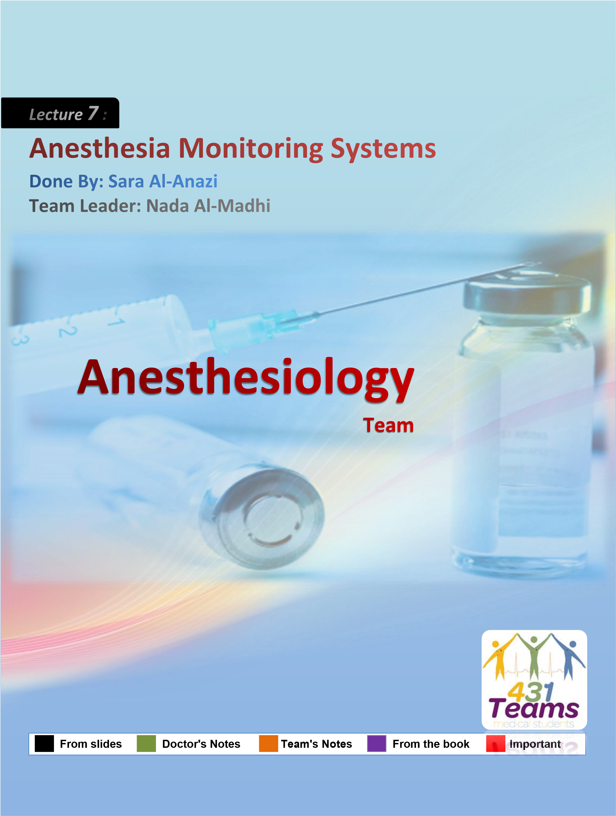
Why do we monitor our patients?
To make sure his vitals are normal, to ensure that he is not hypoxic, not hypotensive, temperature is not falling or rising, he is not tachycardic, we watch respiratory rate, cardiac output, urine output, we watch everything.

We are taking care of the patient as a whole, he is dependent on anesthesiologist who is given the anesthesia, he is no more dependent on himself, even we take care of his eyes, why do close the eyes of the anesthetized patient? Because he cannot blink. “General Anesthesia”.

Monitoring Definition:
- Interpret available clinical data to help recognize present or future mishaps or unfavorable system conditions.
How do we get future or upcoming mishaps? We get signals. For example, you can see hypoxia. What is the first sign you will see? The Oxygen saturation will drop, once it drops, you immediately take care.

Most patient die from hypoxia, not from overdose of anesthesia. You read a lot in the newspaper that a patient die from over dose. This is not true, most of the time, It is something to do with hypoxia, the patient was not properly oxygenated .This is the most common cause.

- Not restricted to anesthesia (change “clinical data” above to “system data” to apply to aircraft and nuclear power plants).
Monitoring is not restricted to anesthesia. Not only during anesthesia, Pre-anesthesia and Post-anesthesia as well. So the patient has a continuous monitoring till he is safe and can depend on himself.

- One of the primary responsibilities of an anesthesiologist is to act as a guardian of the anesthetized patient during surgery. monitoring is helpful in maintaining effective vigilance You have to respect the privacy of the patient. Patient has the right to ask for either male or female anesthesiologist. If a female patient refused a male anesthesiologist. He has to leave.

- Optimal vigilance requires an understanding of the technology of sophisticated monitoring equipment—including cost–benefit considerations.
What the mind doesn’t know, the eye cannot see. Even if you have the best monitors, if you don’t know the heart rate, you will not be able to recognize the abnormality if present. The brain should know, so the eyes can see.

This is the screen we see every morning, if I don’t see this screen, I don’t feel happy at all, because everything related to patient is here.

If you are a very good doctor, what can you tell from the screen? What about the HR of this anesthetized patient? Heart rate is 100, he is tachycardic, he is feeling pain. So this is not a good anesthesiologist, he doesn’t know how to anesthetize the patient, (or 100 is considered normal in pediatric patient).

Next, see the saturation, it is 100%. I am happy with this. There is an alarm set at 94% to alarm the anesthesiologist if the saturation drop below 94. Be careful.

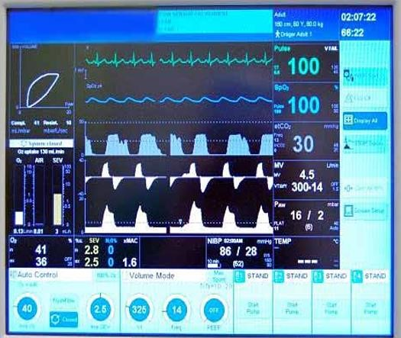
A low oxygen saturation (SpO2 < 90%) demands an immediate response. Oxygenation of the tissues depends on the inspired oxygen concentration, lung function, hemoglobin concentration and cardiac output.
Inhalation

anesthesia agents

Inspiratory

and expiratory O
2

NBP

Non
-
invasive Blood
Pressure: this reading is
not for adult, I think this is
child, Pediatric patient.

Then, see expiratory CO2, here 30 (inspiratory will be 0).

4,5 is the minute volume as you see (which is the total amount of air given in a whole minute). 300 is tidal volume. 14 is respiratory rate. Temperature should be monitored as well.

Now this is an important thing, Peak airway pressure here around 16 and mean is 2, if this number goes up this patient is not relaxed or having problem with ventilation, so you should take care.

Peak Airway Pressure /Peak inspiratory pressure (PIP) is the highest level of pressure applied to the lungs during inhalation. In mechanical ventilation the number reflects a positive pressure in centimeters of water pressure (cmH2O). Peak inspiratory pressure increases with any airway resistance. Things that may increase PIP could be increased secretions, bronchospasm, biting down on ventilation tubing, and decreased lung compliance. PIP should never be chronically higher than
40(cmH2O) unless the patient has Acute Respiratory Distress Syndrome_{. Wikipedia}
Patient Monitoring and Management involves:
- Things you measure (physiological measurement, such as BP or HR) and temperature and Respiratory rate.
- Things you observe (e.g. observation of pupils)
Either dilation or constriction. Most of our drug causes constriction of the pupil. If you have a patient that is hypoxic, pupil are dilated and not responsive to light. What happen? You patient is dead.
- Planning to avoid trouble (e.g. planning induction of anesthesia or planning extubation) If you have a patient that is hypotensive, would you give him another drug that causes hypotension? NO! If you have a patient that is still in deep anesthesia and not ready for extubation. Would you remove the tube? NO! You should make sure that patient is able to maintain his own airway first.
- Referring diagnoses (e.g. unilateral air entry may mean endobronchial intubation)
- Planning to get out of trouble (e.g. differential diagnosis and response algorithm formulation)
How to plan to get out of the trouble? By having differential diagnosis.
Example: Patient is becoming hypoxic, you give everything needed and maintained and provided O₂. But the patient is still becoming hypoxic. What do you do then? Have another differential diagnosis .Maybe your tube in one side in one lung, (one lung ventilation) you have to pull the tube and auscultate. Most of the time the tube goes to right main bronchus because it short. It is rare to be in the left side, but in children in could be in both sides.
The most common cause of low-oxygen saturation is an obstructed airway and this should be excluded before other diagnoses are considered.

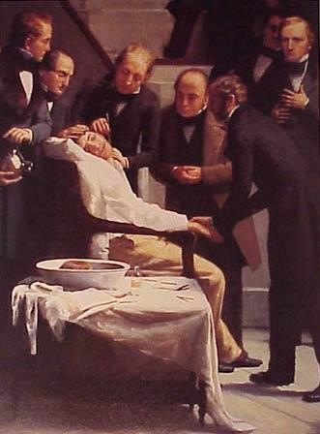
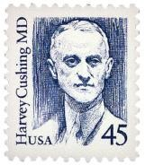
Monitoring in the Past
First anesthesia was in 1846 on 16th of October, 16th of October is the world anesthesia day.
- Visual monitoring of respiration and overall clinical appearance
- Finger on pulse
- Blood pressure (sometimes)

Harvey Cushing
Not just a famous neurosurgeon, but the father of anesthesia monitoring.
  - Invented and popularized the anesthetic chart.
  - Recorded both BP and HR.
  - Emphasized the relationship between vital signs and neurosurgical events.
( increased intracranial pressure leads to hypertension and bradycardia )
Why anesthesia monitoring is important?
- The most important and serious side effect of anesthetic drugs is depression of respiration and the cardiovascular system.
- Occur at "therapeutic" doses
- Severe depression of either respiration or the cardiovascular system is life-threatening.

The most serious effect of the anesthetic drug is depression of respiration, most deaths occurs from hypoxia, 3 minute of hypoxia and the brain can be damaged. Why other organs do not suffer like the brain? Because the brain does not have a Glucose, he doesn’t have storage of glycogen, and insulin cannot cross the blood brain barrier. It depend on oxygen and oxygen only. Hypoxia of the brain has to be treated by O2 only. Nothing else.

Monitoring in the Present
- Monitoring facilities have improved greatly in recent years but still fall short of two essential requirements:
  - the ability to monitor cerebral oxygenation
  - The ability to monitor routinely the depth of anesthesia (many false dawns).

- Full monitoring has three requirements:
  - Presence of anaesthetist
  - Checking and monitoring anaesthetic equipment 3- Patient monitoring – (clinical – technical)
Clinical : | Technical:
The continuous observation of the patient’s colour, chest movement and pattern of respiration, absence or presence of sweating and lacrimation, reactions of the pupil,use of a stethoscope,and palpation of a peripheral pulse provide essential basic monitoring of the patient. | The circulation and ventilation need continuous monitoring in all forms of anaesthesia. If muscle relaxants are used, a peripheral nerve stimulator should be used.

Standardized basic monitoring requirements (guidelines) from the ASA (American Society of Anesthesiologists), CAS (Canadian Anesthesiologists’ Society) and other national society

  - STANDARD I
Qualified anesthesia personnel shall be present in the room throughout the conduct of ala general anesthetics, regional anesthetics and monitored anesthesia care.
http://www.asahq.org/publicationsAndServices/standards/02.pdf

  - STANDARD II
During all anesthetics, the patient’s oxygenation, ventilation, circulation and temperature shall be continually evaluated. These four are mandatory monitors, this is the minimum.
http://www.asahq.org/publicationsAndServices/standards/02.pdf

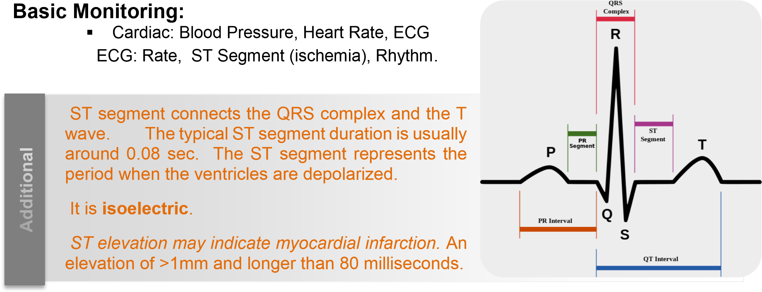
  - Respiratory: Airway Pressure, Capnogram, Pulse Oximeter, Spirometry, Visual Cues “ex. you see the color of the patient”
  - Temperature [pharyngeal, axillary, esophageal, etc.]
  - Urine output (if Foley catheter has been placed)
  - Nerve stimulator [face, forearm] (If muscle relaxants are used, a peripheral nerve stimulator should be used).
  - Cardiovascular – heart rate – electrocardiogram – noninvasive arterial pressure – oximeter
Respiratory – respiratory rate – end-tidal carbon dioxide concentration – inspired oxygen • Muscle relaxation – peripheral nerve stimulator
  - In specialised surgery, facilities for further monitoring are required
  - The electrocardiogram needs special emphasis because it is important to remember that electrical activity can exist even though there is no adequate cardiac output. Its value lies principally in monitoring changes in heart rate and in the diagnosis of arrhythmias. ▪ ETT cuff pressure (keep < 20 cm H O) In the endotracheal tube because if this
2
pressure is high It could cause ischemia to the trachea.
  - Auscultation (esophageal or precordial stethoscope) repeatedly, especially if you change the position of the patient.
  - Visual surveillance of the anesthesia workspace and some exposed portion of the patient.

There are 2 types of monitors:
- Non-invasive ex. (ECG ) : It used in any surgery – it is basic
- Invasive ex. (CVL) Central Venous Line: Used only in critical conditions or major surgeries.

Visual Surveillance:
  - Anesthesia machine / workspace checkout
  - Patient monitor numbers and waveforms
  - Bleeding/coagulation (e.g., are the surgeons using a lot of suction or sponges?
  - Diaphoresis / movements / grimaces
If patient starts to sweat under anesthesia, means there is something wrong, he is accumulating carbone dioxide or he is having pain (activation of sympathetic system).
  - Line quality (is my IV reliable?)
Sometimes IV line under sheets get discorrected, whatever you give drug the heart rate is not corrected, you give fentanyl and more fentanyl and heart rate is not coming down at all ,you see the IV line is coming out, all the drug is coming out to the floor, the floor is anesthetized and the patient still not anesthetized.
  - Positioning safety review
  - Respiratory pattern (e.g. tracheal tug, accessory muscle use etc.).
Low Tech Patient Monitoring:
These are not very important thing, but still you have to have them with you. Blood pressure cuff, finger on pulse and forehead, and stethoscope. You should have these when you don’t have monitors. When I was studying back then in India. This was the situation.

Now it is changed completely, now you can leave the room because everything is automated, before we never used to leave the patient ever.

  - Manual blood pressure cuff
  - Finger on the pulse and forehead
  - Monaural stethoscope (heart and breath sounds).
  - Eye on the rebreathing bag (spontaneously breathing patient)
  - Watch respiratory pattern
  - Watch for undesired movements
  - Look at the patient’s face, (Color OK? Diaphoresis present? Pupils?)

Special Monitoring:
Patient are not the same, you can have young, old, some having heart disease, some are diabetic, some have respiratory problems, and huge number of patients coming to us in Saudi Arabia are diabetic, and many are obese. They are not simple patients, so these patients need a special type of monitoring.
- Pulmonary artery lines (Swan Ganz)
Catheter goes to internal jugular vein then to right atrium to right ventricle then turn around and go to pulmonary artery and stop in one of its branches.
- Transesophageal echocardiography
Used in people with cardiac problems.
- Intracranial pressure (ICP) monitoring
- Electrophysiological CNS monitoring it is like EEG
- Renal function monitoring (indices) creatinine, urea, urine output and others.
- Coagulation monitoring (e.g. ACT) ACT= activated clotting time.
- Acid-base monitoring (ABGs).
- Monitoring depth of anesthesia, the newest monitoring, not that much accurate but at least gives you an idea where the patient is.

Alarms:
Purpose: Alarms serve to alert equipment operators that some monitored variable or combination of variables is outside some region.There are alarms in all monitors. The function of the alarm is to alert the anesthesiologist about the impending problem.
8 Axes of Clinical Anesthesia Monitoring (A Conceptual Model)
- Axis I - Airway /Respiratory
- Axis II - Circulatory / Volume
- Axis III - Depth of Anesthesia
- Axis IV - Neurological
- Axis V - Muscle Relaxation this axis is unique to the anesthesia
One of the nurses went to pharmacist and said that she has severe back pain and muscle spasm. The pharmacist opened a pharmacology book and read that Atracurium is very nice muscle relaxant, he gave it to her and she relaxed forever, she died from hypoxia. So you should always double check the medication.
- Axis VI - Temperature
- Axis VII - Electrolytes / Metabolic ▪ Axis VIII - Coagulation
Airway / Respiratory Axis:
- Correct ETT placement ,
This is important, half of your patient will go hypoxic because you did not put the tube in the right place. Do not put the tube till you see the vocal cords, and watch the tube go through it. And then check that you are in the right place by watching chest breathing movement and auscultate the breath sound in both lungs.

- ETT cuff pressure. You have to measure it so you don’t cause injury and later tracheal stenosis as result to the injury.

- Airway pressure .This is going to tell you that the tube in the right place and the lung in the doing fine.

- Oxygenation
- Ventilation
- Spirometry
- Pulmonary biomechanics
- Airway gas monitoring
- Clinical: wheezing, crackles, equal air entry, color, respiratory pattern (rate, rhythm, depth,.. Circulatory Axis: ▪ Cardiac output
- Input pressures (CVP, LAP) CVP central Vascular Pressure indicate intra vascular volume.
- Output pressures (BP, PAP)
- Pacemaker: rate, conduction
- Cardiac contractility the better the cardiac contractility the better the cardiac output.
- Vascular resistances (SVR, PVR)
- Intracardiac shunts
What are the common shunts you know?
Example: patent foramen ovale. 40% of us have insignificant patent foramen ovale.

Cardiac Monitoring:
Arterial blood pressure: direct and indirect.

1. Direct blood pressure measurement involves placing a catheter in an artery and connecting it to a transducer via a fluid-filled line. Tubing should be narrower and stiffer. No bubbles in the system. The transducer is connected to an amplifier and display unit. Shows the waveform, systolic/diastolic/mean pressures calculated from the waveform. The shape of the waveform gives useful information about the state of the circulation, in particular the peripheral resistance

Indications:
Elective hypotension anticipation of wide intra-operative blood pressure swings and blood gases. Do it if you have a patient with cardiac problems that you know he will not maintain his pressure normally.

Contraindications :
Catheterization should be avoided in arteries without documented adequate collateral blood flow.
Ex. If I can’t find ulnar artery in the patient hand, I will not catheterized the radial artery. Why? Because there will be no collateral blood flow to the hand if the ulnar artery is injured or clotted. Check both arteries before putting arterial line.

Radial artery is preferred for arterial line because it has low complication rates compared with other sites. It is a superficial artery which aids insertion, and also makes it compressible for hemostasis. Allen’s test is recommended by many textbooks before the insertion of a radial to make sure the is reliable collateral blood flow . Allen test is performed by having the patient clench their fist several times while the operator occludes the radial and ulnar artery at the wrist. The patient then extends their fingers, palm up, which should show a "blanched" hand. The operator then releases the pressure on the ulnar artery and the hand is observed for "blushing". If the color of the hand does not return in 5-10 seconds the Allen test is considered positive and arterial puncture should not be attempted at that site.
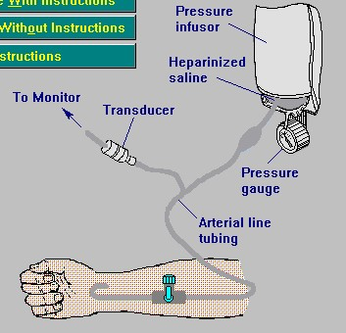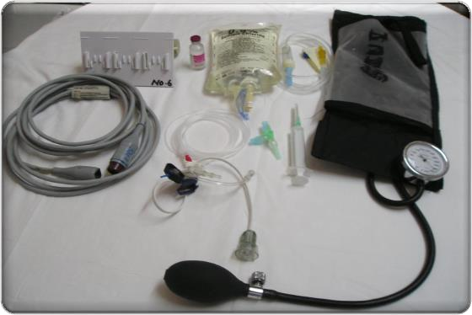

Why do we need a pressure bag?

The
pressure bag

where
you put the saline bag
inside and pressurize it
.

The
pressure
bag
and
the sali
ne
bag inside

Transducer is a
device that
converts the
pulsatile arterial
blood pressure
waveform into an
electrical signals
that’s show on the
monitor screen.

You know that my blood pressure 120/80 mmHg. Let’s say 100 Ok. What is atmospheric pressure? 760 mmHg. When I cut my self? How the blood is coming out? 760 is higher than 120 80 right?
The atmosphere should press the blood back in, or at least stop it from coming out? The absolute arterial pressures would be 860 mmHg if atmospheric is 760 mmHg. When I say blood pressure is 100 mmHg, It means 100 mmHg higher than atmospheric pressure.

Absolute pressure determines whether the blood will shoot out or shoot back into our body
In physics, absolute pressure = gauge pressure + atmospheric pressure absolute pressure = 100 + 760 = 860mmHg absolute pressure > atmospheric pressure so, when we cut our finger, blood will shoot out

By using a pressure bag, Saline is pressurized to 300 mmHg, which a pressure higher than arterial systolic pressure to prevent backflow of blood to saline bag.

The pressurized saline bag should be flushed with heparinized saline to keep the line free from clots. If I don’t it will clot.

2. Indirect blood pressure : involves inflating a cuff around the limb and monitoring the blood flow in the limb distal to the artery Contraindication:
Best to be avoided in patient vascular abnormalities (A-V fisula).

Electrocardiogram:
▪ The electrocardiogram only monitors the electrical activity of the heart and the heart rate ▪ Tell nothing about the mechanical function of the heart or the state of the circulation ▪ Essential for diagnosis and treatment of arrhythmias .

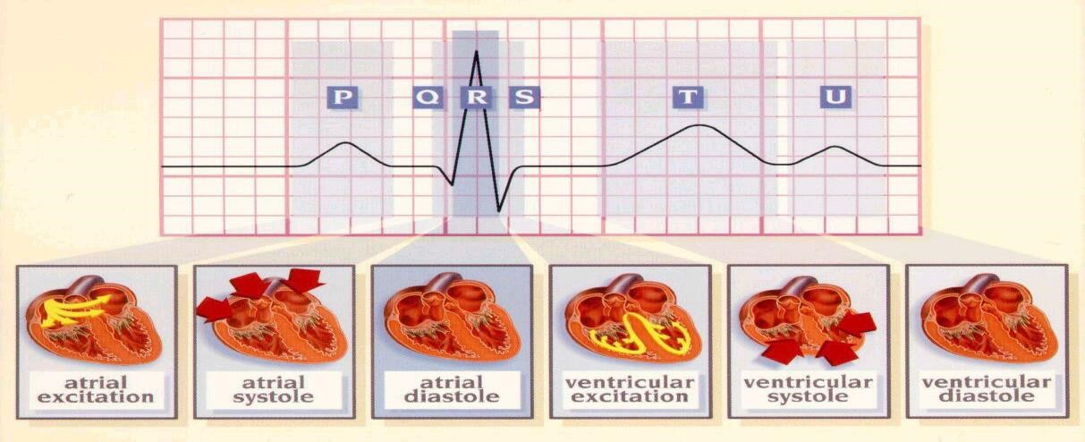

Waves of the ECG monitor:
- QRS represents depolarization of the ventricles.
- T wave repolarization of the ventricles. “Repolarization of the atrium is masked with the ventricular depolarization”.
- P wave represents atrial demoralization, “ DO NOT say contraction, It is an electrical monitoring not a mechanical one” , depolarization starts from SA node then move through bundles to AV node, there are three bundles:

There are 3 types of heart block:
- 1st degree block (only prolongation of PR interval)  2nd degree block ( We have 2 types):
  - Type1 (Wenckebach)
In Wenckebach Phenomenon there is progressive prolongation of the PR interval
  - Type 2 ( Mobitz)

- 3rd degree block (complete disassociation between the atrium and ventricle)

There are 3 bundles coming from SA node to AV node:
- Wenckebach bundle
In Wenckebach Phenomenon there is progressive prolongation of the PR interval
- Bachmann's bundle.
- Thoral's bundle.

What is PR interval is saying? The state of conduction system, NOT the circulation. (Normal PR interval is 0.12 to 0.20 s).

- If the electrical impulses passes immediately from atrium to ventricle what will happen?? I will die. The atria and the ventricle will contract at the same time and will oppose each other and the heart will not work properly. Okay, How these impulses are prevented from jumping immediately to the ventricles? Because there is a delay in the impulses caused by fibrous tissue.

- Impulses go very fast from AV node through bundle of His to Purkinje fibers and then concentrate first in the apex of the heart , the heart start to depolarize from the apex to the base, so the heart will pump from below to above toward the Aorta.

Artifacts in ECG Monitoring:
- Loose electrodes or broken leads,
First thing you do when there is something wrong, is to put your finger and feel the pulse. We had a senior lady anesthesiologist, she was anesthetizing a small baby and suddenly she starts shouting: come quickly!! The patient has no HR! ECG was flat. I went inside and I put my finger and I felt the pulse nicely beating, everything was Ok, The child was pink. The problem was the ECG lead was out. So the reason was loose ECG electrode. Always try to feel the pulse before you shout.

- Misplaced leads like if you put the right lead left or the left lead right.

- Wrong lead system selected Like you select lead 5 for lead 3.

- Emphysema, pneumothorax, pericardial effusion These condition will make the heart away from the leads.

- Shivering or restlessness
- Respiratory variation and movement
- Monitor Pulse Oximetry, Invasive ABP

Central venous catheterization:
  - Indicated for monitoring CVP for fluid management ( Hypovolemia , shock ) “ most important”
You want to know here the atrial compliance, the intravascular volume is reflected by the right atrial compliance, if the right atrium is empty you will get low CVP, If you have full atrium you will have good CVP, If you have too much full atrium you will have High CVP.
  - Infusion of drugs
  - Infusion of TPN Total parenteral nutrition given for NPO patient for long time, like patients with bowel surgeries you keep them NPO for long time.
  - Aspiration of air embolism
  - Insertion of pacemaker
  - Giving venous access in pt with poor peripheral vein
  - Acess for insertion of pulmonary artery cathetre

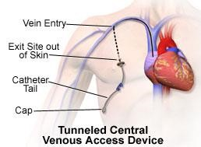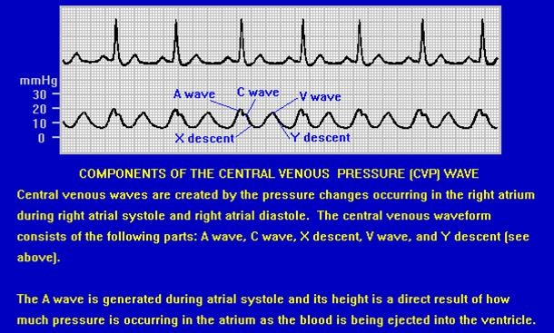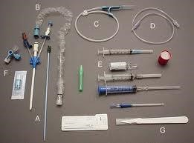

- A wave represents Atrial contraction.
- C wave represents bulging of the valve into the atrium
What happen in regurgitation? C wave will be very high because blood will come back to the right atrium.

The " a " wave corresponds to right Atrial contraction.
The " c " wave corresponds to right ventricular Contraction causing the triCuspid valve to bulge towards the right atrium.
The " x " descent follows the 'a' wave and corresponds to atrial relaXation and rapid atrial filling due to low pressure.
The " x prime' " descent follows the 'c' wave and occurs as a result of the right ventricle pulling the tricuspid valve downward during ventricular systole. (As stroke volume is ejected, the ventricle takes up less space in pericardium, allowing relaXed atrium to enlarge). The x' (x prime) descent can be used as a measure of right ventricle contractility.
The " v " wave corresponds to Venous filling when the tricuspid valve is closed and venous pressure increases from venous return.
The “y " descent corresponds to the rapid emptYing of the atrium into the ventricle following the opening of the tricuspid valve. Wikipedia

What is the method of introducing CVP catheter? Seldinger method, it is very important method.

Seldinger Method:
percutaneous insertion of a catheter into a blood vessel or space. A needle is used to p uncture the structure and a guidewire is threaded through the needle; when the needle i s withdrawn, a catheter is threaded over the wire; the wire is then withdrawn, leaving the catheter in place.

Central venous catheterization contraindicated in:
- Renal cell tumre extended to RT ventricle
- PT with anticoagulation
- Ipsilateral carotid end-arterectomy because if you puncture the artery you will be in trouble, the artery will go in spasm.

Complications :
  - Air embolism
During insertion of CPV the patient will be in Trendelenburg position, head down so the vein will fill up with blood and decrease the possibility for air embolism

Air embolism can occur whenever a blood vessel is open and a pressure gradient exists favoring entry of gas. Because the circulatory pressure in most arteries and veins is greater than atmospheric pressure, an air embolus does not always happen when a blood vessel is injured. In the veins above the heart, such as in the head and neck, the pressure is less than atmospheric and an injury may let air in. This is one reason why surgeons must be particularly careful when operating on the brain, and why the head of the bed is tilted down when inserting or removing a central venous catheter from the jugular or subclavian veins.
When air enters the veins, it travels to the right side of the heart, and then to the lungs. This can cause the vessels of the lung to constrict, raising the pressure in the right side of the heart. If the pressure rises high enough in a patient who is one of the 20% to 30% of the population with a patent foramen ovale, the gas bubble can then travel to the left side of the heart, and on to the brain or coronary arteries. Such bubbles are responsible for the most serious of gas embolic symptoms.

  - Infection
  - Thrombus embolism
  - Dysrhythmia caused by catheter itself, it could stimulate the SA node.
  - Hematoma
  - Pneumothorax, hemothorax if you are not carful you and go deep with the needle you may puncture the pleura.
  - Cardiac tamponade if you go through the ventricles
  - Trauma to nearby tissue

- You have two internal jugular veins, right and left vein. Which do you choose? You chose the Right one. Why?
  - Because it goes straight to the right atrium.( while left internal jugular goes to innominate vein then to the SVC then to Right atrium)
  - You avoid injury to the Thoracic duct which is on the left side,
  - Also there is less injury to the pleura because it is little far away more than the left side.

- Where do you position the catheter exactly? At the junction of SVC and right atrium.

Pulmonary artery catheter :
    - Indicated to monitor CO cardiac output , PAP Pulmonary artery Pressure , SVR Systemic Vascular Resistance , mixed venous oxygenation ( pulmonary artery blood is mixed venous).There are direct measures and calculated measure. CO, cardiac index, SVR are calculated. PAP and CVP are direct measures.

    - Contraindicated :
    - Complete LBBB
    - Sever arrhythmia
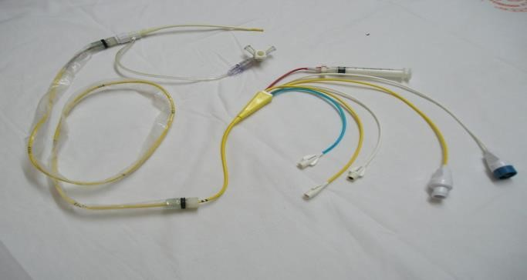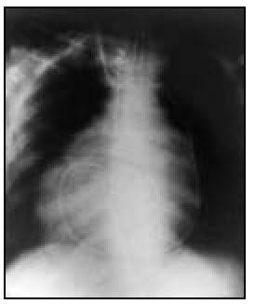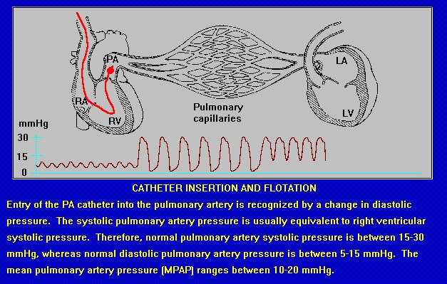

Hemodynamic Profiles Obtained from PA Catheters:
- SV = CO / HR (60-90 mL/beat)
- SVR = [(MAP – CVP) / CO]  80
(900-1500 dynes-sec/cm⁵)
If SVR falls, for example 400. What does it mean? A sepsis.
When there a sepsis, What will you do to correct the very low BP? give norepinephrine immediately.

- PVR Pulmonary vascular resistance = [(MPAP – PCWP) / CO]  80
(50-150 dynes-sec/cm⁵)
Why you want to know this? Because sometimes you need to do pulmonary dilatation, if patient has ARDS , PVR will be very high like 300 -400, so to reduce that you give a direct pulmonary dilator which is NO Nitric Oxide. It is a good pulmonary vasodilator.

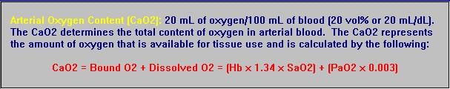

➢ What is the O₂ content? It is the amount of O₂ carried by hemoglobin in physical solution, not in dissolved form. Each gram of hemoglobin carries 1.34 ml of Oxygen.

- O₂ delivery (DO₂) = C.O.  O₂ content
- Arterial O₂ content (CaO₂) = ( Hb  1.38 )  (SaO₂)
- Mixed venous O2 content (CvO₂)= ( Hb  1.38 )  (SvO₂)
- O₂ consumption (VO₂) = C.O.  (CaO₂-CvO₂)
- SvO₂ = SaO₂ – [VO₂ / (Hb  13.8)(CO)]

Mixed venous oxygen saturation (SvO2) is the percentage of oxygen bound to hemoglobin in blood returning to the right side of the heart. This reflects the amount of oxygen "left over" after the tissues remove what they need. It is used to help us to recognize when a patient's body is extracting more oxygen than normally. An increase in extraction is the body’s way to meet tissue oxygen needs when the amount of oxygen reaching the tissues is less than needed.
Mixed venous oxygen saturation (SvO2) can help to determine whether the cardiac output
and oxygen delivery is high enough to meet a patient's needs. It can be very useful if measured before and after changes are made to cardiac medications or mechanical ventilation, particularly in unstable patients.

You should know the O2 content and the oxygen delivery. These 2 are very important

Respiratory system:
Respiratory system monitoring include pulse oximetry, capnography, a fraction of inspired oxygen analyzer, and a disconnect alarm.
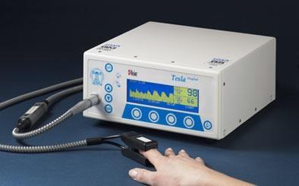
How does the pulse oximeter works?
Pulse oximeter combines the principles of oximetry and plethysmography to noninvasively measure oxygen saturation in arterial blood. The pulse oximeter probe contains two light emitting diodes at wavelengths of 940nm and 660 nm. Oxygenated and reduced hemoglobin differ in light absorption (940 and 660 nm respectively). Thus the change in light absorption during arterial pulsation is the basis of oximetry determination. The ratio of the absorption at the two wavelengths is analyzed by a microprocessor to record the oxygen saturation. (pulse oximeter measure O2 Saturation and HR).
.
Pulse Oximeter Wavelengths:
- Red (660 nm) absorbed by unoxygenated hemoglobin.
- Near infrared (940 nm) , absorbed by oxygenated hemoglobin.

False Readings:
- Nail polish
- Intravenous dyes
- Intravenous drugs : methylene blue, indocyanine green
- Carbon monoxide poisoning
- Diminished pulse, Poor Peripheral circulation.
- Movement of finger now we have pulse oximeters that overcome this • Ambient light Florescent light interfere with oximeter.
- Abnormal hemoglobin.
- Values below 70% obtained by pulse oximetry are unreliable.
Notes from 429 Team work :
REMEMBER : A pulse oximeter gives NO information on any of these variables:
- Oxygen content of the blood - The Repiratory Rate or tidal volume - Amount of oxygen dissolved in the blood - The cardiac output or BP.

Abnormal Hemoglobin
- Carboxyhemoglobin:
 false high reading in carbon monoxide patients
The actual saturation will be 84 or 85 but the monitor will show 99 or 98, you feel happy because you think the patient is fine. But the patient is not fine.
What is the first sign of Carbone monoxide poising?
First dizziness then you see Red Cherry sign. ▪ Methemaglobin : reads 85% regardless of actual saturation ▪ Fetal hemoglobin: little effect on pulse oximetry.
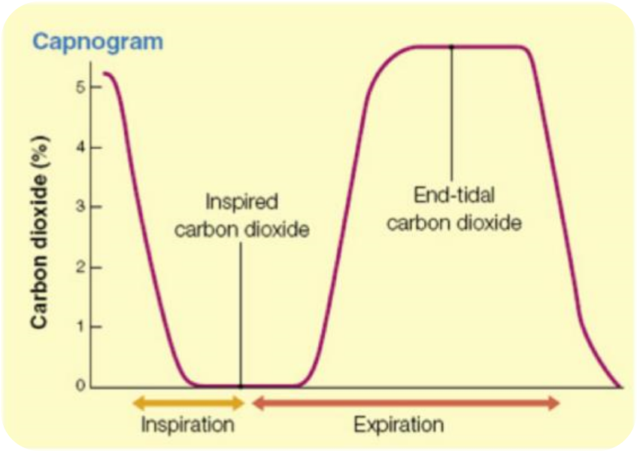
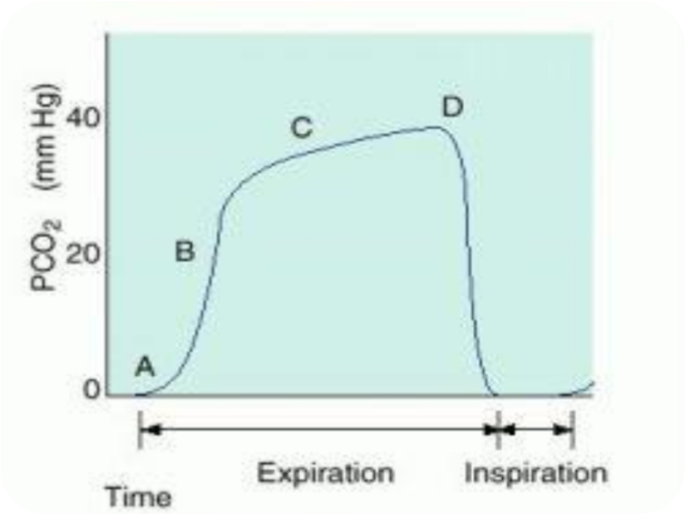
What is Capnometry?
- Is the measurement of end-tidal carbon dioxide tension.
- This provides valuable information to the anesthesiologist.
- The presence of end tidal CO2 aids in
confirming endotracheal intubation. This is one of the best thing to confirm endotracheal intubation.
- Alteration in the slope of the graph can give clues to the presence of airway obstruction.
- A rapid fall in reading may signify extubation, air embolism or low cardiac output with hypovolemia.

A normal Capnograph demonstrating the three phases of expiration:
- Phase A—dead space.
- Phase B—mixture of dead space and alveolar gas.
- Phase C—alveolar gas plateau.

Monitoring ETCO2:
- Confirms the movement of air in and out of the lungs
The only place In the body which contains Co2 is the lungs,So capnography is used to insure correct intubation.If there is no CO2 on the monitor that means the ETT is put inside the esophagus

- Assumed to reflect alveolar CO2
- Assumed to indicate adequacy of ventilation and cardiac output
- Better indicator of ventilation
- Measures high point of the expiratory plateau
- Normally less than the PaCO2
- Normal gradient about 5-8

CO2 Increases with: | CO2 Decreases with:
- Hypoventilation  - Malignant hyperthermia this condition is also unique to anesthesia.  - Sepsis and fever  - Rebreathing  - Bicarbonate administration  - Insufflation of CO₂ | - Hyperventilation  - Hypothermia  - Low cardiac output  - pulmonary embolism  - Circuit disconnect  - Cardiac arrest

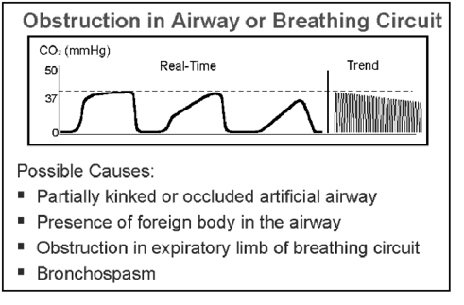
Describe Wave Forms representing the following:
- Normal wave form
- COPD
- Inadequate neuromuscular relaxation
- Unequal lung emptying Restrictive lung disease.
- Esophageal intubation
- Malignant hyperthermia
- Cardiac arrest
- Pulmonary embolism

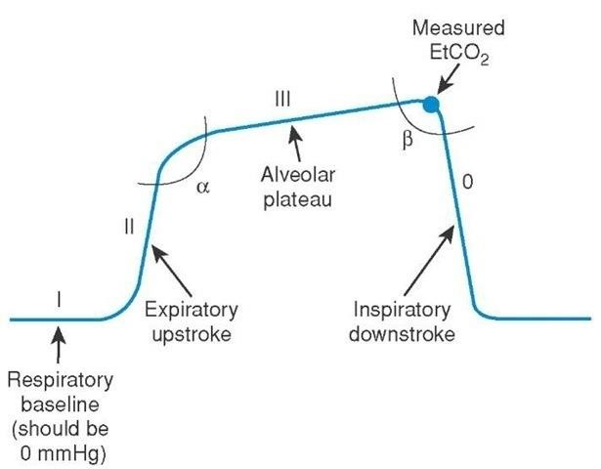

Clinical Applications: (The doctor did not comment on the pictures below, I found these interpretation in 429 team work, Thanks to them)
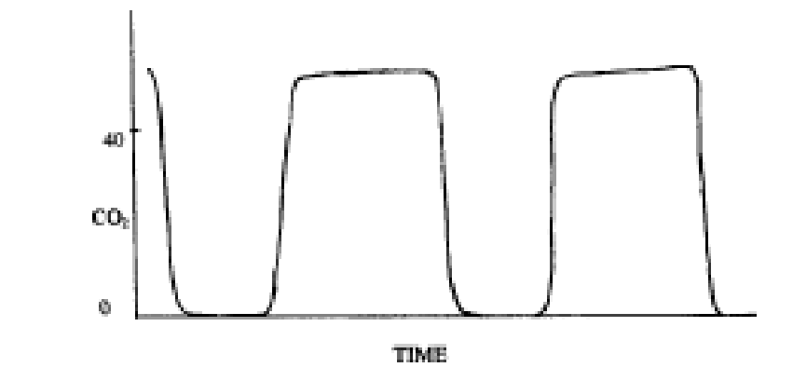 | 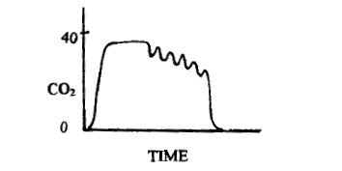
High Co2 level: indicate hypoventilation OR malignant hyperthermia | Indicate Air Embolism
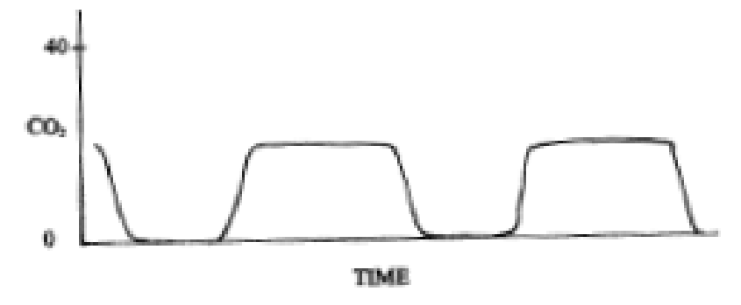 | 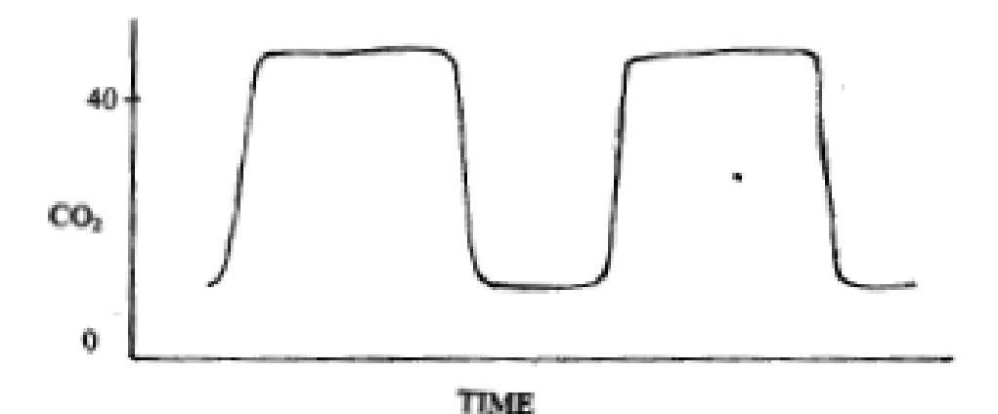
Low Co2 level: indicate hyperventilation | Inspiration phase does not hit the 0 level:  indicate old Soda lime* which cause  rebreathing
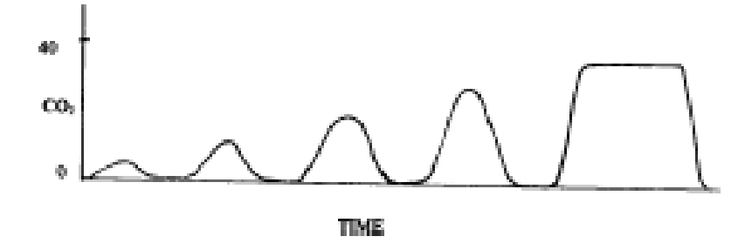 | 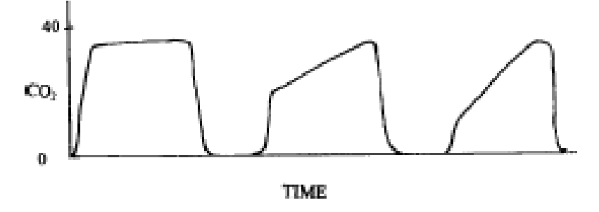
Indicate the machine disconnection | Show slope plateau: indicate COPD  (Ex: asthma)
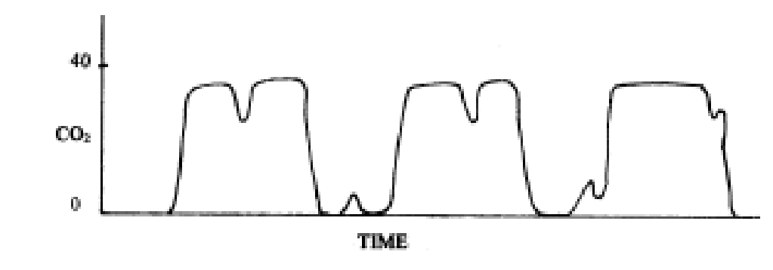
Indicate that the patient starting to recover from the muscle relaxants (hiccup)
*In this breathing system, Soda Lime is chemical component used to absorb the patient’s exhaled carbon dioxide, when Soda lime is exhausted, patient will rebreathe Co₂. So that’s why Co₂ in the graph doesn’t reach 0.

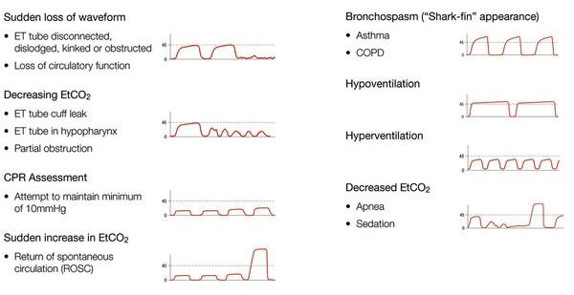
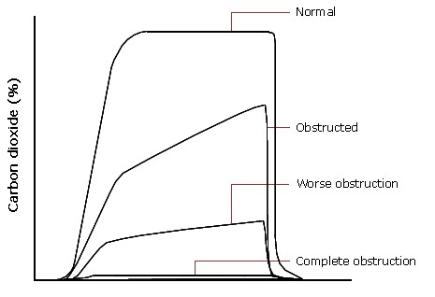
Clinical Uses of Capnography:
- Detection of untoward events
- Maintenance of normocarbia
- Weaning from mechanical ventilation
- Evaluating effectiveness of CPR

Anesthetic Gas Monitoring:
What types of gases are present?
- What are their concentrations?
  - partial pressure
  - volume percent

Mass Spectrometry:
- Gas enters high vacuum area ▪ Bombarded by electron beam
- Charged particles passed over strong magnet
- Different components are deflected according to their chemical composition ▪ Specific collectors measure composition

Infrared Analyzers:
- Measures energy absorbed from narrow band wavelengths of infrared light passing through a gas sample
- Molecules that absorb energy
  - carbon dioxide
  - nitrous oxide
  - water vapor
  - volatile anesthetics
- Molecules that do not absorb energy
  - oxygen
  - argon
  - nitrogen
  - helium
  - xenon

Peripheral Nerve Stimulation:
You connect this stimulator to ulnar nerve to monitor the recovery from the muscle relaxant agents,
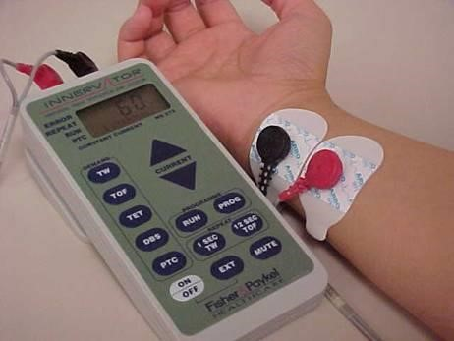
- Neuromuscular blockade is monitored during surgery to guide repeated doses of muscle relaxants and to differentiate between the types of block.
- All techniques for assessing neuromuscular blockade use a peripheral nerve stimulator (PNS) to stimulate a motor nerve electrically.
- A peripheral nerve stimulator delivers a current of variable frequency and amplitude to a pair of either ECG silver chloride pads or subcutaneous needles placed over a peripheral motor nerve.
- The evoked mechanical or electrical response of the innervated muscle is observed.
- Ulnar nerve stimulation of the adductor pollicis muscle (You see thumb movement) and facial nerve stimulation of the orbicularis oculi (The stimulus will produce eyebrow twitching) are most commonly monitored.
- Train-of-four (TOF) testing is the most commonly used method of peripheral nerve stimulation monitoring. Nondepolarizing neuromuscular blocking drugs induce train-of-four (TOF) fade (reduction of muscle twitch under TOF stimulation).

Peripheral nerve stimulation helps to decrease avoidable effects related to the use of NMBA’s (Neuromuscular Blocking agents) such as unwanted movement, prolonged paralysis and delayed recovery from drug and/or metabolite accumulation.

TOF (train of four) is done by counting the number of twitches elicited though electrodes placed along a nerve path. The stimulus delivered as a group of 0.2 millisecond pulses, spaced 500 milliseconds. This pattern is repeated every 10 seconds. The number of contractions observed reflects the degree of blockade achieved.

Difference between Nondepolarizing and depolarizing NMB agents under TOF stimulation? Non-depolarizing blockers have The tetanic fade ( the failure of muscles to maintain a fused tetany at sufficiently high frequencies of electrical stimulation.) (Muscle twitches fades).
Depolarizing blockers do not cause the tetanic fade.

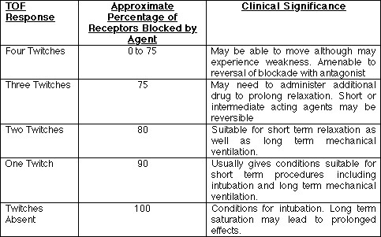

The response is measured as follows:
- When 4 twitches are seen, 0-75% of the receptors are blocked.
- When 3 twitches are seen, at least 75% of the receptors are blocked.
- When 2 twitches are seen, 80% of the receptors are blocked.
- When 1 twitch is seen, 90% of the receptors are blocked.
- When No twitches are seen, 100% of receptors are blocked.
(Medscape)

Neurological monitoring:

Depth of Anesthesia
- Clinical Signs
  - eye signs, respiratory signs, cardiovascular signs, CNS signs.
- EEG monitoring
- Facial EMG monitoring (experimental)
- Esophageal contractility (obsolete)

CNS Monitoring
- Clinical: sensorium, reflexes, “wake up test”
- Electroencephalography, BIS
- Evoked potentials (esp. somatosensory EPs)
- Monitoring for venous air emboli
- Intracranial pressure (ICP) monitoring
- Transcranial doppler studies (MCA flow velocity) (Research)
- Jugular bulb saturation (Research)
- Cerebral oximetry (Research)

Wake-up Test No body is using it now.
- Test neurologic function following reversible surgical manipulation
- Movement must not cause damage
- Patient is allowed to awake, Amnesia must be maintained ▪ After awakening, patient follows verbal commands
  - Evaluates corticospinal tracts (thoracic)
- Response to painful stimuli
  - Lumbar cord function

Measuring ICP (Intracranial pressure)
- Ventricular catheter
- Subdural bolt
- Lumbar CSF catheter ▪ Scanning techniques

Bispectral index
- A new two channeled EEG
- Bispectral data takes the data generated EEG, through number of steps calculate single number correlate with depth of anesthesia
- BIS value 65-85 advocated a measure of sedation ▪ BIS value 40-65 recommended for general anesthesia

Temperature Monitoring
Rationale for use
- detect/prevent hypothermia
- monitor deliberate hypothermia
- adjunct to diagnosing MH
- monitoring CPB cooling/rewarming

Sites:
- Esophageal (most accurate site).
- Nasopharyngeal
- Axillary

Electrolyte / Metabolic Axis
- Fluid balance
- Sugar
- Electrolytes
- Acid-base balance
- Nutritional status

Coagulation Monitoring
- Clinical signs
- PT / PTT / INR ▪ ACT
- Platelet counts
- Factor assays
- Rectal ▪ Bladder ( invasive).

- TEG Thromboelastogram it is special device to monitor the coagulation.

Mishaps you can detect by using monitors:
- Disconnection  - Hypoventilation  - Esophageal intubation  - Bronchial intubation | - Circuit hypoxia  - Halocarbon overdose  - Hypovolemia  - Pneumothorax  - Air Embolism | - Hyperthermia  - Aspiration  - Acid-base imbalance  - Cardiac dysrhythmias  - IV drug overdose

Monitors and number of problem detected by this monitor (See mishaps above with their numbers):
- Pulse oximeter 1,2,3,4,5,8,9,11,14
- Mass spectrometer 1,2,3,6,9,10,12
- Capnograph 1,2,3,9,10,12
- Automatic BP 6,7,9,14
- Stethoscope1,3,4,13 ▪ Spirometer 1,2
- Oxygen analyzer 5
- EKG 13
- Temperature 10

Conclusion:
The most important monitor during any anaesthetic procedure is the presence of a trained, vigilant anaesthetist. Under no circumstances must you ever leave the theatre while a patient is under your care. Careful, repetitive clinical observation of the patient is the next essential procedure, followed by the appropriate use of monitors to assess the respiratory and cardiovascular system. These principles apply to all surgical procedures.
.
- Monitoring Definition: Interpret available clinical data to help recognize present or future mishaps or unfavorable system conditions.

- Monitoring facilities have improved greatly in recent years but still fall short of two essential requirements:
1-the ability to monitor cerebral oxygenation
2-The ability to monitor routinely the depth of anesthesia (many false dawns).

- Standardized basic monitoring requirements from the ASA :
  - STANDARD I : Qualified anesthesia personnel shall be present in the room throughout the conduct of ala general anesthetics, regional anesthetics and monitored anesthesia care.
  - STANDARD II : During all anesthetics, the patient’s oxygenation, ventilation, circulation and temperature shall be continually evaluated.

- There are 2 types of monitors:
  - Non-invasive ex. (ECG): It used in any surgery – it is basic
  - Invasive ex. (CVL) Central Venous Line: Used only in critical conditions or major surgeries.

- The most important and serious side effect of anesthetic drugs is depression of respiration and the cardiovascular system. Most deaths occurs from Hypoxia. Low oxygen saturation (SpO2 < 90%) demands an immediate response. The most common cause of low-oxygen saturation is an obstructed airway and this should be excluded before other diagnoses are considered.

- Temperature Monitoring is very important and most accurate monitor is Esophageal.

- Ulnar nerve stimulation of the adductor pollicis muscle and facial nerve stimulation of the orbicularis oculi are most commonly monitored. Train-of-four (TOF) testing is the most commonly used method of peripheral nerve stimulation monitoring.

- Capnometry Is the measurement of end-tidal carbon dioxide tension .The presence of end tidal CO2 aids in confirming endotracheal intubation. Can be used to evaluate effectiveness of CPR.

- Causes of Pulse Oximeter False Readings: Nail polish, Intravenous dyes, Intravenous drugs, Carbon monoxide poisoning, Diminished pulse, Poor Peripheral circulation, Movement of finger, Ambient light.

- Abnormal Hemoglobin is cause of false Pulse oximeter readings
1-Carboxyhemoglobin: false high reading in carbon monoxide patients
2-Methemaglobin: reads 85% regardless of actual saturation
3-Fetal hemoglobin: little effect on pulse oximetry

- Right internal jugular artery is preferred for CVL because:
1-It goes straight to the right atrium.( while left internal jugular goes to innominate vein then to the SVC then to Right atrium)
  - You avoid injury to the Thoracic duct which is on the left side,
  - Less injury to the pleura because it is little far away more than the left side.

- The Electrocardiogram ECG only monitors the electrical activity of the heart and the heart rate. Tells nothing about the mechanical function of the heart or the state of the circulation.IT is Essential for diagnosis and treatment of arrhythmias

- Indirect blood pressure best to be avoided in patient vascular abnormalities (A-V fisula).

- Direct blood pressure measurement involves placing a catheter in an artery and connecting it to a transducer via a fluid-filled line. Indications: Elective hypotension anticipation of wide intraoperative blood pressure swings and blood gases. Catheterization should be avoided in arteries without documented adequate collateral blood flow. Radial artery is preferred for arterial line because it has low complication rates compared with other sites. Perform Allen test first.

- Central venous catheterization Indicated for monitoring CVP for fluid management (Hypovolemia , shock ) .

